Azure Naming Quick Reference
Use this quick reference guide in conjunction with the SSC Naming and Tagging Standard for Azure detailed design specification. Compliance is mandatory for resources deployed into the SSC PBMM Virtual Data Centre in Azure. Unclassified workloads should follow the same standard.
NOTE: Specific resource types have character restrictions enforced by Azure, this cheat sheet provides quick reference lookup tables for common resources. The authoritative source for naming rules is in Section 3.3, Object Tables of the detailed design specification (DDS).
IaaS/PaaS Naming Rules:
- Reserved characters: Hyphen “-“ and underscore “_” are reserved characters for field delimitation.
- Hyphen “-“ is only used to separate mandatory Departmental fields.
- Underscore “_” may be used by resource owners for field delimitation.
- Case is not used as a field delimiter – Camel Case is supported (mix upper/lower).
- Resource types have a mandatory resource type suffix, VM names are an exception to support NetBIOS restrictions (cloud resource names and NetBIOS names do not need to match).
- For resources that have a parent – child relationship, the parent name makes up the first part of the child name. The suffix is replaced as applicable.
Parent | Child
(Virtual Machine)  ScDcSRV-APP01 | (VM resources)  ScDcSRV-APP01-nic1  ScDcSRV-APP01-nsg  ScDcSRV-APP01-osdisk1
(Virtual Network)  ScPcCNR-CORE-vnet | (Subnets)  ScPcCNR-CORE-PROD-snet  ScPcCNR-CORE-MRZ-snet  ScPcCNR-CORE-PAZ-snet

GC GOVERNANCE FIELDS: Three mandatory fields, case insensitive, alphabetic characters only, no delimiter (see example above). <Dept. Code><Environment><CSP and Region>
Field 1 – Two character department code – SCC uses “Sc”
Field 2 – Single character environment code (extensible):
P = Production
D = Development
Q = Quality Assurance
S = Sandbox

Field 3 – CSP and Region:

c = Azure Canada Central
e = Azure Canada East
CONTAINER NAMES: (Management Groups / Subscriptions / Resource Groups)
Typically, the Cloud Team (CSD) assigns container names. Field delimiters are used. Spaces are allowed in container names.
Format: <Dept. Code><env><CSP region>-<owner>_<project>-<suffix>
<owner> = Division or group responsible for security and financial commitment
<project> = short string selected by the resource owner
<suffix> = used on resource groups only for container names (-rg)
Example:
Subscription: ScSc-CTO_VDC
Resource Groups: ScSc-CTO_VDC-Core-rg / ScSc-CTO_VDC-Dev-rg

RESOURCE NAMES: (all Azure resource types)
General guidelines for Azure resource types, see DDS object tables (in appendix) for specific field restrictions and exceptions. Note where field delimiters are used, spaces are not allowed in resource names.
Format: <Dept. Code><env><CSP region><device type>-<user_defined_string>-<suffix>
<device type> = three character string not preceded by “-“. Device types are defined in the table below and align with the SSC SACM end-state naming convention for CMDB and DNS compliance
<user_defined_string> = resource owner defined string, spaces and special characters are not allowed.
<suffix> = cloud resource type based on MSFT best practice. Resource suffix defined in the table below
EXAMPLE:
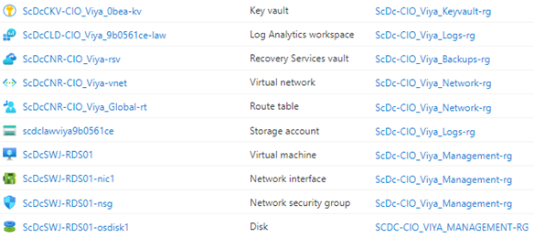

DEVICE TYPE TABLE: Contact CSD for additional device types – typically uppercase (optional)
SSC Device Type: | Short Code: | Cloud Device Type: | Short Code:
Servers (*see note below) | SRV | Generic Cloud Entity | CLD
Bastion Host | BST | Cloud Network Resource | CNR
Firewall | FWL | Cloud Storage Account | CSA
Application Delivery Controller | ADC | Cloud Secret Vault | CSV
Intrusion Detection System | IDS | Cloud Container Registry | CCR
Intrusion Prevention System | IPS | Cloud Platform Service | CPS
Router | RTR | Generic Cloud Entity / Object | CLD
Network Switch | XSW | Cloud Network Resource | CNR
Storage SAN Switch | QFC | Cloud Storage Account | CSA
Virtual Desktop | VDI | Cloud Platform Service | CPS
 |  | <extensible>

*Example - Server Naming: The first character of a hostname is ‘S’ for server (reserved) in the standard, the second and third characters of the functional device type portion of the hostname should be specified using the tables below <extensible>.
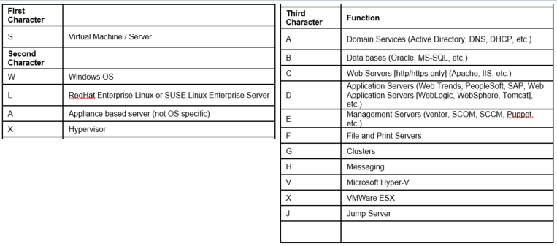

SUFFIX TABLE: Contact SIPC for additional resource suffixes – typically lowercase (optional)

Azure Object Type | Short Code: | Azure Object Type | Short Code:
Subscription | (none) | Application Gateway | agw
Resource Group | rg | App Service | asv
Virtual Machine | vm | Key Vault | kv
Availability Set | as | App Service Plan | asp
Virtual Network | vnet | Sql Database | sdb
Subnet | snet | Sql Server | sql
Public IP Address | pip# | Disk | dsk
Firewall | fw | DNS Zone | dns
Network Security Group | nsg | Log Analytics Workspace | law
Storage Account | stg | Function | fnc
Traffic Manager | tm | Logic App | log
Load Balancer | lb | Network Interface | nic#
Azure Load Balancer | alb | Connection | con
Load Balancer Rule | lbr | Route Table | rt
Load Balancer Health Probe | lbhp | Route | route
Load Balancer Backend Pool | lbbp | VM OS Disk | osdisk#
Virtual Network Gateway | vng | VM Data Disk | datadisk#
Local Network Gateway | lgn | Management Group | mg
Vnet peering | gwp | Azure Firewall | azfw
Network Watcher | nw | App Service Plan | svcplan
Azure Bastion end-point | bstn | Application Service | svc
Application Insights | appi | Search Service | ss
Web Application | wapp | SQL Assessment | sgla
Databricks Service | dbw | Synapse Workspace | syn
Azure Data Factory | adf | <extensible>

Device suffix based on Microsoft best practice: https://docs.microsoft.com/en-us/azure/cloud-adoption-framework/ready/azure-best-practices/naming-and-tagging

Azure Tagging Quick Reference
The following object tagging rules must be respected by all resource deployments that use this convention. Governance tag enforcement may be implemented through Azure policy.
- Tag format is written <key>:<value> and supports extensible fields in either position
- The hyphen (“-“) is a reserved character used for field delamination in tags
- Tags are assigned at the resource level and are not inherited automatically.
- Governance tags must be assigned for supporting resource types
- Lower case alphanumeric should be used
- Resource owner <user defined> tags can use any character supported by the cloud provider.
- Spaces are not allowed in either the key or value fields of governance tags.
- Date format uses the ISO8601 GC standard <YYYY-MM-DD>

Governance Tags:
Environment: Identifies the resource environment
Division: Track the resource owner’s division
Classification: Confidentiality, Integrity, Availability (CIA) of system/data
Owner: Owner is a valid email address and represents the person for non-technical responsibility of the object – specifically security compliance, risk acceptance and financial
Contact: Contact is a valid email address and represents the person or functional mailbox for technical responsibility of the object – specifically the level 2 operational support team
Cost Center: Not yet defined
EXAMPLES:
<environment>:<production>, <sandbox>, etc...
<division>: <csd>, <viya>, etc...
<classification>:<pbmm>, <ull>, etc...
<owner>:jane.doe@canada.ca
<contact>:john.doe@canada.ca

Resource Owner Tags:
Container owners (subscriptions/resource groups) may implement mandatory tags on child objects within their scope. Resource owners can create up to 30 tags provided reserved governance key strings not be used. Resource types have various tagging restrictions, see Tag support for Azure resources.
See SCC Naming and Tagging Standard for Azure detailed design specification (DDS) for additional info.

Azure Active Directory Object Naming Quick Reference

Sample only – these are used by Global Affairs Canada – SSC AD team has not yet defined naming requirements in this standard

Accounts:
Applicable to cloud-only accounts.
Format: identifier.firstname.lastname@005gc.onmicrosoft.com
Identifiers:
Admin | Used for any account that is assigned an elevated privilege above a standard user, not including any Reader privilege
Dev | Used for developer accounts, may also contain a notion of what they are for vs. a generic developer account, e.g. dev-D365 for a Dynamics 365 dev account
Ops | Used for operational roles in Azure AD including those assigned to help desk, security, compliance, etc.
gacadmin | Used for any GAC account that is assigned an elevated privilege above a standard user
srv.app.purpose | Service account standard for access to Azure AD and M365 services
Test | Used for designated test accounts, may also contain a notion of what they are for vs. a generic test account, e.g. test-D365 for a Dynamics 365 test account

Groups:
Applicable to cloud-only groups.
Format: GAC-Scope-Symbol/Purpose (group name will always start with GAC)
Scope: (securityenabled=true)
Org: Internal Organizational Teams – only contains GAC users
PS: Purpose Specific Teams - internal plus external authorized Guest accounts
Lic: Groups used to manage licenses in the tenant.
Symbol/Project: Organizational symbol or the Purpose name, supports user defined strings using underscore “_” as the field delimiter. Spaces are also allowed

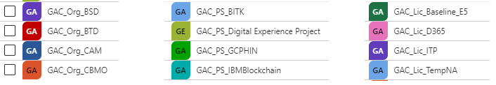

Policies:
Applicable to all policies defined in Microsoft 365 and Azure.
Format: GAC_Scope_ServiceName_PolicyType, policy name will always start with GAC.
The Scope defines the scope that the policy applies to. If the scope is service or tenant wide, it is not used but if it is applicable to a defined set of objects, e.g. Office 365 group or Azure resource group, then it would be identified. Example is "CorpGov" or "eCRMS".
The ServiceName relates to what service the policy is applicable to in Microsoft 365 and/or Azure. Example "Teams_ChatService" or "DevOps"
Policy type identifies what the policy is for, what are the settings doing, etc. Example "Retention".
Additional Azure AD Object types are underdevelopment – contact SIPC for up to date naming rules:
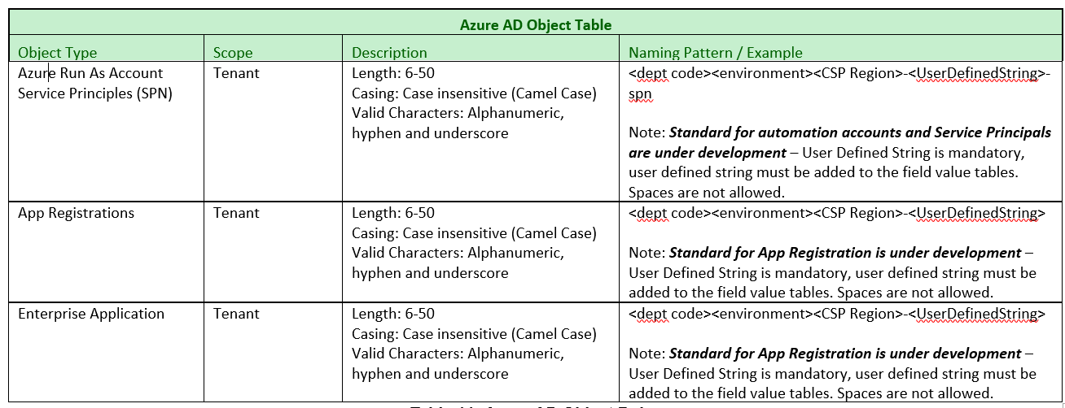

- Appendix – Resource Naming Object Tables

General Object Rules
General Object Rules
Object Type | Scope | Character Set | Naming Pattern / Example
Management Group | Tenant | User defined string, spaces are allowed in Azure AD object names | <GC Governance>-<user defined> Azure AD objects are not included in this version of the convention. The Cloud team is working with the AD team to map roles across the ADFS relying party trust.  Example: ScPc-PBMM Core  SccSc-SIPC BITK
Subscription | Management Group | Length: 1-90  Casing: Case insensitive (Camel Case)  Valid Characters: Alphanumeric, underscore, hyphen, spaces  Spaces are allowed in subscription name to assist in readability | <dept code><environment><CSP Region>-<owner>-<UserDefined_String>[-<UserDefined_String>]  Notes:  <owner> SCC Division, or VDC governance values  Spaces are allowed in subscription names, at least one <UserDefined_String> is mandatory in the subscription name (subfields are optional)  Example: ScPc-PBMM Production  ScSc-SIPC VMM  ScDc-SICT BITK
Resource Group | Subscription | Length: 1-90  Casing: Case insensitive (Camel Case)  Valid Characters: Alphanumeric, underscore, and hyphen | <dept code><environment><CSP Region>-<owner>-[-<sub owner_string>]<UserDefined_String>[-<UserDefined_String>]-rg  Notes:  <owner> is the resource group owner and assigned by the subscription owner (typically the SCC division, exception applies to VDC core infrastructure). Primarily used for identification and accountability (cost/security) of the contained resources – tracked in tables.  [<Subscription owner_string>] is optional and defined by the subscription owner if additional governance is required.  At least one <UserDefined_String> is mandatory in the resource group name, subfields are optional and defined by the resource group owner.  Suffix applies  Example: ScPc-SIPC-MySCC_dev_r23-rg  ScDc-Security_Core-rg
Table 7: General Object Rules

Compute Object Rules

Compute
Object Type | Scope | Description | Naming Pattern / Example
Virtual Machine | Resource Group | Length: 1-15 (Windows), 1-64 (Linux)  Casing: Case insensitive  Valid Characters: Alphanumeric and hyphen (underscore not supported in Azure) | <dept code><environment><CSP Region><device type>-<User Defined_String1>  Note: Suffix is not used on Virtual Machines.  Example: ScPcSWA-MyAp01
Managed Disk  Virtual Machine – OS Disk | Resource Group | Length: 1-80  Casing: Case insensitive  Valid Characters: Alphanumeric, hyphen and underscore | <vm name>-osdisk<###>  Example: ScPcSWA-MyAp01-osdisk1
Managed Disk  Virtual Machine – Data Disk | Resource Group | Length: 1-80  Casing: Case insensitive  Valid Characters: Alphanumeric, hyphen and underscore | <vm name>-datadisk<###>  Example: ScPcSWA-MyAp01-datadisk1
Availability Set | Resource Group | Length: 1-80  Casing: Case insensitive  Valid Characters: Alphanumeric, underscore, and hyphen | <VM name>-<UserDefined_String>-as  Note: An availability set is considered a child object of its virtual machine (instance number is dropped on clusters)  Suffix applies  Example: ScScFWL-FGPROD-as
Function App | Global | Length: 1-60  Casing: Case insensitive  Valid Characters: Alphanumeric and hyphen | <dept code><environment><CSP Region><device type>-<UserDefined_String>]-fnc  Note: (automation under development)
Table 8: Compute Object Rules

Storage Object Rules

Note: Storage object names require globally unique lowercase alphanumeric strings, at this time the only mandatory string is the GC Governance field prefix.

Storage
Object Type | Scope | Description | Naming Pattern / Example
Storage account (data) | Global | Length: 3-24  Casing: Lowercase  Valid Characters: Alphanumeric | <dept code><environment><CSP Region><device type><UserDefinedString>  Note: must be globally unique, can use a function to calculate a unique guid for naming storage accounts, number is optional. “-“ not supported as a field delimiter.  Example : ScPcMyUniquieGUIDFromFunction
Storage account (disks) | Global | Length: 3-24  Casing: Lowercase  Valid Characters: Alphanumeric | <dept code><environment><CSP Region><device type><UserDefinedString>  Note: must be globally unique, can use a function to calculate a unique guid for naming storage accounts, number is optional. “-“ not supported as a field delimiter.  Example : ScPcMyUniquieGUIDFromFunction
Container name | Storage account | Length: 3-63  Casing: Lowercase  Valid Characters: Alphanumeric and hyphen | <storage account name>-<UserDefinedString>  Note: (automation under review)  Example: Scpcmyuniquieguid-mycontainername
Queue name | Storage account | Length: 3-63  Casing: Lowercase  Valid Characters: Alphanumeric and hyphen | <storage account name>-[<UserDefined-String>[<number>]][-<system generated string>]  Note: (automation under review)  Example: Scpcmyuniquieguid-myqueue
Table name | Storage account | Length: 3-63  Casing: Case insensitive  Valid Characters: Alphanumeric | <storage account name>[<UserDefinedString>[<number>]][<system generated string>]  Note: (automation under review)  Example: Scpcmyuniquieguidmytable
File name | Storage account | Length: 3-63  Casing: Lowercase  Valid Characters: Alphanumeric and hyphen | <storage account name>-[<UserDefined-String>[<number>]][<system generated string>]  Note: (automation under review)  Example: Scpcmyuniquieguid-myshare
Data Lake Store | Global | Length: 3-24  Casing: Lowercase  Valid Characters: Alphanumeric | <dept code><environment><CSP Region> [<UserDefined-String>[<number>]][<system generated string>]  Note: (automation under review)  Example : Scpcmyuniquieguid
Table 9: Storage Object Rules

Networking Objects Rules

Note: Typically networking object names do not require DNS entries, resource suffixes are mandatory. Release 2a uses a “catch all” <device type> of CNR (Cloud Network Resource) to identify network infrastructure components and align with SACM functional device type reservation (“C”). Network Interface Cards (NIC), Public IPs, etc. use their parent object name to track ownership (VM / VM-nic1 or VNET / VNET-snet). The <user defined_string> is leveraged to identify resource specifics and tracked in the Value Tables. When using the parent object name as part of the child object name the suffix is truncated (see examples).

Networking
Object Type | Scope | Description | Naming Pattern / Example
Virtual Network (VNet) | Resource Group | Length: 2-64  Casing: Case insensitive  Valid Characters: Alphanumeric, hyphen and underscore | <dept code><environment><CSP Region><device type>-<User Defined_String>-vnet  Note: IP addresses are not allowed in object names,zone acronym aligns with ITSG-22 zoning convention.  Example: ScPcCNR-Core_MRZ-vnet
Subnet | Virtual Network | Length: 2-80  Casing: Case insensitive  Valid Characters: Alphanumeric, hyphen and underscore | <Vnet name>-<User Defined_String>-snet  Note: Do not include the IP address or mask in the subnet names, it is easily queried and appears in the portal anyway. Parent vnet name is used with vnet suffix truncated.  Note: “GatewaySubnet” is a reserved name in Azure and required for SDN fabric to route over VPN or ExpressRoute  Example: ScPcCNR-Core_Core-Ext-snet  ScScCNR-Core_MRZ-Security-snet
Route Table | Resource Group | Length: 2-80  Casing: Case insensitive  Valid Characters: Alphanumeric, hyphen and underscore | <VNET name>-rt or <SNET name>-rt depending on scope of the route table.  Note: A single route table can be assigned to multiple subnets and is used to override some default system routes.  Examples: (vnet scope): ScPcCNR-VDC_Core-rt  (snet scope): ScPcCNR-VDC_Core-Mgmt-rt
Route | Parent Route Table | Length: 2-80  Casing: Case insensitive  Valid Characters: Alphanumeric, hyphen and underscore | <User Defined_String>-route  Note: Routes can be used in multiple route tables. The naming convention is defined by the cloud network team or resource owner of the route. The PBMM VDC uses the following syntax:  to<device>_<source>_<destination>-route  Examples: toCoreLB_Transit_Internet-route  toCoreFW_Transit_Spoke-route  toCoreFW_Mgmt_Core-route
Virtual Network Gateway | Resource Group | Length: 1-80  Casing: Case insensitive  Valid Characters: Alphanumeric, hyphen and underscore | <vnet name>-[<UserDefined_String>-]vng  Note: User defined string is optional / check if more than one per vnet is supported Azure feature support changes often.  Example: ScPcCNR-Core-vng (under review)
Local Network Gateway | Resource Group | Length: 1-80  Casing: Case insensitive  Valid Characters: Alphanumeric, hyphen and underscore | <vnet name>-[<UserDefined_String>-]lng  Note: User defined string is optional / check if more than one per vnet is supported Azure feature support changes often.  Example: ScPcCNR-Core-App-Ing
Connection | Virtual Network | Length: 1-80  Casing: Case insensitive  Valid Characters: Alphanumeric, hyphen and underscore | <vnet name>-[<UserDefined_String>-]con  Note: User defined string is optional  Example: ScPcCNR-Core_MRZ-con
Network Interface | Resource Group | Length: 1-80  Casing: Case insensitive  Valid Characters: Alphanumeric, hyphen and underscore | <parent object name>-nic<#>  Note: The network interface is an exception to the suffix rule (parent object is typically a VM but may also be a load balancer, firewall, etc.). User defined field is not used, instance number is assigned to the suffix  Example: ScPcSWA-App01-nic1
Network Security Group | Resource Group | Length: 1-80  Casing: Case insensitive  Valid Characters: Alphanumeric, hyphen and underscore | <parent object name>-[<UserDefined_String>-]nsg  Note: Typically <UserDefined_String> is not assigned if the parent object is a single VM or subnet.  Example: ScPcSWA-MyApp01-nsg
Public IP Address | Resource Group | Length: 1-80  Casing: Case insensitive  Valid Characters: Alphanumeric, hyphen and underscore | <parent object name>-[<UserDefined_String>-]pip<#>  Note: The public interface is an exception to the suffix rule (parent object is typically a VM but may also be a load balancer, firewall, etc.). User defined field is optional, instance number is assigned to the suffix. Public IPs are attached to Network Interfaces, not VMs directly.  Example: ScPcSWA-MyApp01-pip1
Vnet Peering | Vnet | Length: 1-80  Casing: Case insensitive  Valid Characters: Alphanumeric, hyphen and underscore | <source vnet>-<dest vnet>-gwp  Note: parent object type truncated, exception to the global guidelines, user defined field not allowed.  Example: ScDcCNR-Prod-ScDcCNR-Core-gwp
Load Balancer | Resource Group | Length: 1-80  Casing: Case insensitive  Valid Characters: Alphanumeric, hyphen and underscore | <dept code><environment><CSP Region><device type>-<User Defined_String>-lb  Note: Load balancers typically server a parent object. In this case use the parent object name (truncate instance ## for cluster) and add suffix  Example: ScPcADC-F5PROD-lb
Load Balanced Rules | Load Balancer | Length: 1-80  Casing: Case insensitive  Valid Characters: Alphanumeric, hyphen and underscore | <load balancer>-lbr#  Note: Parent object name suffix truncated. User defined field not supported  Example: ScPcADC-F5PROD-lbr3
Load Balancer Backend Pool | Load Balancer | Length: 1-80  Casing: Case insensitive  Valid Characters: Alphanumeric, hyphen and underscore | <load balancer>-lbbp  Note: Parent object name suffix truncated. User defined field not supported  Example: ScPcADC-F5PROD-lbbp
Load Balancer Health Probe | Load Balancer | Length: 1-80  Casing: Case insensitive  Valid Characters: Alphanumeric, hyphen and underscore | <load balancer>-lbhp  Note: Parent object name suffix truncated. User defined field not supported  Example: ScPcADC-F5PROD-lbhp
Azure Application Gateway | Resource Group | Length: 1-80  Casing: Case insensitive  Valid Characters: Alphanumeric, hyphen and underscore | <dept code><environment><CSP Region>-<UserDefinedString>-agw  Example: (under review)
Traffic Manager Profile | Resource Group | Length: 1-63  Casing: Case insensitive  Valid Characters: Alphanumeric and hyphen | <dept code><environment><CSP Region><UserDefinedString>-tm  Example: (under review)
Table 10: Network Object Rules

    - Container Object Rules (placeholder)

Containers
Object Type | Scope | Description | Naming Pattern / Example
Container Registry | Global | Length: 5-50  Casing: Case insensitive  Valid Characters: Alphanumeric | <dept code><environment><CSP Region><UserDefinedString>registry  (under review)
Table 12: Container Object Rules
Excerpt: “Blob and container names are passed to the Blob service within a URL. Certain characters must be percent-encoded to appear in a URL, using UTF-8 (preferred) or MBCS. This encoding occurs automatically when you use the Azure Storage client libraries. However, there are certain characters that are not valid in URL paths even when encoded. These characters cannot appear in blob or container names. Code points like \uE000, while valid in NTFS filenames, are not valid Unicode characters, so they cannot be used. In addition, some ASCII or Unicode characters, like control characters (0x00 to 0x1F, \u0081, etc.), are also not allowed.
For rules governing Unicode strings in HTTP/1.1 see:”
- RFC 2616, Section 2.2: Basic Rules and RFC 3987

Azure Active Directory Object Naming
This section defines object naming in Azure AD (cloud objects only).

Azure AD Object Table
Object Type | Scope | Description | Naming Pattern / Example
Azure Account | Tenant | Length: 6-50  Casing: Case insensitive (Camel Case)  Valid Characters: Alphanumeric, hyphen and underscore | <identifier>.<first>.<last>@005gc.onmicrosoft.com  Identifiers:  Admin: Used for any account that is assigned an elevated privilege above a standard user, not including any Reader privilege  Dev: Used for developer accounts, may also contain a notion of what they are for vs. a generic developer account, e.g. dev-D365 for a Dynamics 365 dev account  Ops: Used for operational roles in Azure AD including those assigned to help desk, security, compliance, etc.  SSCAdmin: Used for any SSC account that is assigned an elevated privilege above a standard user  Srv.app.purpose: Service account standard for access to Azure AD and M365 services  Test: Used for designated test accounts, may also contain a notion of what they are for vs. a generic test account, e.g. test-D365 for a Dynamics 365 test account
Azure Groups | Tenant | Length: 6-50  Casing: Case insensitive (Camel Case)  Valid Characters: Alphanumeric, hyphen and underscore | <SCC>-<Scope>-<Symbol/Purpose>[-<user_defined string>]  The group name will always start with SCC.  Scope: (securityenabled=true)  Org: Internal Organizational Teams – only contains SCC users  PS: Purpose Specific Teams - internal plus external authorized Guest accounts  Lic: Groups used to manage licenses in the tenant.  The Symbol/Project relates to the Organizational symbol or the Purpose name. Additional user defined strings are supported.
Azure Policy | Tenant | Length: 6-50  Casing: Case insensitive (Camel Case)  Valid Characters: Alphanumeric, hyphen and underscore | Applicable to all policies defined in Microsoft 365 and Azure.  Format is SCC_Scope_ServiceName_PolicyType  The policy name will always start with SCC. The Scope defines the scope that the policy applies to. If the scope is service or tenant wide, it is not used but if it is applicable to a defined set of objects, e.g. Office 365 group or Azure resource group, then it would be identified. Example is "CorpGov" or "eCRMS".  The ServiceName relates to what service the policy is applicable to in Microsoft 365 and/or Azure. Example "Teams_ChatService" or "DevOps"  Policy type identifies what the policy is for, what are the settings doing, etc. Example "Retention".
Azure Run As Account  Service Principles (SPN) | Tenant | Length: 6-50  Casing: Case insensitive (Camel Case)  Valid Characters: Alphanumeric, hyphen and underscore | <dept code><environment><CSP Region>-<UserDefinedString>-spn  Note: Standard for automation accounts and Service Principals are under development – User Defined String is mandatory, user defined string must be added to the field value tables. Spaces are not allowed.
App Registrations | Tenant | Length: 6-50  Casing: Case insensitive (Camel Case)  Valid Characters: Alphanumeric, hyphen and underscore | <dept code><environment><CSP Region>-<UserDefinedString>  Note: Standard for App Registration is under development – User Defined String is mandatory, user defined string must be added to the field value tables. Spaces are not allowed.
Enterprise Application | Tenant | Length: 6-50  Casing: Case insensitive (Camel Case)  Valid Characters: Alphanumeric, hyphen and underscore | <dept code><environment><CSP Region>-<UserDefinedString>  Note: Standard for App Registration is under development – User Defined String is mandatory, user defined string must be added to the field value tables. Spaces are not allowed.
Table 11: Azure AD Object Rules

