vExpo Lobby Content Submission Form

General Instructions  After reviewing the vExpo Content and Design Guidelines, fill out the fields below with the final links and text to be used in the lobby. Please note that the links to the breakout sessions and main presentation webcast can be provided at a later date (at least 1 week prior to the event) if it’s not possible to submit them in advance - just let us know in the comment section.  - You may need or want the lobby to reflect your departmental branding and/or the look and feel of the event's visual branding used on promotional material. If so, make sure to send us the required image source files and branding guidelines along with this template (optional).  - Provide the content and material as soon as available, and no later than the agreed-upon deadline. Content sent past the deadline may result in inability to meet deadlines.  - Once completed, submit this document and file attachments to csps.digitalacademyvexpo-vexpodelacademiedunumerique.efpc@csps-efpc.gc.ca.  Event Information  Organization / Department :  Point of contact (name and email) : Name: Email:  Official Event Title (EN and FR): EN: FR:  Date & time: Date: Time: | Lobby Anatomy  Before filling-out this form, please take a look at the image below. This is what a virtual lobby design looks like. You can refer to this image while filling out the form.  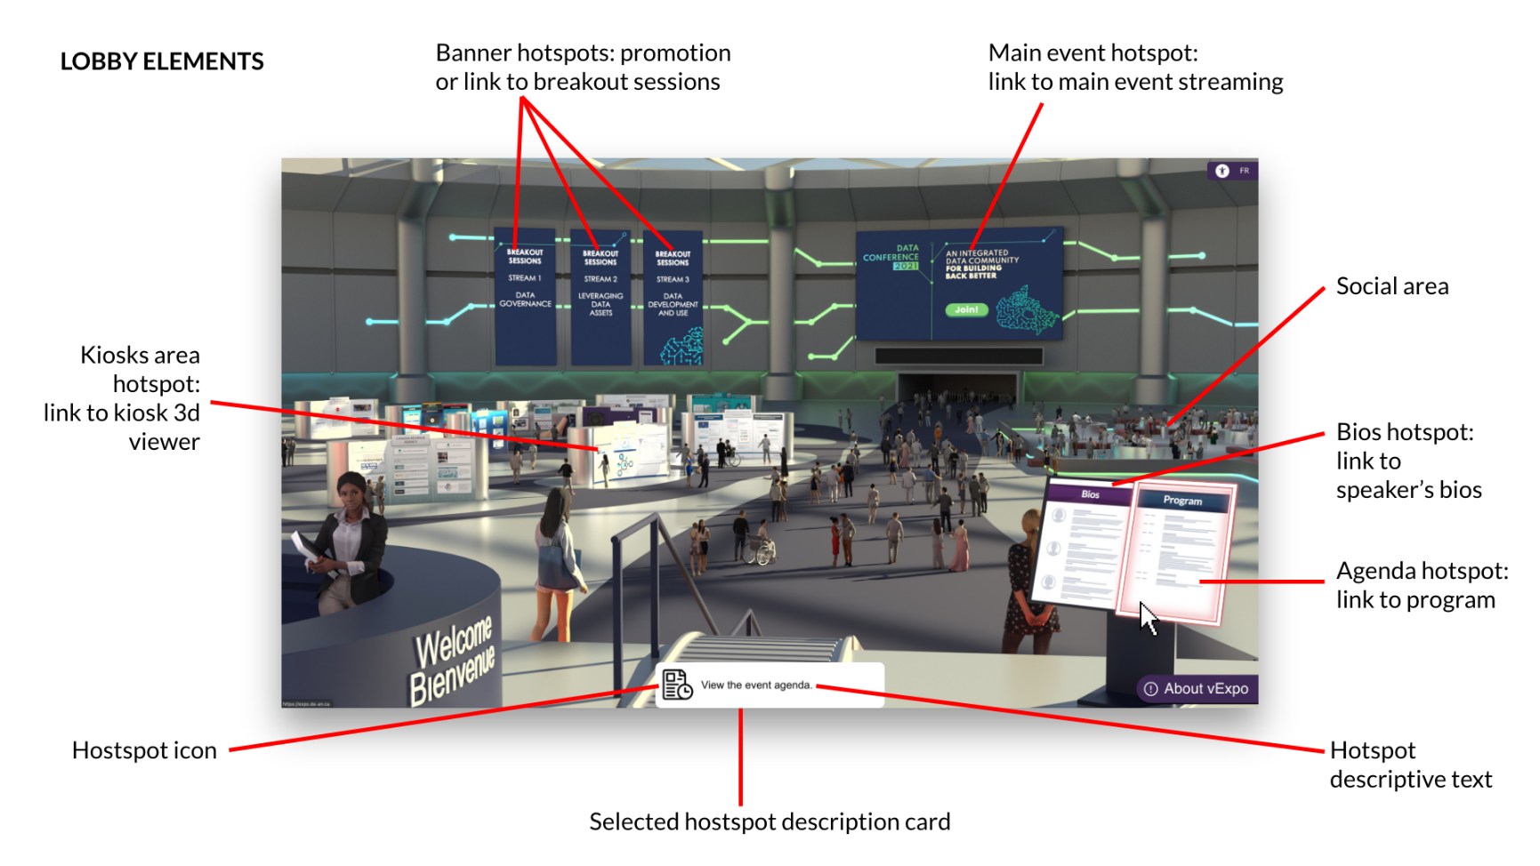

Lobby designs
The following lobby designs are available and can be used for your event. Please inicate below which design you would like use:
We would like to use the following Lobby Design: ___________________ | 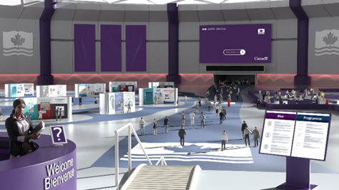  Lobby 1 – Standard | 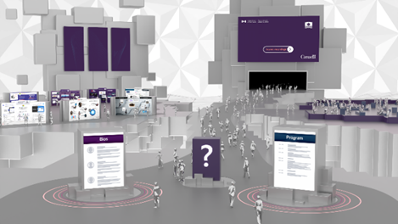Lobby 2 – Low Poly | 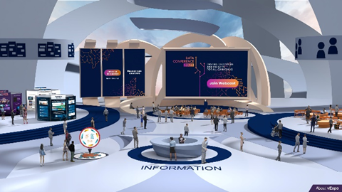Lobby 3 – Modern

Content Accessibility  As per the vExpo content requirements, your content must be available on the Web, in both official languages and be accessible. Please confirm the following:  YES NO  Can the content you are about to provide in the following tables be accessed by the public (outside of your organization's firewall)?  Is your content accessible; readable using assistive technology, alt text, transcripts, closed captions, etc. ? | Lobby - Color Scheme (Optional)  It is possible to customize the color theme of the Lobby, according to your preferences. Please note that the choice of colors remains at the discretion of the designers. If you are interested, please indicate the color codes you prefer to use (up to 3). You may also send us your visual guide for your branding (if applicable):  Color Code (ex: R.B.G., Hex)  Primary Color  Secondary Color  Accent Color

Decorative Banners
The lobby includes 3 banners that appear on the left side of the back wall, above the kiosk area. They can be used to link to breakout sessions, link to other web pages (i.e. Twitter), or as decorative banners (with or without text). Specify below the text and links to be used for each banner, if any.
 | Image to appear on banner | Text to appear on banner | URL – Link to content
Banner 1 (left) |  | EN:  FR: | EN:  FR:
Banner 2 (middle) |  | EN:  FR: | EN:  FR:
Banner 3 (right) |  | EN:  FR: | EN:  FR:

Other Lobby Hotspots
The lobby includes other clickable areas (hotspots) used to navigate to event material, such as the event’s main presentation/webcast, event program, speaker biographies, networking space and kiosk area. Specify below the links to be used for each of these hotspots.
Hotspot/ Objects | Default text that appears in the description card. | (OPTIONAL) Customized text to replace the default description card. | URL - Link to Content | Additional Comments
Event Program | EN: View the event program.  FR: Consulter le programme de l’évènement | EN:  FR: | EN:  FR:
Speakers Biographies | EN: Get to know the speakers! View their biographies.  FR: Apprenez-en davantage sur les conférenciers. Consultez leurs biographies. | EN:  FR: | EN:  FR:
Main presentation - Webcast  Please make sure to include all the links to be used for the event webcast. | EN: Attend the event’s main presentation.  FR: Assistez à la présentation principale de l'événement. | EN:  FR: | EN:  FR:
Networking area (ex: Wonder.me, GCmessage, etc.) - Optional | EN: Connect with other participants in the networking area.  FR: Connectez avec d’autres participants dans la zone de réseautage. | EN:  FR: | EN:  FR:

Kiosk List
The lobby includes a kiosk area where participants can go visit virtual kiosks to learn more about programs, initiatives and organizations. In the table below, specify which kiosks should be included in your event and the order of appearance.
 | Is this a new Kiosk?
Names of the Kiosk (in order of appearance) | YES | NO
1.
2.
3.
4.
5.
6.
7.
8.
9.
10.
11.
12.
13.
14.
15.

If you have any questions regarding this submission document, please feel free to contact us at: csps.digitalacademyvexpo-vexpodelacademiedunumerique.efpc@csps-efpc.gc.ca

