Grants and Contributions
Centralized Publishing System-Training Guide

Contents
1 – The Registry 3
2 - How to register an account 3
3 - Logging in to the Registry 4
4 - Finding your organization 5
5 - Accessing your template: 5
6 - Completing your template 7
7 - Uploading your template 8
8 – Adding, modifying or deleting an item 10

1 – The Registry

- The Open Data Registry houses all of the Government of Canada’s metadata records for all datasets across federal organizations and allows you to upload and manage your summaries.
- All proactive disclosure documents (Access to Information, Contracts, Travel and Hospitality, Reclassification and Founded Wrongdoing) will be uploaded to the Registry and then published and made searchable on the Open Government portal.

2 - How to register an account

- If you don’t already have a registry account you will need to register for one.
- On the right side of the page, click on the email address to request an account.
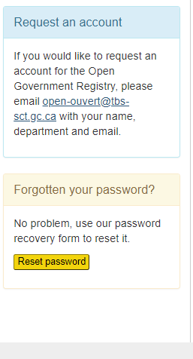
- Once you’ve applied, the Open Government Secretariat (OGS) will link your account to your department and notify you by email. Please note – as some organizations have moved to Canada.ca email extension, it is important to add your organization name when registering.
- If there are any issues with your account throughout the registration process, please contact the OGS team by sending an email to the Open Inbox.
- If there are any issues with your account throughout the registration process, please contact the OGS team by sending an email to the Open Inbox.

3 - Logging in to the Registry

- You now have access and can log in to the Registry by selecting the Log in tab in the menu bar.
- Once you enter your Username and Password you can select the “Remember me” checkbox to save your information in your browser.
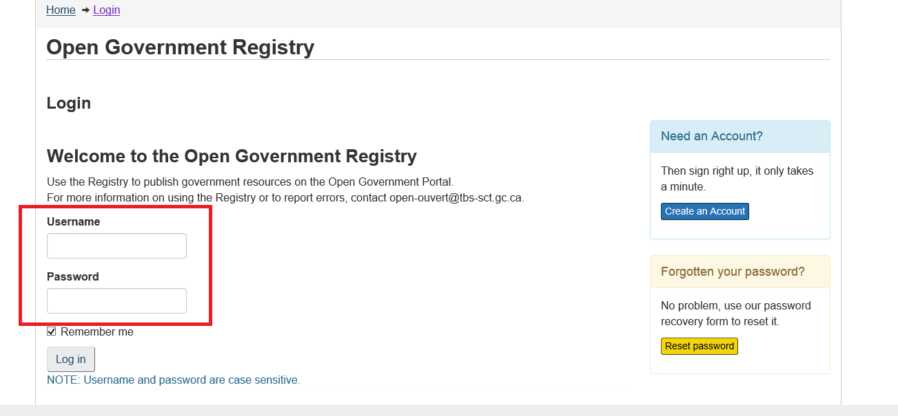
- If you have logged in successfully you will see a note at the top of the page indicating that you are logged in. You will also see the “Log Out” option in the top menu bar:
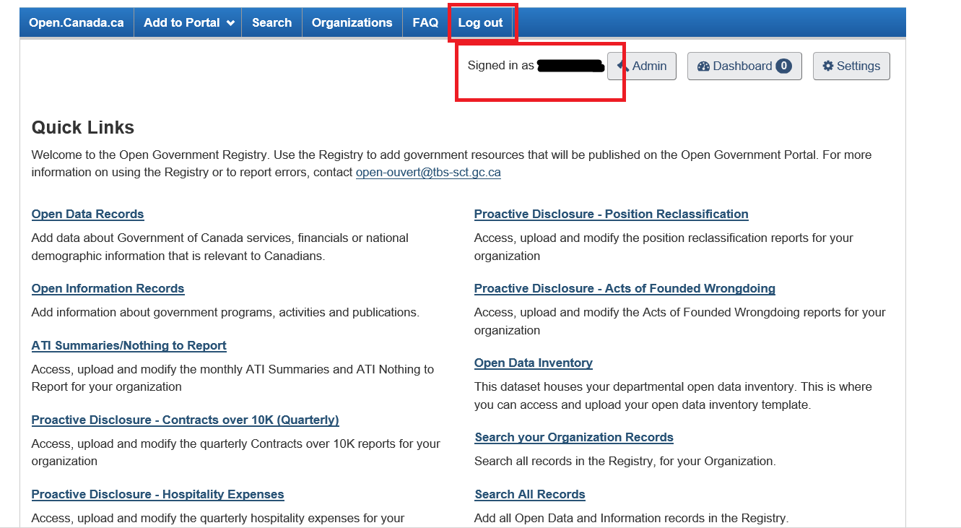

4 - Finding your organization

- Now that you are logged into the registry, you will see the “Quick Links” menu where you can select “Grants and Contributions”:

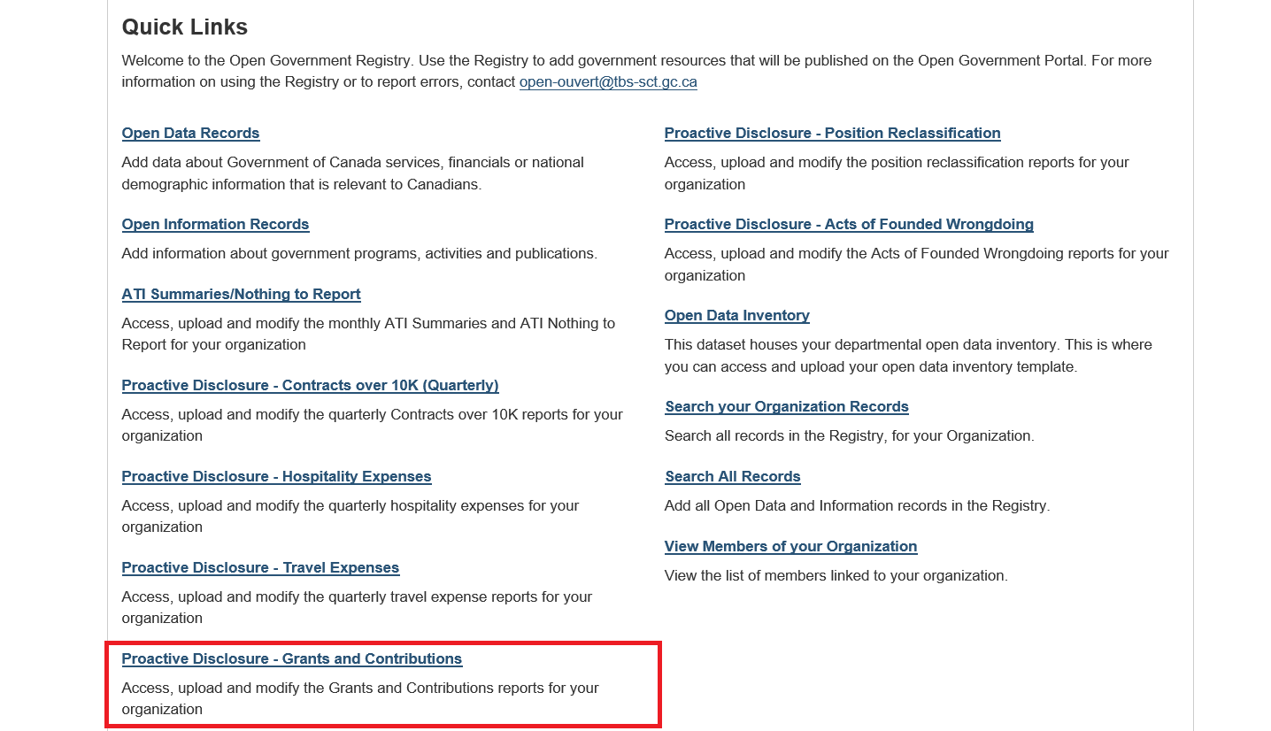

5 - Accessing your template:

- After selecting your proactive disclosure type you will be brought to the Grants and Contributions page where you will select your organization from the drop down menu:
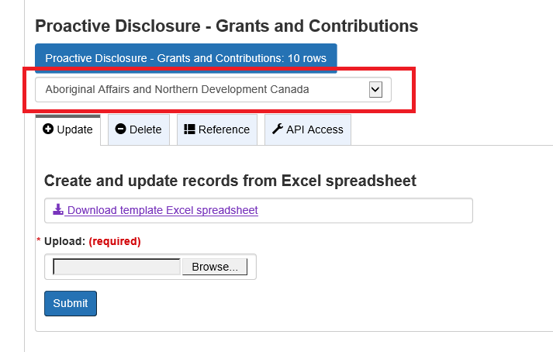

- After you’ve selected your organization from the drop down menu, you’re ready to download your template. The first step is to download the document and save it to your desktop or hard drive:
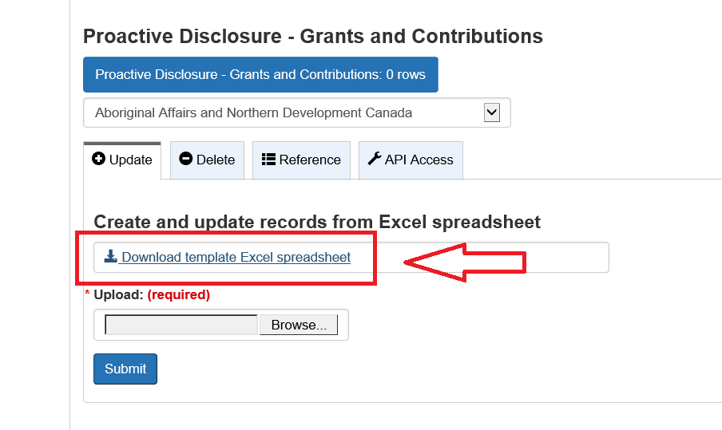
- PLEASE NOTE – it is imperative that you do not alter the file name in any way, PLEASE SAVE IT AS IS. The template is named uniquely for your department and will not allow you to upload the completed version if it has been changed.
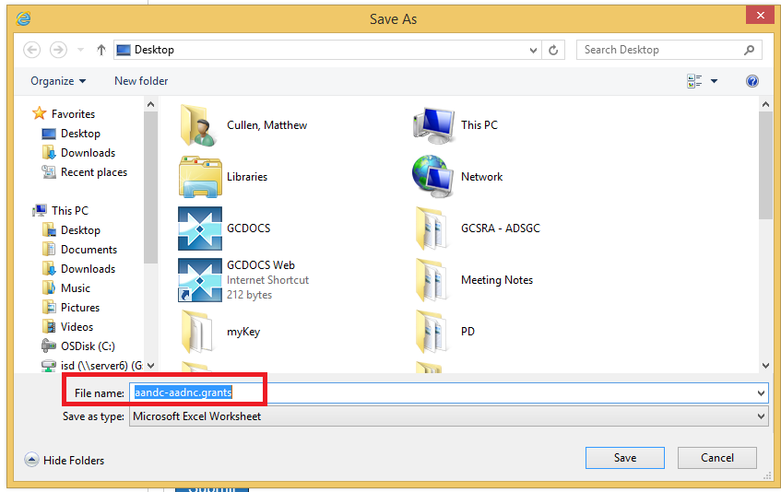

- Completing your template

- Now that you’ve saved your organization’s template on your hard drive, you can begin to complete the document. Of note – every proactive disclosure line item MUST have a “Reference Number”, this will allow users to modify and delete items if necessary:
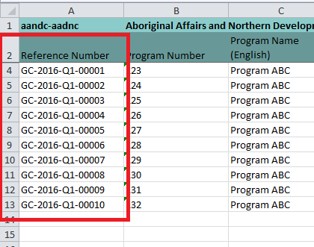
- If any of the columns are highlighted red, this means that an incorrect value has been selected from one of the drop down menus. For example, of you enter a country acronym that is not in the “Country” drop down menu, the template will show the following error message:
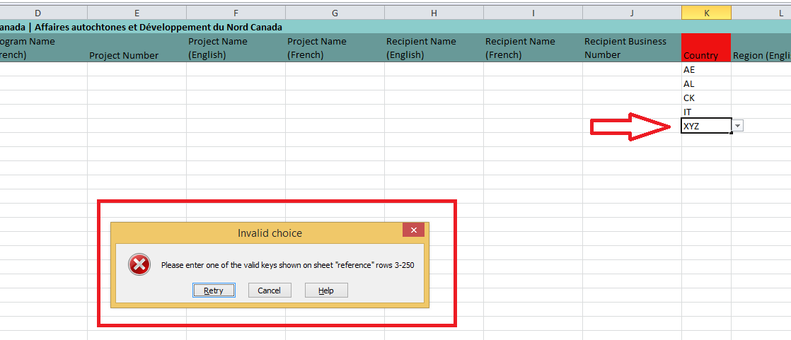
Note - you will still be able to upload your template, but the error message has identified that the value of that cell is not one of the items in the drop down menu.
- If you are unsure why there are errors, please refer to the reference tab in the template. This tab displays the correct formatting and language for all the fields within the template.
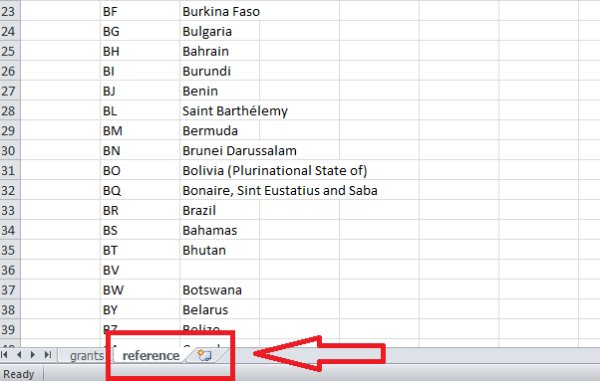
- As always, if there are any issues when completing your template, please contact the OGS team through the Open Inbox for assistance.

7 - Uploading your template
- Now that you’ve completed your template, you’re almost done.
- The next step is to log back in to the registry and return to your organizations page (the same page where you downloaded the template).
- You will see the “Upload” option directly below the button where you downloaded your template. Click the “Browse” button and select your completed template from your hard drive:

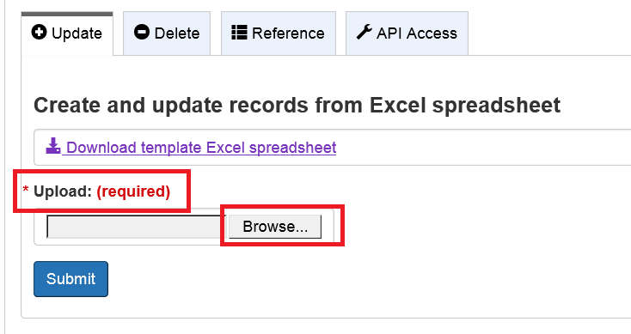

- Once you’ve selected your completed template from your computer you will see the file name in the upload box:
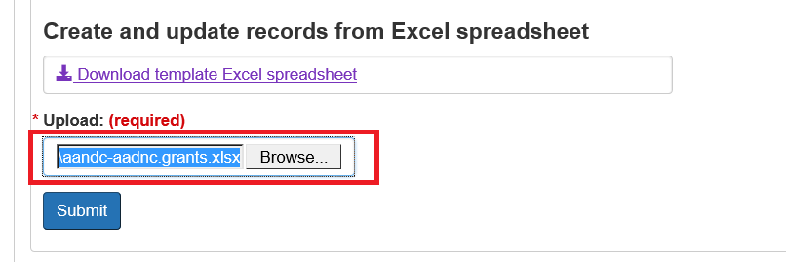

- Click “Submit” and your template will be uploaded to the registry. You will receive a message on the top of the form indicating that your template has been successfully added to the system, and you will be able to see the information that was captured in the template on this page:
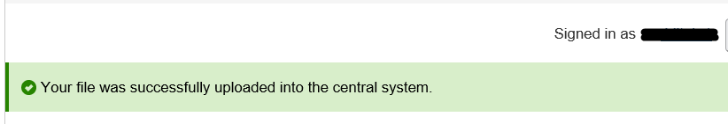

- Once your template has been successfully uploaded, you will be able to view all of the uploaded data in the “Preview” section below. You can also Search for a single line item by entering the “Reference Number” in the Filter items section:

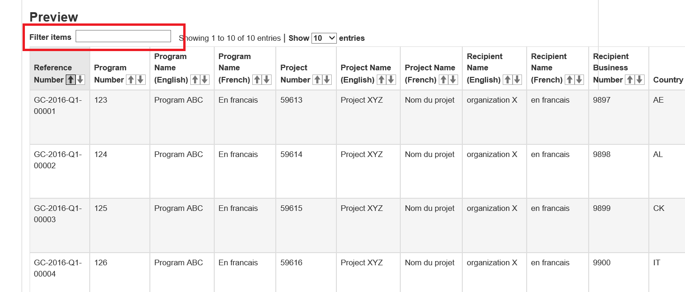
(Note: templates are harvested overnight, so you will not be able to see your completed template on the open.canada portal until the next morning)

- If you receive an error message, try re-uploading your template.

8 – Adding, modifying or deleting an item
- Once completed templates are uploaded, they may contain errors and omissions that need to be fixed. To delete an item, you will select the Delete tab below the Organization drop down menu:
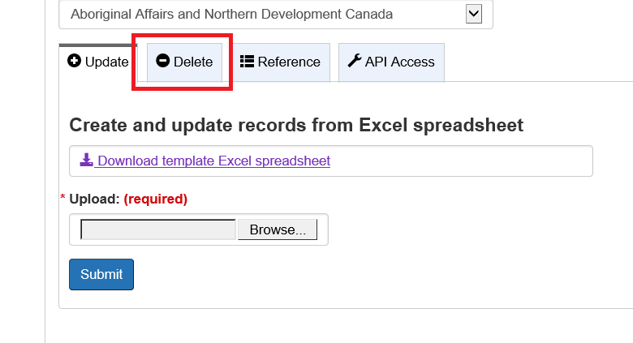

- When you have selected the Delete tab, the system will prompt you to enter the “Reference Number” of the item you wish to delete: (The reference number is the unique identifier in the first column of all Proactive Disclosure templates)

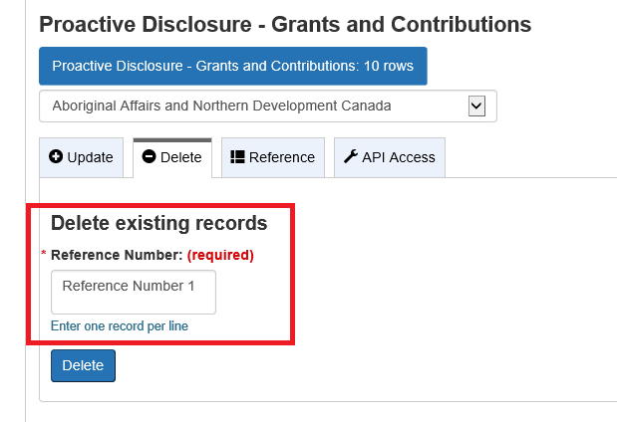
(If you have multiple line items to delete, please ensure you enter only one Reference Number per line)

- You will enter the Reference Number of the item you wish to have removed and will be prompted to make sure you want to delete the record:
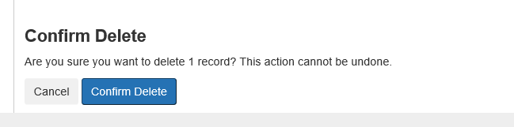

- Once you have confirmed the deletion of the record, you will be taken back to the previous page where you will see the confirmation (1). You should also see the change reflected in the number of records (2):
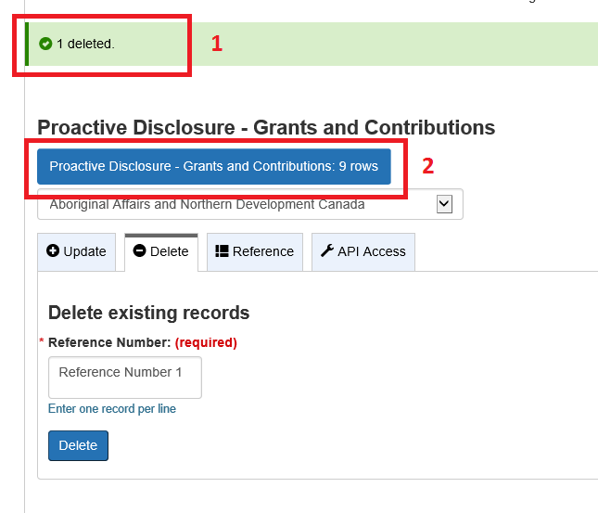
- To add or modify an item, the spreadsheet simply needs to be re-uploaded into the registry and it will add any new items or modify and existing ones.
- You will be able to preview any of these changes in the Preview section within each organization.

As always, if you are still experiencing any issues, contact the OGS team by sending an email to the Open Inbox.

