GCworkplace Consultation Series on Accessibility

Final Report
Last Updated: October 2021

08
Fall

Table of contents
Executive Summary 7
GCworkplace and Accessibility 8
What is the GCworkplace Consultation Series on Accessibility? 11
Consultation series overview 13
Regional breakdown: 13
Participants by primary type of disability: 14
Objectives of the consultation series 16
Three key takeaways 18
Key takeaway #1 19
Key takeaway #2 20
Key takeaway #3 22
GCworkplace and Accessibility 24
Inclusive Design and Accessibility – PSPC/Accommodation Management and Workplace Solutions (AMWS) 25
Inclusion and Neurodiversity - PSPC/Accommodation Management and Workplace Solutions (AMWS) 25
Contactless Access App for Elevators and Interactive Signage Pilot Projects – PSPC/Office of Accessibility in the Built Environment (OABE) 26
SafeCheckTM Pilot Project – PSPC/Office of Accessibility in the Built Environment (OABE) 27
GC Workplace Accessibility Passport – TBS/Office of Public Service Accessibility 27
In Conclusion 27
Project Team and Partners 28
Public Services and Procurement Canada 28
Accommodation Management and Workplace Solutions, Real Property Services 28
Office of Accessibility in the Built Environment, Real Property Services 28
PSPS Accessibility Office 28
TREASURY BOARD SECRETARIAT 28
Office of Public Service Accessibility 28
Useful Links 29
For Government of Canada employees only 29
Public 29

A LETTER FROM
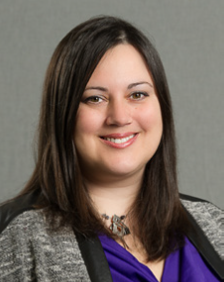
Sonia Powell
Director General
Accommodations Management and Workplace Solutions
Public Services and Procurement Canada

and

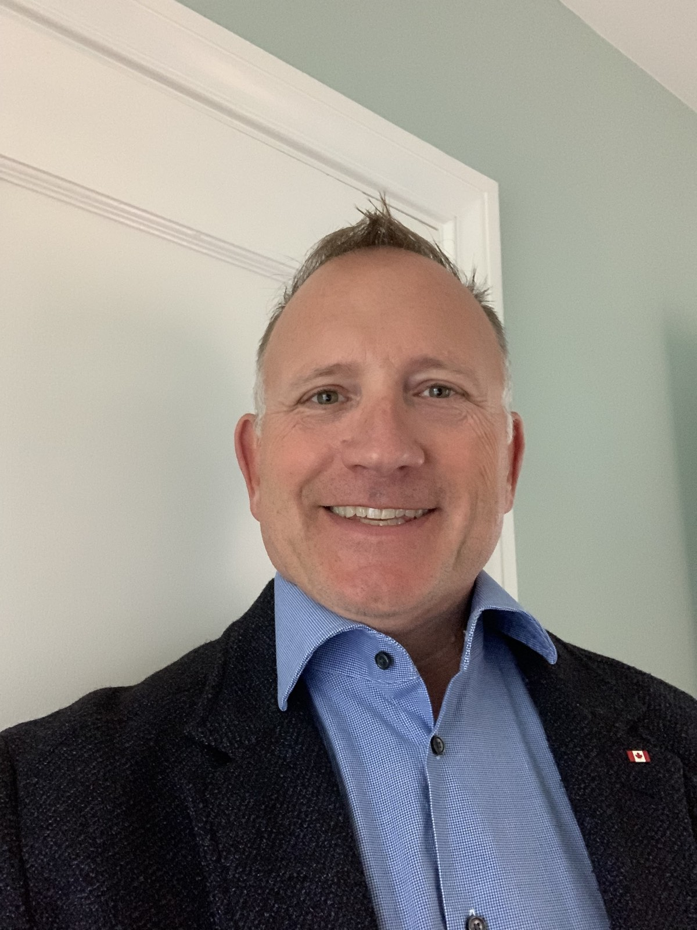
Kelby Hamilton
Director General
Technical Services
Public Services and Procurement Canada
Public Services and Procurement Canada is committed to advancing accessibility through our activities and programs. From the beginning, inclusivity has been one of the key dimensions of GCworkplace. The goal of GCworkplace was to design workplaces that were accessible to everyone by offering flexibility, mobility, and choice to all employees.
While accessibility and inclusivity are already important components of GCworkplace, there is always more we can do. To that end, the GCworkplace Consultation Series on Accessibility was held in order to hear directly from people with disabilities about the barriers they face in the workplace and how future workplaces can be as accessible as possible.
With this in mind, we are very pleased to present the final report from the GCworkplace Consultation Series on Accessibility, which outlines key findings from the sessions. We encourage you to read it and share it widely. We also encourage you to read and share the eight reports specific to the different sessions, which go into far more detail about the barriers faced and possible solutions.
We would like to take this opportunity to commend the participants in these sessions for their openness and willingness to share what in some cases were painful personal experiences. Without you, we would not have been able to make the changes to GCworkplace that we have already made, nor have the larger conversation about how to make the workplace of the future accessible for everyone.
We know that workplaces of the future are going to be different than the ones we have now, and it is these future workplaces that GCworkplace is aiming to create. With the information and lived experiences shared during the consultation series, we can shift the conversation around workplace design to ensure that workplaces are not considered fully complete unless and until they are accessible and inclusive.
Thank you,
Sonia Powell and Kelby Hamilton

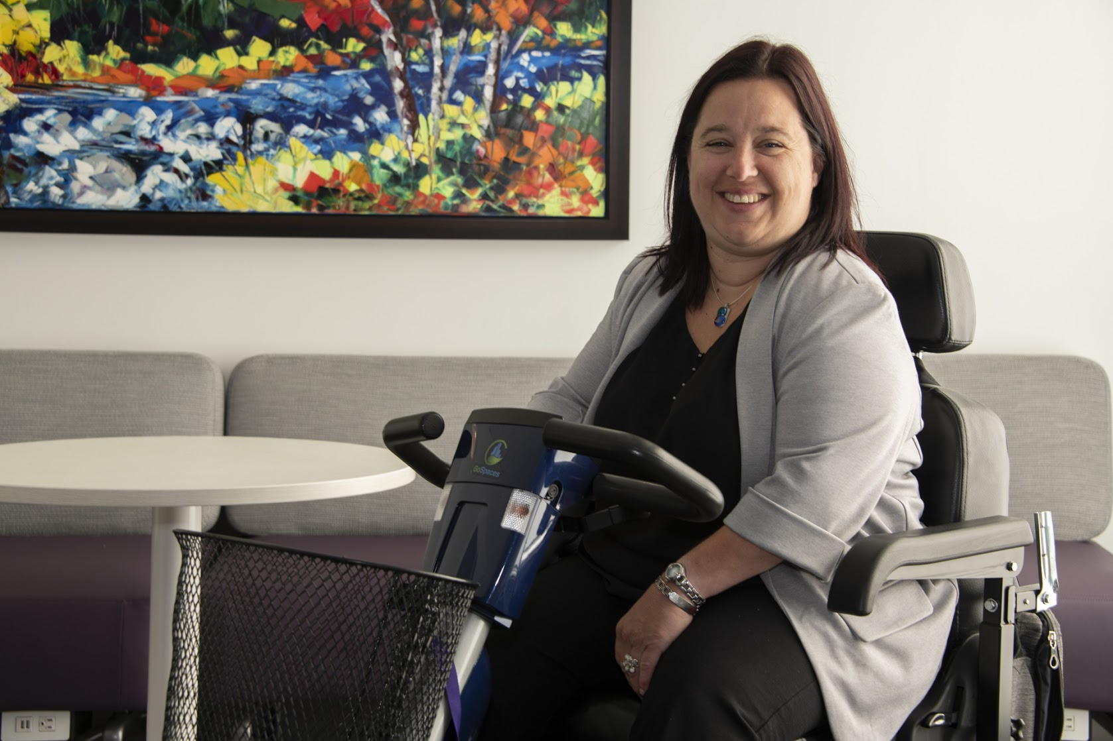
A LETTER FROM
Mélanie Provost
GCworkplace Accessibility Champion and Consultation Series Coordinator

As a person living with a disability, I’ve had to face barriers all my life. In my case, most of the barriers have been physical in nature since I have a mobility, flexibility, and dexterity disability. When I first moved into a GCworkplace a few years ago, I was truly impressed. It was way more accessible for me than the ugly salmon carpet cubicles that I had to work in for too many years in various buildings in the National Capital Region! I was able to find an ergonomic chair that was low enough for my height, the work surface was also height adjustable by just pressing a button at the front of the desk, and I had room to move around in the space.
I was able to choose a workpoint that fitted my needs without having to make accommodation requests—no need to “steal” my colleague’s chair on my first day of work in a new department (true story). I could start working from the minute I got on the floor. A first in all my career! Over time, I noticed a few potential issues, not for me but for other people with various types of disabilities. And I wanted to know if they were real barriers or not.
As all disabilities and experiences are different, I knew the best way to do this was to ask people with disabilities what barriers they experienced in their workplace, and so was born the GCworkplace Consultation Series on Accessibility.
I would like to take this opportunity to thank once more all the participants in the sessions. Your engagement in the sessions was just amazing. I would like to express my gratitude for the trust in sharing your personal stories.
Also a huge thank you to our partners and our team on this endeavour. Your expertise and experience helped us create a truly successful project. And all of this work wouldn’t have been possible without all of you.
Thank you,
Mélanie Provost

Executive Summary
The GCworkplace Consultation Series on Accessibility was a series of virtual workshops held between September 2020 and March 2021. The consultations were designed to engage with employees with disabilities in order to learn about the barriers they face in the workplace, with the ultimate goal of improving GCworkplace to remove as many of these barriers as possible when offices are modernized to GCworkplace standards.
Participants provided feedback on what worked and what didn’t in their current workplaces, what their dream workplaces would look like, and what barriers they encountered at specific places in their workplaces, such as at entrances or in bathrooms. The full list of barriers participants identified can be found in the Summary of feedback table, which details which issues were completely or partially resolved by the physical design of GCworkplace, as well as which physical design barriers remained outstanding and which barriers fell outside the built environment elements of GCworkplace.
Three key points were heard repeatedly from participants over the course of the consultations: the whole office should be designed with inclusivity and accessibility from the beginning; work location and schedule should be flexible for all; and accommodations, adaptations, and support should be rapid and available for all types of disabilities.
Following the consultations, the findings and lessons learned will be shared widely with various stakeholders, particularly those within the human resources and technology sectors who have the authority and ability to address those barriers that fall outside the built environment elements of GCworkplace.

GCworkplace and Accessibility
WHAT IS GCWORKPLACE?
GCworkplace is the term adopted by the Government of Canada for workplace modernization. It is based on the implementation of Activity Based Working (ABW), which is a way of working that offers all employees shared use to a variety of workpoints, allowing them to choose the optimal setting to perform their tasks and functions. It optimizes office space and is based on creating a space that meets the seven dimensions of being:
- flexible
- collaborative
- healthy
- inclusive
- efficient
- digital
- green
GCworkplace has an integrated vision for workplace modernization, one that includes not only the physical design of a workplace but also the technology used, the processes that support work, and the culture of organizations.

SEVEN DIMENSIONS OF GCWORKPLACE AND ACCESSIBILITY
A truly accessible workplace will meet the seven dimensions that make up GCworkplace.
Flexible
I work anywhere, anytime — flexibility no matter what I’m working on.
An accessible workplace allows employees to choose where and how they work, as well as the ability to set their own hours, so that they are able to work to the best of their abilities and are not constrained by someone else’s idea of when and where they should be working.
Collaborative
I am able and encouraged to collaborate with others.
An accessible workplace ensures that employees have the space, tools and support that they need to collaborate with others, including access to sign language interpretation, easily visible presentations, and technologically advanced meeting rooms that allow employees working remotely to collaborate as easily as employees there in person.

Healthy
My workplace is comfortable, flexible, and welcoming, which supports my physical, emotional, and mental health.
An accessible workplace supports work-life balance, as well as being open about mental health and actively working to remove stigma around mental health conditions. Managers are educated about invisible disabilities and use their influence to ensure that people with these types of disabilities are not discriminated against or treated differently because of their disabilities.
Inclusive
I can work where and how I want no matter my needs and abilities.
An accessible workplace understands that employees will have different needs and abilities and proactively works to make the workplace welcoming for everyone. It is one where meeting rooms, workpoints, and common areas are designed with people with disabilities in mind.
Efficient
With the right tools, resources, and trust, I can be efficient in my work.
An accessible workplace trusts employees to make the right decisions to be the most productive they can be, instead of dictating where and how to work. It provides them with the tools and support they need at the time they need it.
Digital
I have the tools to do my work anywhere, anytime.
An accessible workplace is connected so that employees can do their work from anywhere. Software programs are accessible, managers and employees are aware of accessibility requirements for documents and products, and employees have access to applications and online tools that help them do their work efficiently.
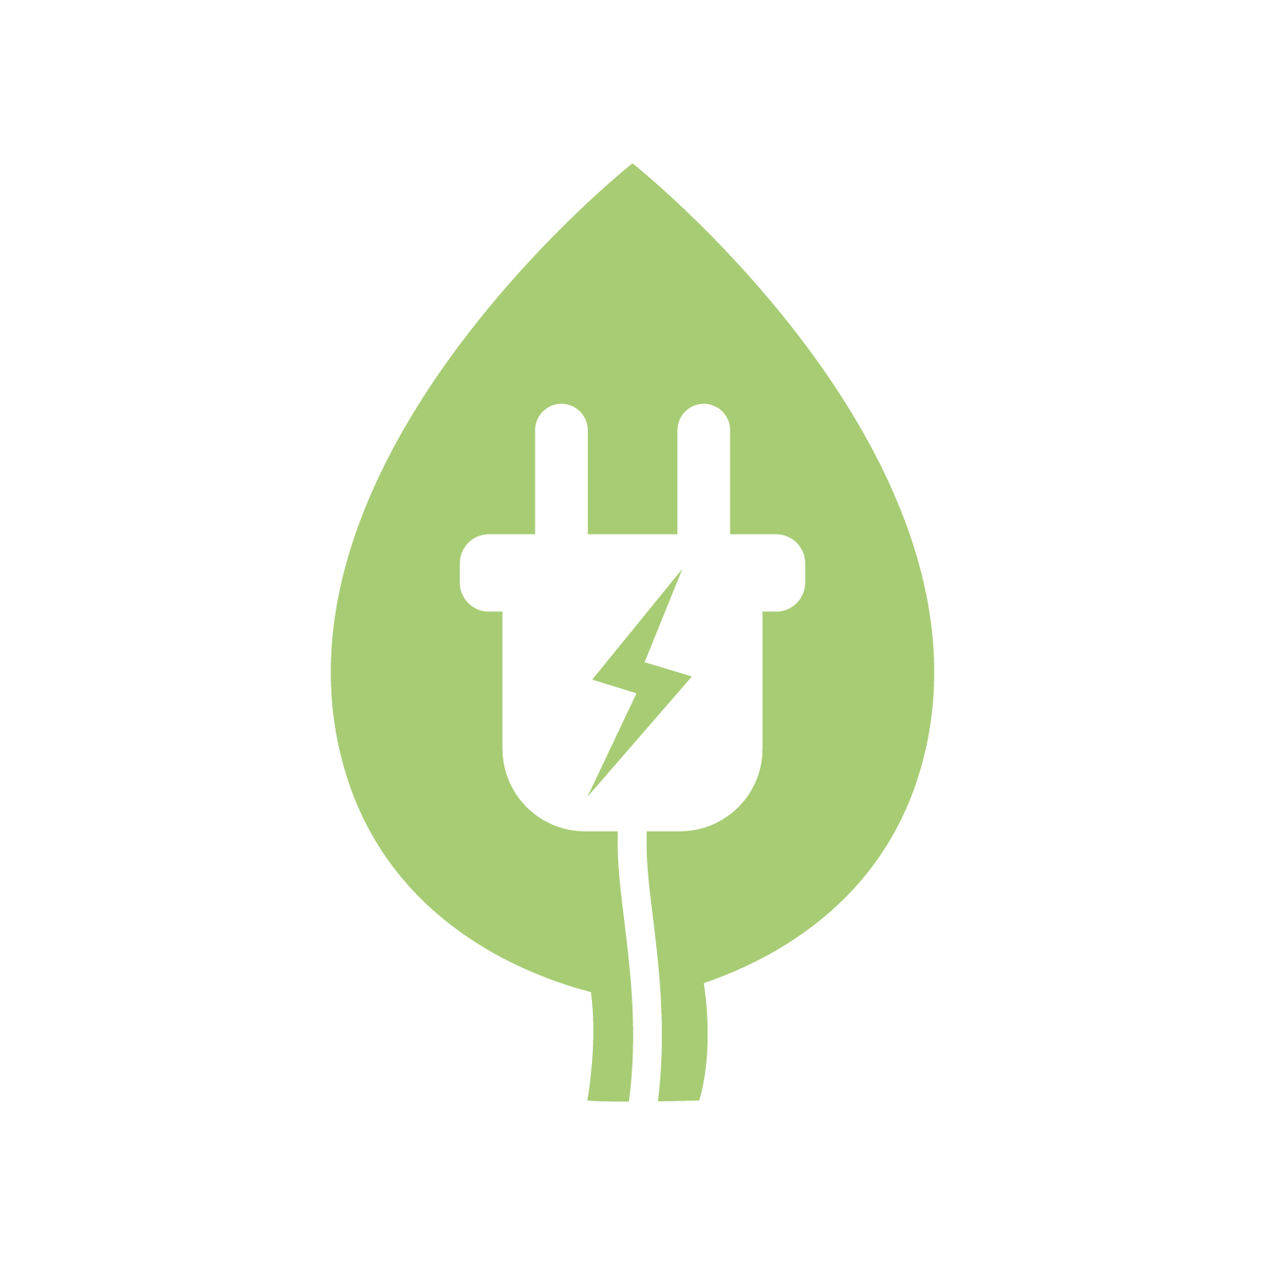
Green
My workplace is sustainable — energy efficient, paperless, low carbon emissions.
An accessible workplace allows employees more control over their individual actions, such as dimming lights, using technological solutions instead of paper ones, and working remotely when desired, all of which reduce carbon emissions.

What is the GCworkplace Consultation Series on Accessibility?
The GCworkplace Consultation Series on Accessibility was created as part of the mandate of the Centre for GCworkplace Innovation, which is to foster knowledge transfer and innovation as well as develop new concepts and tools for the Government of Canada (GC) workplace in collaboration with GC departments, agencies, and external partners. It was also created following the GC’s priority and commitment towards accessibility by partnering with key stakeholders.
The GCworkplace Consultation Series on Accessibility consisted of a series of 25 virtual workshops where people with different types of disabilities (visible and invisible) talked about barriers they face in their workplace. Although the main goal of the series was to get feedback that would help make the built environment as accessible as possible, comments were also accepted on barriers such as technology and human resources, as GCworkplace encompasses more than just the physical elements of a workplace.
The series was launched in September 2020 with weekly sessions held from September to December. Due to high demand, additional sessions were held twice weekly from January to March 2021.
Through engagement and consultation with users of workplaces, each session addressed existing and emerging or potential workplace barriers for a specific type of disability. Sessions were held for participants with eight broad types of disabilities:
- seeing
- hearing
- mobility, flexibility, or dexterity
- mental health
- sensory/environmental
- cognitive
- intellectual disabilities
- chronic health conditions or pain
In order to ensure optimal inclusiveness, there were no bilingual sessions. For the initial sessions in the fall of 2020, seven English and seven French sessions were organized. Of the additional 11 sessions that were added during winter 2021, ten were in English and one in French. Live captioning was offered for all sessions, and sign language interpretation was available for the hearing disabilities sessions and upon request for other sessions.
The series was open to GC employees of all levels, any status (including students and casual employees), and from any department or agency.
CONSULTING DURING COVID-19
The GCworkplace Consultation Series on Accessibility was intended to be held in person. The sessions were adapted to be virtual after the COVID-19 pandemic closed most government offices and made in-person consultations impossible.
Virtual consultations had their own set of challenges, such as finding an accessible platform and missing out on body language from participants, but they also presented opportunities.
Participants were able to participate in the way and from the location that best suited them, live captioning was provided, and participants from different regions were able to join on equal footing.
Many participants appreciated being able to participate virtually, and it was a useful demonstration of the need for flexibility in the workplace.

Consultation series overview
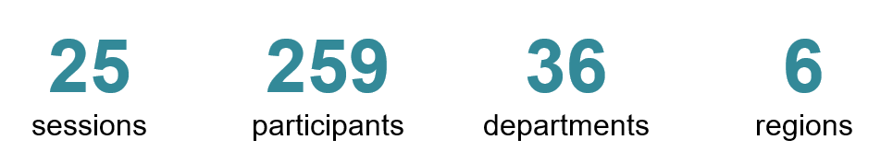

Over half of the participants identified having an “invisible” disability.
Less than 2% of participants worked in a GCworkplace prior to the pandemic.

Regional breakdown:

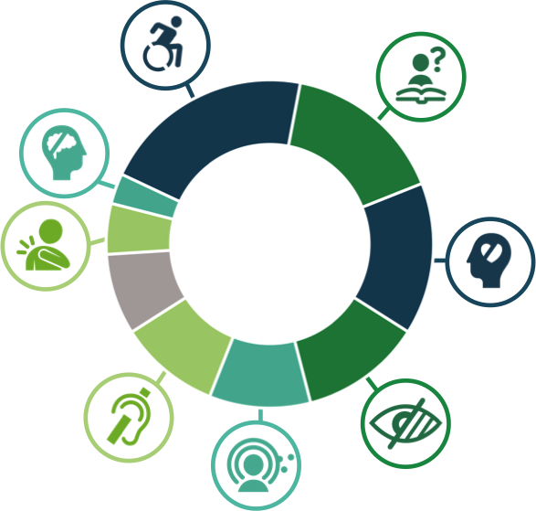

Participants by primary type of disability:
Over 70% of participants identified having more than one type of disability.
21% 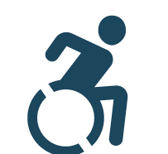 Mobility, flexibility, or dexterity issues
16% Cognitive disabilities
15% Mental health
12% Seeing disabilities
10% Sensory/environmental disabilities
10% Hearing disabilities
8% Unknown
5% Chronic health/pain
3% Intellectual disabilities

Participating departments:

- Agriculture and Agri-Food Canada
- Canada Revenue Agency
- Canada School of Public Service
- Canadian Border Services Agency
- Canadian Coast Guard
- Canadian Food Inspection Agency
- Canadian Heritage
- Canadian Human Rights Commission
- Canadian Nuclear Safety Commission
- Canadian Radio-television and Telecommunications Commission
- Canadian Space Agency
- Correctional Services Canada
- Department of Justice Canada
- Department of National Defense
- Employment and Social Development Canada
- Environment and Climate Change Canada
- Fisheries and Oceans Canada
- Global Affairs Canada
- Health Canada
- Immigration, Refugees and Citizenship Canada
- Immigration and Refugee Board of Canada
- Innovation, Science and Economic Development Canada
- National Research Council
- Natural Resources Canada
- Parks Canada
- Public Health Agency of Canada
- Public Safety Canada
- Public Service Commission
- Public Services and Procurement Canada
- Service Canada
- Shared Services Canada
- Statistics Canada
- Transport Canada
- Treasury Board Secretariat
- Veterans Affairs Canada
- Women and Gender Equality Canada

Objectives of the consultation series
The overarching objective of the GCworkplace Consultation Series on Accessibility was to improve the implementation of GCworkplace so that future workplaces could be as accessible as possible.
With this in mind, the consultation series was designed with three main goals.
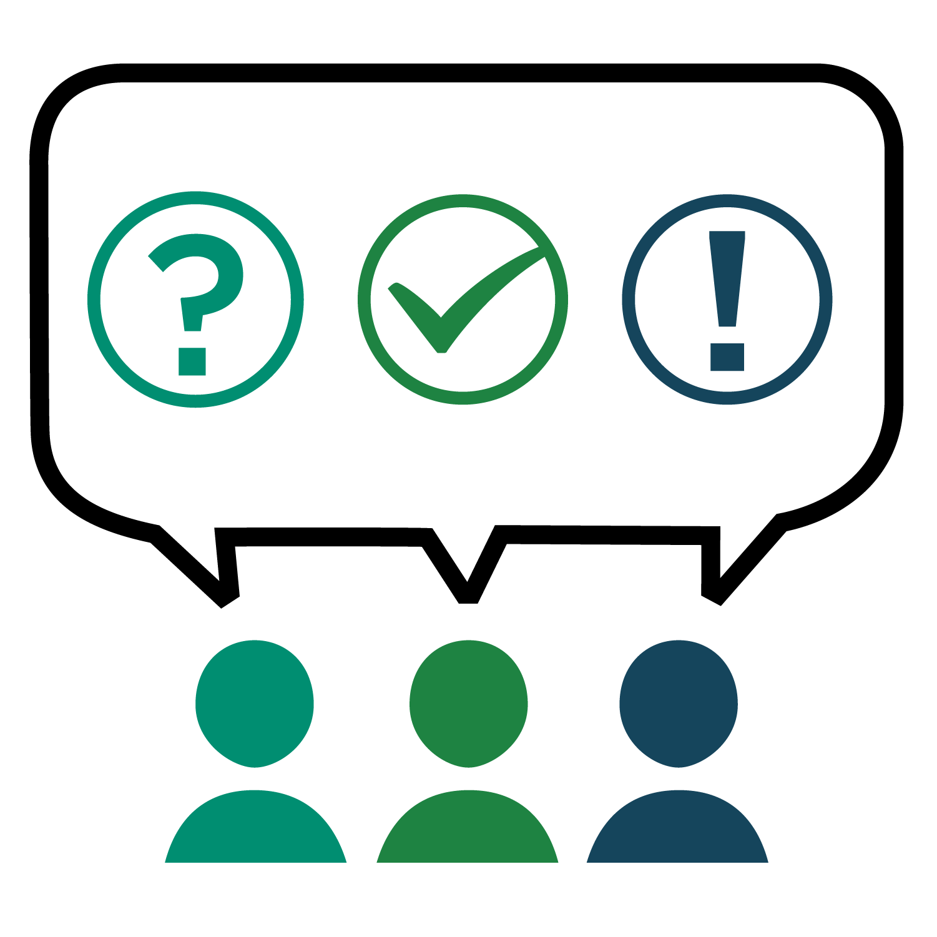
UNDERSTAND
First and foremost, the series aimed to understand the needs of people with various types of disabilities as they relate to the workplace by creating a forum to share experiences and ideas. All too often, discussions and ideas about workplace design and accessibility in the workplace don’t come from those most affected by decisions about what constitutes accessibility. This exclusion can lead to people with disabilities either dealing with poorly conceived accessibility initiatives or being left out of workplace design decisions altogether.
In the spirit of “nothing about us without us”, the consultation series aimed to hear directly from people with disabilities to identify and understand the barriers that they face in their everyday work lives. The focus was on barriers in the physical workplace; however, participants also shared human resources and technological barriers, as those two areas also play a major role in participants’ experiences at their workplaces.
Comments were collected on participants’ current workplaces. As fewer than 2% of participants were already working in a GCworkplace environment, some of the barriers they identified have already been addressed in the GCworkplace design guide.

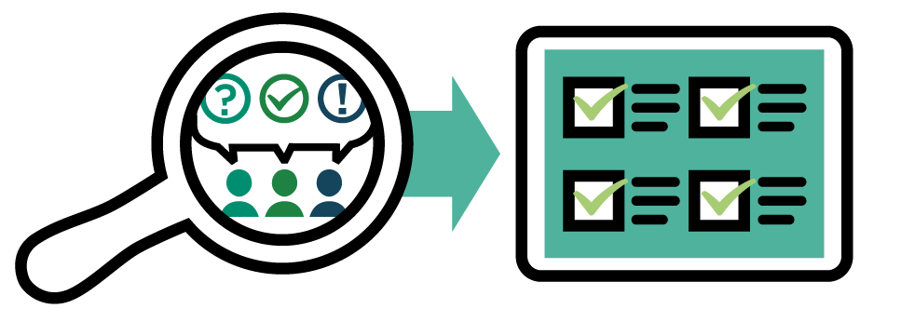
ANALYZE
A second goal of the consultation series was to develop a list of lessons learned and prepare best practices documents so that the information and lived experiences shared by participants during the sessions were not lost and could be used both within Public Services and Procurement Canada and also across the GC.
The intent was to analyze what participants said and use it to inform future planning documents, guides, and decisions around workplace design to make future workplaces as accessible and inclusive as possible. The information and lived experiences shared by participants could also be used to inform changes to human resources and technological policies and guidelines. As the barriers identified by participants were based on their current workplaces, not GCworkplace, an analysis was performed to identify which barriers had already been addressed by the physical design elements of GCworkplace and which barriers could be improved on in future GCworkplace environments.

SHARE
The final goal of the consultation series was to ensure that the findings were shared widely with various stakeholders across the GC. This would be done both through targeted presentations to organizations that requested them as well as through presentations for a general audience. The findings would also be shared specifically with departments and agencies that deal with human resources and technology in order to ensure that they understand the barriers identified during the consultation series.
As of the release of this final report, the findings and their analysis have been shared with the Treasury Board of Canada Secretariat’s for the HR related elements, with Shared Services Canada for the IT related elements and to the .
A communication plan will be developed to share the findings with all government departments and agencies, through different platforms.
The ultimate goal is to use the information gathered to remove as many barriers as possible from the workplace and integrate changes into design processes going forward to make future workplaces as accessible as possible.

Three key takeaways

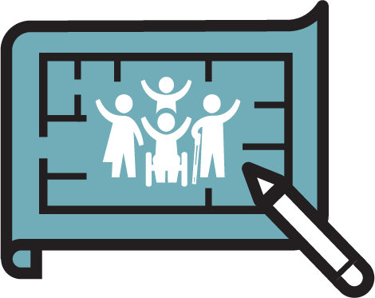
1. The whole office should be designed with inclusivity and accessibility from the beginning

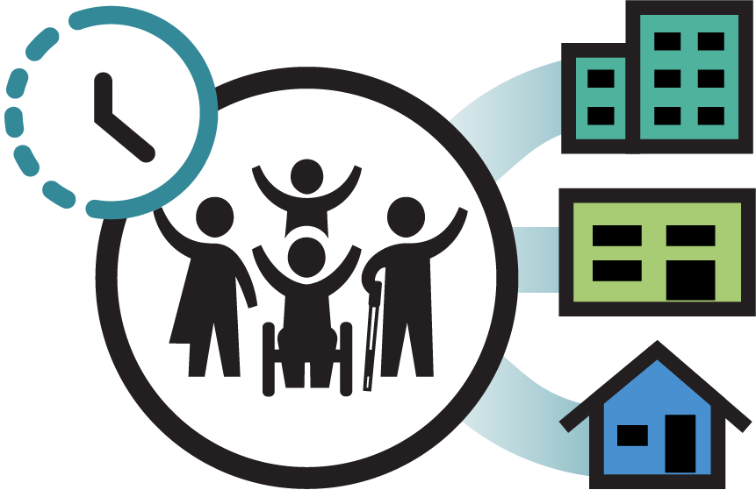
2. Work location and schedule should be flexible for all

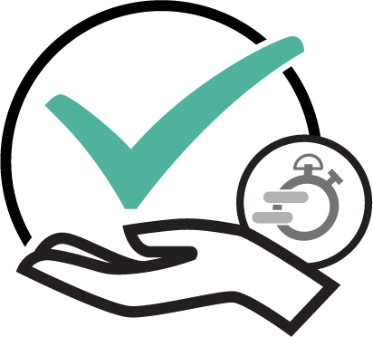
3. When needed, accommodations, adaptations, and support should be rapid and available to all types of disabilities

Key takeaway #1
1. The whole office should be designed with inclusivity and accessibility from the beginning
The most common refrain heard during the consultation series was about the need for accessibility to be an integral part of workplace design, not something that was added on as an afterthought or an addition.
Participants stressed that offices should be inclusive and accessible from the beginning, instead of them having to request changes or adaptations later. This requires a shift in thinking from believing that something can be complete without being accessible to understanding that something is not actually complete unless it is accessible.
This change in mindset from a “build first, make accessible later” approach to one that views a project as complete only if it is accessible is vital to improve accessibility in the workplace for everyone. This approach has the added benefit of making the workplace accessible even for those who haven’t requested accommodations or haven’t been diagnosed with a specific disability.
During the consultation series, participants spoke of a lack of accessible bathrooms, meeting rooms with no space for wheelchairs or walkers, doors that didn’t open automatically, overly crowded kitchens, locker areas with poor acoustics and strong smells, and workpoints that offered no respite from noise. They were frustrated by design choices that seemed to prioritize aesthetics over accessibility.
Participants noted improvements that could be made to many parts of the built environment, not just individual workpoints. Currently, accommodations are often made only to an employee’s workpoint, but that isn’t sufficient when that same employee can’t access other parts of the workplace. All employees should be able to have access to all parts of the workplace, including entrances, meeting rooms, bathrooms, and common areas such as kitchens and lockers. All employees should also have access to quiet zones of focus areas away from common areas to reduce workplace noise and help with concentration.

Key takeaway #2
PARTICIPANTS SAID:

“We need to have more projects where people with disabilities have a voice.”
“There’s no place to go that’s private to have a quiet moment to regroup.”
“There should be more than one type of workstation — it’s not one-size-fits-all.”
“I tend not to go to any common areas…because there are so many obstacles.”
“I use so much energy each day just blocking out distractions.”
“We need to have space on every floor where people with different needs can work.”
“If we mention the challenges, we’re seen as being difficult.”
2. Work location and schedule should be flexible for all
A second common comment heard during the consultation series was that all employees, regardless of level, should have the flexibility to choose their own work location, whether it be at the office, at home, or at another location such as a coworking facility or a coffee shop.
Participants also stressed that employees should have access to flexible schedules that allowed them to set their own working hours, instead of being confined to a standard “9 to 5” schedule.
Both flexible work locations and flexible schedules were highlighted by participants as being vital to supporting employees with disabilities, particularly those whose disabilities can have a greater or lesser impact on them depending on the day or the situation. Employees who have the ability to set their own hours and work locations also have the ability to be the most productive they can be, as opposed to employees who are required to work at a certain time or place regardless of the impact on their health of those requirements.
Participants spoke of having their telework requests denied by managers despite them having doctors’ notes for telework as a medical accommodation. They talked about telework being treated as only for a privileged few and about how many managers across the public service didn’t believe that employees could be productive while teleworking, something which has been proven conclusively to be untrue during the pandemic.
When it came to being able to choose their own workpoints at the office, employees stressed that there needed to be enough workpoints that addressed such things as ergonomic, collaboration, focus, and assistive technology needs, without requiring special accommodations. This in-office flexibility would give employees the ability to choose the workpoint that was right for them and their needs at any given time.

Key takeaway #3
PARTICIPANTS SAID:

“It would be great to have the flexibility to set my own hours so that I can adapt them to my needs.”
“I would love to have access to coworking and collaboration spaces.”
“The thing that’s been most helpful is a flexible arrangement where I can work from home or a different part of the workplace.”
“One of my hardest challenges is inflexible HR policies.”
“I want the ability to work from home so I can take my medication as needed without worrying about driving home at the end of the day.”
“I don’t need an assigned workplace but I do need to have my needs met.”
“Choosing to work from home is different from being forced to work from home because the office isn’t accessible.”

3. When needed, accommodations, adaptations, and support should be rapid and available to all types of disabilities
The third key takeaway from the consultation series was that accommodations need to be available quickly and easily for employees who need them, instead of requiring employees to jump through multiple hoops and rely on the understanding or empathy of an individual manager.
Participants stressed that there need to be standardized responses to requests for accommodations, since the current process of leaving decisions to managers means that there is tremendous inequality between and within departments as to how these requests are dealt with. Participants spoke of losing accommodations when they switched teams or managers as their new managers challenged the need for them.
Accommodations should be available to all following the same simple process, giving people the surety of knowing that they can have access to the support that they need, no matter what position they hold or who their manager is. Employees who have this level of consistent support and who get the accommodations they need in a timely manner can do their jobs to the best of their ability, instead of being held back by the lack of necessary accommodations.
Participants were also tired of having to constantly justify or defend the accommodations they needed. Employees with invisible disabilities found it particularly difficult to get accommodations, as they faced disbelief or stigma from their managers since it didn’t “look like” they needed accommodations.
Participants spoke of delays in getting accommodations that lasted months or even years, of insults and ostracizing behaviour from managers and coworkers, of being denied accommodations that had been recommended by their doctors, and of not wanting to change jobs for fear of losing the accommodations they did have.

GCworkplace and Accessibility
PARTICIPANTS SAID:

“It’s extremely difficult to get any accommodations and it makes you feel like less of a person.”
“There’s still resistance from management when it comes to accommodations.”
“We’re so trapped by the bureaucratic processes that the solutions get lost.”
“I want to be accommodated properly so that I can do my work.”
“We shouldn’t have to fight for basic work tools like noise-cancelling headphones.”
“I would love to be accommodated when I ask for it instead of having to justify my needs every time.”
“Accommodations should be seen as supporting employee excellence, not as a pity handout.”

As a result of the analysis, a Summary of feedback table was created showing which issues were completely or partially resolved by the physical design of GCworkplace, as well as which physical design barriers remained outstanding and which barriers fell outside the built environment elements of GCworkplace.
Below are some examples of the elements pertaining to the physical workplace that were added to the GCworkplace Design Guide:

Inclusive Design and Accessibility – PSPC/Accommodation Management and Workplace Solutions (AMWS)
Inclusive design is used as a philosophy to create workplaces that are welcoming and equitable for all. Inclusive design principles must be followed for all GCworkplace projects to ensure spaces are functional and accessible to all.
For PSPC’s AMWS, Inclusive Design means a flexible and adaptable workplace that provides many options for different user needs and preserences. It can be accessed, understood and used by all people regardless of their age, size, sex, gender identity, ability or disability.

Inclusion and Neurodiversity - PSPC/Accommodation Management and Workplace Solutions (AMWS)
When designing the workplace, it is important to consider both hypersensitive and hyposensitive occupants. For hypersensitive occupants, it is important to have some spaces where the noise, light and temperature are controlled. On the other hand, hyposensitive occupants will thrive in a space that is over-stimulating. Neurodiversity emphasize the importance of a great variety of workpoints, well distributed in each of the GCworkplace zones.
GCworkplace proposes a variety of individual and collaborative open, semi-enclosed and fully enclosed workpoints. All of which are well distributed in each of the zones (quiet, transitional and interactive).
For example, and enclosed workpoint could be ideal for someone that is hypersensitive. It can shield them from visual distractions, ambient noises and allow them to control lighting levels. An open workpoint can do the opposite for someone that is hyposensitive.
In short: By providing users with a variety of workpoints to choose from, we hope to enable those with neurodevelopmental disorders and cognitive and mental health issues, thrive in the workplace and succeed in their role.

Wellness Room - PSPC/Accommodation Management and Workplace Solutions (AMWS)
A wellness room is a short-term enclosed refuge with acoustical and visual privacy. It offers a space to escape from the traditional working environment and allows employees to deal with stressful situations or to take a break from work. The use of a wellness room varies from one employee to another. It can be used for stretching, for meditation, to perform relaxation or religious activities, for breastfeeding or as a sensory relief space. Wellness room should include comfortable furniture and floor space for wheelchair access or a mat for stretching or yoga for example. It is also suggested to add LED color changing light with user control.
A ‘’Wellness Room’’ is fully enclosed support space, that is not a workpoint. Meant for short-term occupancy, this room provides the user with acoustical and visual privacy as well as lighting control. People that use this space may use it to mediate, stretch, pray, decompress, breastfeed, etc. By not being reservable, this space should be used by those who need it, in that moment. Wellness Rooms should include comfortable seating and enough floor space for wheelchair access or a yoga mat for example.

Contactless Access App for Elevators and Interactive Signage Pilot Projects – PSPC/Office of Accessibility in the Built Environment (OABE)
OABE is exploring touchless technologies through some pilot projects in various buildings in the National Capital Region. These includes a touchless elevator button app and an interactive signage pilots. Both pilot projects will be tested by persons with disabilities in the fall of 2021.
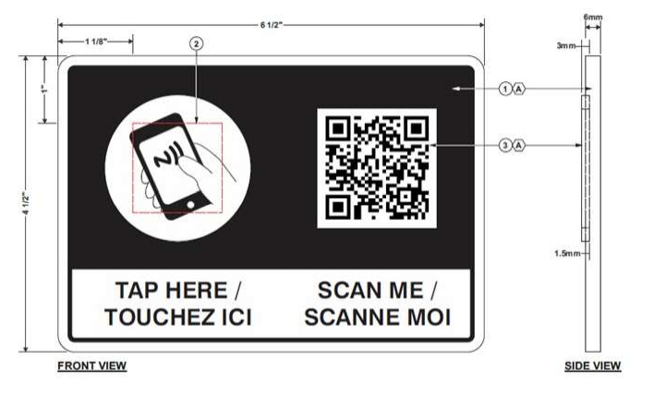

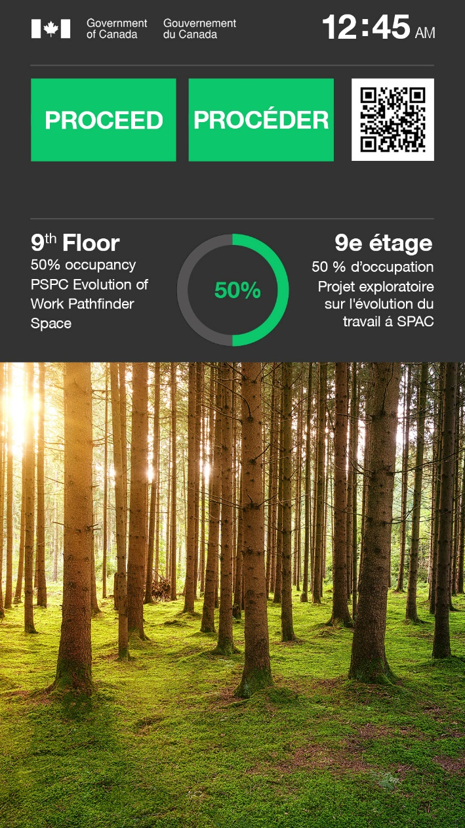
SafeCheckTM Pilot Project – PSPC/Office of Accessibility in the Built Environment (OABE)
This pilot will enable PSPC to evaluate different analytics and messaging for deployment at federal office buildings and related properties. The pilot has been deployed at Portage III, Tower A entrance and featured in the Pathfinder pilot to assist with the return to work strategy.

GC Workplace Accessibility Passport – TBS/Office of Public Service Accessibility
The GC Workplace Accessibility Passport ensures employees have timely access to the adaptive equipment and supports they need to be successful in their job. The passport includes the various barriers they face in the workplace, the solutions found to alleviate or remove the barriers as well as the agreement between the employee and their manager. The passport follows the employee throughout their entire public service career. For further information, please consult the Accessibility Hub on GCpedia.

In Conclusion
The consultations being completed, we are now shifting our efforts towards supporting the inclusion of the findings into processes within our Real Property Services. We will also collaborate with our partner organizations to support modifications to IT and HR tools in support of the consultations findings not related to work spaces. We will ensure that the links included in this document are always kept up to date. Finally, we will strive to make our processes more organic to enable flexibility, cooperation and timeliness in modifying elements due to your comments, lessons learned and new discoveries.
We encourage anyone with an idea or a valid point to continue to leverage the power of GCConnex and communicate it to us, as we strive to continuously improve our workplaces.
Thank you to everyone who participated in the consultations, may you see your efforts and suggestions transformed into concrete actions.

Project Team and Partners

Public Services and Procurement Canada

Accommodation Management and Workplace Solutions, Real Property Services
Nadia Lacelle
Lisa Goodlet
Matthew Penney
Alexandrine Ménard
Carine Paré
Kimberly Monette
Véronique Boton
Carolyn Wood
Rose Hunt

Office of Accessibility in the Built Environment, Real Property Services
Marie-Pierre Dagenais
Christopher Robinson
Joseph Wong
Jemal Djari
Buffy Doyle
Gabriela Rodriguez

PSPS Accessibility Office
Diane Bélanger-Vena
Martin Paquette

TREASURY BOARD SECRETARIAT

Office of Public Service Accessibility
Stephanie Austin
Kirsten Perreault

Useful Links

For Government of Canada employees only
GCworkplace Accessibility Community of Practice and Interest: GCconnex
Office of Public Service Accessibility/ Bureau de l’accessibilité au sein de la fonction publique - GCpedia
Office of Accessibility in the Built Environment - GCpedia

Public
GCworkplace Consultation Series on Accessibility Reports — wiki (gccollab.ca)
Treasury Board of Canada Secretariat – Office of Public Service Accessibility - Canada.ca
Accessibility in the public service - Canada.ca

