2016
GCTools User Study
Prepared by the GCTools Team
Treasury Board of Canada Secretariat
1/1/2016

Executive Summary
The GCTools, the Government of Canada’s collaboration tools, were developed to offer all public servants the ability to collaborate between federal organizations inside the secure Government of Canada (GC) firewall. In 2016, the GCTools team at the Treasury Board of Canada Secretariat conducted the third GCTools user study to collect public servants’ feedback and comments about their experience in working with the GCTools. The purpose of this report is to analyze the responses collected by the user study, as the responses are believed to measure the usability of the GCTools and provide directions for further improvements of the GCTools.
From October to November 2016, public servants across Canada were invited to participate in an online survey that inquired about a) their work environments, b) their experience of working with the GCTools, and c) their demographics. The user study collected 5,920 responses from public servants of 115 government departments, across 10 provinces and 3 territories of Canada, regarding their experience of GCconnex, GCpedia, and GCintranet.
Work Environment
The majority of the study respondents reported to engage in collaborative activities in a typical work day: 47% collaborated with others on a document or other information resource, 44% shared or sent information to others, and 84% reported to be involved with at least one group activity in a typical day. The percentage of respondents using collaborative tools almost doubled since the 2014 user study (46% in 2016, compared to 25% in 2014)!
GCconnex Results
The study showed that 83% of respondents were aware of GCconnex and that 49% of those aware of the tool had been using it for at least one year. Results also showed that 23% of respondents were using GCconnex either daily (15%) or a few times a week (8%), with 33% using it occasionally (few times a month). The top three reasons for using GCconnex were to find and reuse information (53%), to find and connect with people (32%) and to find official/authoritative content (27%). Respondents who use GCconnex also reported finding the information on the tool to be relevant, current, and legible (65%). When asked about the highest perceived benefit for using GCconnex, 64% agreed that it helped public servants to work together regardless of geography.
GCpedia Results
Results indicated that that 69% of respondents were aware of GCpedia and that 47% of those aware of the tool had been using it for at least one year. Results also showed that 19% used it either daily (6%) or a few times a week (13%), with 31% of respondents who used it occasionally. The top reason for using GCpedia was to find and reuse information (68%), with the top perceived benefit for using it being that it is open and accessible to help share documents across departmental boundaries (66%).

GCintranet Results
The study showed that 30% of respondents were aware of GCintranet. Of those aware, 40% had been using GCintranet for at least one year, with the top reason for using the tool being to find official and authoritative content (42%). Results also revealed that 71% of respondents found information in GCintranet to be useful.
Results from Open-ended Questions
To protect the privacy and anonymity of respondents, participant responses to open-ended questions are presented in the form of general statements. Interesting findings from open-ended questions include:
- Public servants generally find the GCTools helpful for work purposes.
- Information management is the primary reason why people use the GCTools.
- The main reason why public servants do not use the GCTools is because of their lack of knowledge on how to use the tools.
Conclusion
Results from the 2016 user study will be used further evaluated and used to prioritize enhancements the GCTools, as well as to help develop a plan to further increase awareness and usage of the GCTools across organizations, regions, and communities. Results and comments from survey participants will also help inform decision on the future direction of the GCTools.

Table of Contents
Executive Summary 1
Table of Contents 3
Introduction 4
Previous GCTools user studies 5
GCTools user study 2016 6
Research Design 6
Survey Respondents 7
Users’ Work Environment 8
Users’ Experience of the GCTools 14
GCconnex 14
GCpedia 23
GCintranet 31
Conclusion 37
Annexes 39
Annex 1: Demographic information of Survey Respondents compared to those of Public Servants, 2016 39
Annex 2. Demographic information of Survey Respondents from the 2016 user study, compared to those of Public Servants in 2015 40
Annex 3. Long-time users and non-users of GCconnex 41
Annex 4. Long-time users and non-users of GCpedia 43
Annex 5. Long-time users and non-users of GCintranet 45

Introduction
The GCTools operate within the secure firewall of the Government of Canada (GC) with the purpose of enabling collaboration among public servants across GC organizations. With an expanding user base of the GCTools, it is important to regularly conduct user studies to understand the GCTools users and their needs, and to identify the strengths and weaknesses of the GCTools. The purpose of this report is to summarize the findings from the third GCTools user study, which was conducted from November 28 to December 9, 2016. The findings from the study will help the GCTools Team to make informed decisions related to the GCTools and the adoption of collaborative behaviours across the Government of Canada.
The GCTools include GCpedia, GCconnex, GCintranet, and GCdirectory. This user study considered GCconnex, GCpedia, and GCintranet. GCdirectory was not included as part of the user study as it joined the GCTools suite in November 2016, only one week before the launch of the study.
In November 2016, when the user study was conducted:
- The number of registered users on GCconnex passed the 100,000 milestone!
- GCpedia had over 71,250 registered users, over 31,500 articles, and over 1,719,800 edits!
- GCintranet had over 102,250 site visitors!

A professional networking and collaborative workspace for all public service, allowing people to connect and share information, leveraging the power of networking towards a more effective and efficient public service.
GCconnex
GCpedia
GCintranet
An authoritative, central communications channel to reach all public servants. It makes it faster and easier for people who work for the GC to find the information and tools they need to do their jobs and collaborate across institutions via a single entry point.
An essential knowledge sharing tool, designed to facilitate collaboration, co-creation of information and providing access to subject matter experts across all of government.

Previous GCTools user studies
Previous user studies on GCconnex and GCpedia were conducted by the GCTools team at Treasury Board of Canada Secretariat (TBS). The first user study was conducted from July 31 to September 6, 2013, and generated 4,869 responses from GC employees. The second user study was conducted from October 6 to November 19, 2014, and generated 7,198 responses from GC employees.
The main purpose of the previous user studies was to better understand the nature of the collaborative work the public servants performed on a regular basis, and whether or not they were familiar with external social media platforms, such as Facebook, Twitter, and LinkedIn. The studies also looked at the level of awareness of the GCTools among public servants and why they used (or did not use) the GCTools.
Key findings from previous user studies included the following.
How respondents worked
- Respondents spent a great amount of time collaborating with others.
- More respondents in 2013 than in 2014 reported that they used smartphones provided by their employer for work purposes.
- The majority of respondents believed that activities such as finding or managing information could benefit from collaborative tools.
Why respondents used the GCTools
- When seeking an online group or community, public servants reported to use GCconnex more than other social media (Facebook, Twitter, LinkedIn, etc.), and when looking for information to accomplish a task, public servants reported to use GCpedia more than other social media (Twitter, LinkedIn, etc.).
- Younger public servants were more likely to report using the GCTools than older public servants.
- The majority of public servants who reported to use the GCTools were located in the National Capital Region.
Why respondents did not use the GCTools
- Many public servants were not aware of the GCTools, and those who were aware did not know how and why they would use the GCTools.
- The more often a public servant worked with secure information, the less often she/he reported to use the GCTools.
- Many public servants would not join the GCTools because their colleagues did not join.
The 2013 and 2014 user studies provided a baseline for further analysis and helped identify additional areas of improvements for the GCTools.
From 2014 to 2016, support from the Chief Information Officer Council (CIOC) enabled GCpedia and GCconnex to become robust and responsive to evolving needs and expectations, with a more reliable infrastructure and enhanced usability and user experience.
In April 2016, the GCTools were relaunched providing users with streamlined navigation, a simpler interface and new user-centered design. The GCTools adopted a new common header, along with new advanced cross-platform search and sharing features, providing users with a more seamless navigation and consistent experience from one platform to another. As part of the relaunch, GCconnex was completely overhauled offering a multitude of new and updated features. Later in 2016, a new onboarding module was launched on GCconnex, making it easier for new users and non-digital natives to learn about digital collaboration and the key features of the tool. Among many other initiatives, the GCTools team continued its efforts to grow the GCTools Ambassadors Network. In 2016, the network included over 240 ambassadors located in 50 departments and different regions. The ambassadors help onboard employees and provide support to departmental or regional teams in understanding how the GCTools can enhance their work.

GCTools user study 2016
The third GCTools user study was conducted from November 28 to December 9, 2016 by the GCTools team at TBS. The study was motivated by an ecological approach: finding a balance between what users want and what they get. Similar to previous user studies, the purpose of the third user study was to add more context and insight into the design process of the GCTools. The 2016 user study was built on previous user studies and added questions tailored to the current developments of the GCTools.
Some of the additions to the third GCTools user study included:
- A research framework based on previous usability research to measure perceived website usability (Wang, and Senecal, 2007)
- Specific questions about what features users use on the tools, what sort of tasks they perform, and the pain points they face.
- An inclusive research design that appreciates differences in the increasing user base of the GCTools. Supposed differences included: different types of users (frequent, occasional, or rare users of the GCTools), work arrangements (flexible, compressed, or telework) and levels of familiarity with external social media platforms (beginner, intermediate, or advanced).

Research Design
The 2016 user study was developed by the GCTools team at TBS. The GCTools team worked in collaboration with the Strategic Communications and Ministerial Affairs at TBS for the development of the online survey, using the licensed FluidSurvey software.
- Part I of the user study looked at the nature of the collaborative day-to-day work of public servants and their use of external social media platforms (such as, Facebook, Wikis, and Google docs) for work-related purposes.
- Part II of the user study looked at the perceived usability and benefits of each the GCTools (GCconnex, GCpedia, and GCintranet) and their features.
- Part III of the user study looked at the demographics and background characteristics of survey respondents (e.g., age, gender, language, Government organizations, work communities, levels of familiarity with social media, etc.).
The user study targeted both GCTools users and non-users.
To reach the GCTools user population, the online survey was promoted through:
- email to all GCconnex and GCpedia registered users;
- GCconnex (Wire message, Latest news, News feed, discussions and blog posts, site-wide notice)
- GCpedia (site-wide notice, Spotlight article, GCTools ECHO newsletter)
- GCintranet (activities and initiatives).
To reach the GCTools non-users population, the survey was promoted through Blueprint 2020 Update newsletter as well as through an email sent out to all BP2020 Champions, asking them to promote the GCTools user study within their organizations. Further promotion was also done through Twitter and word of mouth.

Survey Respondents
A total of 5,920 public servants took part in the survey, on a voluntary basis, through an online questionnaire. To manage potential non-response bias, the demographic characteristics of the 4,860 respondents who completed at least 20% of the demographic questions were compared to the ones of federal public servants. The results from the GCTools user study are based on the data from these 4,860 respondents.
The demographics of Federal Public Servants were obtained from the following sources.
- Population of public servants by department, 2016: http://www.tbs-sct.gc.ca/psm-fpfm/modernizing-modernisation/stats/ssa-pop-eng.asp
- Population of public servants by province or territories, 2016: https://www.tbs-sct.gc.ca/psm-fpfm/modernizing-modernisation/stats/fpsppt-efpfrde-eng.asp
- Demographic snapshot of public servants, 2015: http://www.tbs-sct.gc.ca/psm-fpfm/modernizing-modernisation/stats/demo15-eng.asp
To determine if the demographics of 2016 survey respondents (n=4,860) differed from the available demographics of 2016 public servants (n=256,466), the percentages of different demographic characteristics were calculated out of the total number of respective sample size. The top 10 departments, each province and territory, and each kind of employment status of 2016 public servants had similar percentages to the ones of the GCTools user study respondents. (See Annex 1).
The similarities between the demographics of the 2016 survey respondents (n=4,860) and the available demographics of 2015 public servants (n=257,034) were also investigated by calculating the percentages of different demographic characteristics out of the total number of respective sample size. The age, gender, first official language, largest work community, and years of experience of 2015 public servants had similar percentages of survey respondents. (See Annex 2).
It was concluded that the demographics of the 2016 GCTools user study respondents were similar to the ones of federal public servants. However, there should still be some caution in generalizing the results from the user study to the federal public servants as the views reported here are only from those who completed 100% of the survey.
In the remaining 1060 respondents who completed less than 20% of Part III of the survey, 273 of them left the entire questionnaire blank. Because the background characteristics of the 1060 respondents could not be compared with the background characteristics of federal public servants, their responses were excluded from the current report. However, separate analyses were conducted on their responses for the GCTools to investigate if the findings were different from the ones mentioned in the current report. None of the main findings were different and are therefore not mentioned in the current report.
The 2016 user study results are presented in the following sections:
- Users’ work environment
- Users’ experience of the GCTools (GCconnex, GCpedia, and GCintranet)

Users’ Work Environment
Part 1 of the 2016 user study looked at respondents’ work environment to help support decisions related to the development of the GCTools and need for government-wide collaborative tools.
Survey participants were asked how much time they spent doing specific types of activities in a typical day. When looking at activities performed for at least 30 minutes a day, a high percentage of respondents reported to be performing activities requiring collaboration (see Figure 1). Forty-seven percent (47%) collaborate with others on a document or other information resource for comments or feedback. The finding indicates that the prevalence of collaborative work increased from previous years, where 29% of respondents in 2013, and 40% in 2014 reported to co-create documents for at least 30 minutes a day.

Figure 1. Percentage of respondents doing different activities for 30+ minutes a day.
Content analysis of 462 comments by the 2016 user study respondents revealed additional collaborative work activities, such as creating new information or sharing existing information (see Figure 2).
- “Find what others are doing on a given subject so that I can adapt it to my organization.”
- “Creating user-guides, tip sheet for admins.”
- “Sharing knowledge with co-workers.”
49%
of the respondents reported searching or sharing different information.
43%
of the respondents reported collaborating with colleagues to meet work goals.
8%
of the respondents reported addressing other people’s requests or issues
- “Collaborating with others on documents or information resource.”
- “Problem solving with members of my team.”
- “Scoping a project, activity or initiative with colleagues.”
- “Respond to ATIP requests.”
- “Assisting others via Windows Remote Assistance.”
- “Responding to questions from a network, meetings.”
Figure 2. Other collaborative work activities performed by 2016 user study respondents.
The survey looked at public servants’ involvement in group activities in a typical day (see Figure 3).

Figure 3. Percentage of respondents involved with group activities in a typical day.
Results show that 84% of respondents reported to be involved in group activities, where the majority of respondents are involved with 1 to 3 group activities in a typical day. The finding strongly support continued development and refinement GCTools featured aimed at facilitating online group activities.
To investigate whether or not public servants use collaborative tools, survey respondents were asked to rate their use of external social media (e.g., Facebook, Twitter, or LinkedIn), online collaborative platforms (e.g., wikis, blogs, or online forums), and online collaborative tools (e.g., Google docs, SharePoint, or Evernote). (See Figure 4).

Figure 4. Percentage of respondents using collaborative tools compared to previous user studies.
A high percentage of the respondents reported to be using collaborative tools, where 23% use external social media, 22% use online collaborative tools, and 21% use online collaborative platforms for both work and personal use in 2016. The percentage of respondents using online collaborative platforms and tools increased substantially from previous user studies. However, the 2016 study shows a sharp decrease in the use of external social media for work purposes compared to previous user studies. This could be attributed to the increased use of social media for personal purposes.
To investigate the prevalence of mobile devices at work, the study looked at the use of mobile devices. Figure 5 compares the use of mobile devices for work purposes from the 2013, 2014, and 2016 user studies.

Figure 5. Percentage of respondents using mobile devices compared to previous user studies.
The percentage of respondents who reported using smartphones, tablets or laptops provided by employers increased in 2016 compared to previous years. The use of personal smartphones and laptops for work purposes also increased from previous user studies. The findings from the study support the need for open and mobile-friendly collaboration tools and show that the lines between personal and professional use are getting blurry.
The study looked at the prevalence of different levels of classified information at work. Figure 6 shows the percentage of respondents who reported using protected A, protected B, protected C, secret and top secret or higher levels of information in 2014 and 2016.

Figure 6. Percentage of respondents working with a level of classified information.
The percentages reported in the 2016 user study remained similar to the percentages reported in the 2014 user study. Most respondents work with information classified as Protected A and Protected B, and a smaller percentage of respondents work with protected C, secret and top secret or higher levels of information.

Users’ Experience of the GCTools
Part II of the 2016 user study inquired about users’ experience of the GCTools: GCconnex, GCpedia, and GCintranet. The section investigated five primary research questions about each tool.
- What percentages of respondents are using (or not using) the tool and why?
- How do respondents rate the benefits of using the tool?
- How do respondents rate different features of the tool?
- What are some of the differences between frequent, occasional, and rare users of the tool?
- What are some of the differences between long time users and non-users of the tool?
The following sub-sections analyze the research questions separately for each tool: GCconnex, GCpedia, and GCintranet. To protect the anonymity and privacy of survey respondents, only average percent counts and word clouds of textual comments are reported.

GCconnex
The study looked at the level of awareness of GCconnex amongst federal public servants. Figure 7 shows the percentage of respondents who reported to be aware of GCconnex in 2016, compared to previous user studies conducted in 2013 and 2014.

Figure 7. Awareness of GCconnex.
Results show a consistent increase in the reported awareness of GCconnex. Awareness of GCconnex increased by 18% since the 2013 user study, and by 8% since the 2014 user study.
The study also looked at the actual use of GCconnex. Respondents who reported being aware of GCconnex in the 2016 study were also asked about the length of time they have been using GCconnex.

Figure 8. Length of time respondents aware of GCconnex had been using the tool.
The majority of GCconnex-aware respondents have been using the tool for various lengths of time. Results showed that 73% of the respondents who were aware of GCconnex were also using the tool, and 32% had been using it for more than one year.
The 27% of respondents who were aware of GCconnex, but not using it, were asked why they did not use GCconnex.

Figure 9. Reasons for not using GCconnex.
Results show that respondents who did not use GCconnex did not know why or how they should use it. This result is also supported by content analysis performed on comments provided by participants, which showed that “know”, “use”, “time” and “work” were four popular words in the 261 comments given by respondents to describe their reasons for not using GCconnex.
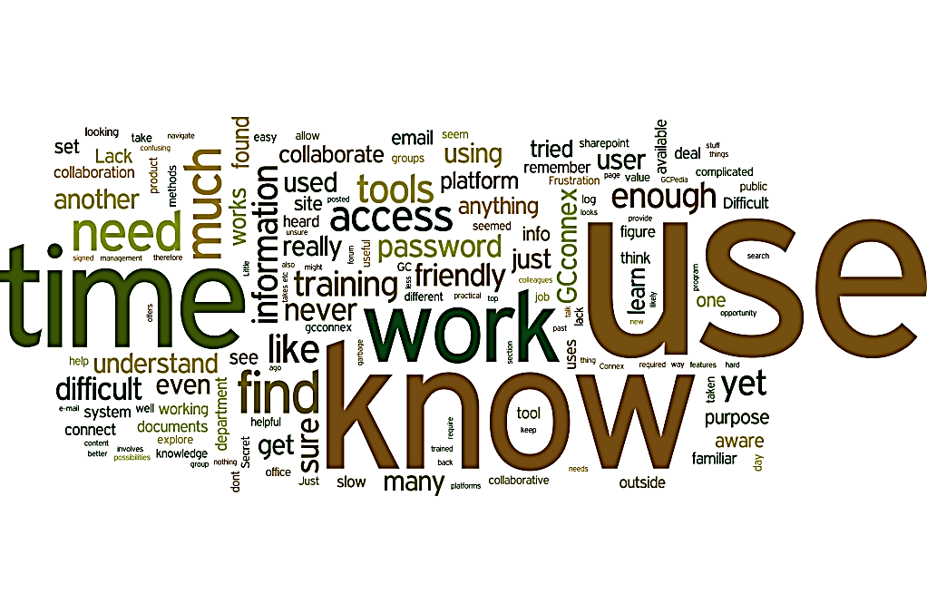
Figure 10. Reasons for not using GCconnex.
The study also looked at the reasons why respondents were using GCconnex. The 73% of respondents who were aware of GCconnex and also using it were asked why they used the tool.

Figure 11. Reasons for using GCconnex.
The top three reported reasons for using GCconnex were to find and re-use information, to find and connect with people, and to find content. Manifest content analysis of the 402 comments given by respondents to describe their reasons for using GCconnex also showed the same results, where “find”, “information”, and “group” were the three most popular words in.
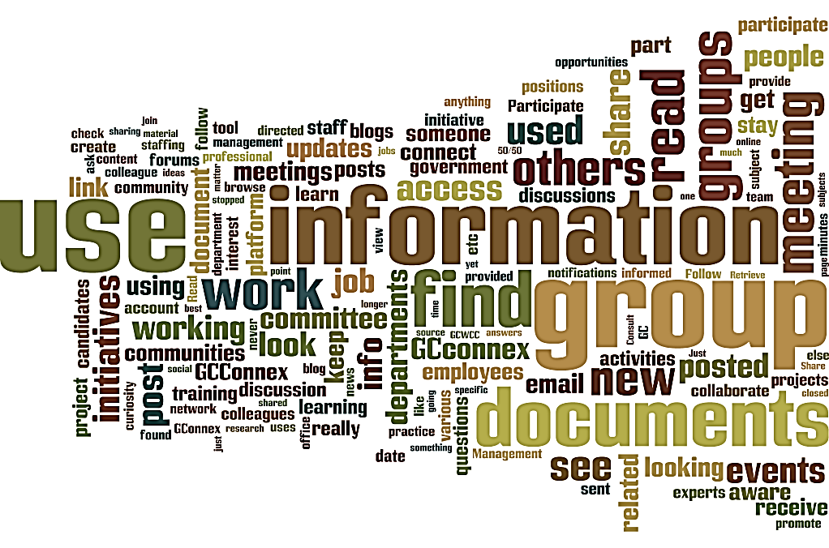
Figure 12. Word Cloud - Reasons for using GCconnex.
Respondents who reported to be using GCconnex were asked to rate the benefits of using the tool.

Figure 13. Percentage of users agreeing/disagreeing with each benefit of GCconnex.
Results showed that, the majority of respondents agreed with most of the listed benefits of using GCconnex. When looking at the highest ranked benefit for using GCconnex, 64% of participants agreed (23% strongly agreed and 41% moderately agreed) that GCconnex helps public servants work together regardless of geography. In addition, 53% of respondents agreed that GCconnex is open and accessible (19% strongly agreed and 34% moderately agreed), 44% agreed that GCconnex is aligned with broader government priorities (33% strongly agreed and 11% moderately agreed) and 41% agreed that GCconnex is reliable and stable (11% strongly agreed and 33% moderately agreed).
However, only 20% of respondents agreed that GCconnex has competitive functionality with private social networking tools, (4% strongly agreed and 16% strongly agreed), with 48% of respondents who reported being undecided. This shows a need to continue making enhancements to GCconnex functionalities to bring the platform to par with those of other social media platforms.
GCconnex users were also asked to rate their experience when working with GCconnex. For this purpose, questions were developed to look at user experience, including attitude, interactivity, speed and ease of navigation.

Figure 14. Respondents’ experience of working with GCconnex.

Results showed that 65% or respondents agreed that information found on GCconnex is useful (e.g., relevant, current, and legible). However, finding the needed information was not easy for 53% of respondents.
Further analysis was performed to compare the ratings of long-time users (more than a year) and short-time users (less than a month). Results showed that 52% of long-time users found GCconnex easy to use (compared to 35% of short-time users), and 67% of long-time users found the information useful (compared to 35% of short-time users). Further studies would be required to find out if the speed of finding information and if the information is useful are determining factors for using GCconnex.
GCconnex users then rated whether or not they found the following activities easy to perform in GCconnex.

Figure 15. Ease of performing activities on GCconnex.
When asked about the ease of performing various activities on GCconnex, 74% of respondents found profiles to be easy to create, 65% found receiving notifications was easy, and 58% found it easy to view the content of the News Feed. For most activities, a higher percentage of respondents found GCconnex activities easy to perform than not. Areas where a higher percentage of respondents have difficult performing the activity included using chatrooms (17%), posting images (17%), creating polls (13%), writing a blog (13%), using group widgets (13%) and noting ideas (13%). Many users were undecided about the ease of use of some GCconnex activities, which could indicate that these features are not well known by users.
Predictive model analysis:
What determines if a user finds GCconnex easy to use?
To better understand the trends underlying the 2016 GCTools user study, a predictive model (random forest classifier) was used to predict if respondents found GCconnex easy to use by analyzing their answers to the survey. By constructing a predictive model based on survey responses, it is possible to uncover any underlying patterns and determine which variable will most likely predict is a user finds GCconnex easy to use, or not.
Results from the random forest analysis provided an accuracy rate of approximately 80% in classifying users’ perceived ease of use of GCconnex. Analysis showed that the most important variables to predict if a user will find GCconnex easy to use, are “ease to find information”, and “ease of collaboration in groups”. Consequently, users’ positive or negative experience on GCconnex is correlated with their ability to find information and collaborating in groups. Making it easier for users to accomplish these tasks will go a long way to improve GCconnex.

Next, GCconnex users were grouped into four categories based on how frequently they use GCconnex: very frequently (e.g., daily), frequently (e.g., few times a week), occasionally (e.g., few times a month), and rarely (e.g., less than once a month).

Figure 16. Frequency of use of GCconnex users.
Results showed that a higher percentage of respondents were either occasional (33%) or rare (44%) users of GCconnex.
Further analysis was performed to identify factors that drive the different types of GCconnex users to use the platform. Among many factors investigated (e.g., demographics and user needs), two factors were found to clearly distinguish the different types of users: work arrangements and level of familiarity with social media.

Figure 17. GCconnex users’ frequency of use by type of work arrangement.
Results showed that users who telework and have flexible work schedule were most likely to be very frequent user of GCconnex (23% and 21%). Frequent users had similar percentages of users who have compressed and flexible work weeks, and who telework.

Figure 18. GCconnex users’ frequency of use by level of familiarity with social media.
Results showed that intermediate level of familiarity with social media is prevalent among all types of GCconnex users. However, very frequent users have the highest percentage (45%) of advanced level familiarity, and the lowest percentage (7%) of beginner level familiarity with social media. Rare users have the lowest percentage (23%) of advanced level familiarity, and the highest percentage (26%) of beginner level familiarity with social media. This indicates that those who use GCconnex more frequently are more familiar with social media.
To investigate the factors that distinguish GCconnex users from non-users, demographics differences between long-time users and non-users were investigated. Demographic differences of at least 5% were identified between long-time users and non-users of GCconnex.
Several work communities, such as human resources, information technology, and communications/public affairs, appeared to be more representative of long-time GCconnex users than non-users. In addition, most long-time users of GCconnex were from National Capital region (60%), and with University certificate or diploma including a bachelor’s degree (42%), or a masters or doctorate degree (31%). Annex 3 provides details of the percentage of long-time GCconnex users and non-users by organization.

GCpedia
The study looked at the level of awareness of GCpedia amongst federal public servants. Figure 19 shows the percentage of respondents who reported to be aware of GCpedia in 2016, compared to previous user studies conducted in 2013 and 2014.
Figure 19. Awareness of GCpedia.
Level of awareness for GCpedia reached 69% in 2016, a decrease from 73% in 2014 and 78% in 2013.
To gain a better understanding of GCpedia users, the study looked at respondents’ use of the tool. Respondents who reported being aware of GCpedia (3,371) were asked for how long they had been using GCpedia.

Figure 20. Length of time respondents aware of GCpedia had been using the tool.
Results showed that 65% of the respondents who were aware of GCpedia reported using the tool, and for various lengths of time. In total, 34% of GCpedia-aware respondents have been using the tool for more than one year.
The 35% of respondents who were aware of GCpedia, but not using it, were asked why they did not use GCpedia.

Figure 21. Reasons for not using GCpedia.
The main reason why respondents were not using GCpedia was because they did not know why or how they should use it. Manifest content analysis also showed that the words “know” and “use” were most often used in comments given by respondents to describe their reasons for not using GCpedia.
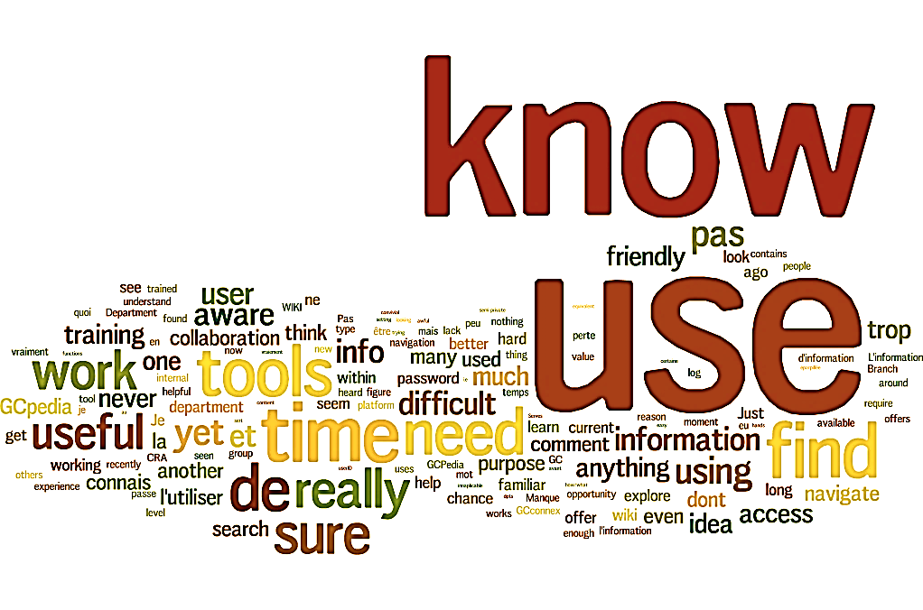
Figure 22. Reasons for not using GCpedia.
The study also looked at the reasons why respondents were using GCpedia. The 65% of respondents who were aware of GCpedia and also using it were asked why they used the tool.

Figure 23. Reasons for using GCpedia.
When looking at the main reason why respondents were using GCpedia, 68% reported using it to find and re-use information provided by other individuals or groups. Manifest content analysis of the 163 comments given by respondents showed that “information”, and “find” were the two most common words used to describe their reasons for using GCpedia.
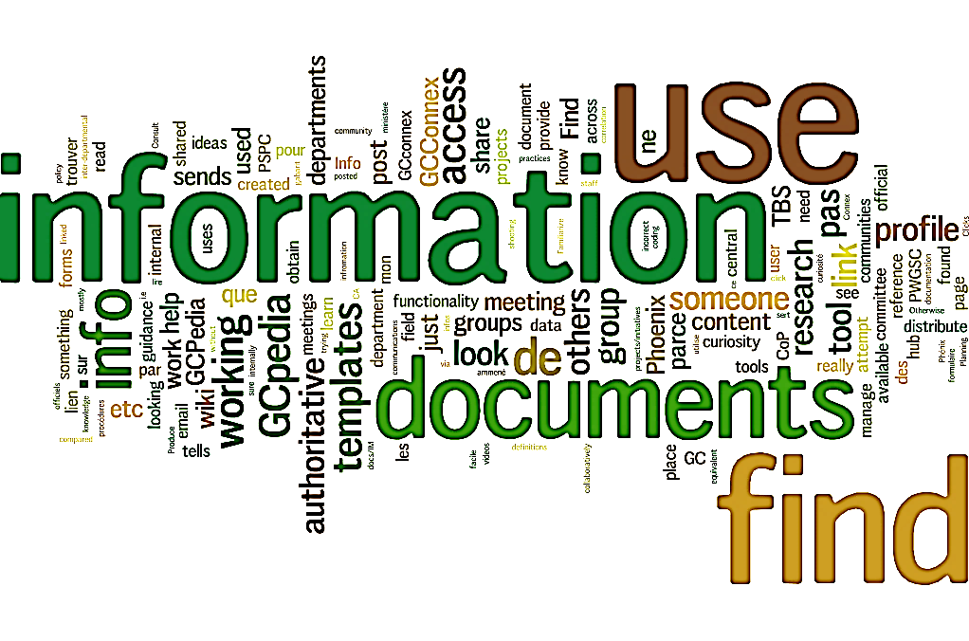
Figure 24. Word cloud - Reasons for using GCpedia.
GCpedia users were also asked to rate the benefits of using the tool.
Figure 25. Percentage of users agreeing/disagreeing with each benefit of GCpedia.
In most cases, respondents agreed with the listed benefits of using GCpedia. When looking at the highest ranked benefits for using GCpedia, 66% of participants agreed that GCpedia helps public servants work together regardless of geography (24% strongly agreed and 42% moderately agreed), and that GCpedia is open and accessible (28% strongly agreed and 38% moderately agreed). Furthermore, 51% agreed that GCpedia is aligned with broader government priorities (15% strongly agreed and 36% moderately agreed) and 47% agreed that GCpedia helps public servants be more innovative and agile in responding to shifting priorities (13% strongly agreed and 34% moderately agreed).
However, less than one quarter of respondents agreed (7% strongly agreed and 17% moderately agreed) that GCpedia has competitive functionality with private social networking tools, with 48% of respondents who reported being undecided.
Respondents who used GCpedia were asked to rated their experience when working with the tool. For this purpose, questions were developed to look at user experience, including: attitude, interactivity, speed and ease of navigation.

Figure 26. Respondents’ experience working with GCpedia.
Overall, user experience on GCpedia rated positively. More than two-thirds (69%) of respondents stated that pages loaded quickly, 63% found the information useful and 61% found GCpedia easy to use. A slightly lower percentage of respondents (45%) stated it was easy to find the information they needed.
Fun Fact
GCpedia uses the same software as one of the most familiar websites to the general population: Wikipedia (in fact, it uses the same template!). As such, GCpedia users tend to find it easy to navigate the platform.
Similarly to GCconnex, a predictive model (random forest classifier) was trained to answer the following question: “When you used GCpedia, was the information useful (relevant, current, legible, etc.)?” Through simple visual examination, results showed that more technical communities (e.g., Science and Technology and Information Technology) are less likely to find information on GCpedia useful, compared to other active communities (e.g., Administration Operations and Human Resources). However, it is difficult to determine if there are any trends pertaining to individuals. Implementing the random forest model helped uncover some useful patterns and determine if there are variables that can predict if a user finds GCpedia easy to use, or not.
Results from the random forest analysis provided an accuracy rate of approximately 80% in classifying users’ perceived ease of use of GCpedia, however, results are heavily skewed toward accurately classifying yes’s rather than no’s. Analysis showed that the most important variables to predict if a user will find GCpedia easy to use is whether or not the individual found it easy to find the information they needed (similar to GCconnex!).

GCpedia users were asked whether or not they found various activities easy to perform on the platform.

Figure 27. Ease of performing activities on GCpedia.
When asked about the ease of performing activities on GCpedia, 61% of respondents found it easy to understand the language of the information posted on GCpedia, 52% found it easy to navigate the menu items and 50% found it easy to find information. However, results showed that many users did not know about the ease of creating a page on GCpedia (65%), which can indicate that a large number of GCpedia users mainly read and browse content, as opposed to creating pages of their own.
Next, GCpedia users were grouped into four segments based on how frequently they used GCpedia: very frequently (e.g., daily), frequently (e.g., few times a week), occasionally (e.g., few times a month), and rarely (e.g., less than once a month).

Figure 28. Percentage of different types of GCpedia users.
Results showed that a higher percentage of respondents were occasional and rare users of GCpedia.
Further analysis was performed to identify factors that drive users to use GCpedia. Among many factors investigated (e.g., demographics and user needs), two factors were found to influence different types of users: GC organizations and communities.
Figure 29 shows the frequency of use of the top three organizations, by type of user (very frequent, frequent, occasional, and rare users).

Figure 29. GCpedia frequency of use for the top three GC organizations, by user type.
Results showed that Public Services and Procurement Canada (PSPC) is amongst the top departments with the highest percentage of survey responses, across all types of GCpedia users. Respondents from PSPC reported using GCpedia very differently across the organization, with 50% of respondents who use it frequently (27% very frequently and 23% frequently), 20% use it on occasion and 14% use it rarely. Results from respondents of the Treasury Board of Canada Secretariat showed that of those using GCpedia, they are using the tool more frequently (15% very frequently and 7% use it frequently) than other organization. These results indicate that the use of GCpedia may be related to organizational needs and requirements. Some organizations also continue to use internal wikis, which would be expected to detract from GCpedia use.
The same analysis was performed for communities that exist across the GC. The top three communities that received the highest percentage of responses, by type of user (very frequent, frequent, occasional, and rare users) are showed in Figure 30.

Figure 30. GCpedia frequency of use for the top three GC organizations, by user type.
Results showed that the community of “communications or public affairs” has the highest percentage of very frequent users (21%). The work community of information technology has the same percentages of frequent and rare users (13%). This indicates that the use of GCpedia might also be related to the needs and requirements of different work communities.

GCintranet
GCintranet joined the GCTools in April 2016. As such, the third GCTools user study is the first to evaluate users’ experience of GCintranet. The study looked at the level of awareness of GCintranet amongst federal public servants. Figure 26 shows the percentage of respondents who reported to be aware of GCintranet in 2016.

Figure 31. Awareness of GCintranet.
In 2016, the number of respondents aware of GCintranet was 1,442 (30% of respondents). The number respondents unware of GCintranet was 3,418 (70% of respondents).
The study also looked at respondents’ use of the tool to gain a better understanding of GCintranet users. When looking at the length of time respondents aware of GCintranet, the results showed a wide variability.

Figure 32. Length of use by respondents who reported to be aware of GCintranet.
The majority of respondents who were aware of GCintranet had been using the tool for various lengths of time, in total 1,021 respondents were using the tool (71% of the GCintranet-aware respondents).
Respondents who were aware of GCintranet, but not using the tool, were asked why they were not using it.

Figure 33. Reasons for not using GCintranet.
Similar to other GCTools, the majority of respondents who did not use GCintranet did not know why or how they should use it. Manifest content analysis shows that “know”, and “use” were the two most popular words in the 98 comments given by respondents to describe their reasons for not using GCintranet.
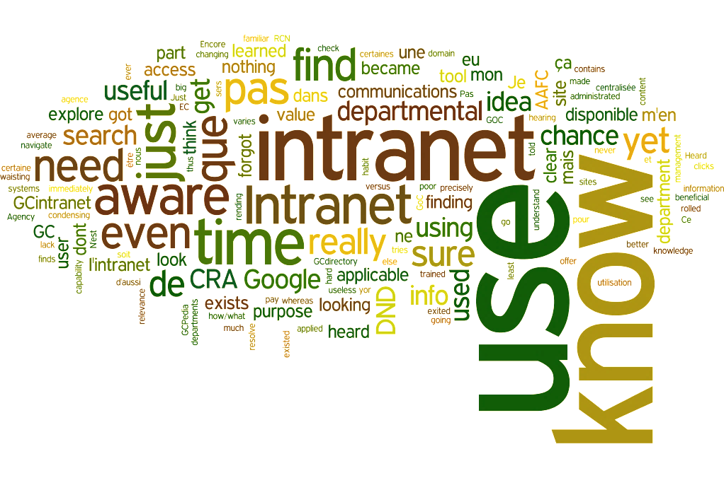
Figure 34. Reasons for not using GCintranet.
The GCintranet-aware users were also asked why they were using GCintranet (see Figure 35).

Figure 35. Reasons for using GCintranet.
Results from the study shows that the main reason why respondents use GCintranet is to find official and authoritative content (41%). Another 35% use GCintranet to find and re-use information provided, and 18% use it for career development purposes. Manifest content analysis shows that “information” and “access” were the two most popular words in the 95 comments given by respondents to describe their reasons for using GCintranet.

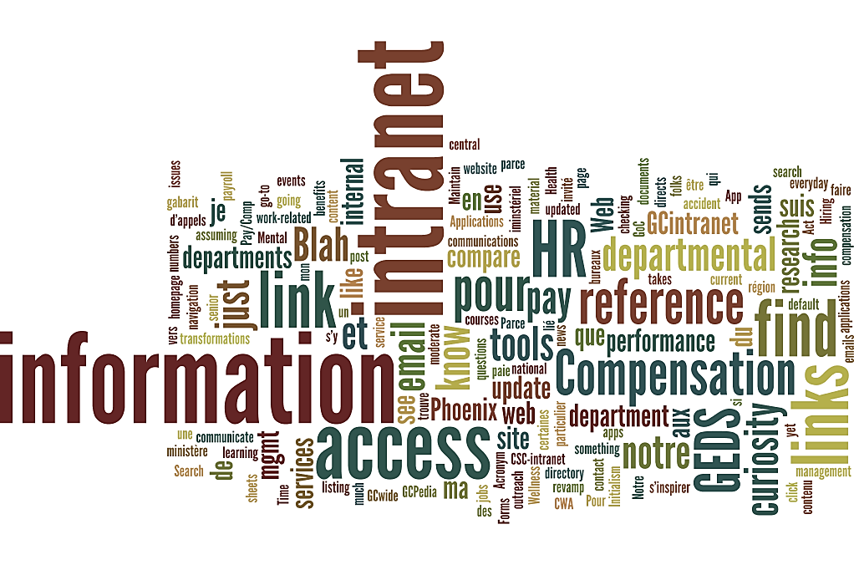
Figure 36. Reasons for using GCintranet.
GCintranet users were also asked to rate the benefits of using the tool.

Figure 37. Percentage of users agreeing/disagreeing with each benefit of GCintranet.
In most case, respondents agreed with the listed benefits of GCintranet. When looking at the highest-ranked benefit, 69% of respondents agreed that GCintranet is a good source of authoritative and official information and 57% of respondents agreed that GCintranet is stable and reliable.
Respondents who used GCintranet were asked to rated their experience of working with the tool. For this purpose, questions were developed to look at user experience, including speed and ease of navigation.

Figure 38. Respondents’ experience of working with GCintranet.
Overall, user experience on GCintranet is favourable. When asked about the speed of navigation, 72% of respondents agreed that pages on GCintranet load quickly. Also, 71% of respondents found the information useful and found GCintranet easy to use. Finally, 49% of respondents reported being able to find the information they were looking for, with 36% who reported the opposite to be the case.
GCintranet users were asked to rate whether or not they found activities easy to perform on the site.

Figure 39. Ease of performing activities on GCintranet.
When asked about the ease of performing activities on GCintranet, 67% of respondents agreed that the home page carousel was easy to navigate and 56% found it easy to access tools such as the performance management application. Also, 40% of respondents reported it was easy to find “spotlight on” articles, and 42% of respondents reported ease in accessing learning and training.
GCintranet users were then grouped into four segments, based on how frequently they used GCintranet: very frequently (e.g., daily), frequently (e.g., few times a week), occasionally (e.g., few times a month), and rarely (e.g., less than once a month).

Figure 40. Percentage of different types of GCintranet users.
Results show similar results for the proportion of very frequent (19%) and frequent (20%) GCintranet users. A slightly higher percentage of users reported using the tool occasionally (26%), with more than one third who reported rarely using the GCintranet (36%).
To identify what distinguishes GCintranet users from non-users, demographics differences between long-time users and non-users of GCintranet were investigated (see annex 5).
Among these factors, not all the detected demographic differences between the users and non-users were deemed meaningful. However, results showed that the department of Public Services and Procurement Canada (20% users and 9% non-users), the community of administrations and operations (21% users and 16% non-users), and the region of Quebec (excluding NCR) (11% users and 5% non-users) were representative of GCintranet users, compared to non-users.

Conclusion
The GCTools User Study evaluated the users’ experience of the GCTools: GCconnex, GCpedia, and GCintranet. The study investigated the work environment of federal public servants, the perceived usability and benefits of using the GCTools for work related responsibilities, as well as the demographics and background characteristics of study respondents.
When looking at the work environment, most survey respondents reported to be collaborating with others for work purposes and were engaged with at least one group on a typical day. Results showed that most respondents were familiar with collaborative tools, with a high percentage of respondents using online collaborative platforms (wikis, blogs, or online forums), and online collaborative tools (Google Docs, SharePoint, or Evernote) for work purposes. The majority of survey respondents also reported working with information rated as Protected A and Protected B levels and using smartphones and laptops provided by their employer, for work purposes.
When looking at the differences between GCTools users and non-users, the majority of survey respondents reported to be aware of the GCTools (83% of respondents were aware of GCconnex, 69% of GCpedia, and 30% of GCintranet), and those aware had been using the tools for various lengths of times. Most GCTools users were from the National Capital Region and had obtained a university degree. Further analysis showed that while the communities of human resources, information technology, and communications or public affairs seemed to have influenced the use of GCconnex, the use of GCpedia appeared to be primarily influenced by the human resources community, and the use of GCintranet by the administrations and operations community. Familiarity with social media and work style also showed to be factors that influenced how frequently respondents used GCconnex. The department of Public Services and Procurement Canada seemed to have influenced the use of both GCpedia and GCintranet.
The study also examined the advantages and benefits of the GCTools. Results showed that the top reason for using GCconnex and GCpedia was to find and reuse information provided by other individuals. The top reason for using GCintranet was to find official and authoritative content. When looking at the highest perceived benefits for using the tools, results showed that respondents agree that GCconnex and GCpedia help public servants work together regardless of geography, and agree that GCintranet is a good source of official and authoritative information.
When looking at the main reasons why respondents were not using the tools (GCconnex, GCpedia, and GCintranet), it was because they did not know why they would use them. Most respondents disagreed that the GCTools (GCconnex, GCpedia, and GCintranet) had competitive functionalities compared to those of private social networking tools.
Results from the study also provided valuable information about the various features of the GCTools. All three tools (GCconnex, GCpedia, and GCintranet) received high ratings on speed (e.g., the pages in GCconnex loaded quickly and information in GCconnex was relevant, current and legible). On the other hand, GCconnex received lower ratings on interactivity (e.g., it did not provide adequate feedback on work performance and did not provide personalized content), and GCpedia and GCintranet received lower ratings on the ease of finding needed information. A higher percentage of respondents found features of the GCTools easy to use (e.g., creating a page, or navigating menu items).
Results from the 2016 user study will be used to further evaluate and prioritize enhancements of the GCTools, as well as to help develop a plan to further increase awareness and usage across organizations, regions, and communities. Results and comments from survey participants will also help inform decision on the future direction of the GCTools.

Annexes

Annex 1: Demographic information of Survey Respondents compared to those of Public Servants, 2016
Top 10 GC Organization | Study respondents | Public servants
Canada Revenue Agency | 16% | 16%
Public Services and Procurement Canada | 11% | 5%
National Defence | 8% | 9%
Health Canada | 5% | 4%
Employment and Social Development Canada | 3% | 9%
Correctional Services Canada | 3% | 7%
Canada Border Services Agency | 3% | 6%
Fisheries and Oceans Canada | 3% | 4%
Immigration, Refugees, and Citizenship Canada | 3% | 3%
Royal Canadian Mounted Police (Civilian Staff) | 3% | 3%

Provinces and Territories | Study respondents | Public servants
National Capital Region | 50% | 42%
Quebec (excluding National Capital Region) | 13% | 12%
Ontario (excluding National Capital Region) | 13% | 15%
British Columbia | 6% | 9%
Alberta | 4% | 6%
Nova Scotia | 3% | 4%
Manitoba | 3% | 4%
Prince Edward Island | 2% | 1%
New Brunswick | 2% | 3%
Saskatchewan | 2% | 2%
Newfoundland and Labrador | 1% | 2%

Employment Statuses in 3 Large Locations | Study respondents | Public servants
Indeterminate – NCR | 47% | 37%
Indeterminate – Ontario (excluding NCR) | 12% | 12%
Indeterminate – Quebec (excluding NCR) | 11% | 9%
Term - NCR | 2% | 3%
Term – Quebec (excluding NCR) | 2% | 2%
Term – Ontario (excluding NCR) | 1% | 2%
Casual – NCR | 1% | 1%
Student – NCR | 1% | 1%
*NCR – National Capital Region

Annex 2. Demographic information of Survey Respondents from the 2016 user study, compared to those of Public Servants in 2015
 | Study respondents, 2016 | Public servants, 2015
Age
Under 24 years | 2% | 3.40%
25-29 years | 4% | 6.60%
30-34 years | 8% | 10.70%
35-39 years | 15% | 13.70%
40-44 years | 15% | 13.70%
45-49 years | 16% | 14.70%
50-54 years | 18% | 17.20%
55-59 years | 12% | 12.20%
60-64 years | 6% | 7.40%
Gender
Male | 38% | 45%
Female | 59% | 55%
Language of choice
French | 21% | 28.70%
English | 67% | 71.30%
Largest work community
Administration and operation | 16% | 15.20%
Years of experience at the government
0-4 years | 5% | 11.10%
5-14 years | 41% | 18.70%
15-24 years | 31% | 23.90%
25+ years | 21% | 16.20%

Annex 3. Long-time users and non-users of GCconnex
 | GCconnex long-term users  (using for more than a year) | Non-users
Top 10 GC Organizations
Canada Revenue Agency | 16% | 21%
Public Services and Procurement Canada | 11% | 11%
Immigration, Refugees and Citizenship Canada | 5% | 2%
Treasury Board of Canada Secretariat | 5% | 1%
Department of National Defence | 4% | 6%
Health Canada | 4% | 5%
Environment and Climate Change Canada | 4% | 4%
Shared Services Canada | 4% | 3%
Indigenous and Northern Affairs Canada | 3% | 2%
Canadian Food Inspection Agency | 3% | 3%
Top 10 work communities
Administration and operations | 15% | 11%
Human resources | 15% | 3%
Information technology | 12% | 6%
Communications or public affairs | 8% | 3%
Compliance, inspection and enforcement | 6% | 6%
Information management | 5% | 2%
Science and technology | 5% | 3%
Financial management | 3% | 3%
Real property | 3% | 3%
Federal regulators | 3% | 3%
Years of experience at the government
1 to 10 years | 38% | 35%
11 to 20 years | 39% | 40%
21 to 30 years | 19% | 19%
31 to 40 years | 4% | 6%
41 to 50 years | 0% | 0%
Employment Statuses
Indeterminate (permanent) | 93% | 91%
Term | 5% | 5%
Other (e.g., minister's exempt staff): | 1% | 2%
Contracted via a temporary help services agency | 1% | 1%
Casual | 1% | 1%
Student | 1% | 0%
Provinces and Territories
National Capital Region (NCR) | 60% | 43%
Ontario (excluding National Capital Region) | 10% | 18%
Quebec (excluding National Capital Region) | 9% | 8%
British Columbia | 6% | 8%
Alberta | 4% | 5%
Nova Scotia | 3% | 3%
Prince Edward Island | 3% | 2%
Manitoba | 2% | 4%
New Brunswick | 2% | 4%
Saskatchewan | 1% | 2%
Newfoundland and Labrador | 1% | 1%
Age
24 years and under | 1% | 0%
25 to 29 years | 4% | 3%
30 to 34 years | 9% | 9%
35 to 39 years | 18% | 14%
40 to 44 years | 18% | 16%
45 to 49 years | 17% | 17%
50 to 54 years | 17% | 18%
55 to 59 years | 10% | 14%
60 years and over | 5% | 8%
Gender
Female | 59% | 64%
Male | 41% | 36%
Language of choice
English | 68% | 76%
French | 19% | 14%
either | 13% | 10%
Education
Bachelor's degree | 42% | 38%
Diploma or certificate from a community college, CEGEP, institute of technology, nursing school, etc., or a trades certificate or diploma | 16% | 25%
University certificate or diploma above the bachelor's level including a master's degree or doctorate | 31% | 23%
Secondary or high school graduation certificate, equivalent or less | 7% | 10%
University certificate or diploma below the bachelor's level | 5% | 4%

Annex 4. Long-time users and non-users of GCpedia
 | GCpedia long-term users  (using for more than a year) | Non-users
Top 10 Government departments
Public Services and Procurement Canada | 16% | 8%
Canada Revenue Agency | 6% | 19%
Shared Services Canada | 6% | 2%
Treasury Board of Canada Secretariat | 5% | 1%
Health Canada | 5% | 5%
Global Affairs Canada | 5% | 4%
Indigenous and Northern Affairs Canada | 4% | 3%
Department of National Defence | 4% | 5%
Environment and Climate Change Canada | 4% | 5%
Immigration, Refugees and Citizenship Canada | 3% | 3%
Top 10 work communities
Information technology | 13% | 9%
Human resources | 13% | 7%
Administration and operations | 11% | 21%
Communications or public affairs | 11% | 4%
Information management | 7% | 3%
Procurement | 6% | 2%
Real property | 5% | 3%
Science and technology | 4% | 6%
Financial management | 4% | 3%
Compliance, inspection and enforcement | 2% | 9%
Years of experience at the government
1 to 5 years | 8% | 9%
6 to 10 years | 30% | 27%
11 to 15 years | 25% | 22%
16 - 20 years | 17% | 18%
21 to 25 years | 8% | 10%
26 to 30 years | 8% | 9%
31 to 35 years | 3% | 4%
36 to 40 years | 1% | 1%
Employment Statuses
Casual | 1% | 1%
Contracted via a temporary help services agency | 1% | 0%
Indeterminate (permanent) | 94% | 93%
Other (e.g. minister's exempt staff): | 1% | 1%
Provinces and Territories
Alberta | 3% | 6%
British Columbia | 5% | 8%
Manitoba | 2% | 4%
National Capital Region | 67% | 47%
New Brunswick | 2% | 3%
Newfoundland and Labrador | 0% | 1%
Nova Scotia | 2% | 3%
Ontario (excluding National Capital Region) | 7% | 14%
Age
24 years and under | 1% | 1%
25 to 29 years | 4% | 4%
30 to 34 years | 9% | 9%
35 to 39 years | 20% | 14%
40 to 44 years | 18% | 17%
45 to 49 years | 15% | 19%
50 to 54 years | 16% | 18%
55 to 59 years | 11% | 13%
60 years and over | 5% | 7%
Gender
Female | 56% | 64%
Male | 43% | 36%
Language of choice
English | 66% | 77%
French | 20% | 13%
either | 13% | 10%
Education
Bachelor's degree | 42% | 38%
Diploma or certificate from a community college, CEGEP, institute of technology, nursing school, etc., or a trades certificate or diploma | 42% | 23%
Secondary or high school graduation certificate, equivalent or less | 42% | 9%
University certificate or diploma above the bachelor's level including a master's degree or doctorate | 42% | 25%
University certificate or diploma below the bachelor's level | 42% | 4%

Annex 5. Long-time users and non-users of GCintranet
 | GCintranet long-term users  (using for more than a year) | Non-users
Top 10 Government Departments
Public Services and Procurement Canada | 20% | 9%
Canada Revenue Agency | 9% | 19%
Employment and Social Development Canada | 5% | 1%
Global Affairs Canada | 5% | 4%
Department of National Defence | 5% | 8%
Immigration, Refugees and Citizenship Canada | 5% | 3%
Environment and Climate Change Canada | 5% | 4%
Treasury Board of Canada Secretariat | 5% | 3%
Health Canada | 4% | 7%
Indigenous and Northern Affairs Canada | 4% | 4%
Top 10 Communities
Administration and operations | 21% | 16%
Human resources | 10% | 7%
Information technology | 8% | 12%
Real property | 7% | 2%
Communications or public affairs | 6% | 7%
Compliance, inspection and enforcement | 6% | 10%
Other services to the public | 5% | 5%
Information management | 4% | 4%
Procurement | 4% | 4%
Science and technology | 4% | 5%
Years of Experience at the Government
1 to 5 years | 13% | 10%
6 to 10 years | 30% | 28%
11 to 15 years | 18% | 19%
16 to 20 years | 17% | 16%
21 to 25 years | 9% | 10%
26 to 30 years | 9% | 11%
31 to 35 years | 4% | 4%
36 to 40 years | 1% | 1%
41 to 45 years | 1% | 1%
Employment Statuses
Indeterminate (permanent) | 91% | 89%
Term | 8% | 6%
Contracted via a temporary help services agency | 1% | 1%
Provinces and Territories
Alberta | 3% | 4%
British Columbia | 6% | 7%
Manitoba | 2% | 3%
National Capital Region | 50% | 50%
New Brunswick | 2% | 3%
Newfoundland and Labrador | 1% | 1%
Nova Scotia | 2% | 4%
Ontario (excluding National Capital Region) | 15% | 17%
Prince Edward Island | 2% | 2%
Quebec (excluding National Capital Region) | 11% | 5%
Saskatchewan | 3% | 1%
Age
24 years and under | 1% | 1%
25 to 29 years | 5% | 4%
30 to 34 years | 9% | 8%
35 to 39 years | 16% | 13%
40 to 44 years | 15% | 17%
45 to 49 years | 13% | 16%
50 to 54 years | 21% | 20%
55 to 59 years | 13% | 13%
60 years and over | 6% | 8%
Gender
Female | 64% | 61%
Male | 36% | 38%
Language of choice
English | 72% | 82%
French | 17% | 10%
either | 11% | 10%
Education
Bachelor's degree | 36% | 35%
Diploma or certificate from a community college, CEGEP, institute of technology, nursing school, etc., or a trades certificate or diploma | 25% | 26%
Secondary or high school graduation certificate, equivalent or less | 12% | 9%
University certificate or diploma above the bachelor's level including a master's degree or doctorate | 23% | 24%
University certificate or diploma below the bachelor's level | 5% | 6%

Variables with a difference of at least 5% in the percentage of users and non-users were deemed to influence whether or not a public servant would use GCconnex.
Variables with a difference of at least 5% in the percentage of users and non-users were deemed to influence whether or not a public servant would use GCpedia.
Variables with a difference of at least 5% in the percentage of users and non-users were deemed to influence whether or not a public servant would use GCintranet.

