How to Accept or Refuse a Claim Request on the TBS Applications Portal
- Once you have been notified that your manager sent you a claim request, either through the automatically generated email by the application or by your manager, you must log into the TBS Applications Portal (TAP).
  - If your manager informed you that a claim request was sent, yet you haven’t received an automatically generated email, the email address associated to your TAP profile might be inaccurate.
- Select the application myEmployees on the top right.
- Select the button Accept besides the name of your manager.
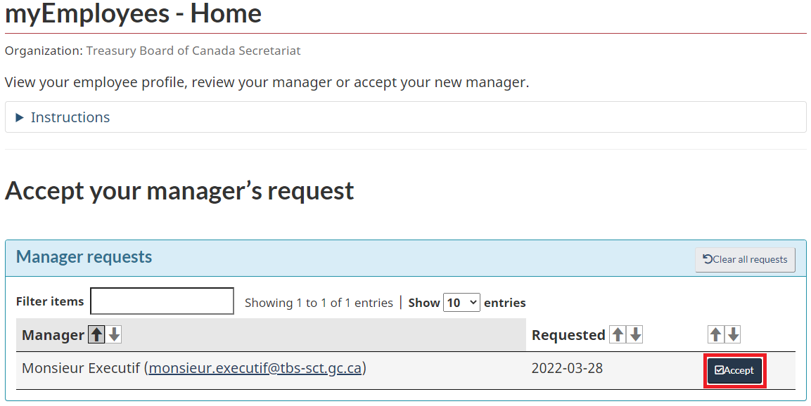
  - Once you have accepted a manager, all other requests will be cleared.
  - If none of the managers listed are your current manager, click on Clear all requests.
- Confirm that you accept your manager’s request.

