**New Employee Info Guide**

This Guide aims to answer the various administrative and HR questions many new hires (Terms and Indeterminate) may have. For other useful information for new employees, consult the New AO reference folder (including the New Hire Guide).

Co-op students and Casuals may consult this Guide for questions regarding pay, but other topics (i.e. benefits) may not apply. For additional information about pay and benefits, see [the additional information page on the mySOURCE Intranet.](http://mysource.hc-sc.gc.ca/eng/ss/programs-services/human-resources/pay-and-benefits/pay-and-benefits-additional-information)

Contents

1.0 Checking your pay 2

CWA, Phoenix, and MyGCPay 4

Getting your myKEY: 4

Logging in to Phoenix/CWA: 5

Phoenix: 6

CWA: 6

Logging into MyGCPay: 7

Phoenix Feedback Form – Pay Issues 8

PAR Form 9

Track myCASE: 9

2.0 Benefits 11

Health Benefits – Sun Life 11

Enrolling in PSHCP: 11

What is covered by the PSHCP? 12

Submitting a Claim 12

Dental Benefits – Great West Life 13

What is covered by the PSDCP? 14

Submitting a Claim 14

Sick leave and vacation 14

Requesting time off – PeopleSoft 15

Vacation Calendar 17

3.0 Performance Management (PSPM and TAP) 17

Registering a PSMP account 17

Links to Courses for the Learning Plan: 18

4.0 Union 19

5.0 Service Buyback 20

Getting an Estimate 20

Service Buy Back Form 21

Medical Exam and Occupational Health Assessment 22

# Checking your pay

Your first paycheque will be deposited into your account on a Wednesday (usually at least 4 weeks after your Start Date). Every subsequent pay will be deposited every two weeks. Note that public servants are paid 2 weeks in arrears, meaning that your pay is for work completed up to and including the end of the day 2 Wednesdays before. This means that you get paid for 10 days, from Thursday to Wednesday, for work that concluded 2 weeks previously.



Work days

Pay day

The following deductions are mandatory:

* [Federal Income Tax](http://www.cra-arc.gc.ca/ndvdls-fmls/menu-eng.html)
* [Canada Pension Plan (CPP)](https://www.canada.ca/en/services/benefits/publicpensions/cpp/contributions.html)
* [Employment Insurance (EI)](https://www.canada.ca/en/services/benefits/ei.html)
* Public Service Superannuation (PSSA) & Supplementary Death Benefit (SDB)
* Disability Insurance (Sun Life)/Long Term Disability (LTD) (Industrial Alliance)
* Union Association Dues

Optional Payroll Deductions

* Credit Union (apply through the Credit Union)
* Recreation Association (RA) (apply through the RA in Ottawa)
* Government of Canada Workplace Charitable Campaign (beginning in January)
* Parking (apply through departmental Facilities Management)
* Union sponsored insurance (apply through your union) not applicable to all employees

## CWA, Phoenix, and MyGCPay

### Getting your myKEY:

For access to Phoenix, the Compensation Web Application (CWA), and MyGCPay, you will need to register for a myKEY. To do this, click on the CWA-AWR black icon on your desktop, and click on the “myKEY” hyperlink near the top of the page.

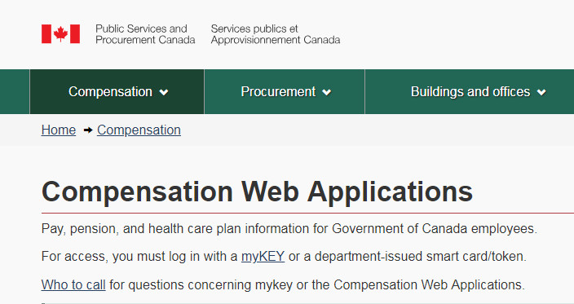

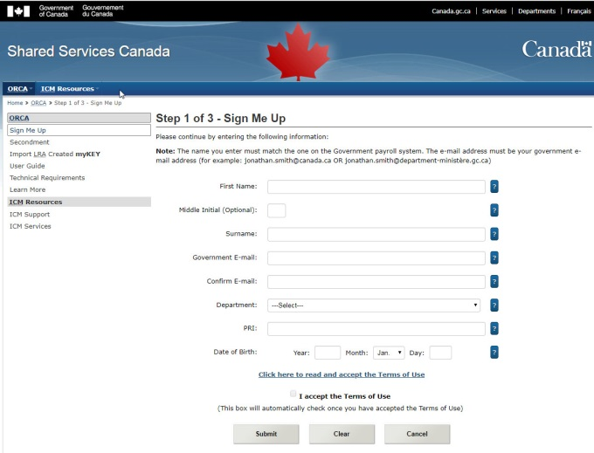This will bring you to the Shared Services Canada page, where you’ll select the “myKEY Sign Up” link in the center of the page. You will need to enter some personal information, your government email, and your PRI number to complete the sign-up.

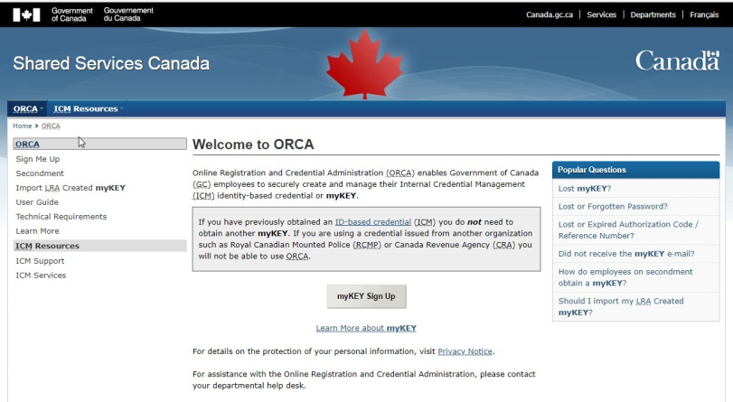

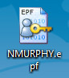

Once you successfully register for a myKEY, make note of where the .epf file is saved on your computer, as you will need it to access Phoenix and CWA. The default location is in the myKEY folder on the C: drive. The file name will be saved with your first initial followed by your last name (i.e. John Smith would become JSMITH.epf). If you have any problems registering for a myKEY, or you lose your myKEY .epf file, call the **National Service Desk at 613-954-8718** for assistance.

### Logging in to Phoenix/CWA:

Phoenix is the pay system used to keep track of your pay stubs, direct deposit, and tax information. The CWA is an older pay system that was used before the implementation of Phoenix, and is now only used as an archive for your previous pay stubs. To access both Phoenix and the CWA, click on the CWA-AWR icon on your desktop that was used to register for your myKEY. Then you’ll select the hyperlink for either Phoenix or the CWA, and on the next page (Access Request to the Compensation Web Application), scroll to the bottom and click “Continue”.

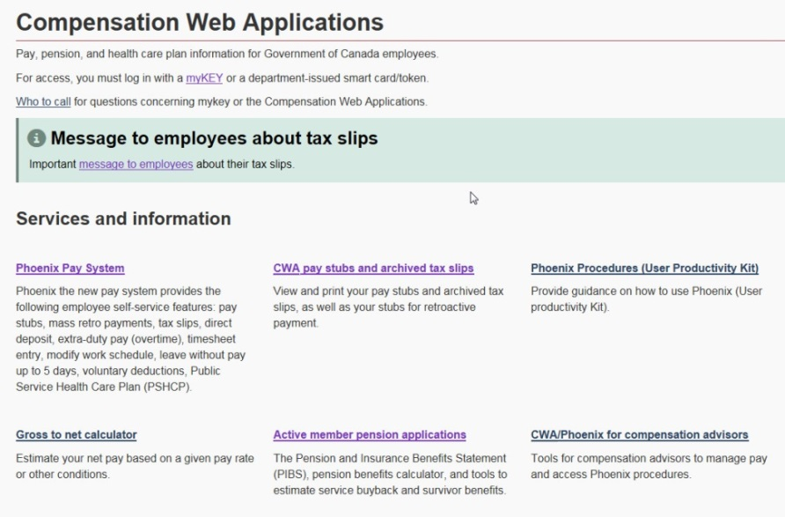



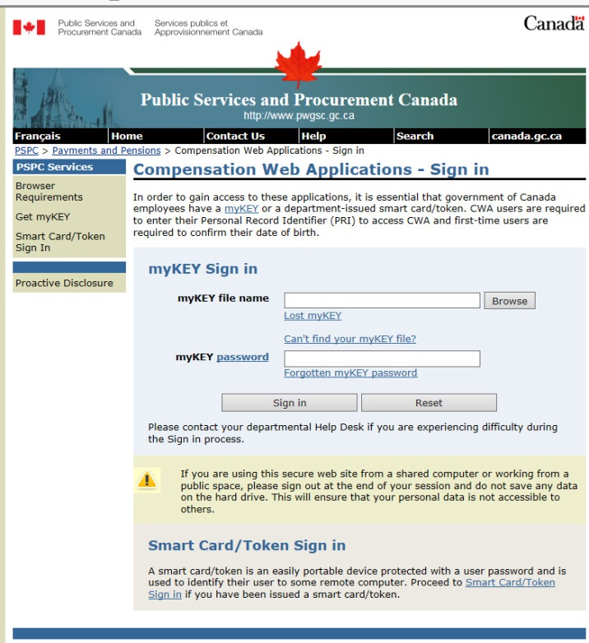This will bring you to the Compensation Web Application log in page. You’ll need to enter your myKEY file by browsing for the file on your computer, and then enter the password associated with your myKEY to sign in. On the next page you’ll be asked to enter your PRI number for validation.

### Phoenix:

Once you have logged into Phoenix, select “Main Menu” from the top bar. This will show several different folders that you can access.

* To check your pay, select “Self Service” followed by “Payroll and Compensation”, and finally “View Paycheck”. This will bring you to a page where you can view your most recent paycheque, as well as past paycheques (up to 2 years).

In Phoenix, you can also update your Direct Deposit information, view your T4/T4a tax slips, and update your personal information.

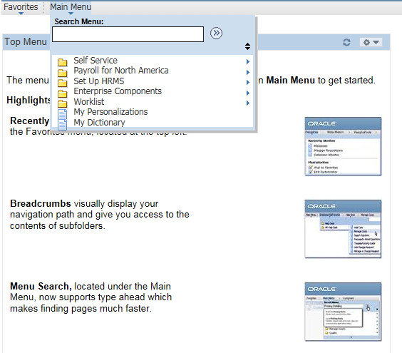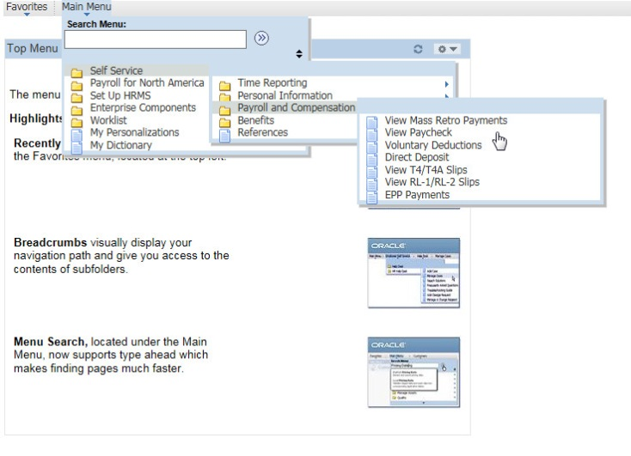

**Tip**: See this handy guide to help you read your paystub through Phoenix (copy and paste this link into your browser to open the link): <http://www.gcpedia.gc.ca/gcwiki/images/5/5a/V.1_New_Phoenix_Pay_stub.pdf>

### CWA:

Once you have logged into CWA, you can select the year that you want to view pay stubs for, as well as view your archived tax slips from previous years. The pay stub is a copy of the Phoenix paycheque, but is broken down in a slightly different way than seen in Phoenix. The pay amount should be identical.

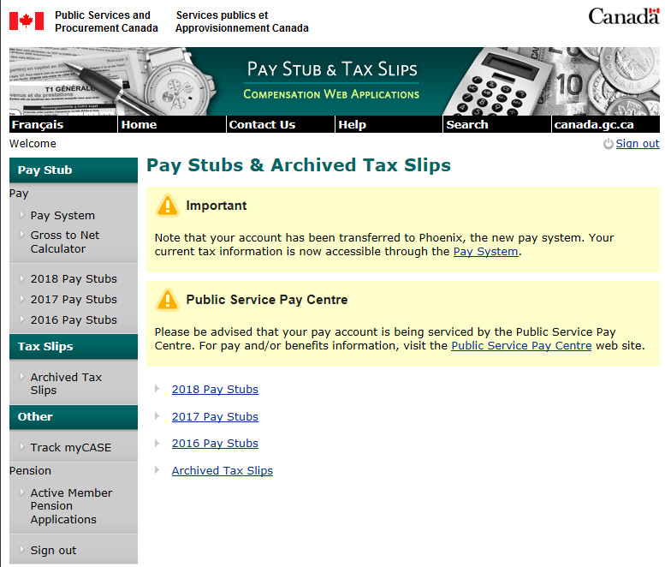

### Logging into MyGCPay:

MyGCPay is a new platform developed to provide clarity to employees about their pay and benefits. It can be used to check your employment status, paycheque, tax slips, benefits information, and obtain proof of employment.

To log in to MyGCPay, use the “MyGCPay – MaPayeGC” icon on your desktop, using your myKey and PRI as outlined above for Phoenix and the CWA. Once logged in, you will be on the home page, where you can see your personal information, employment information (group, step, annual salary, bi-weekly pay, and weekly work hours), employment history, a graph and/or table of your pay period by month and year, and a summary of your benefits. At the bottom of the page there is also a record of all cases and enquiries opened for you by the Pay Centre or Client Contact Centre.

At the top of the page, there are several tabs that will bring you to more detailed pages:



The Employment tab will provide an overview of your current employment information, as well as all the past employment events entered into Phoenix since 2016.

The Paycheque tab has a table with your income history and previous paycheques, as well as a graph and pie chart for your pay breakdown. You can also use this page to view your proof of employment and tax slips, and link to the CWA for your pay stubs.

The Benefits tab contains your benefits information, certificate numbers, and coverage details, and the “Learn More” button can be used to access information on how to enroll in a benefit plan. Check out section 2.0 Benefits below for information on how to access your benefits.

The Enquiries and Cases tab can be used to track your ongoing enquiries and cases, see their status, and a breakdown of the enquiry and case information.

**In summary:**

|  |  |
| --- | --- |
| **Use CWA to:** | **Use Phoenix to:** |
| * view your archived pay stubs (current year plus previous year) | * view the latest pay stub 2 days before the pay date |
| * view pay cycle start and end dates | * access pay stub archives since early 2016 |
| * conveniently print pay stubs | * access Phoenix tax slips |
| * access tax slips predating Phoenix implementation | * view mass retroactive payments |
| * view earning details for overtime |  |
| * view a breakdown of retroactive payments |  |
| * view a breakdown of leave without pay periods |  |

**Use MyGCPay to:**

* view your employment information
* view your employment history
* obtain proof of employment
* view a breakdown of your pay and pay history
* download tax slips
* view your benefits information
* track your enquiries and cases

For more information such as pay codes and abbreviations, check out the [How to Read your Pay Stub](http://www.tpsgc-pwgsc.gc.ca/remuneration-compensation/services-paye-pay-services/paye-information-pay/lire-paye-talon-read-pay-stub-eng.html) page.

## Phoenix Feedback Form – Pay Issues

Please complete the [Phoenix Feedback Form](https://www.tpsgc-pwgsc.gc.ca/remuneration-compensation/services-paye-pay-services/systeme-paye-employes-pay-system-employees/retroaction-phenix-phoenix-feedback-eng.html) if you are experiencing one of the following:

* Cannot get pay stub
* Cannot understand paystub
* Need help with extra-duty pay
* Question regarding Section 34 Manager
* Missing payment
* Require record of employment
* Incorrect deductions
* Receiving too much pay
* Taxation enquiries
* Benefit enquiries

**Tip**: In the “Please provide details” box, provide a detailed breakdown of the pay problem you are experiencing. Provide information on what you should have gotten paid, what you actually got paid, and specify how much is owed.

**Before** you submit your Feedback Form, print a copy of the page for your record.

**After** you click “Submit”, print the confirmation page for your record.

For more details, see the [Experiencing problems with your pay](https://www.tpsgc-pwgsc.gc.ca/remuneration-compensation/services-paye-pay-services/systeme-paye-employes-pay-system-employees/probleme-paie-pay-problem-eng.html) webpage.

## PAR Form

A Pay Action Request (PAR) form is usually submitted by HR to initiate a pay-related action (e.g. new employee, initiation of healthcare benefits, etc.)

Consult the [Pay Action Request guide](https://www.tpsgc-pwgsc.gc.ca/remuneration-compensation/services-paye-pay-services/paye-centre-pay/demande-employee-request-eng.html) on how to fill out the form.

* Human Resources Trusted Sources will route all PARs to the Pay Centre on your behalf. This means that instead of sending PARs directly to the Pay Centre, you should now send these to our Compensation Trusted Source Team at [hc.compensation.trusted.source-source.fiable.remuneration.sc@canada.ca](mailto:hc.compensation.trusted.source-source.fiable.remuneration.sc@canada.ca).
* The Internal Escalation Team can now be contacted at: [hc.compensationescalation-acheminementenmatiereremuneration.sc@canada.ca](mailto:hc.compensationescalation-acheminementenmatiereremuneration.sc@canada.ca)

Please note employees remain responsible for submitting Phoenix feedback forms.

## Track myCASE:

Track myCASE is a Web application that enables employees to view the status of their pay-related cases with the Public Service Pay Centre. Track myCASE is accessed within the Compensation Web Applications (CWA) and the case data is updated daily. You can now also see the status of your case in the MyGCPay application.

1. Click on the CWA-AWR icon on your desktop.
2. Click on Track myCASE under Services and Information. Use your myKey and PRI to log in.



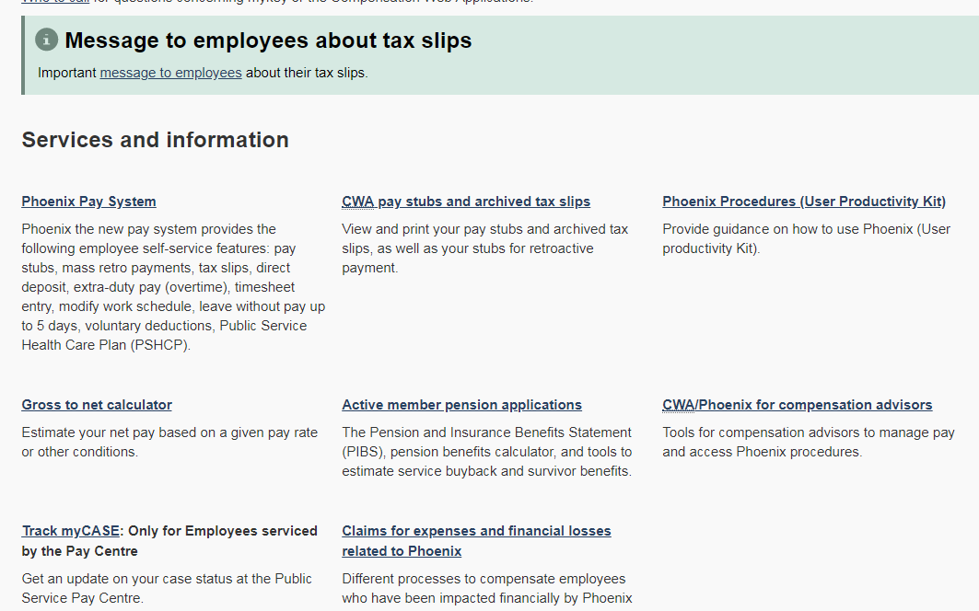

1. Once logged in, you will see a list of all of the cases for your account, including a status.

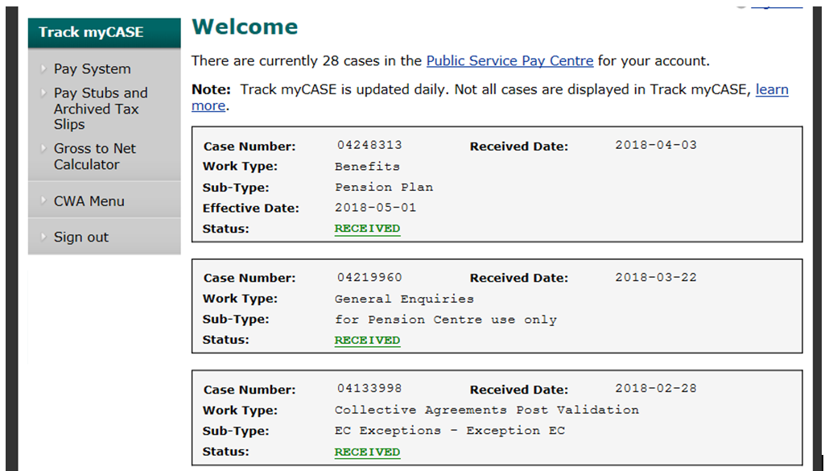

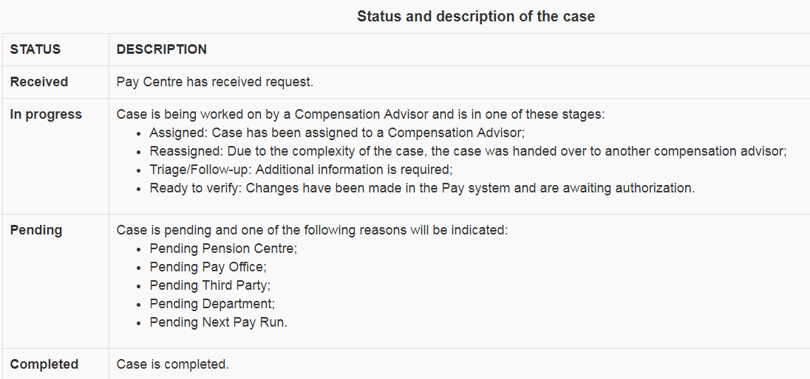

# Benefits

Information on the benefits you are entitled to as a public service employee can be found on the [Benefits Plans page](https://www.canada.ca/en/treasury-board-secretariat/topics/benefit-plans/plans.html) of the Treasury Board Secretariat. Provided that you are going to be employed by the public service of Canada for a period of 6 months or more, you are entitled to both Health and Dental benefits. These benefits are only available to Term or Indeterminate employees; students and Casuals are excluded.

The following sections will cover the Public Service Health Care Plan and the Dental Care Plan. If you want to find out more about other benefits/insurance coverage such as Disability, Employment Insurance (EI), and the Public Service Management Insurance Plan (PSMIP), [see the mySOURCE](http://mysource.hc-sc.gc.ca/eng/ss/programs-services/human-resources/pay-benefits/benefits-and-insurancehttp:/mysource.hc-sc.gc.ca/eng/ss/programs-services/human-resources/pay-benefits/benefits-and-insurance) Benefits and Insurance page.

## Health Benefits – Sun Life

The Public Service Health Care Plan (PSHCP) is through Sun Life Financial, and you have access to these benefits immediately. Note that this plan is optional, not mandatory. A summary of the PSHCP eligibility requirements and application process can be found on the [Public Service Health Care Plan summary](https://www.canada.ca/en/treasury-board-secretariat/services/benefit-plans/health-care-plan/public-service-health-care-plan-glance.html) page. This link also contains information on coverage, reimbursement, hospital provisions, and contributions.

### Enrolling in PSHCP:

**Certificate Number:**

In order to enroll into the PSHCP, you must first obtain your Certificate Number through Phoenix. Once on Phoenix, go to **Main Menu > Self Service > Benefits > Self-Service for PSHCP**. Your Certificate Number should be listed.

* If your Certificate number is not listed, you must fill out an [Application form](http://www.pshcp.ca/media/1688/emp-applic-adhes-006491.pdf) and submit it with a PAR form to the Compensation Trusted Source Team at [hc.compensation.trusted.source-source.fiable.remuneration.sc@canada.ca](mailto:hc.compensation.trusted.source-source.fiable.remuneration.sc@canada.ca).
* When filling out the Application form, you are required to provide your name, PRI number, and date of birth, and you need to indicate if you are applying for the plan for yourself only or if the plan will also cover your dependants. A pension number is not required for the application. The default Hospital Benefit Coverage is Level I (see Tip below).

**Tip**: The Self-Service for PSHCP menu on Phoenix also allows you to select levels I, II, or III for your hospital coverage. For what is covered by each level, see the [Extended Health Provision](http://www.njc-cnm.gc.ca/directive/d9/v9/s72/en#s72-tc-tm). Each level has a different cost associated with it. For Level I, the employee does not have to contribute an amount. See Monthly Contribution Rates of the other two levels [here](http://www.njc-cnm.gc.ca/directive/d9/v9/s87/en).

Once the compensation team emails you your Certificate Number (or if you obtained it through Phoenix), you must go through the **Positive Enrollment** process. Positive enrolment is a mandatory part of the registration process wherein you provide information to Sun Life about yourself, your spouse/common-law partner, and/or each eligible dependant. For more info, visit [the Sun Life page.](http://www.pshcp.ca/managing-my-coverage/positive-enrolment.aspx)

**How to complete positive enrolment:**

1. Register with the Sun Life Member Services website at [www.sunlife.ca/pshcp](http://www.sunlife.ca/pshcp). Sun Life will provide you with an Access ID and **will send your password separately to you by mail.**

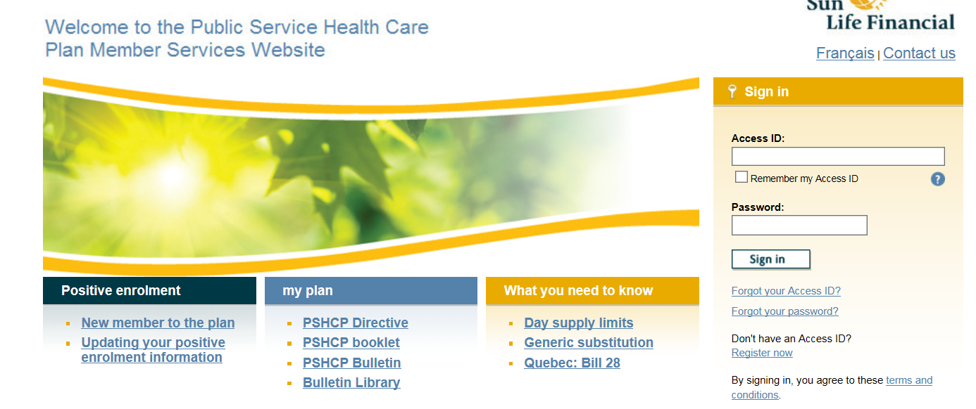

1. Once you receive your password in the mail (which takes about a week), you can use your Access ID and password to log into your account and complete the [Positive Enrolment online form](https://www.sunnet.sunlife.com/GB_PE/wca/blankForm). You will be asked to provide the name, address, gender, and birthdate of those who will be covered under the Plan, as well as information about coverage under other group health plans for coordination of benefits. The Contract number is 55555. The Certificate number is the one you obtained from the compensation team above. Sun Life will send you a package confirming your information and coverage in the mail (which can take 3-4 weeks).
2. Once you are enrolled, you can print your PSHCP Benefit Card or request that Sun Life send a card to you by mail. You can request additional copies of the card for your eligible dependants over the age of 18.

The Sun Life insurance administrator can be reached at 1-888-757-7427 should you have any questions.

### What is covered by the PSHCP?

For a complete list of what is covered by the PSHCP, see [Extended Health Provision.](http://www.njc-cnm.gc.ca/directive/d9/v9/s72/en#s72-tc-tm)

### Submitting a Claim

Visit the [Sun Life website](https://www.sunlife.ca/ca/Support/Sign+in+help/my+Sun+Life?vgnLocale=en_CA) or the My Sun Life app to submit a claim.

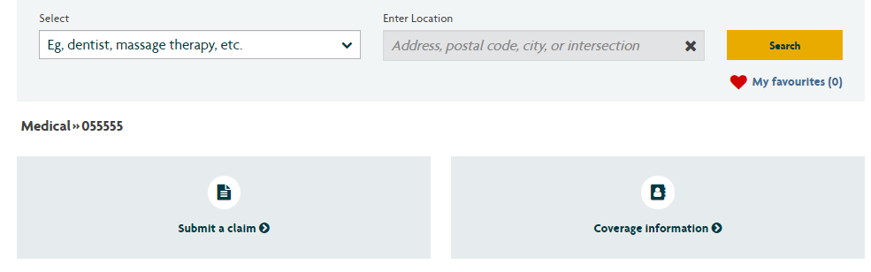

## Dental Benefits – Great West Life

The Public Service Dental Care Plan (PSDCP) is offered through Great West Life, and you have access to these benefits after 3 months of continuous employment in the public service. Unlike the PSHCP, the PSDCP is mandatory and does not require the submission of an application. You should receive an email with information on your PSDCP after 3 months.

If you do not receive an email after 3 months, you can:

* Call Great West Life at 1-800-957-9777 and ask for your ID number. The group plan number is 55555. Sometimes, your ID number is already active, but the email is delayed.
* If Great West Life does not have your ID number, there is the potential that your Dental benefit info has not been sent to the Pay Centre. If this is the case, you need to submit a PAR form to the Pay Centre for the initiation of your dental benefits.

Once you have obtained your ID number, you can register on the Great West Life Group Net website, found [here](https://groupnet.greatwestlife.com/public/signin/login.public?e=&username=unauthenticated&dl=/pkmslogin.form). To register, select Register Now. You will need to provide your plan number (55555), complete ID number (e.g. CF 0123456), as well as your first and last name, birthdate, email address, and home postal code. Once this information has been validated by the system, you will be asked to make a username and password for your Great West Life account, which will be used to sign in to your PSDCP benefits account. You will also be given an option to print off your benefits card.

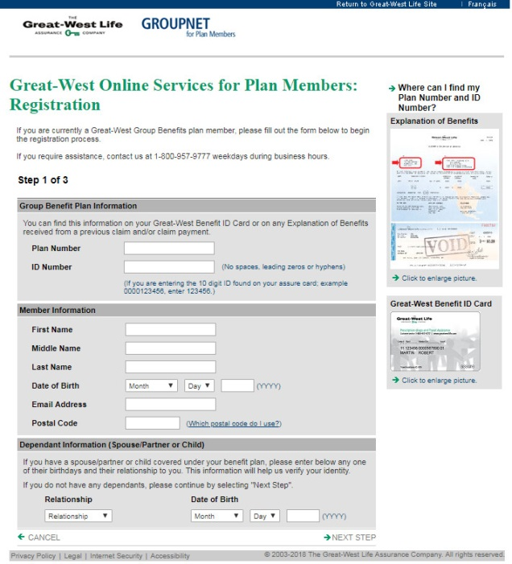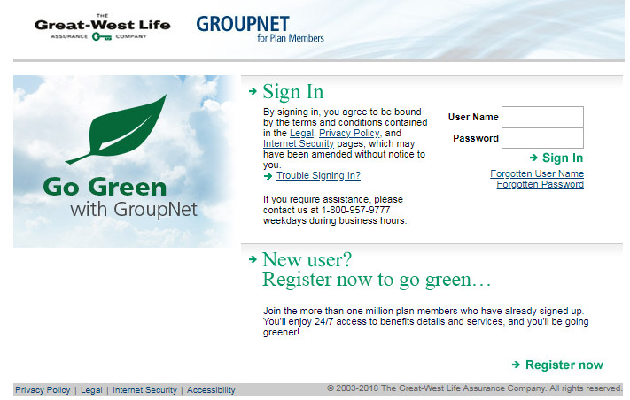

### What is covered by the PSDCP?

For a complete list of what is covered by the PSDCP, see the [Member Booklet](https://www.canada.ca/en/treasury-board-secretariat/services/benefit-plans/dental-care-plan/public-service-dental-care-plan-member-booklet.html).

### Submitting a Claim

Visit the [Great West Life website](https://groupnet-pa.greatwestlife.com/publicGnPA/signin/loginpa.public?lang=en) to submit a dental claim (if your dentist does not automatically file the claim for you).

## Sick leave and vacation

Vacation leave, sick leave, family-related leave, and other paid leaves are entered through PeopleSoft. Depending on your tenure and collective agreement, employees are entitled to:

* **Sick Leave:** Sick leave credits are accrued at the rate of 9.375 hours per month for each calendar month. Unused sick days are typically carried over to the new fiscal year.
* **Vacation Leave:** You will earn annual leave credits based on your years of service.
  + 9.375 hours until the month in which the employee’s eighth (8th) anniversary of service occurs;
  + 12.5 hours commencing with the month in which the employee’s eighth (8th) anniversary of service occurs;
  + 13.75 hours commencing with the month in which the employee’s sixteenth (16th) anniversary of service occurs; etc.…

Vacation leave credits are advanced for the new fiscal year on April 1st. Vacation hours can be carried over depending on your collective agreement. For Term employees, at the beginning of your time with the public service, vacation leave is accrued at the rate of 9.375 hours per month for every month where the employee works at least 75 hours, up a total of 3 weeks (15 days, 112.5 hours) vacation. After 6 months of continuous service, the remaining vacation leave for the fiscal year will be advanced to you.

* + Unused vacation days are carried over to the new fiscal year up to a maximum of 35 days. All vacation leave credits in excess of 35 days will be paid at the employee’s hourly rate of pay as calculated from the employee’s classification.
* **Family-Related Leave:** Leave with pay may be granted for an illness in the family, medical or dental appointments and meetings with school authorities up to a maximum of 37.5 hours per fiscal year, depending on your collective agreement.
* **Medical/Dental Leave:** Leave with pay may be granted for routine or periodic check-ups, which is normally limited to appointments of a preventive nature such as appointments for annual physical, dental check-up, and eye exam. This could also include appointments that are diagnostic in nature, such as mammograms or colonoscopies. Up to half a day (3.75 hours) may be granted as paid time off for these absences, which includes the time required to travel to and from the appointment. Note that appointments for specific conditions or complaints (e.g. follow-up appointments for treatment) are to be taken as sick leave. Please see the FAQ document in the New AO folder for medical and dental appointments, or follow the link for more information: <https://www.canada.ca/en/treasury-board-secretariat/services/information-notice/time-off-personal-medical-dental-appointments.html>
* **Other Types of Leave Entitlements:** Two personal days (15 hours total; to be used in periods of 3.75 or 7.5 hours each); and One-Time Special Leave, for a maximum of 37.5 hours (if applicable), depending on the collective agreement.

**Please note**: Part-time employee leave entitlements are prorated based on their hours of work.

Depending on your collective agreement, you may be granted leave with or without pay for other reasons, such as:

* Court attendance/Union activities
* Education/Care and nurturing of pre-school age children
* Spousal relocation/ Personal needs
* Maternity/Parental
* Bereavement

In the event that you take leave without pay (LWOP), please ensure that Pay and Benefits are advised at least one (1) month in advance to ensure that your pay is adjusted accordingly.

For employees that have past experience in the federal government (i.e. student employment), any periods of continuous/discontinuous service as a student within the public service can count towards the calculation of vacation leave entitlements when you become subject to the vacation leave provisions of your collective agreement. To have your previous student employment count towards your vacation leave entitlement calculation, you need to contact **Compensation Escalation** ([hc.compensationescalation-acheminementenmatiereremuneration.sc@canada.ca](mailto:hc.compensationescalation-acheminementenmatiereremuneration.sc@canada.ca)) to have a review conducted of your file and to make the necessary adjustments. In the email to Compensation Escalation, reference the notice linked below. You do **not** need to Buy Back your Service prior to adjusting your vacation entitlement. For more information, please see the following link: <https://www.canada.ca/en/treasury-board-secretariat/services/information-notice/continuous-discontinuous-service-employees-prior-service-student.html>

## Requesting time off – PeopleSoft

PeopleSoft is the Oracle software used by employees to request vacation, sick leave, and other leave. The icon for PeopleSoft can be found on your desktop. To register, open PeopleSoft and select the “Register” link. You will need to provide your PRI, @Canada.ca email address, birthdate, family name, and company. For company, you should select Health Canada. Once the information is filled in, click “Submit”, and a confirmation email will sent to your @Canada.ca email account.

Once you have created an account, you can access PeopleSoft to view your Leave Summary and Personal Information. To submit a leave request, sign in to PeopleSoft and go to **Self Service** on the left-hand side of the homepage. From there, you can select **Employee Leave (GC).** Under Employee Leave, you can select **Leave Request** to submit a new request for leave, **Leave Amendment Request** to amend a previous leave request, **Leave Balances** to view your existing leave, and **Leave/Amendment Approval Confirmation** to view the status of your leave request.

**Self Service -> Employee Leave -> Leave Request**

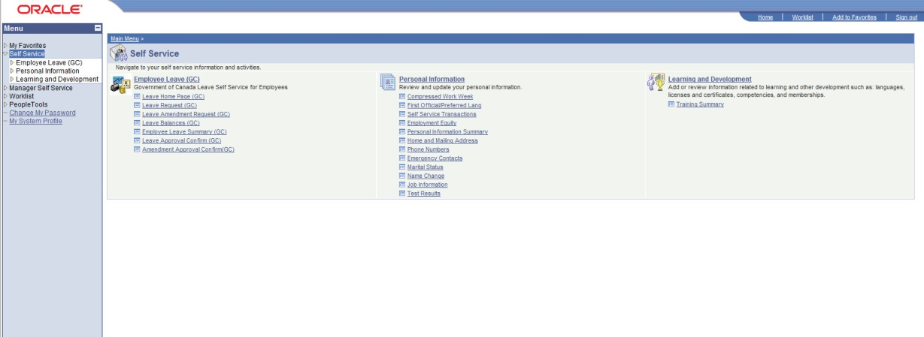

To view your available leave, select Leave Balances. The resulting page will show the types of leave available, the hours carried over from the previous fiscal year, the hours advanced for the current fiscal year, the hours used in the current fiscal year, and finally the remaining leave balance. Sick and Vacation leave should both have hours shown in the table, while other leave types, such as Personal leave, will not show a leave balance. This does not mean that you do not have personal leave – once you take the leave you are entitled to, the hours will show up under the “Used” category and show a negative balance in the “Balance” category. This is the same for the other leave types shown below.

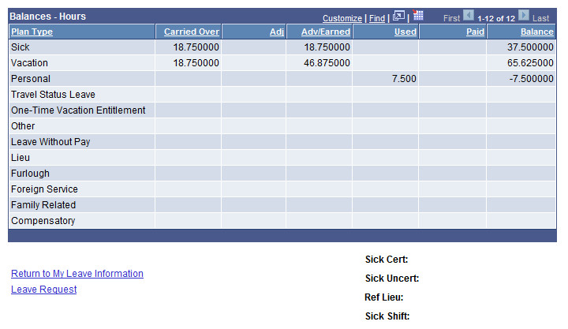

To submit a leave request:

1. Go to the Employee Leave page and select Leave Request.
2. You can select the leave type from the dropdown menu, and your available leave balance will be shown to the right.
3. Select the dates for your leave (from the day the leave starts to the day the leave ends), and enter the total hours of leave requested.
4. Finally, to submit the request to your supervisor (your Unit Head or Manager), click on the magnifying glass beside “Supervisor ID” and search for your supervisor’s name.
5. Once completed, click Submit, and the request will be sent to your supervisor for approval or refusal. You will receive an email with the status of your request once your supervisor has completed the request.

Note that leave should be discussed with your supervisor before submitting a leave request, if possible.

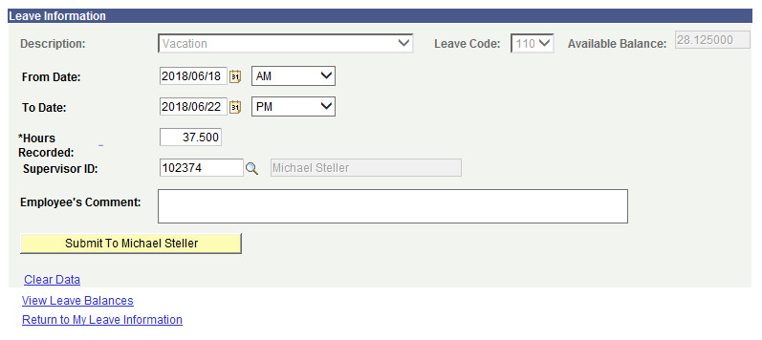

## Vacation Calendar

Once approved, please register your vacation in the PAD Vacation Calendar.

# Performance Management (PSPM and TAP)

The Public Service Performance Management Application (PSPM App) is a mandatory tool that documents conversations on performance. It allows managers/supervisors and employees to discuss work objectives, competencies, learning and development plans. The Public Service Performance Management Application (PSMP) provides an automated means for capturing information to drive performance in the federal public service. Discussions are required at three points in the performance management annual cycle:

* When they [establish performance expectations](http://intranet.canada.ca/hr-rh/ptm-grt/pm-gr/pmc-dgr/establish-etablir-eng.asp):
  + At the beginning of the year;
  + At the start of the probation period; or
  + When an employee begins a new job.
* At [mid-year](http://intranet.canada.ca/hr-rh/ptm-grt/pm-gr/pmc-dgr/myr-eme-eng.asp), when they discuss:
  + Progress against work objectives and competencies; and
  + The learning and development plan.
* At [year-end](http://intranet.canada.ca/hr-rh/ptm-grt/pm-gr/pmc-dgr/year-annee-eng.asp) (or at the end of probation), when performance is assessed.



## Registering a PSMP account

Here are the steps to register on the performance management application:

1. Double click on the **TAP** icon on your desktop.
2. 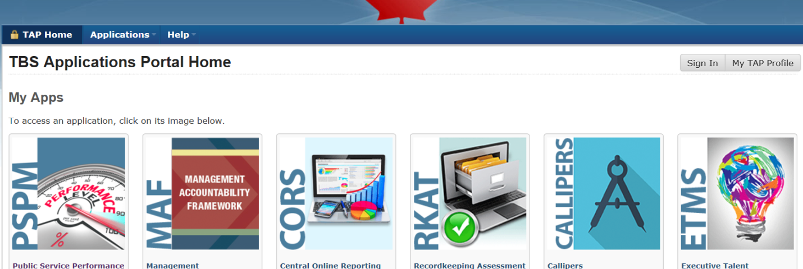Click on “Sign In” at the top right hand side of the page.
3. Enter your myKey and password. Click “Submit”
4. You will be asked for your PRI and your date of birth - this is to confirm that you are who you say you are - once you are registered, you won't be asked for this information again. Continue to follow the prompts and enter the accurate information.
5. Once you have successfully registered, you will be asked to create your "TAP profile".
6. You will now have access to the PSPM Application. Click on “TAP Home” and under My Apps, select PSPM on the left hand side.
7. Once you are in the PSPM App, you will be asked to create your "settings". The only thing you have to do here is say whether you are an EX, a manager, or an employee, then click “Save”.
8. Once all of this is done, make sure you let you manager know that you are registered, so that he/she may go into the system and claim you. If you have identified yourself as a manager, you will also have to claim all of your direct reports. You do this through the "add employee" function.

## Links to Courses for the Learning Plan:

[GC Campus / Canada School of Public Service](https://learn-apprendre.csps-efpc.gc.ca/application/en) (CSPS)

[Scientific and Regulatory Learning Services](http://mysource.hc-sc.gc.ca/eng/hc/about-health-canada/branches/health-products-and-food-branch/hpfb-learning-and-training) (SRLS)

[Health Canada Online Resource Center](http://onlinelearning.hc-sc.gc.ca/moodle/login/index.php) (ORC)

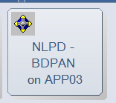[MySource Learning and Training Page](http://mysource.hc-sc.gc.ca/eng/ss/my-career/learning-and-training-0)

NLPD Learning Programs – Application in Lotus Notes

* To add NLPD to your Lotus Note Workspace, right click on an empty spot in the Workspace.

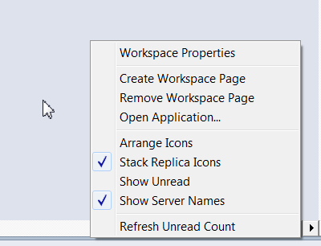

* This should pull up a menu. Select “Open Application”

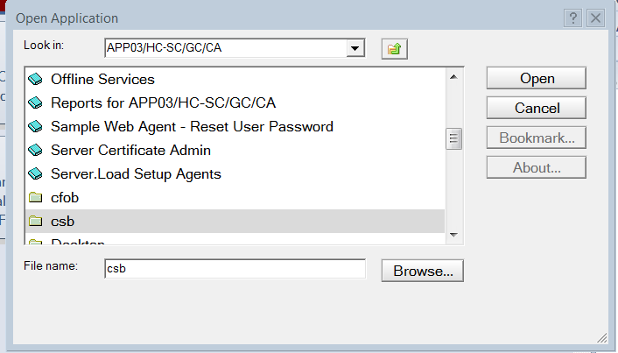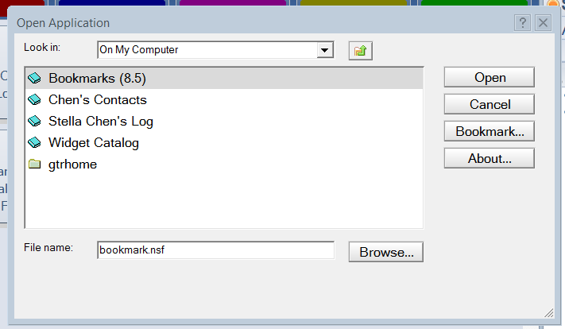

* In the “Look in” drop-down, select “APP03”, then scroll down to find and click on “csb”. Once in “csb”, find and click on “hrd”, then click on “NLPD – BDPAN”.

# Union

Usually, within 3 months of your Start Date, you will get an email from the Professional Institute of the Public Service of Canada (PIPSC). This email will contain a link for you to register as a PIPSC member. If you do not receive an email, you can register on the [PIPSC website](http://www.pipsc.ca/member-tools/application) yourself. It is suggested that you use a personal email address rather than your @Canada.ca email address, so that you can access emails from the union at home.

After getting your member ID, sign up for [ServicePlus](http://www.serviceplusgroup.ca/). The ServicePlus Program gives union members access to preferential rates on insurance as well as financial and consumer products and services. PIPSC will also send you periodic emails with updates on union business, or with information on events run by the union available to PIPSC members.

# Service Buyback

Before you started contributing to the public service pension plan, you may have accumulated service in the public service or with another employer. Once you become an Indeterminate employee, you may wish to buy back that service to increase your pension. Once it is bought back, the service is included in your pensionable service used to calculate your pension.

The following are types of prior service you may wish to buy back:

* **Prior service within the public service**: You can buy back virtually any full-time service in the public service, including Casuals, Co-op, FSWEP, etc. The contribution rate is single rate.
* **Prior service outside the public service:** You can buy back service with any employer with an approved pension plan registered under the Income Tax Act. You may be able to buy back other types of prior service. You should [consult the Pension Centre](http://www.tpsgc-pwgsc.gc.ca/remuneration-compensation/services-pension-services/pension/cn-cu-eng.html) if you have any questions about whether you can buy back a specific period of prior service. The contribution rate is double rate.

*See section 2 – Sick leave and vacation for information on calculation of vacation entitlement for previous accumulated service (e.g. Co-op, FSWEP, Casual service).

## Getting an Estimate

You may obtain an estimated cost of your service buyback through CWA using the Service Buyback Estimator. However, calling the Pension Centre directly simplifies the process. When you call the Pension Centre for an estimate, they also send you all of the required Forms along with instructions.

1. Call the Pension Centre at **1-800-561-7930** (Monday to Friday, 8:00 a.m. to 4:00 p.m., Your Local Time).
2. Provide them with your PRI number and inform them you would like a buyback estimate. The estimate is completed by a pension specialist and could take a few days.
3. Ask the Pension Specialist to send the estimate and all of the required forms to you via **Secure Messaging within the Pension Application.** A notification will not be sent to you when a message comes, so be sure to check your Pension Application every few days.

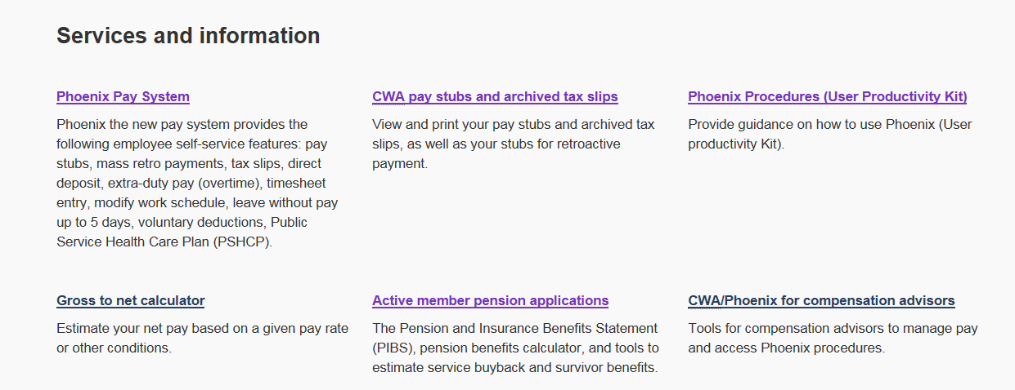

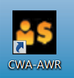

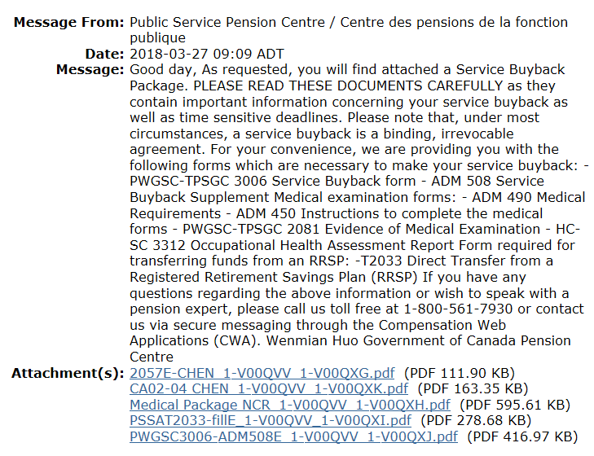

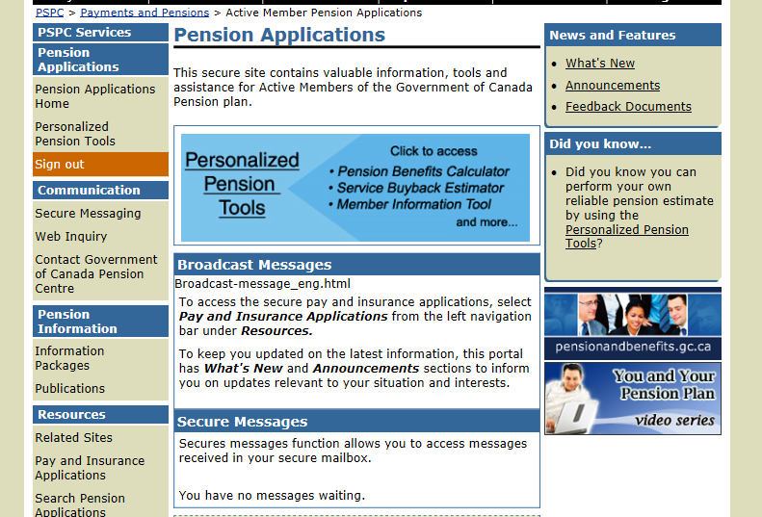

1. The Estimate will provide with you the total number of days you get to buyback and the cost. In addition, it also provides the payment plan options (e.g. lump sum, 5 years, 10 years etc.).

## Service Buy Back Form

The first form you need to complete is the **Service Buyback Form (PWGSC-TPSGC 3006)**. This is the form where you specify the previous service you wish to buy back and the payment plan option of your choice (e.g. monthly deductions, lump sum). Specifics on how to complete the form can be found on the last page of the form.

* **If you are buying back via a lump sum**, it is recommended you send the cheque with the Service Buyback form, as if the payment is not received within 30 days of the date you sign the service buyback form, the Public Service Pension Centre will authorize the commencement of deductions at the minimum monthly instalment. Cash payments received after 30 days will be applied to the cost of service buyback calculated as of the date they are received.

After completing the form, retain a copy for your records and forward the original to:

**Public Service Pension Centre - Mail Facility**

150 Dion Blvd

PO Box 8000, Matane QC G4W 4T6

Use of registered mail is recommended. If sent by registered mail, the receipt of registration should be kept for your records.

## Medical Exam and Occupational Health Assessment

In order to buyback your past service, you must complete a medical exam and an Occupational Health Assessment (Note that this medical exam is not covered by OHIP, therefore you will need to pay out of pocket for it).

As of 2016, the time period to undertake a medical examination has been extended to six months before and one year after the date of signing the service buyback form. It is your responsibility to undergo the medical examination and the Pension Centre will not issue any reminder of this requirement.

Among the forms sent to you via Secure Messaging is a **Medical Package**, which includes the two forms and the accompanying instructions. You and your doctor need to complete both forms during the medical exam.

1. Evidence of Medical Examination form (PWGSC-TPSGC 2081)
2. Occupational Health Assessment Report (HC-SC 3312).

Send the Evidence of Medical Examination form to:

**Public Service Pension Centre - Mail Facility**

150 Dion Blvd

PO Box 8000, Matane QC G4W 4T6

If you are in the NCR, you should send the Occupational Health Assessment Report to:

**NCR Occupational Health Clinic**

Vanguard Building

12th floor

171 Slater Street,

Ottawa, ON, K1A 0K9

You may receive a conditional Service buyback notice (PWGSC-TPSGC 2097) which will confirm the cost and the amount of service to be credited before we receive the interpretation of the medical examination from Health Canada. This Service buyback notice **does not** mean that a medical examination is no longer required. Until we receive confirmation from Health Canada that the medical requirement has been met, the service purchased will not show to your credit on the Compensation Web Applications.

If you have further questions, consult the [Service buyback package](http://www.tpsgc-pwgsc.gc.ca/remuneration-compensation/services-pension-services/pension/info/tirs-sbp-eng.html).