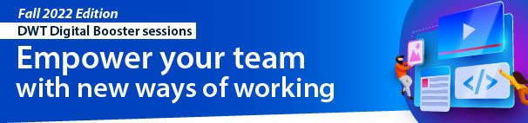
AGENDA
How Microsoft Forms can empower all your team members to make data driven decisions

En Octobre 18, 2022 2:30 - 3:30 pm EDT
FR Octobre 20, 2022 2:30 - 3:30 pm EDT
Slide | Content | Duration
Slide 1,3-5 | Intro & Welcome session | 5 min
Slide 2 | Agenda | 1 min
Slide 6-7 | (Booster tip) – Schedule Teams Chat Messages | 2 min
Live | Advising where the find the links shared during the session:  How Microsoft Forms can empower all your team members to make data driven decisions | 3 min
Slide 8 | Introduction of Mentee – Kevin Lagace  Indigenous Apprenticeship Program | 3 min
Slide 9 - 11 | Show-and-Follow  - Creating Forms  - Anonymous vs non-anonymous  - How to build a basic survey in minutes  - How to make your form bilingual  - Sharing a form  - How to collaborate  - How to share a form  - How to get a French link  - Getting the Data  - View the collected data  - Show results and visuals  - Exporting the data | 22 min
Slide 12 | Forms Best Practices | 10 min
Slide13 | Q&A | 5 min
Slide 14 | Spotlight  ESDC Chief Data Office, Kimberly | 3 min
Slide 15 | ESDC Forms 101 training on Oct 25 and 26  And DWT Smoothie time on Oct 26, 2022 | 2 min
Slide 16 | Promotion of next sessions  Include name, date, time, and links | 2 min
Slide 1 | Closing slide and survey | 2 min

