**Attendee instructions**

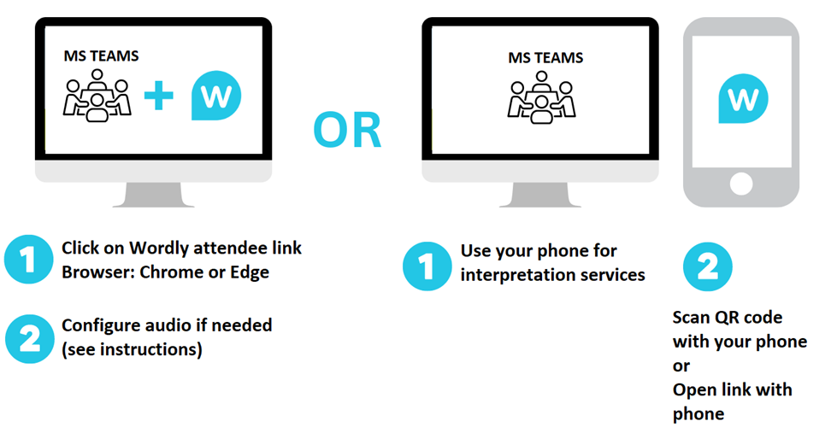

**Option 1 : Join Wordly interpretation with your computer**

1. Click on Wordly Attendee Hyperlink (e.g., https://attend.wordly.ai/join/...)
2. Choose the language you want Wordly to translate spoken dialogue into.  
     
   A screenshot of a phone

   AI-generated content may be incorrect. A screenshot of a phone

   AI-generated content may be incorrect. A screenshot of a phone

   AI-generated content may be incorrect.

Example: If the speaker is speaking in English and you want to translate into French, select French.

1. Click **Attend**

**Wordly Platform:**

**\*IMPORTANT NOTE\***

If you want to hear simultaneous interpretation, you will have to turn off the MS Teams audio. Follow these instructions:

1. **Phone audio**

* Mute your computer audio
* Keep your phone audio on. You can use a headset or the phone speaker.

1. **Computer audio**

* Turn off your MS TEAMS audio by using your Volume Mixer
* Keep your Browser audio on (Wordly)

**Using the Volume Mixer**You can use the Volume Mixer to change the volume level of apps individually. This is useful when you want to increase the sound level of one program, then turn the volume down for another app such as MS Teams.  
  
**How to open the volume mixer in Windows 10:**

* Go to the bottom-right corner of your taskbar, then right-click the **Volume Control icon.**
* Select **Open Volume Mixer** from the options.

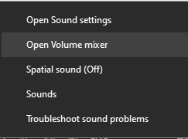 

* A new window will pop up. Here, you will see the running applications and their audio levels. You can move the slider up or down for each app if you want to adjust their volume. When you change the sound levels for one app, you won’t affect the audio for the other programs.  
    
    
    
    
    
    
    
    
    
  Make sure to increase the size of the window, if you do not immediately see MS TEAMS.   
    
     
  A screenshot of a computer

  AI-generated content may be incorrect.

**If you are running Windows 11**, go to the taskbar, right-click on the sound icon, and select *Open Volume Mixer*. The operating system will redirect you to the **System > Sound > Volume Mixer** page where you can adjust the volume for specific applications.