Logging in to MyGCHR for the first time

- Access MyGCHR

The MyGCHR link can also be found on the ATSSC’s intranet home page as well as in the MyGCHR at the ATSSC GCwiki page.

- Select a certificate

The following window will appear. You will be prompted to select an Entrust Certificate (myKEY). If you have more than one Entrust Certificate, you must select your personal certificate.

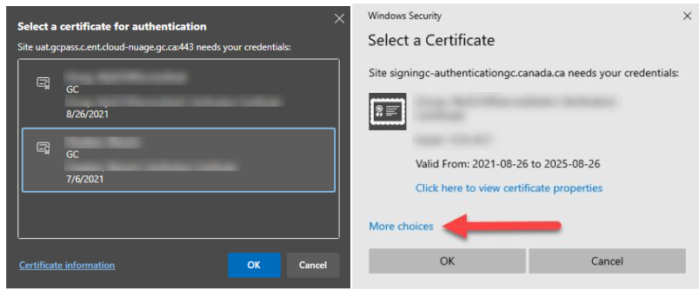

- Provide your Entrust password

The following window will appear. You will be prompted to enter your Entrust password.

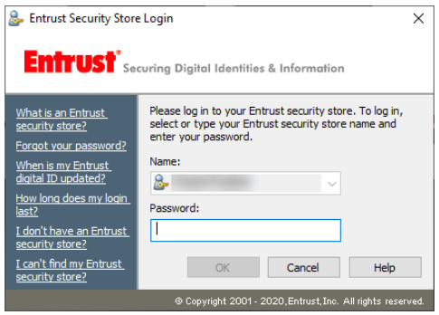
- Complete the self-authentication by entering four (4) required fields

The following window will appear. Enter your PRI, Date of Birth, Last Name (as indicated in Phoenix), and Email Address to link your myKEY to your MyGCHR account. You will only be asked to do this once. Note: Your last name must also match the name indicated on your myKEY.

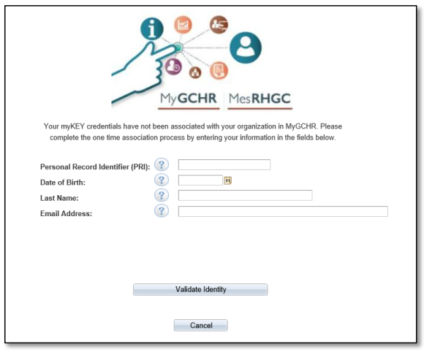

- Click “Submit”

Upon successfully providing your information, you will be successfully validated and allowed in MyGCHR.

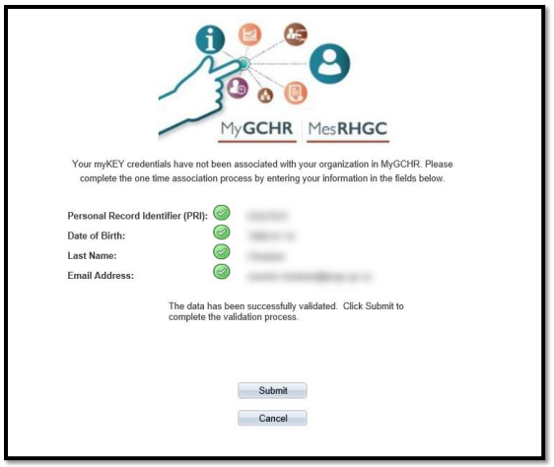

- Complete the Employment Equity Self-ID form (only Part A is mandatory)

MyGCHR has a pre-set default for all departments and agencies that requires the Employment Equity Self-Id Form to be completed before any other module functionality can be accessed. This only needs to be done the first time you log on but you can update your Self-ID form at any time after that.

(Main Menu > Self Service > Government of Canada > Employment Equity Self-Id Form)
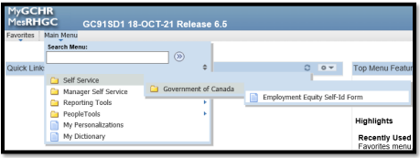

- Review your personal information (and update if required) and add your emergency contact information

(Main Menu > Self Service > Personal Information > Personal Information Summary)
(Main Menu > Self Service > Personal Information > Emergency Contacts)
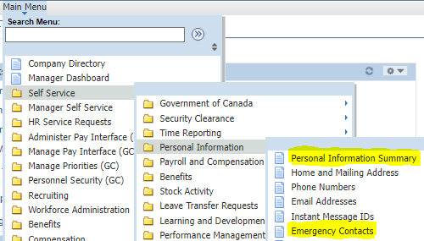

References:

General

- MyGCHR at the ATSSC GCwiki page
- Introduction to UPK - MyGCHR's built-in help module (video)

Staff

- Introduction to MyGCHR Self-service (video)
- View Your Personal Information Summary
- Update Emergency Contacts
- Update Phone Numbers

Manager

- Navigate the Manager Dashboard
- Managing Work Schedules (video)
- View, Update or Correct an Employee's Work Schedule

Please contact the MyGCHR Service Desk at mygchr-mesrhgc@tribunal.gc.ca should you run into any difficulties or if you have questions.

