vExpo Kiosk Content Submission Form
General Instructions  After reviewing the vExpo Content and Design Guidelines, fill out the fields below with the final links and text to be used in the kiosk.  - You may need or want the kiosk to reflect your departmental branding and/or the program’s look and feel. If so, make sure to send us the required image source files in vector format (.ai, .eps, .svg, etc.), and branding guidelines along with this document (when available).  - Provide the content and material as soon as available, and no later than the agreed-upon deadline. Content sent past the deadline may result in our inability to include the kiosk in the events (where applicable).  - Once completed, submit this document and file attachments to csps.digitalacademyvexpo-vexpodelacademiedunumerique.efpc@csps-efpc.gc.ca.  Kiosk Anatomy  Before filling-out this form, please take a look at the image below. This is what a virtual kiosk design looks like. You can refer to this image while filling out the form.  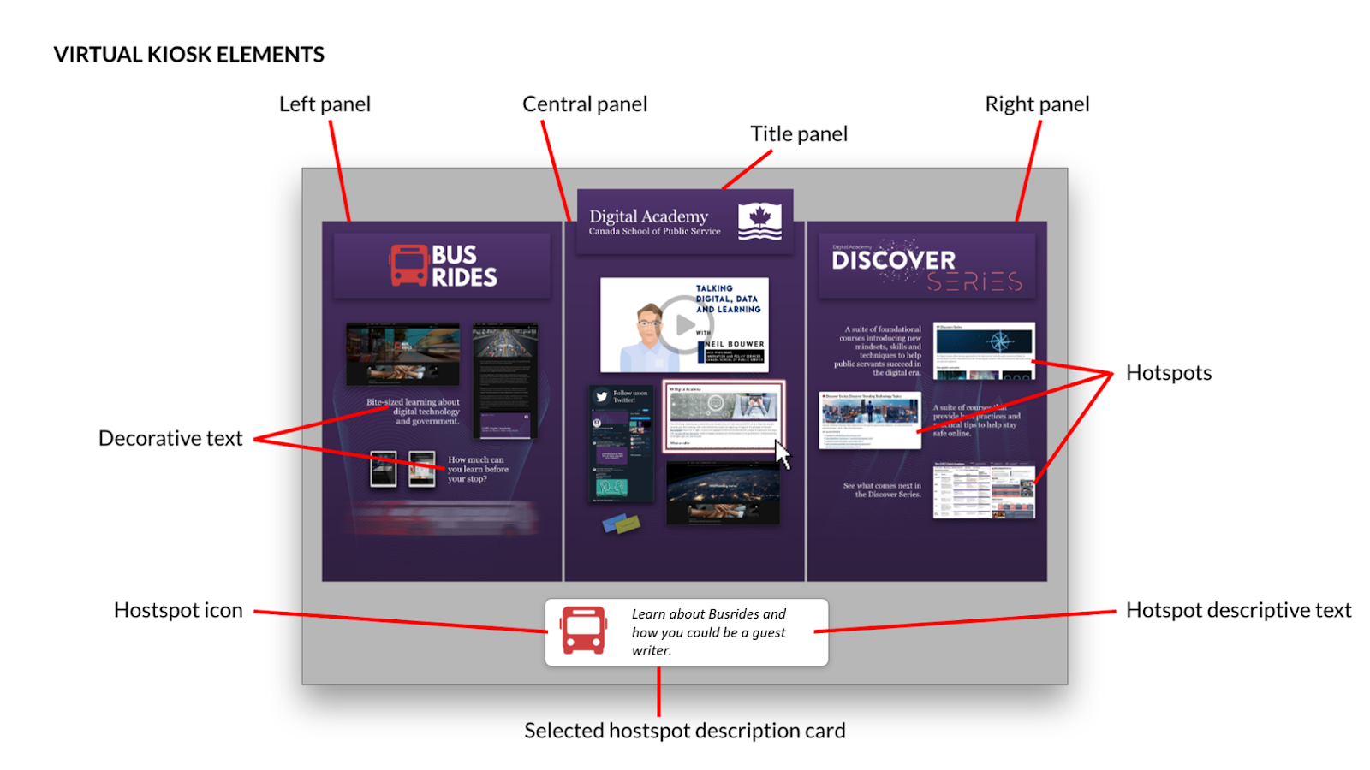 | Kiosk Information  Organization / Department : Digital Academy  Point of contact (name and email) : Name: Ferdos Taleb Email: Ferdos.TalebNajafabadi@csps-efpc.gc.ca  Kiosk Title (EN and FR): EN: CSPS Digital Academy FR:  Visual Style Reference URL(s) : (Visual Guides, Branding Norms, Comms Pieces, etc) https://miro.com/welcomeonboard/a1VLZERPWGVHRFdSSEJxckRSeW5pcUpndGtMbzZIQ3hPQ05kYnByeUI5VnVIMzNtMG5kT09zSkhPVmpJUUZmOHwzMDc0NDU3MzY3MzIwNTkxOTk3?share_link_id=554805723074  Content Accessibility  As per the vExpo content requirements, your content linked from the Hotspots in your kiosk must be available on the Web, in both official languages and be accessible. Please confirm the following: YES NO  Can the links to your kiosk content be accessed by the public (outside of your organization's firewall)? Yes  Is your content accessible; readable using assistive technology, alt text, transcripts, closed captions, etc.? Yes

How to Fill Out the Hotspot List
A hotspot is typically represented by an image or a decorative text, or both. If an image provided needs to be used as is, mark it as required in the filed below. All text, images and URLs need to be provided in both official languages. | Once the final kiosk design is completed, it will be incorporated into the 3D kiosk. When a user interacts with that hotspot in the virtual kiosk, a description card appears at the bottom of the kiosk with an icon and description text (call to action). The text from this description card is the text that will appear on the accessible and mobile version of the kiosk. | When the user clicks on a hotspot, they will be directed to a website (using the URL provided in the field below). The web content available through a hotspot should meet accessibility requirements and be available in both official languages.
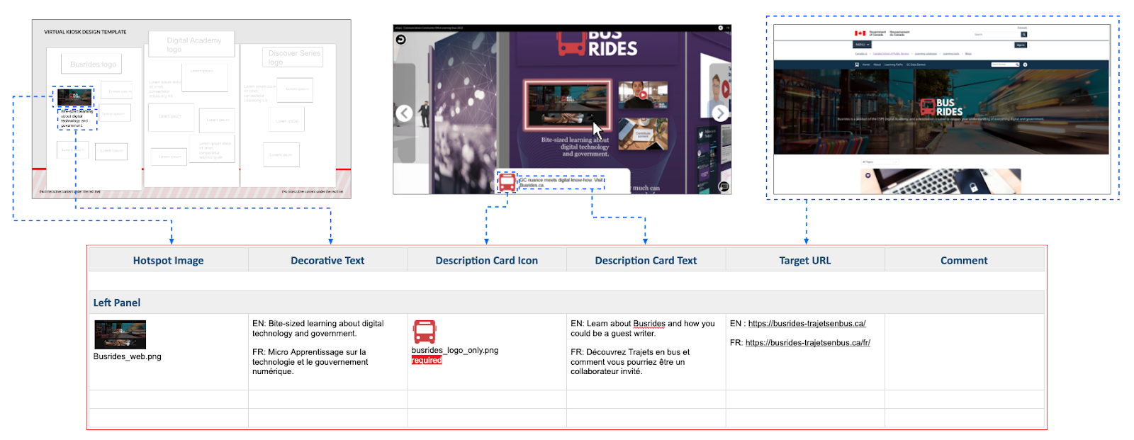
The image above represents how hotspot information fits in each column of the Hotspot List section below. Each row represents one hotspot inside each panel of your kiosk.

Hotspot List
Feel free to add more rows, as needed, to allow for additional hotspots on your kiosk panels.
Note: When visual assets are provided, we will assume they are just references so the designers may change them for similar or but better equivalents, if needed. If the images provided need to be used as is, mark it as required in the field below.

Hotspot Image | Decorative Text | Description Card Icon | Description Card Text | Target URL | Comment
Left Panel
Image: 12-a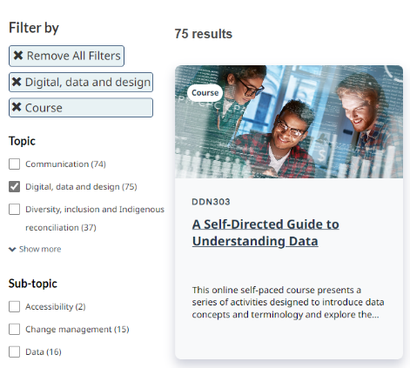 | EN: A suite of virtual and self-led courses on digital, data, and design topics  FR: Une série de cours virtuels et autodirigés sur les thèmes du numérique, des données et de la conception. | Icon:12-b | EN: Browse the CSPS learning catalog for our courses on digital, data, and design topics.  FR: Parcourez le catalogue d’apprentissage de l’EFPC pour découvrir nos cours sur les thèmes du numérique, des données et de la conception. | EN: https://catalogue.csps-efpc.gc.ca/catalog?cm_locale=en&reveal_topic=0&topic%5B%5D=70&reveal_subtopic=0&reveal_type=0&type%5B%5D=8&reveal_duration=0&reveal_delivery_method=0&query=&products_per_page=12&products_sort_order=product_name_asc&pagename=Catalog  FR: https://catalogue.csps-efpc.gc.ca/catalog?cm_locale=en&reveal_topic=0&topic%5B%5D=70&reveal_subtopic=0&reveal_type=0&reveal_duration=0&reveal_delivery_method=0&query=&products_per_page=12&products_sort_order=product_name_asc&pagename=Catalog
Image:13 | EN: Learning paths designed to help public servants learn more about their digital learning needs  FR: Parcours d’apprentissage conçus pour aider les fonctionnaires à mieux connaître leurs besoins en matière d’apprentissage numérique. | Icon:13 | EN: View our learning paths on digital, data, and design topics.  FR: Consultez nos parcours d’apprentissage sur les thèmes du numérique, des données et de la conception. | EN: https://www.csps-efpc.gc.ca/digital-academy/index-eng.aspx  FR: https://www.csps-efpc.gc.ca/digital-academy/index-fra.aspx
Image: 14 | EN: Quick learning designed to explore topics related to data and digital  FR: Apprentissage rapide conçu pour explorer les sujets liés aux données et au numérique. | Icon:14   | EN: View our Microlearning offerings on digital, data, and design topics.  FR: Consultez nos offres de micro-apprentissage sur les thèmes du numérique, des données et de la conception. | EN: https://busrides-trajetsenbus.csps-efpc.gc.ca/  FR: https://busrides-trajetsenbus.csps-efpc.gc.ca/fr
Center Panel
Image: 1-a   | EN: Digital Academy is the CSPS digital and data business line. It equips public servants with the knowledge, skills, and practical experience needed for government in the digital age.  FR: L’Académie du numérique est le secteur d’activité de l’EFPC consacré au numérique et aux données. Elle permet aux fonctionnaires d’acquérir les connaissances, les compétences et l’expérience pratique nécessaires aux activités du gouvernement à l’ère numérique. | Icon:1-b   | EN: Watch our video on ‘How to Be Digital in the Government of Canada.’  FR: Visionnez notre vidéo « Comment être numérique au gouvernement du Canada ». | EN: https://www.csps-efpc.gc.ca/video/digital-government-canada-eng.aspx  FR: https://www.csps-efpc.gc.ca/video/digital-government-canada-fra.aspx
Image: text container -theme   | EN: Digital  FR: Numérique | Icon: 2   | EN: View our offerings on the ‘digital’ theme.  FR: Consultez nos offres sur le thème « numérique ». | EN: https://catalogue.csps-efpc.gc.ca/catalog?cm_locale=en&reveal_topic=0&topic%5B%5D=70&reveal_subtopic=0&reveal_type=0&reveal_duration=0&reveal_delivery_method=0&query=%22digital%22&products_per_page=12&products_sort_order=product_name_asc&pagename=Catalog  FR: https://catalogue.csps-efpc.gc.ca/catalog?cm_locale=fr&reveal_topic=0&topic%5B%5D=70&reveal_subtopic=0&reveal_type=0&reveal_duration=0&reveal_delivery_method=0&query=%22num%C3%A9rique%22&products_per_page=12&products_sort_order=product_name_asc&pagename=Catalog
Image: text container -theme | EN: Data  FR: Données | Icon:3   | EN: View our offerings on the ‘data’ theme.  FR: Consultez nos offres sur le thème « données ». | EN: https://catalogue.csps-efpc.gc.ca/catalog?cm_locale=en&reveal_topic=0&topic%5B%5D=70&reveal_subtopic=1&subtopic%5B%5D=139&reveal_type=0&reveal_duration=0&reveal_delivery_method=0&query=&products_per_page=12&products_sort_order=product_name_asc&pagename=Catalog  FR: https://catalogue.csps-efpc.gc.ca/catalog?cm_locale=fr&reveal_topic=0&topic%5B%5D=70&reveal_subtopic=1&subtopic%5B%5D=139&reveal_type=0&reveal_duration=0&reveal_delivery_method=0&query=&products_per_page=12&products_sort_order=product_name_asc&pagename=Catalog
Image: text container -theme | EN: Digital Leadership  FR: Leadership numérique | Icon:4   | EN: View our offerings on the 'digital leadership' theme.  FR: Consultez nos offres sur le thème « leadership numérique ». | EN: https://catalogue.csps-efpc.gc.ca/catalog?cm_locale=en&reveal_topic=0&topic%5B%5D=70&reveal_subtopic=1&subtopic%5B%5D=100&reveal_type=0&reveal_duration=0&reveal_delivery_method=0&query=&products_per_page=12&products_sort_order=product_name_asc&pagename=Catalog  FR: https://catalogue.csps-efpc.gc.ca/catalog?cm_locale=fr&reveal_topic=0&topic%5B%5D=70&reveal_subtopic=1&subtopic%5B%5D=100&reveal_type=1&reveal_duration=0&reveal_delivery_method=0&query=&products_per_page=12&products_sort_order=product_name_asc&pagename=Catalog
Image: text container -theme | EN: Service Design  FR: Conception des services | Icon:5   | EN: View our offerings on the 'service design' theme.  FR: Consultez nos offres sur le thème « conception des services ». | EN: https://catalogue.csps-efpc.gc.ca/catalog?cm_locale=en&reveal_topic=0&topic%5B%5D=70&reveal_subtopic=1&subtopic%5B%5D=134&reveal_type=0&reveal_duration=0&reveal_delivery_method=0&query=&products_per_page=12&products_sort_order=product_name_asc&pagename=Catalog  FR: https://catalogue.csps-efpc.gc.ca/catalog?cm_locale=fr&reveal_topic=0&topic%5B%5D=70&reveal_subtopic=1&subtopic%5B%5D=134&reveal_type=0&reveal_duration=0&reveal_delivery_method=0&query=&products_per_page=12&products_sort_order=product_name_asc&pagename=Catalog
Image: text container -theme | EN: Cloud  FR: Nuage | Icon:6   | EN: View our offerings on the 'cloud' theme.  FR: Consultez nos offres sur le thème « nuage ». | EN: https://catalogue.csps-efpc.gc.ca/catalog?cm_locale=en&reveal_topic=0&topic%5B%5D=70&reveal_subtopic=0&reveal_type=0&reveal_duration=0&reveal_delivery_method=0&query=%22cloud%22&products_per_page=12&products_sort_order=product_name_asc&pagename=Catalog  FR: https://catalogue.csps-efpc.gc.ca/catalog?cm_locale=fr&reveal_topic=0&reveal_subtopic=0&reveal_type=0&reveal_duration=0&reveal_delivery_method=0&query=%22nuage+%22&products_per_page=12&products_sort_order=product_name_asc&pagename=Catalog
Image: text container -theme | EN: Cyber Security  FR: Cybersécurité | Icon:7   | EN: View our offerings on the 'cyber security theme.  FR: Consultez nos offres sur le thème « cybersécurité ». | EN: https://catalogue.csps-efpc.gc.ca/catalog?cm_locale=en&reveal_topic=0&topic%5B%5D=70&reveal_subtopic=0&reveal_type=0&reveal_duration=0&reveal_delivery_method=0&query=%22cyber+security%22&products_per_page=12&products_sort_order=product_name_asc&pagename=Catalog  FR: https://catalogue.csps-efpc.gc.ca/catalog?cm_locale=fr&reveal_topic=0&topic%5B%5D=70&reveal_subtopic=0&reveal_type=0&reveal_duration=0&reveal_delivery_method=0&query=%22cybers%C3%A9curit%C3%A9+%22&products_per_page=12&products_sort_order=product_name_asc&pagename=Catalog
Image: text container -theme | EN: Agile  FR: Agile | Icon:8   | EN: View our offerings on the 'agile' theme.  FR: Consultez nos offres sur le thème « agile ». | EN: https://catalogue.csps-efpc.gc.ca/catalog?cm_locale=en&reveal_topic=0&topic%5B%5D=70&reveal_subtopic=0&reveal_type=0&reveal_duration=0&reveal_delivery_method=0&query=%22agile%22&products_per_page=12&products_sort_order=product_name_asc&pagename=Catalog  FR: https://catalogue.csps-efpc.gc.ca/catalog?cm_locale=fr&reveal_topic=0&topic%5B%5D=70&reveal_subtopic=0&reveal_type=0&reveal_duration=0&reveal_delivery_method=0&query=%22agile%22&products_per_page=12&products_sort_order=product_name_asc&pagename=Catalog
Image: text container -theme | EN: Artificial Intelligence  FR: Intelligence artificielle | Icon:9   | EN: View our offerings on the 'artificial intelligence theme.  FR: Consultez nos offres sur le thème « intelligence artificielle ». | EN: https://catalogue.csps-efpc.gc.ca/catalog?cm_locale=en&reveal_topic=0&topic%5B%5D=70&reveal_subtopic=0&reveal_type=0&reveal_duration=0&reveal_delivery_method=0&query=%22Artificial+Intelligence%22&products_per_page=12&products_sort_order=product_name_asc&pagename=Catalog  FR: https://catalogue.csps-efpc.gc.ca/catalog?cm_locale=fr&reveal_topic=0&topic%5B%5D=70&reveal_subtopic=0&reveal_type=0&reveal_duration=0&reveal_delivery_method=0&query=%22+l%27intelligence+artificielle%22&products_per_page=12&products_sort_order=product_name_asc&pagename=Catalog
Image: text container -theme | EN: Emerging Technology  FR: Nouvelle technologie | Icon:10   | EN: View our offerings on the 'emerging technology' theme.  FR: Consultez nos offres sur le thème « nouvelle technologie ». | EN: https://catalogue.csps-efpc.gc.ca/catalog?cm_locale=en&reveal_topic=0&topic%5B%5D=70&reveal_subtopic=0&reveal_type=0&reveal_duration=0&reveal_delivery_method=0&query=%22Emerging+Technology%22&products_per_page=12&products_sort_order=product_name_asc&pagename=Catalog  FR:
Image: text container -theme | EN: Product Management  FR: Gestion de produits | Icon:11   | EN: View our offerings on the 'product management theme.  FR: Consultez nos offres sur le thème « gestion de produits ». | EN: https://catalogue.csps-efpc.gc.ca/catalog?cm_locale=en&reveal_topic=0&topic%5B%5D=70&reveal_subtopic=0&reveal_type=0&reveal_duration=0&reveal_delivery_method=0&query=%22Product+Management%22&products_per_page=12&products_sort_order=product_name_asc&pagename=Catalog  FR: https://catalogue.csps-efpc.gc.ca/catalog?cm_locale=fr&reveal_topic=0&topic%5B%5D=70&reveal_subtopic=0&reveal_type=0&reveal_duration=0&reveal_delivery_method=0&query=%22de+gestion+de+produits+%22&products_per_page=12&products_sort_order=product_name_asc&pagename=Catalog
Right Panel
Image: 15 | EN: Learning events, interactive seminars, forums, and digital expos  FR: Occasions d’apprentissage, séminaires interactifs, forums et expositions numériques | Icon:15   | EN: ​Learn more about our upcoming Events.  FR: Apprenez-en plus au sujet de nos événements à venir. | EN: https://catalogue.csps-efpc.gc.ca/catalog?cm_locale=en&reveal_topic=0&topic%5B%5D=70&reveal_subtopic=0&reveal_type=0&type%5B%5D=7&reveal_duration=0&reveal_delivery_method=0&query=&products_per_page=12&products_sort_order=product_name_asc&pagename=Catalog  FR: https://catalogue.csps-efpc.gc.ca/catalog?cm_locale=fr&reveal_topic=0&topic%5B%5D=70&reveal_subtopic=0&reveal_type=1&type%5B%5D=7&reveal_duration=0&reveal_delivery_method=0&query=&products_per_page=12&products_sort_order=product_name_asc&pagename=Catalog
Image:16 | EN: Courses, workshops, and coaching to support the design, prototyping, and testing of user-centered government services  FR: Cours, ateliers et accompagnement pour soutenir la conception, le prototypage et l'essai de services gouvernementaux centrés sur l'utilisateur | Icon:16   | EN: Learn more about Digital Accelerator  FR: Apprenez-en plus au sujet de l’accélérateur du numérique. | EN: https://wiki.gccollab.ca/CSPS_Digital_Academy/CSPS_Digital_Accelerator  FR: https://wiki.gccollab.ca/CSPS_Digital_Academy/CSPS_Digital_Accelerator
Image: 1-text container -social media 2-17 | EN: CSPS logo  FR: Logo de l’EFPC | Icon:12-b | EN: Learn more about our business line.  FR: Apprenez-en plus au sujet de notre secteur d’activité. | EN: https://www.csps-efpc.gc.ca/about_us/business_lines/digitalacademy-eng.aspx  FR: https://www.csps-efpc.gc.ca/about_us/business_lines/digitalacademy-fra.aspx
Image: 1-text container -social media 2- 18 | EN: GCxchange logo  FR: Logo de GCéchange | Icon:18   | EN: Follow us on GCxchange​​  FR: Suivez-nous sur GCéchange. | EN: https://gcxgce.sharepoint.com/teams/1000585/  FR: https://gcxgce.sharepoint.com/teams/1000585/
Image: 1-text container -social media 2-19 | EN: Twitter logo  FR: Logo de Twitter | Icon:19   | EN: Follow us on Twitter​  FR: Suivez-nous sur Twitter. | EN: https://twitter.com/DigiAcademy  FR: https://twitter.com/DigiAcademy
Image: 1- text container -social media 2- 20 | EN: Newsletter logo  FR: Logo de l’infolettre | Icon:20   | EN: Join the Digital Academy Newsletter to get the latest info on our offerings and upcoming events  FR: Inscrivez-vous à l’infolettre de l’Académie du numérique pour recevoir les dernières nouvelles sur nos offres et les événements à venir. | EN: https://www.csps-efpc.gc.ca/digital-academy/da-newsletter-subscribe-eng.aspx  FR: https://www.csps-efpc.gc.ca/digital-academy/da-newsletter-subscribe-fra.aspx

