Training plan
WORKPLACE MODERNIZATION PROJECT
[INSERT NAME OF PROJECT HERE]

VERSION 1.0
DATE:
PREPARED FOR:
DEPARTMENT:

Table of Contents
1. Background 3
1.1 GCWORKPLACE 3
1.2 [INSERT PROJECT NAME] 3
2. Objectives 3
2.1 TRAINING OBJECTIVES 3
2.2 PROSCI METHODOLOGY AND ADKAR (include as applicable) 4
3. Target audience 5
4. Key elements 5
5. Training activities 5
6. Feedback, monitoring and evaluating 5
7. Schedule and key milestones 6
8. Contacts 6
9. Training plan 7
Annexes 8
ANNEXE A: EXAMPLES OF TRAINING ACTIVITIES 8
ANNEXE B: COLLECTING AND MONITORING FEEDBACK 8
ANNEXE C: FEEDBACK STRATEGY OPTIONS 9

Background

1.1 GCWORKPLACE
GCworkplace principles were developed to align with the vision of creating a high-performing Government of Canada workplace that enables a balanced workforce. This new-age workplace is founded on the principles of flexibility, efficiency, (employee) health, collaboration, and digital capacity, all of which inform GCworkplace principles.
According to the GCworkplace vision, employees can choose where and how they want to work, thus creating a more efficient, healthy and flexible workforce that also increases productivity. There is also a strong emphasis placed on mobility, recognizing that activity-based working is the way of the future and that there is no one-size-fits-all approach to office design.
The principles of GCworkplace were developed with the needs of today’s workforce, as well as those of tomorrow’s, in mind. One of the big questions facing the Government of Canada is how to attract and retain top talent, and GCworkplace takes a step towards answering that question.

1.2 [INSERT PROJECT NAME]
Insert information on your modernization project:
- Project scope
- Vision
- Key principals of the project
- Key components of your change management strategy
- Type of change and size
- Timeline

Objectives

TRAINING OBJECTIVES
When workplaces undergo changes, employees may experience anxiety and negativity due to various uncertain factors. These responses can be minimized through specialized training. Through [Name of your organization], employees will be provided with the right training before, during and after the workplace change.
Before a change is implemented, training should provide an explanation behind the workplace changes. A forum for employees to ask questions and have their concerns heard should be established at the end of each training session to keep employees involved in and updated on the change process.
As employees align themselves with the upcoming workplace changes, skills training workshops should be provided to build employee confidence. This confidence can be enhanced with a change management support team to help employees adjust to the initial changes.
After workplace changes are implemented, surveys should be sent out to employees to determine if they have adjusted to the changes. Those employees who have not yet adjusted should be presented with further training and incentives to integrate to the new workplace.
Employees faced with workplace changes undergo a four-step process. First, denial; second, resistance; third, exploration; and fourth, commitment. Training activities will address each of these mindsets by informing, engaging and preparing employees for the change.
The strategic objectives of the training plan will be to ensure:
- xxx;
- xxx;
- xxx.

PROSCI METHODOLOGY AND ADKAR (include if applicable)
Prosci is an independent research organization that has developed a comprehensive change management methodology based upon best practices identified through their research. As leaders in the field, their methodology is being used across multiple organizations.
Based on Prosci’s research, the foundation for organizational change is successful change at the individual level by building the elements of the ADKAR change model (Figure 1) in each individual. ADKAR stands for:
- Awareness–provides the “why” the change is happening
- Desire–environment that provides the motivation and willingness for the change
- Knowledge–is the information and learning needed to apply the change
- Ability–removes the capability obstacles that could prevent the change
- Reinforcement–sustains the change past the implementation phase
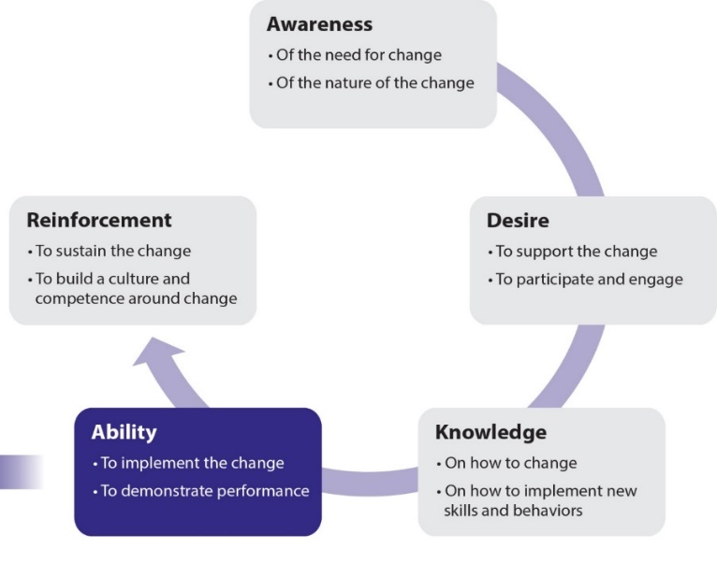
Figure 1. Prosci® ADKAR® Model
The ADKAR model is to be integrated into various tools that will be used by the team along with managers and employees, to manage change. The ADKAR model allows [name of your organization] to shape change management and communications to support employees while facilitating [name of your project] implementation objectives.
Successful communication with staff will be based on the ADKAR model to build the five elements of ADKAR needed for a successful change. When ADKAR is present in change management activities, the desired change happens.

Target audience

Use the results from your stakeholder impact assessment to identify your target audiences. Examples of target audiences include employees, managers, supervisors, senior management, etc.
[Include your text here]

Key elements

The following are examples of key elements of successful training:
- Compelling explanation
- Clear expectations
- Visual presentation
- Memorable information
- Tailor-made to audience
- Real-world application
- Open to questions
- Facilitates discussion
- Consistent check-ins
- Prompt feedback
- Annual evaluation

Training activities

Be mindful and inclusive in the design of training products, tools and activities. The following steps should performed in order to define the various training activities:
- Identify the different audiences [Include here your stakeholder impact assessment developed for the change management strategy].
- Identify the skills and knowledge that each audience will need during its transition toward the new workplace but also after.
- Identify the training material required, delivery channel and timeline.
[Include your training activities here]
See Appendix A for examples

Feedback, monitoring and evaluating

Feedback will be tracked to assess the effectiveness of the [insert project name] change management approaches as well as to monitor the implementation of the integrated projet. Feedback processes will provide the information needed to measure change adoption, integration, effectiveness of training, change saturation, as well as provide means to continuously assess, adapt and improve the project implementation. Outputs from feedback channels may also be used to inform and guide ongoing decision making.
- Evaluate if the change management strategy and activities have been valuable to the adoption of the new workplace.
- Data in this category is connected to the actual activities carried out by the change management team and included in the change management strategy.
See Annexe B for examples of tools and metrics for feedback collection.
See Annexe C for feedback strategy options.

Schedule and key milestones

[Include your project schedule here]
Examples of key milestones and how to address them:
Pre-move:
- Training materials should be developed and delivered to familiarize employees with upcoming changes, new applications, tools, change management, new ways of working, etc.
- Managers should provide time to their employees to develop their skills to be prepare to work in a new environment and with new tools.
Moving day:
- Information should be distributed to employees on the day of the move with the most important information
- A support team should be on site when employees move into their new workplace to ensure employees understand how the space works, how to adjust their desk, their monitors, etc.)
Post-move:
- Surveys should be utilized to determine if employee expectations were met
- Incentives and further training should be provided for employees to adjust to workplace changes

Contacts

[Include workplace change contacts here]

Training plan

# | Name | Audience type | Group size | Level of impact | Training provider | Objective | Key area addressed | Delivery method

Annexes

ANNEXE A: EXAMPLES OF TRAINING ACTIVITIES
Examples of training activities:
- Manager toolkit
- Leadership toolkit
- Change agent toolkit
- Fact sheets
- CSPS training
- One pagers
- Workshops
- GCdocs refresher course
- Clean desk refresher course
- Mobile device training
- New application training
- New ways of working session
- Office ergonomics training
- Managing a mobile team

ANNEXE B: COLLECTING AND MONITORING FEEDBACK
Tools to collect feedback
- Tracker
- Surveys
- Spot survey for events
- Observation
- Interaction with recipients
- Monitoring feedback through various channels and networks
- ADKAR Change-o-meter
Metrics
- Tracking of change management activities conducted according to plan
- Training participation and attendance numbers
- Communication deliveries
- Communication effectiveness
- Performance improvements
- Progress and adherence to plan
- Business and change readiness
- Project KPI measurements
- Adherence to timeline
- Speed of execution
- Number of clicks on a web page
- Number of visits to a modernized space

ANNEXE C: FEEDBACK STRATEGY OPTIONS
Mechanism | Lead | Description | Advantages
Surveys & user polls  (Qualtrics, survey monkey, etc.) | Project lead, middle management | Employee opinions matter! Use surveys and user polls to obtain the overall pulse of the change. Although user feedback is important – don’t overdo it. Be mindful of how many surveys and polls are sent throughout the modernization project. Obviously, this will vary dependent on the size and length of the project.  Keep in mind: you will need to vet the questions and test the tool selected prior to sending it off. | - A quick and easy way to get feedback  - Reaches a large number of employees  - Can be anonymous (optional)
Suggestion & comment box | Project lead, project team | An open discussion or private e-mail option on the intranet or GCconnex page. This option is beneficial post-implementation where the feedback goes directly to the process owner for continuous improvement.  Keep in mind: this option requires an individual or team who will monitor the feedback. | - Live URL available 24/7  - Can be anonymous (optional)  - May leave open indefinitely for ongoing input
1:1 meetings | Middle management & supervisors | Utilize 1:1 meetings to understand how the change is being received. Direct managers and supervisors are the best resources for this as they should already have trust and strong relationships with their employees.  Keep in mind: this option requires safety, trust and transparency amongst managers/supervisors and their employees. | - A comfortable setting that can enable vulnerability  - Gathers individual, in-depth feedback
Team meetings | Middle managers | Allows employees to surface feedback on the change in their current team environment.  Keep in mind: a strong facilitator will be required. | - Creates transparency  - Raises group issues
Focus groups (5-12 participants) | Integrated project team | Allows the project team to solicit specific feedback from key contributors on specific topics.  Keep in mind: a strong facilitator and real-time transparency of information captured will be required. | - A shared experience  - Participants react together and build off each other’s comments  - Option to curate audience based on topics
Townhalls | Project sponsor or champion | Use to summarize findings, celebrate successes and address opportunities related to the change across all key audiences. Great way to share the key objectives & vision of the project and how they are being met.  Keep in mind: a strong facilitator and prepared agenda are required. | - Reaches a large number of employees  - Creates transparency between senior management and employees  - Solicits community input

Source: This chart has been adapted from the Self-Service Feedback options in the Change Management Toolkit (page 38-39) by Berkeley, University of California.

