Microsoft Planner Guide
Author: Cédric Jean-Marie

Contents
Microsoft Planner Guide 3
Why should you care? 3
Background 4
What is a Board? 5
What is a Bucket? 6
What are Tasks? 6
Introduction 7
How to create a Plan 7
How to create/edit Buckets 10
How to create Tasks 11
Anatomy of a Task 13
Assigning a task 13
Labels 15
Bucket 19
Progress 20
Priority 21
Start date and Due date 22
Notes 24
Checklists 25
Attachments 27
Comments 30
Copying tasks 31
Moving Tasks 33
Notifications 34
MS Planner views: Board, Schedule, List, and Charts 36
Board 36
Schedule 37
List 39
Charts 41
Grouping & filtering 44
Group by 44
Filter by 46
The MS Planner app 47
Reporting 52
Export plan to Excel 52
Planner Hub 55
Tips and tricks 57
Templates 57
Workflow buckets 59
Mobile 59
Additional resources 61

Microsoft Planner Guide
This is a straightforward guide to help any Government of Canada folks with the ins and outs of using Microsoft (MS) Planner, don’t let the number of pages intimidate you, there are a lot of images accompanying the text. This tool can enable you to plan work and collaborate more effectively both within your own respective teams as well as across the organization.
Before diving too deep, too fast let’s first get one thing out of the way, what is MS planner? The following image is an example of MS Planner in action:
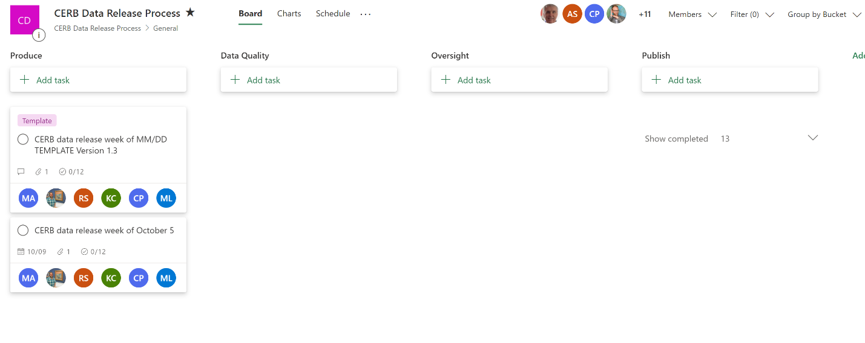
The above is a screenshot of the CERB (Canada Emergency Response Benefit) Data Release Process in MS Planner from the Chief Data Office (CDO) over in Employment and Social Development Canada (ESDC). The beauty of this tool is that it can be designed to reflect many different team-based activities where work needs to be coordinated between individuals and more importantly across different teams.
It could be a project plan that details the granular pieces of work that need to be undertaken, it could be a publishing calendar for content we want to release on the intranet over time, and as can be seen in the above example it can reflect a workflow that units of work, called tasks in MS planner, must follow in order to be completed (from left to right).
This guide aims to raise everyone's’ understanding of what MS Planner is, what it can do, and most importantly help you use it.

Why should you care?
You have likely already been exposed to other methods of managing work across teams such as through Outlook and the Follow Up functionality (as seen below), or some sort of Excel tracker, or possibly even MS Project.
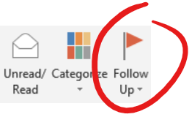
While these methods have served us well in small groups, they leave much to be desired when interacting with many other teams and serve us even less when it comes to real-time metrics on where things stand with each unit of work and team member. Email, Excel, and many other methods can't give you real-time insights into the progress of your work nor can it be inclusive and transparent at all times like MS Planner can. Regardless if a task is assigned to you anyone within the team can look at the task and see where things are at and gain access to its history. Data is at the heart of our existence, then it should be at the heart of how we operate and work together across functional areas.
So, let’s jump into MS Planner and see how this all works.

Background
MS Planner is designed based on a physical concept known as Kanban developed by Toyota and then subsequently adopted and popularized by the lean/agile methodology as a Kanban Board. Simply think of a Kanban board as a whiteboard with sticky notes that represent work tasks that are grouped into 3 possible streams:
- To do – this is where tasks begin their life
- Doing – this is when a task is in progress of being completed
- Done – this is where tasks come when they have been accomplished
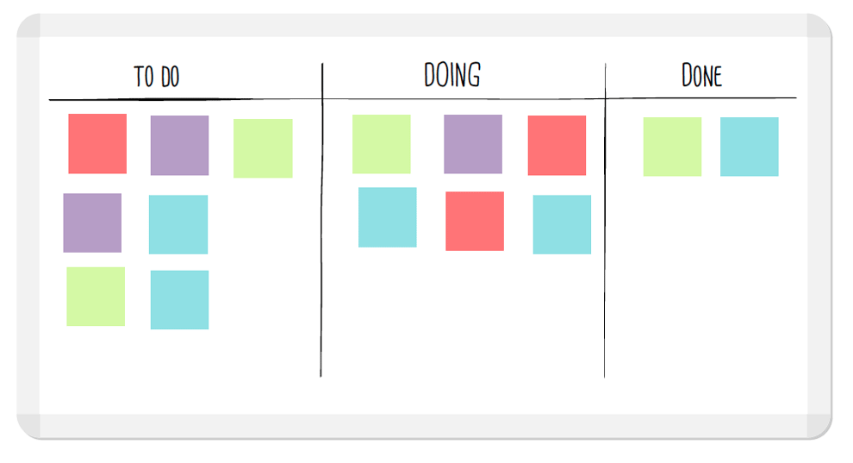
The above essentially describes all work no matter who you are or where you are. Of course, the above is so abstract this is the main reason it can apply to all and this is the underlying foundation of MS Planner. From there you can build and represent many kinds of things as it pertains and relates to your work.

What is a Plan?
There is a simple hierarchy in MS Planner when it comes to the different components you’ll be interacting with and they are as follows:
- Plans – a logical grouping of work for a team (including teams of teams)
- Buckets – a way to cluster work together as you see fit
- Tasks – usually represents a to do item
Everything starts with a Plan. A Plan is a logical grouping of work which can come to represent whatever you want, for many it will be a Plan that represents their team’s body of work. Below is an example of the body of work being done by the Data Governance team in the CDO over at ESDC:
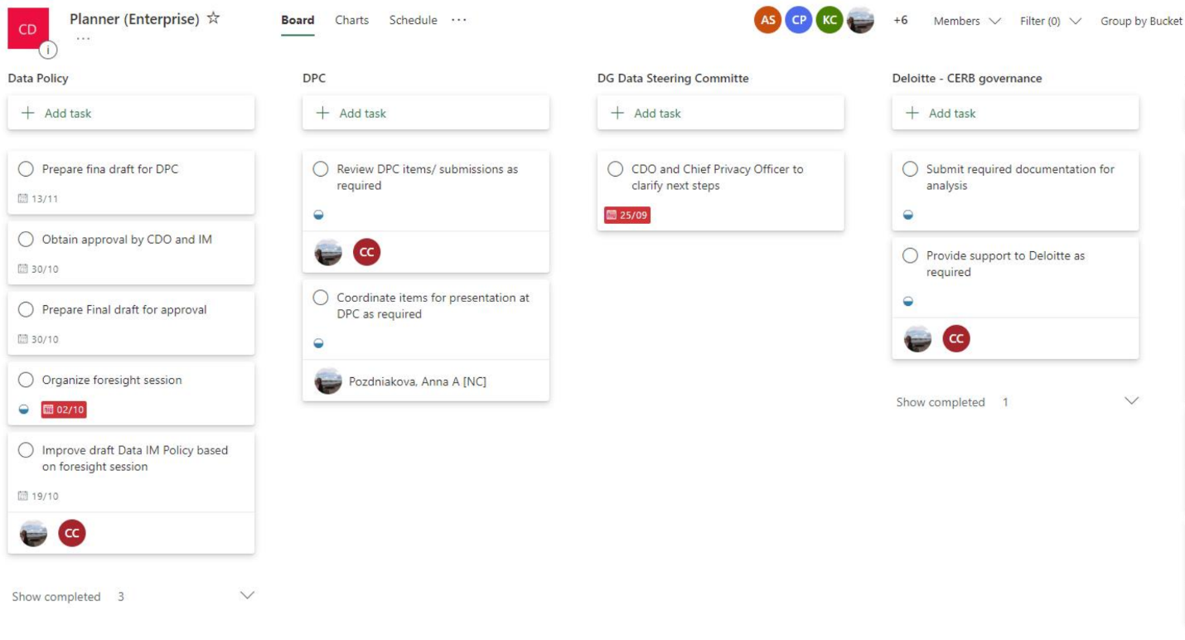
To better illustrate the point just think of the work that you do daily. Some work is quick and has a short turn around such as responding to someone’s question, and other work elapses over a longer period. It is generally the latter type of work that you spend most of your time on and are called upon to give status updates for. Now think of your team members and their work, this is your team’s body of work and it is this type of work that can be easily captured and represented in a digital fashion on a MS Planner Plan. Also note that the default view when accessing a Plan looks like a board similar to the whiteboard example mentioned in the Background section above.
While the above will likely be the most common uses you will see when it comes to how MS Planner Plans are designed it is by no means the only way they can be used. Another popular design is to map out a workflow, a series of steps that must be followed, for a piece of work to be completed. So, keep this flexibility in mind as we move one step down in the hierarchy of components: Buckets.

What is a Bucket?
A Bucket is a way to group similar things together under a Plan. So, with the above example of your team’s body of work, a Bucket could be used to group all tasks related to Briefings together while another Bucket could be used to group all Reporting activities.
When a Plan is created for a team it is up to the team to decide and design the best way to group their disparate types of work, this is done using Buckets. This is an important consideration on how you design your MS Planner plan as this will determine how you can slice and dice your work with regards to reporting, searching and filtering. That being said do not worry about getting it perfect out of the gate as none of this is poured in concrete, it can be changed as things evolve over time and as your team learns to best make use of these powerful tools.
In the figure below you will see the Buckets that were created for work related to Open Data. The groupings that were chosen are aligned with the 3 pillars of Open Government: Open Data, Open Information, and Open Dialogue.
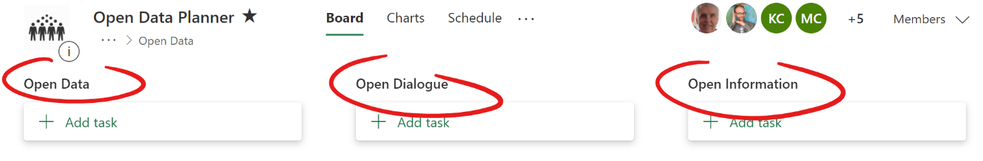

What are Tasks?
A Task is the component in MS Planner you will spend the most time interacting with on a daily basis. They often capture a discrete piece of work: a briefing note to the Assistant Deputy Minister (ADM), a report for your manager, a thing that you must do and track your progress against. Below is an example of what a task looks like in the Board view:
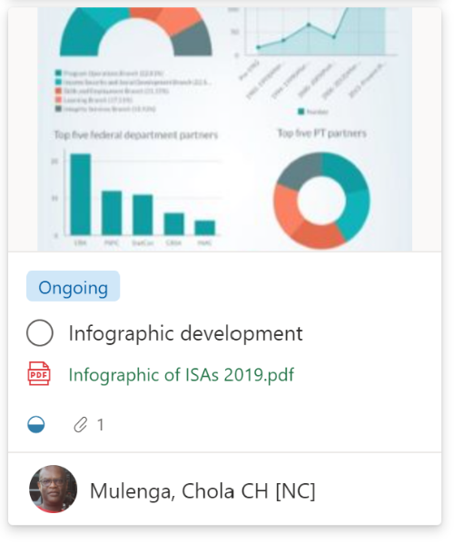
There are many details captured in a task as you can see such as a descriptive name for the task, who it is assigned to, if there are attachments, and so much more. We will dive into all the various elements of a task later. For now, it was important to illustrate the 3 major components found in a MS Planner plan: Plans, Buckets, and Tasks. Now that you know a bit about each let's dive a little deeper.

Introduction
It is impossible to talk about MS Planner without first mentioning MS Teams and Office 365. Since the COVID-19 pandemic hit us we’ve all been forced to work from home, and it became increasingly important for us to play digital catch up to enable us to work better remotely. Take for example meetings where one person projects their desktop onto a screen, we can all see as they walk us through a presentation. Suddenly something so simple became impossible for us to do. We needed a way to improve how we conducted meetings virtually and this was one reason why the department sought to provide us with MS Teams.
Now MS Teams is a platform that allows us to do much more than just conduct virtual meetings together, but it is in this context that most people have been exposed to it. It also enables us to communicate and work together in a more natural and real-time fashion than email allows us to do, similar to working beside each other at work. There is much to explore and unpack when it comes to MS Teams, but we will only cover a fraction of its power in relation to how it interacts with MS Planner.
In order to give us access to MS Teams the department had to purchase an Office 365 subscription as MS Teams cannot be purchased as a standalone product, it is bundled in a suite of productivity tools which includes MS Planner. Think of the MS Office suite which included products such as Word, Excel, and PowerPoint. Office 365 is the online equivalent of the MS Office suite except that it comes with so much more. As you can see below, we are only taking advantage of a small subset of what is available: MS Teams and MS Planner:
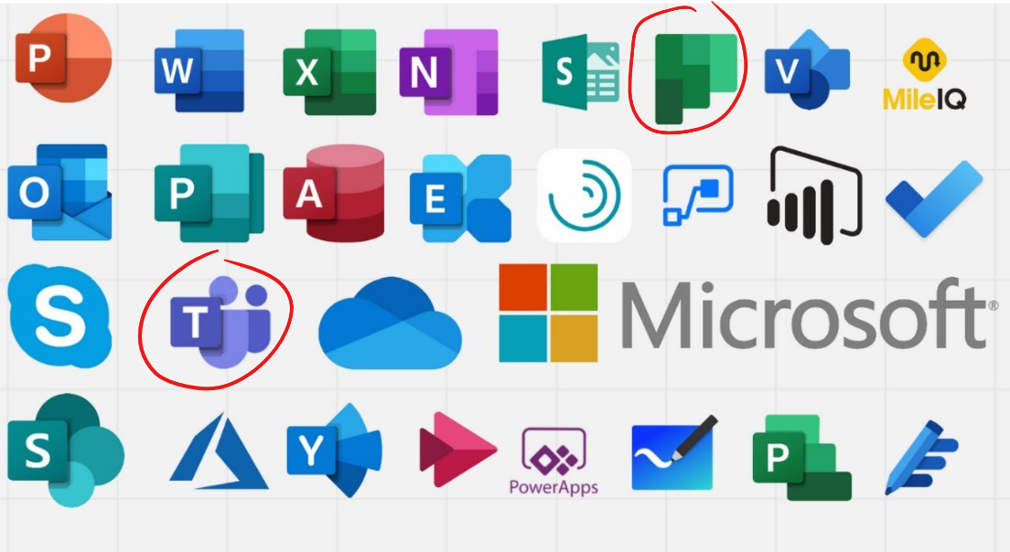

How to create a Plan
So now that we know how MS Planner fits into the Office 365 ecosystem it's time to jump in. Coming back to the whiteboard example from above, in MS Planner you will find a similar hierarchy of concepts. The first is called a Plan, which is the equivalent to the whiteboard in our real-world example.
You can create a plan a few ways in MS Planner, but we will be leveraging your experience and exposure to MS Teams to create your teams' plan. As you follow these steps, feel free to do so in the team and channel of your choice. First, you will need to navigate to the team space that this board will be related to. In the following example, we will be creating a Plan in MS Planner that is meant for all CDO team members and therefore we will navigate to the CDO team in MS teams:
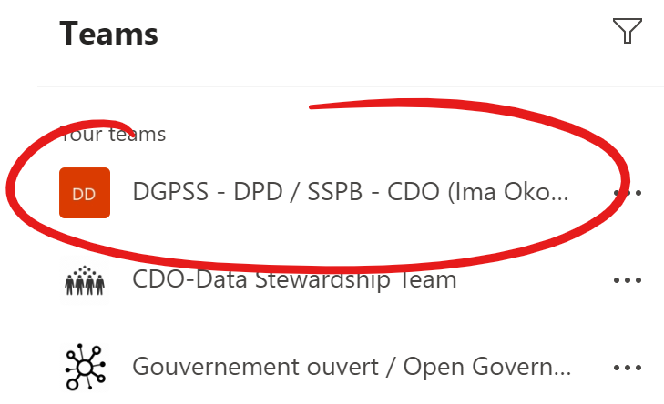
Once you selected what team this MS Planner plan belongs to, you will also want to select the appropriate channel within the selected team. In this example we will be using the General channel which all CDO members have access to:
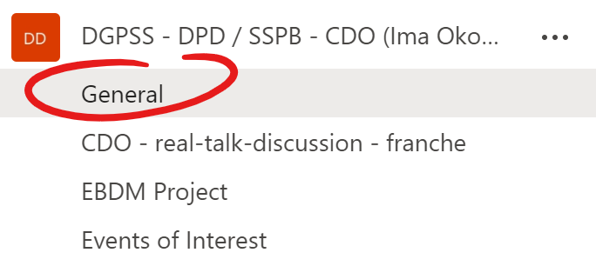
This will by default put you in the Posts section of that channel which is where team members can message each other and discuss various things. If you look near the top middle of the MS Teams window you will see the option to add a new tab indicated by the + symbol, click on the + (plus symbol):
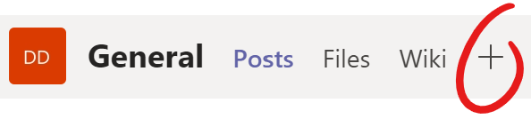
This will present you with a new screen called Add a Tab. From here if you see the Planner icon like we do in the image below then click on it. If you do not you will need to perform a search in the upper right area by typing out Planner, and then clicking on the Planner icon:
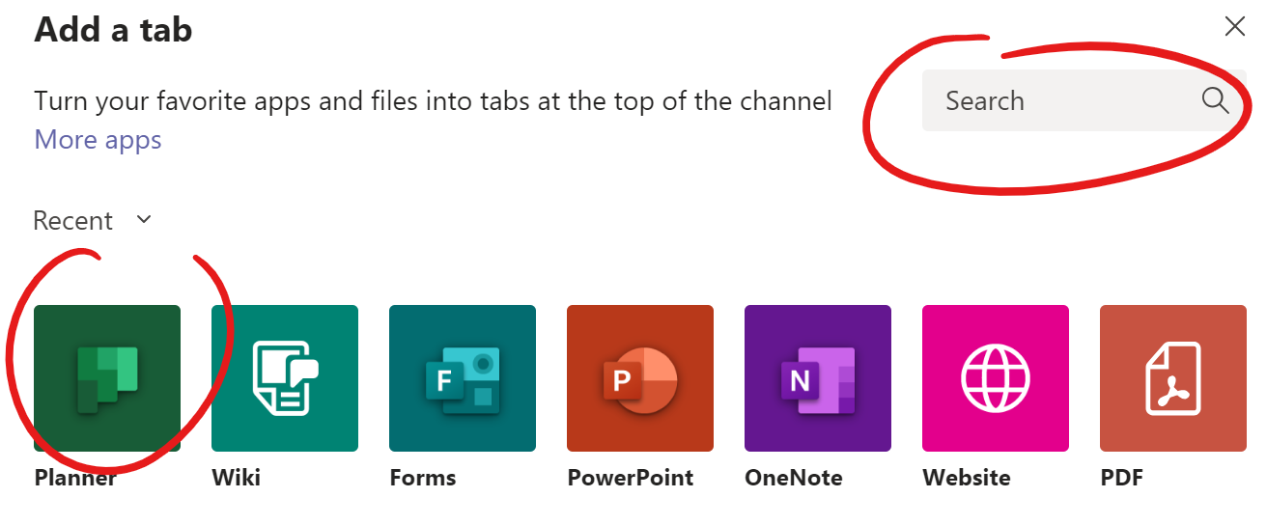
This will present you with yet another new window, here you will want to select the Create a new plan option and give this new tab a name; this will also be the name of your MS Planner Plan. Then you have the option of leaving or removing the check mark for the Post to the channel about this tab option. By default, this option is checked and all it does is post a message in the channel informing members that a new tab was created along with a link to the new Plan. We’ve opted to uncheck it below.
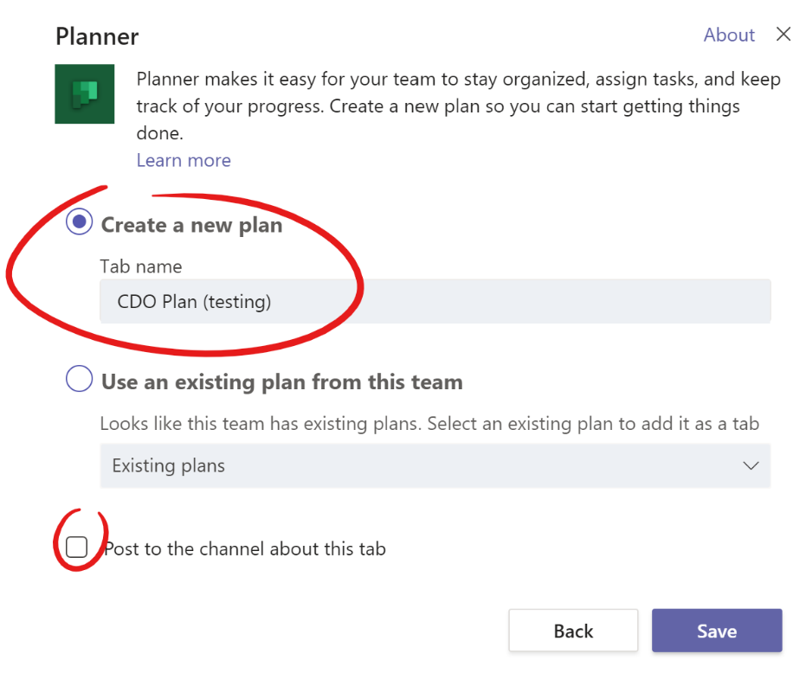
Once you’re done click on Save and a new tab will be created along with your team’s MS Planner plan. The tab name will appear for all members of the Team/Channel and will stay there to provide easy access to your plan for you and your team. Please note that removing the tab does not automatically delete the MS Planner plan.
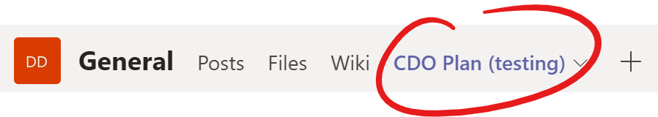
Also noteworthy is that creating a plan under a specific MS Team also grants all members of that team access to the new plan automatically. You’ll want to add this plan as one of your favorites in MS Planner. This can only be done from the web-based version of MS Planner. To get there click on the Go to website button in the upper right section of the screen:
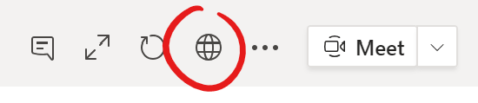
Once the plan loads in your browser look for your plan’s name, it can be seen near the top left-hand side. To the right of the plan’s name is a star icon, this is the favorite icon. By clicking on the star, you indicate that this plan is part of your favorites. This helps surface this plan in other areas of MS Planner and Office 365. When the plan is not part of your favorites the star has a white center:
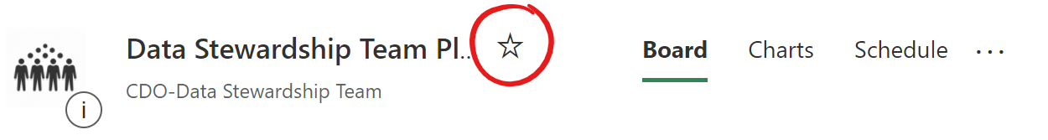
Click on the star to make it one of your favorites which will fill the star to be completely black:
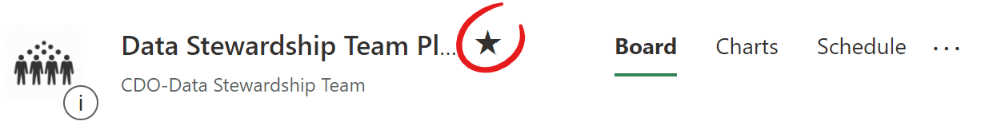

Now that you have a plan for your team and it is one of your favorites it’s time to create your team’s buckets.

How to create/edit Buckets
Creating buckets is more art than science, there are no hard and fast rules about what buckets you should have as every team is different and their body of work can be vastly different from another team. To create a bucket you simply need to click on the Add new bucket link, which is usually found to the right of the last bucket in your plan:
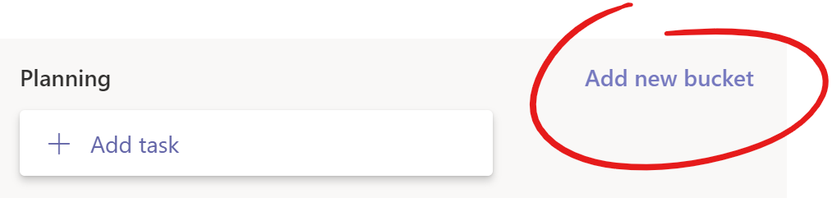
You can also modify any existing bucket by simply single clicking on any current bucket name. Every new plan has a default bucket called To do. You can test this out by clicking that bucket name and editing it. Once you are done just hit enter to save the change.
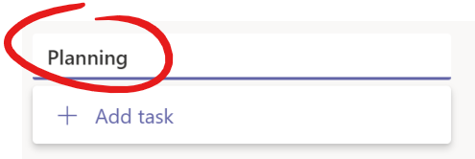
One thing you will want to decide about how you group your work through buckets is whether it is more important to describe the type of work being done or whether your work needs to follow a linear process to completion. The latter often applies in highly operational teams. Think of a McDonald’s burger cook, they likely have a workflow to follow in order to serve up a burger, it might look something like this:
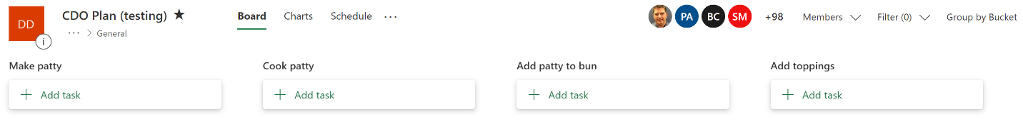
It’s clear with the above example I’ve never worked in a McDonalds, but I hope you get the point. Buckets can be used to describe a workflow.
Alternatively, buckets can be used to separate different types of work. Here’s an example of what that might look like:
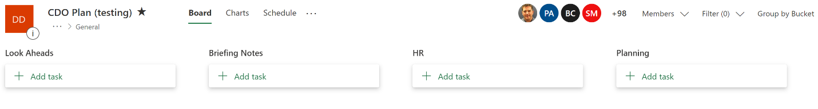
At this point you might be coming to the realization that buckets can be anything you need them to be and this is where a lot of the power of MS Planner comes, it allows you to dissect your work in ways that are meaningful to you and your team. The above two approaches are only examples, feel free to experiment with your team what works best for you. One important consideration with regards to buckets is the fact that you can generate reports and visualizations off these groupings so keep that in the back of your mind as you come up with yours. We will cover the reporting aspects a bit later in the document.

How to create Tasks
Tasks are likely the component in MS Planner that you will interact with the most given that these usually describe and capture the work you are doing. Tasks invariably become the digital representation of your work and all that has transpired, in this way anyone looking to get an update on where things are at with any particular work item they need only look at the task to see where things stand. This can only be possible if we all work with tasks in a similar fashion and this guide aims to help us all get on the same page on this front.
So how do you create a task? It’s quite simple and you’ve likely already seen how as you worked through creating different buckets. Just click on the Add task link, which can be found under each bucket. Depending on which Add task link you click on it will add a task under the respective bucket where you clicked the link:
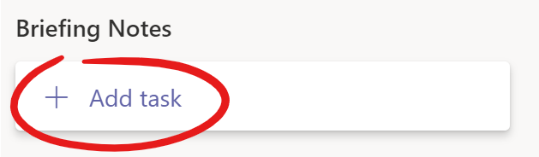
Clicking on the above Add task link will create a new task under the Briefing Notes bucket. When you click on the link you will be presented with a small new box on your screen below the Add task link. This is your new task, which you will have to give a descriptive title, you can also optionally Set a due date as well as Assign a team member to the task.
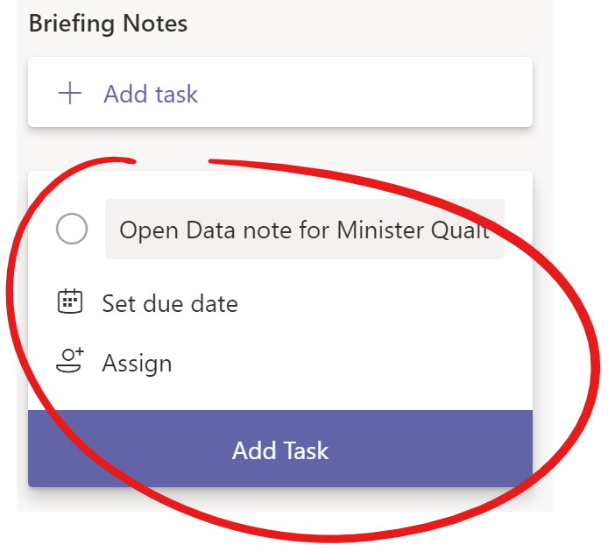
If you are looking to add multiple tasks one after another a good trick to remember is that rather than clicking on the Add Task button you can simply hit the Enter key after entering a descriptive title for the task. This will not only create the task but will allow you to continue creating new tasks by letting you enter another title for a separate task. With this trick you can create dozens of new tasks in minutes.

As you can see creating tasks is relatively easy but there is so much more to know when it comes to tasks than meets the eye. So, before moving on to the next part be sure to create a temporary task so you can follow along as we dissect each element of a task below, and feel free to play with each part as this is the best way to learn how to use them. Once you’ve created a task simply hover over it and click on it once to expand the task and see the other options and details available within it:
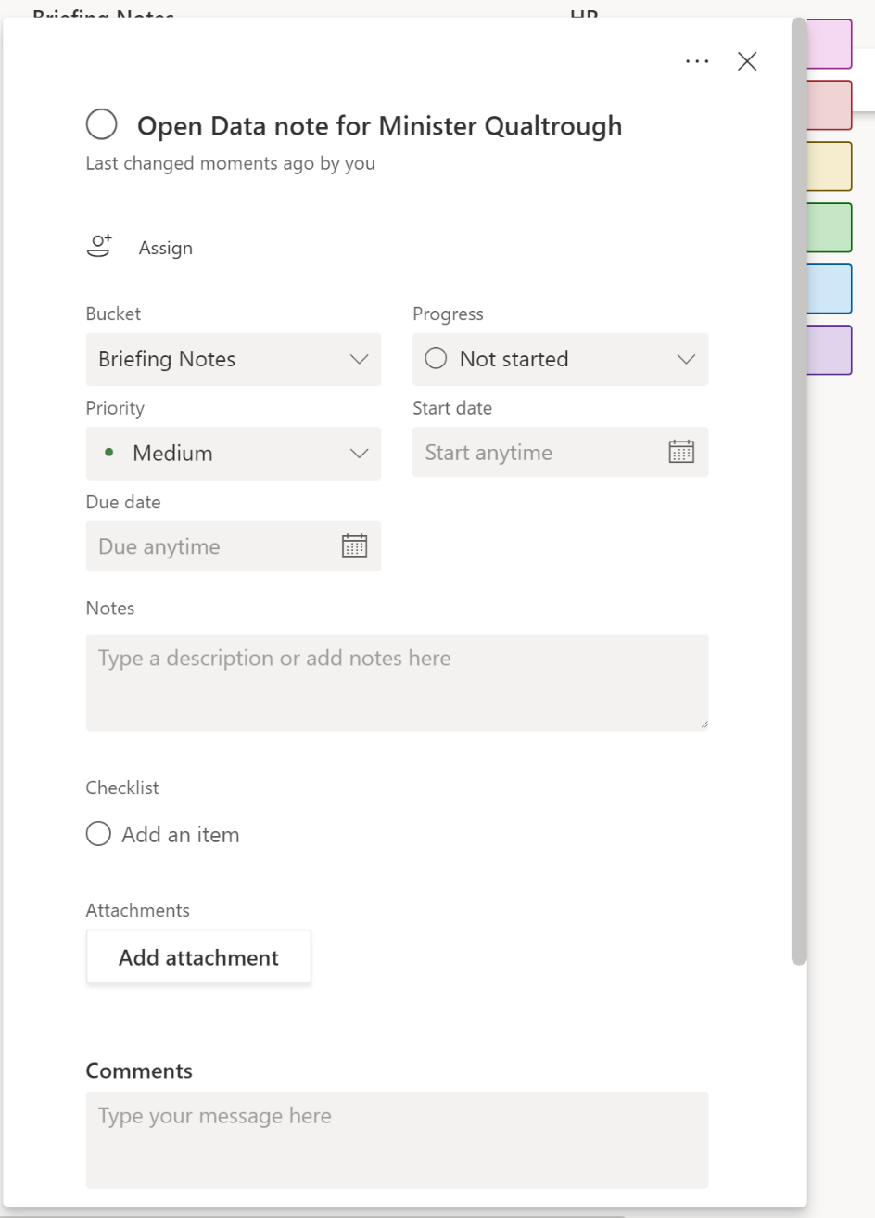

Anatomy of a Task
Once a task is created a whole slew of other options become available. This section will breakdown the various parts of a task to help you gain greater understanding and insight on how to best leverage them.

Assigning a task
The most important part of any task is who it is assigned to. If a task is assigned to no one then it is very unlikely that it will get done. A task can be assigned to one or many people depending on the nature of the work (solitary vs collaborative). To assign a task to a member of your team simply click on the Assign link on the task:
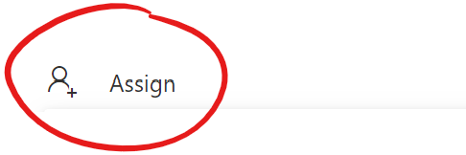
This will present you with a list of your team members along with the option for filtering through that list. You can either scroll down the list and select team members as you find them, or you can filter the list by typing their name in the provided input box:
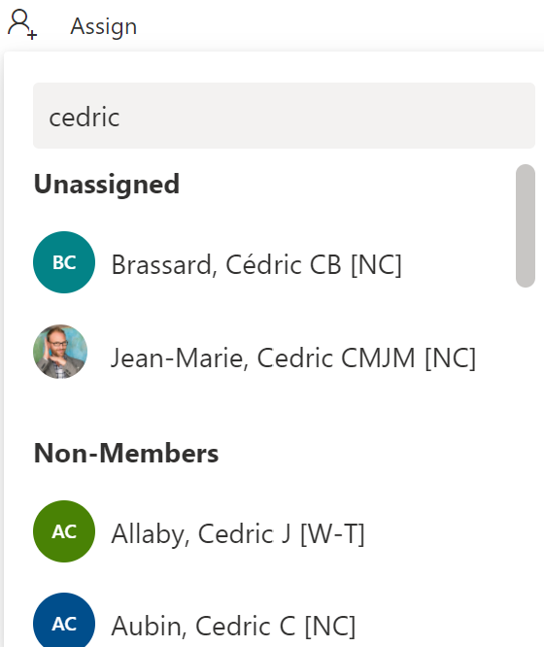
All members first appear under the Unassigned heading but as you assign someone to the task they will not only appear as assigned to the task, but a new Assigned heading will appear in the list with their name beneath it:
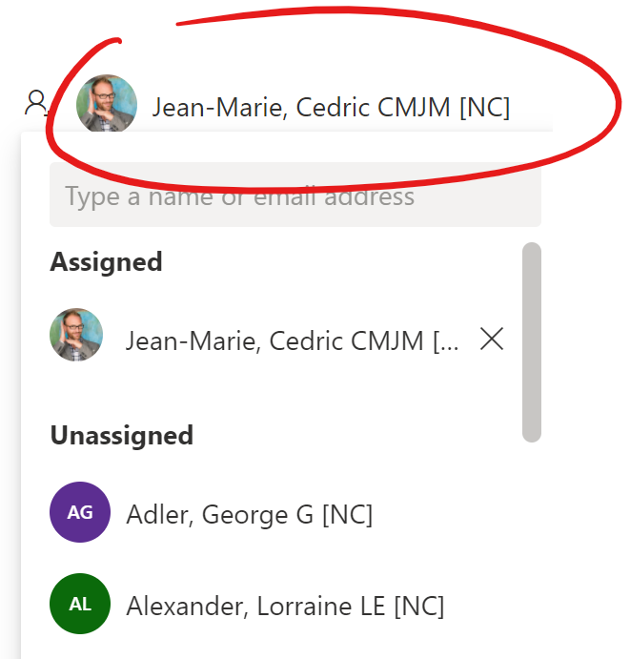
You can also assign team members to tasks while browsing in the Board view. To do so click on the shish kebab menu option that appears in the upper right corner of your task when you hover over it and click on the Assign option:
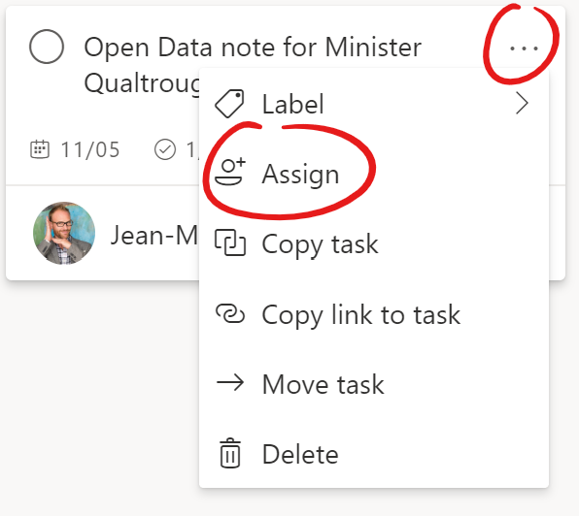
This will present you with the same functionality for assigning team members described above. This method is a quick way of creating multiple tasks within a board as well as assigning them without the need to go into the tasks individually to do so.
Once a task is assigned to someone, they will begin to receive notifications such as a task being assigned to them. If a task is coming close to a set due date or is late, they will also receive a notification both within teams and in their email.
Being assigned to a task indicates a responsibility that they are on the hook for bringing this task to completion. It is a best practice to assign a task to one person as to not muddy the waters when it comes to responsibility. Sometimes a task belongs to more than one person and that is ok, just make sure to identify a lead among the assignees to make sure it doesn’t fall between the cracks, you can do this by leaving a comment in the task.

Labels
Labels are yet another way to provide further clustering in MS Planner which can be applied to all tasks regardless of which buckets they sit in. Every new plan gets to define what each label means and what they represent, however there is a maximum of six labels available and they are colour coded: Pink, Red, Yellow, Green, Blue, and Purple.
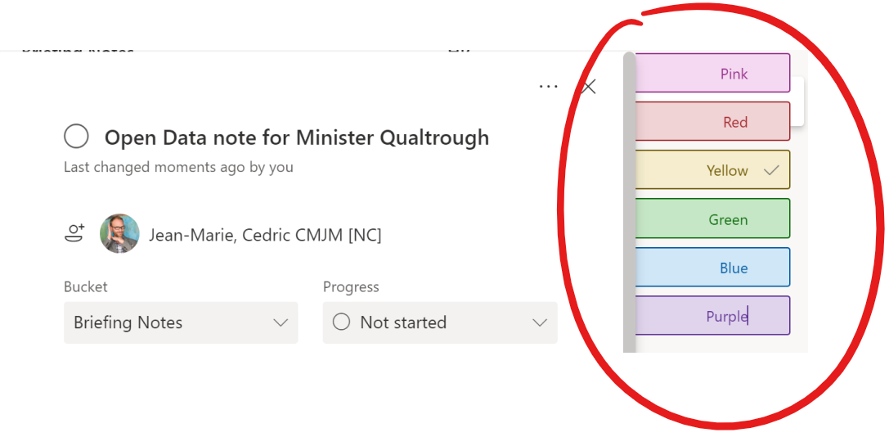
You can usually only see the stubs of the labels when you first enter a task with no labels assigned. They can be seen on the upper right side of the task:
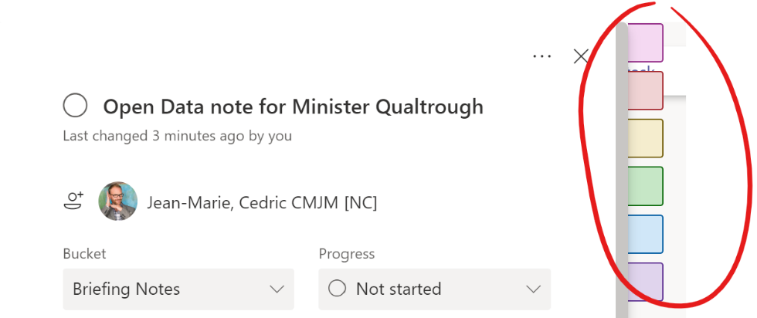
To see them and assign them to your task you just need to hover your mouse over any of them and they will all pop out. Before you assign any labels however, you will need to edit the default names of the labels you wish to use. The default label names match the colour of the label. To edit a label simply click anywhere in the text of the label:
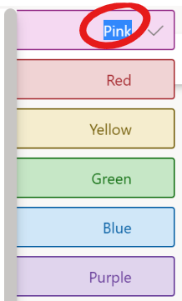
Below are some recommended label names along with some explanations of why a team should use that label. By aligning how each team uses labels across an organization we become a lot more flexible in how we can combine the data from each of these plans so keep that in mind before you make any adjustments, consider raising new promising use cases to other teams so they can be discussed and adopted horizontally.
The recommended label names are as follows:
- Template – used to indicate that this task is to be used as a template for the generation of routine tasks. It captures all the necessary steps and relevant documents to help the assignee accomplish this task without the need to search for all the relevant information or documents needed to complete the task.
- Cancelled – used to indicate that this task was cancelled, the reason should be captured in the comments section. This is useful as while a task may indicate complete in order to remove it from the board we need a mechanism to indicate that in fact it is complete because it was cancelled.
- On Hold – sometimes due to increased workload some tasks need to be put on hold, this label helps to visually indicate which tasks this applies to.
- Ongoing – Some tasks might be unending in that they are something that will always be done regularly and do not require a start date nor a due date. This helps visually distinguish these types of tasks.
- Adhoc Request – This one is critical to help generate valuable data and insight at the end of a year as to how much of our completed work in a fiscal year was planned and how much was adhoc in nature.
- Blocked – This helps to indicate when a task has met an untimely roadblock, perhaps it requires escalation, or perhaps it is blocked due to some unforeseen circumstances. Regardless of the reason this helps to quickly distinguish which tasks are unable to proceed due to outside circumstances.
Once you’ve edited all your labels to reflect the above recommendations you should see something similar to this when you hover over a label on the right:
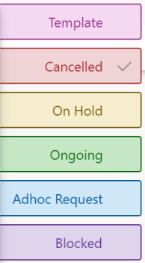
Adding a label to a task is as simple as clicking on the checkmark to the right of the label:
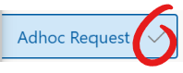
Below you can see that two labels were added to the task:
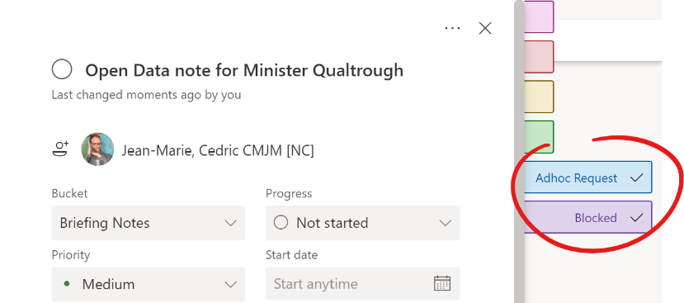
You can even see these labels as you browse the tasks in Board view:
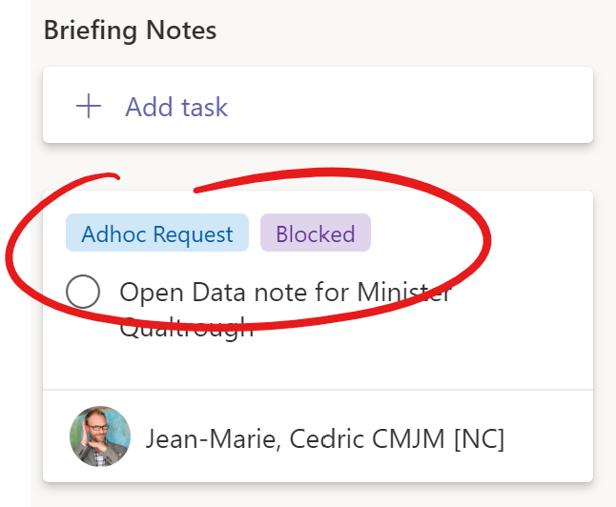
You can also quickly assign labels to a task directly from the board similar to how you can quickly assign someone to a task. To do so click on the shish kebab menu found in the upper right corner of a task when you hover over it and click on the label option. This will surface the labels and allow you to add a label one at a time by clicking on the desired label:
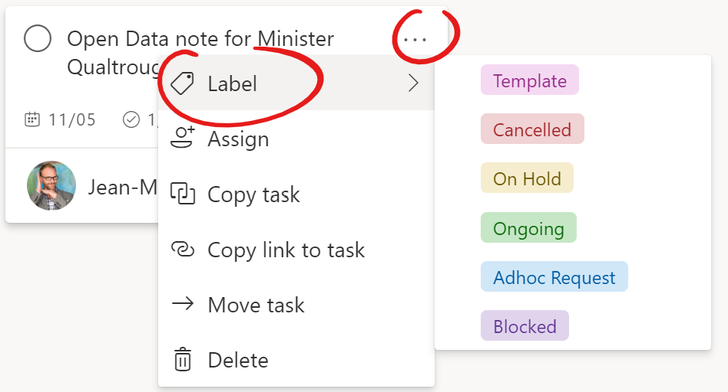
It’s worth noting that some things appear differently in MS Planner if you navigate to your plan through your browser, you can easily do this if you click on the Go to website button in the upper right section of MS Teams while looking at your board:
Labels are a great example of this, while in MS Teams they appear to the right of your task and you need to hover over them to see them in your browser you access those same labels by clicking on the Add label link:
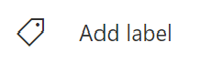
After you click on the link the labels will appear below and you can select them from there:
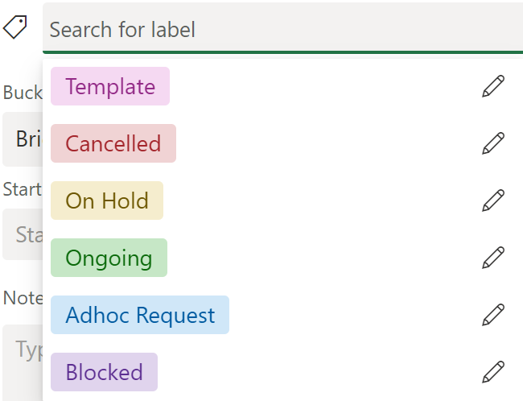

Bucket
The Bucket dropdown is simply the list of the buckets you created for your board. Simply select the bucket that applies to that particular task to set it:
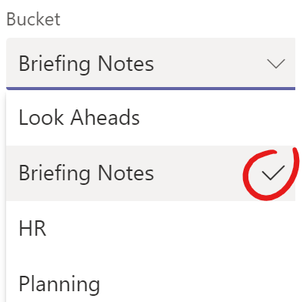
This is often automatically set if you create a task under the right bucket in the first place. To change these values, you must go back to the How to create/edit Buckets section above. You cannot do so from within a task.

Progress
The Progress drop down is how a team member can indicate whether they have started working on a task or not, or if it is complete. There are only ever 3 options available here: Not started, In progress, and Completed.
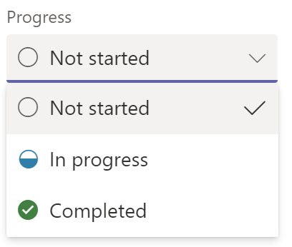
It is through this drop down that we can effectively manage workload and see how things are progressing in our projects and day to day operations. Therefore, everyone must be diligent in keeping this part of their tasks up to date.
There is a handy shortcut to setting a task to Completed while browsing the board and it is by clicking on the circle to the left of the title:
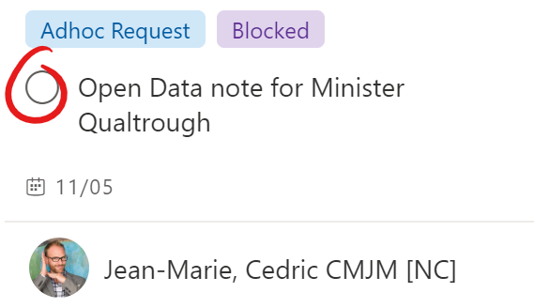
The moment you click within the circle it will set the progress state to Completed. An important feature to remember about Completed tasks is that they visually disappear from your board and are rolled up under a new section that will appear at the bottom of each grouping. You can easily see all completed tasks by clicking on the Show completed link:
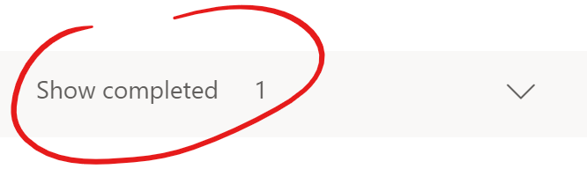
This will surface the list of completed tasks and transform into a Hide completed link so that you may collapse them once more. This functionality of reducing screen clutter focuses your team on the tasks that aren’t completed yet while still giving you access to all completed tasks.
If you accidentally complete a task, there is no need to fret as you can always undo and change the Progress state at any time.
Another way of setting this value is through drag and drop functionality which we will explore under the Group by functionality described further below.

Priority
The Priority drop down allows us to identify a task’s priority level. By setting priority to the appropriate level we can quickly inform team members of which tasks they should focus on first. The priority levels are: Urgent, Important, Medium, and Low. The default priority assigned to a task is Medium:
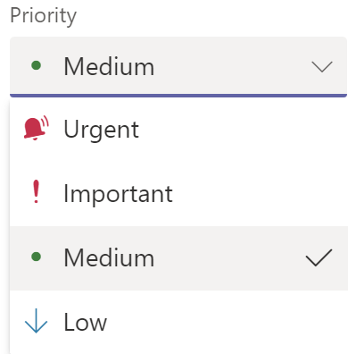
In order to level set how priority is set across teams it is recommended that they are used as follows:
- Urgent – should be set by senior management, this provides executives full control on where we shift our focus when necessary. This indicates that the task must be completed within the desired timeline.
- Important – should be set by a manager, once more provides further control on focus but at a lower level. This can be used on a weekly basis to set the priorities for a team throughout the week. This only applies if you have tons of tasks of course and don’t operate on a first in first out system. This indicates that the task must be completed within the desired timeline.
- Medium – should be used for most tasks and is the default upon any task creation. It indicates that the task should be completed within the desired timeline.
- Low – should be used for tasks that are nice to have completed but are not on a critical path and possibly optional.
To select or change a priority simply click on the drop down and click on the desired priority.

Start date and Due date
The Start date and Due date fields are very similar to each other, they are date picker fields and somewhat self-explanatory, but we are nothing but thorough here in this guide and will do them both justice.
The Start date field allows you to set a task’s start time, this is quite handy when you have a repetitive task that you must do at the beginning of each week. You could create 4 separate tasks for the month that all look identical and give them each a different Start date and Due date, this way while the tasks appear identical, from a schedule standpoint they are different given their different execution times.
To set either field simply click anywhere in the input box or on the calendar icon to be presented with the date picker. The box that appears directly below the field will be the current month with the current day circled:
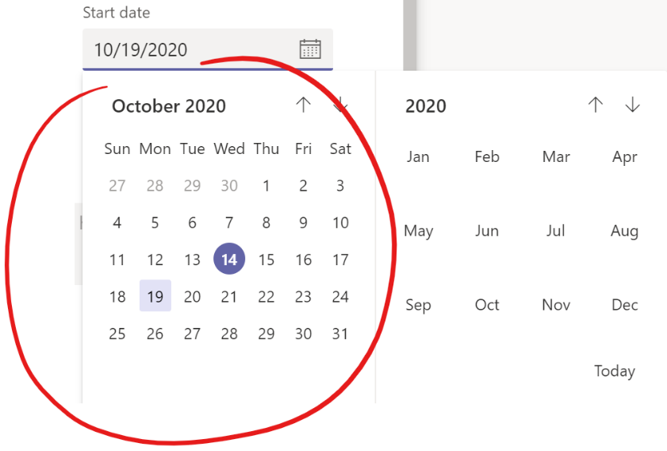
To the right is the year and month selector which allows you to quickly jump to a different year or month should you need to:
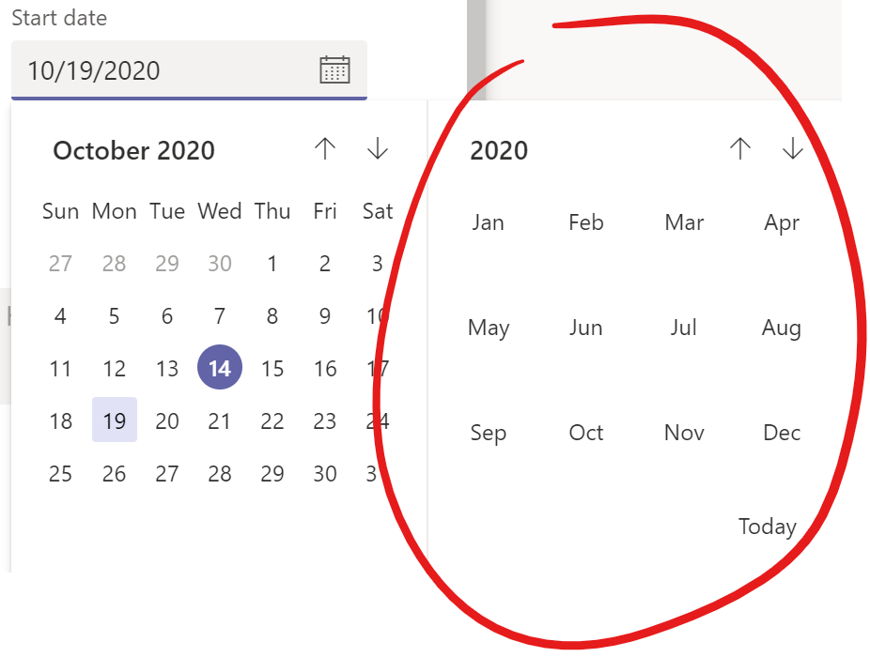
To pick a date simply navigate to the year and month you want and then click on the day you want. This will close the date picker and set the date in the appropriate field. You can also just type the date, the format to follow is MM/DD/YYYY.
If there is already a date in the field when you click on the date it will open the date picker to the month currently set. You can quickly navigate back to the current month and day by clicking on the Today link in the lower right section of the date picker:
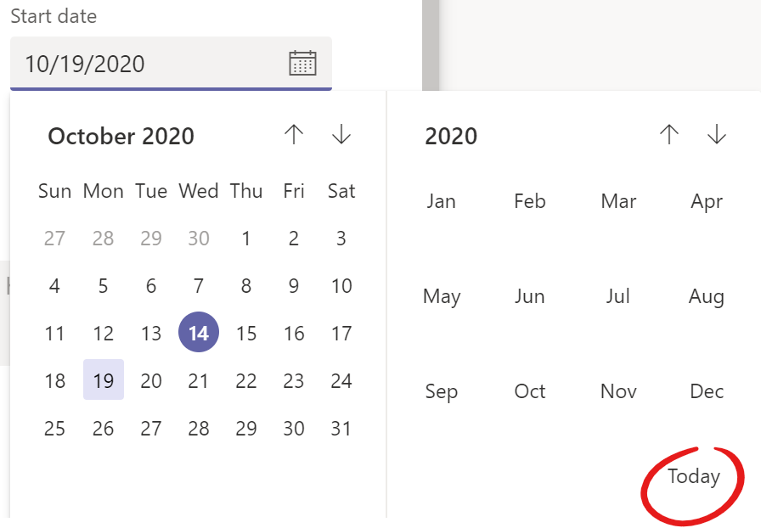
Once the Due date is set it is exposed on the task as you browse your board, the Start date however is not exposed in this same way:
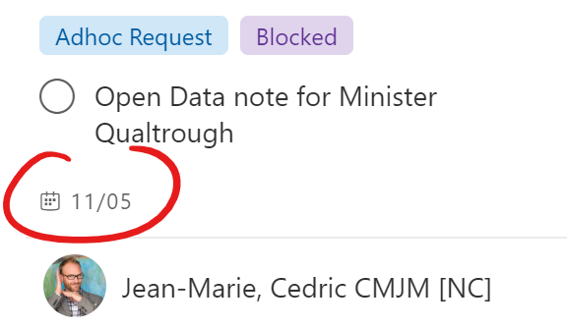
These two fields combined are what plot tasks out in the Schedule section which we will explore in more detail further below but just so you are aware here’s a sneak peak of what that looks like:
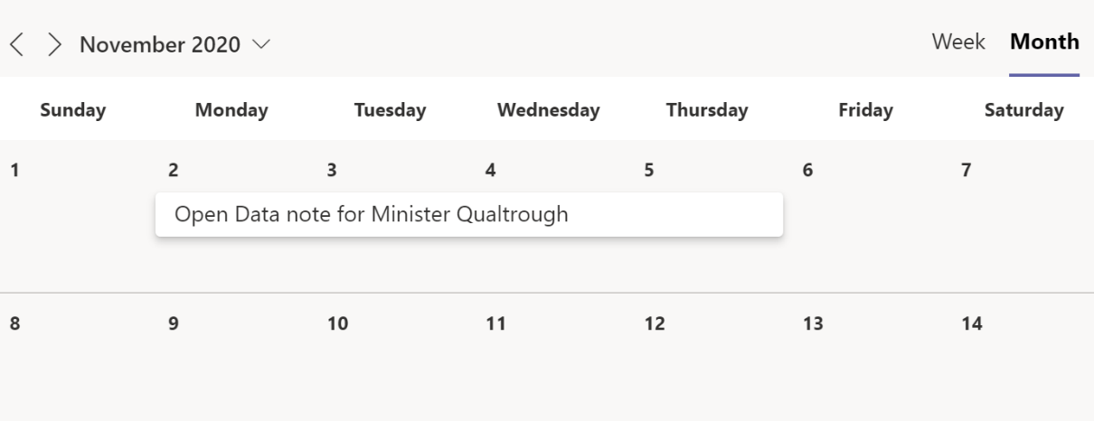

Notes
The Notes section allows you to provide greater detail about the task. You can capture important information relevant to completing the task, provide guidance and instructions should you want to use this task as a template. We will cover the concept of a Template task in the Tips and tricks section below but for now look at an example of the type of content you can capture in the Notes section:
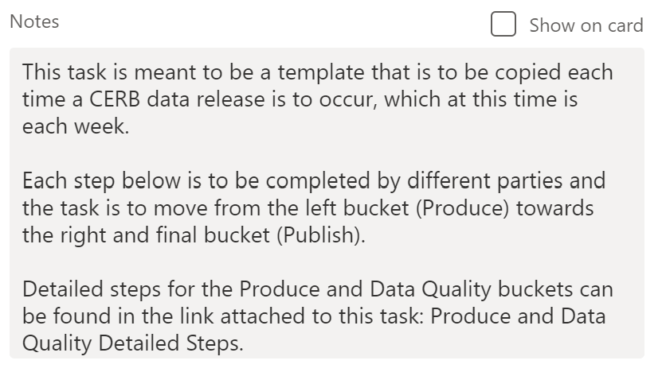
Generally, what you put in here will not change much over the duration and completion of the task, this input will likely stay pretty static over time. You also have the option of making this input appear on the task as you peruse your team board by checking the Show on card option:
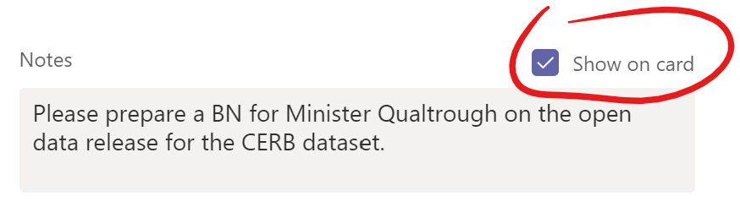
Below is what a task looks like when you choose to show the notes on the card:
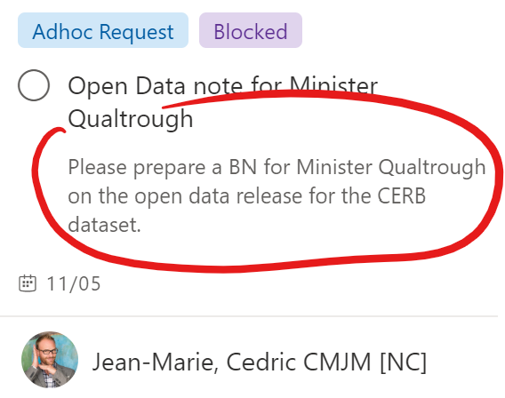
This can be useful if the title alone does not give enough information about the task to fully understand it.

Checklists
Sometimes a task might require further breakdown. Checklists are a great way of capturing the necessary steps in completing a task. So, if you need to capture these steps just click on the Add an item link under the Checklist section:
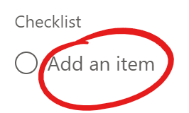
This will allow you to enter text to capture the steps needed to complete the task. Once you are done entering text just hit Enter on your keyboard to capture it. Your cursor will automatically jump underneath the new item and allow you to further capture the subsequent steps. Also notice that in the upper left area it will show the progress of your checklist, below 0 items out of 1 are completed:
You can capture a maximum of 20 items in the Checklist section per task so keep that constraint in the back of your mind as you create tasks in the first place. If your task is too high level and that limit is a problem this is likely an indication that this task needs to be split into smaller tasks. There is also a limit in terms of characters per check list item so keep them succinct but clear.
Similar to the notes section of the task the Checklist also provides the Show on card option, turning it on not only surfaces the checklist on the task as you browse the board, but it also allows you to check off items directly from this view:
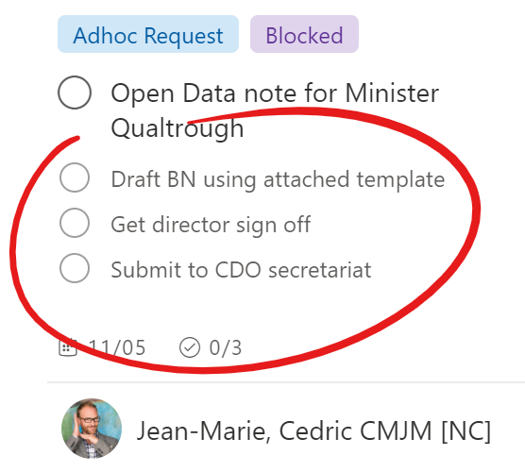
When you click in the circle to the left of the step you want to mark complete it will add a checkmark for that item and remove it from view while also updating the tally near the bottom middle of the card:
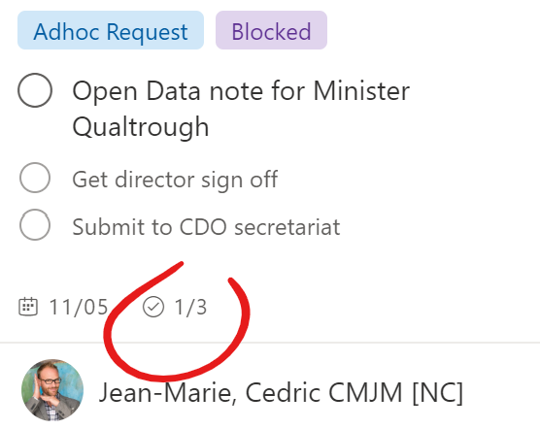
Checklists can be extremely handy when it comes to repetitive tasks that have pre-determined steps that need to be followed. Use them when creating template tasks for your team, this idea will be further explored in the Templates section below. To provide you greater context below is an example Checklist which details a workflow that is meant to be followed with regards to the release of open data:
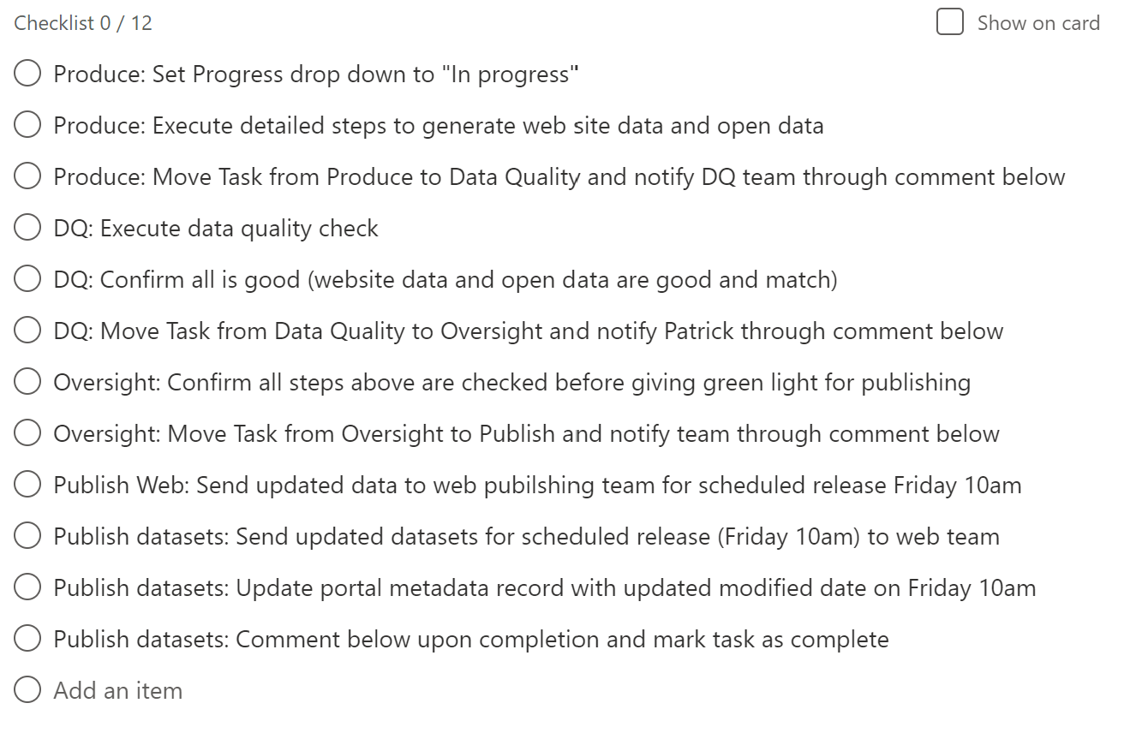

Attachments
As is the case with emails sometimes our work requires us to share resources with each other. It could be a briefing note template, it could be a dataset required to complete the task, whatever the case we need ways to share resources with each other. The attachment functionality allows you to do just that.
It’s important to emphasize that attachments to a task in MS Planner end up sitting on a SharePoint site, think Google Drive, in an external cloud outside of the Government of Canada. This should always be in the back of your mind when sharing resources on platforms like MS Planner or MS Teams. You should never upload any sensitive or protected data/information to these services unless an explicit directive from IT security confirms that it is now safe to do so.
That being said it is still possible to share sensitive resources by first placing them in a common secured space such as a shared drive, then you can simply copy and paste the file path into the Notes section covered above.
If the resource isn’t sensitive in nature, then you have 3 options when you click on the Add attachment button on a task:
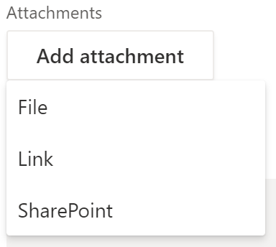
Selecting the File option will present you with a standard Windows file navigation box, navigate through your file structure to the file you want to share, select it and click on the Open button to attach the resource to the task:
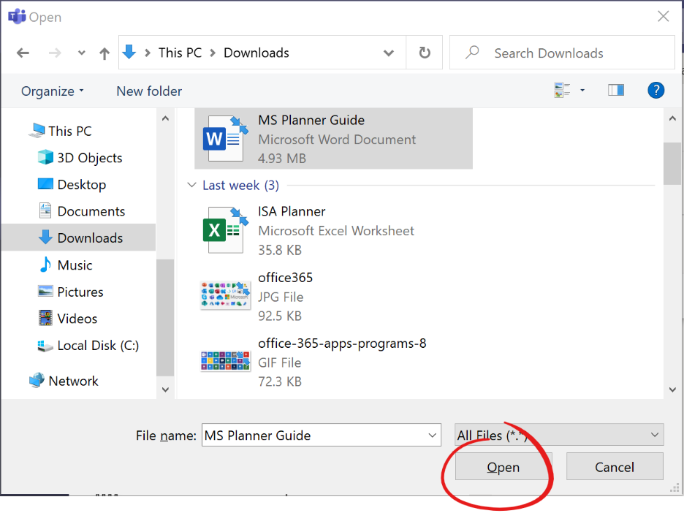
You’ll want to select the Link option if the resource is already available online. This means that it will have a link; this can be a website, a file sitting on Google Drive, or a YouTube video that is pertinent to the task. Clicking on this option will present you with the Add a link window where you’ll want to paste the link of the resource you want to share in the Address text field. Links are usually not reader friendly and so it is also highly recommended that you enter a user-friendly title in the Text to display text field and then click the Save button to add the resource to the task:
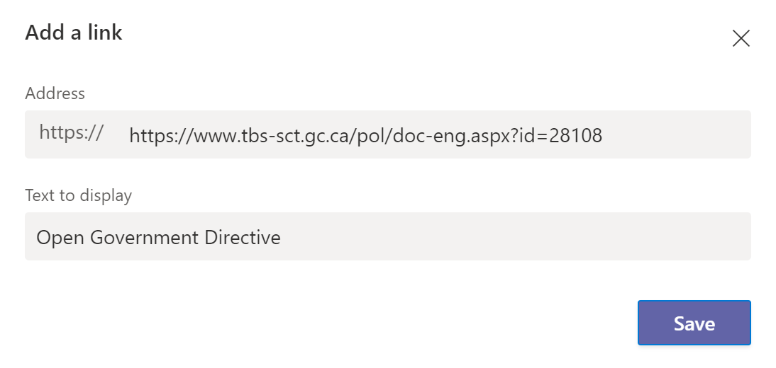
Selecting the SharePoint option should be done if the resource has already been shared in the current MS Team. Clicking on this link will present you with the available resources under the current space your plan exists under. Each channel will have its own folder, in our example we navigated to a file under the General folder. Click the Save button to add that file as an attachment. It’s important to note that SharePoint attachments are links to files on SharePoint and not a copy of that resource at that point in time. So, when the attachment is accessed even if the document has changed over time, they will always see the latest version.
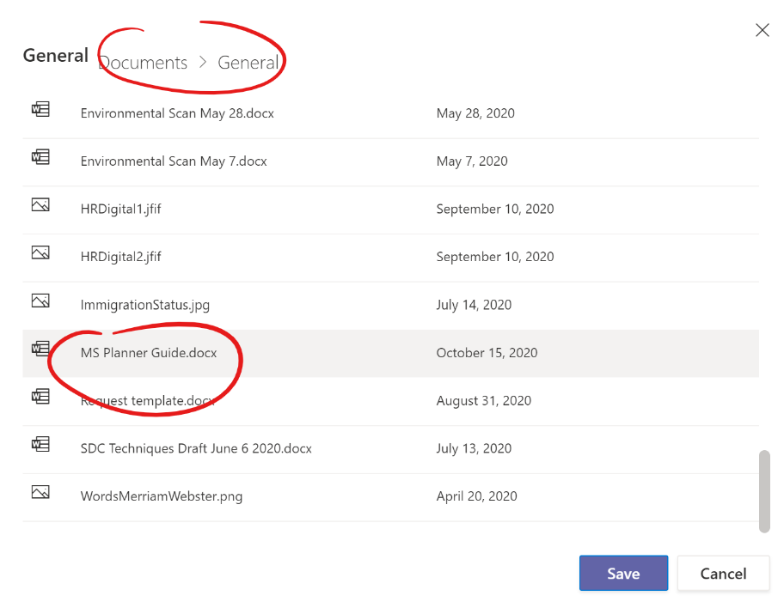
Now that you know what each option does here are some thoughts on how to best make use of them. If the attachment is not going to change very much or at all over time using the File option will be perfectly fine. If it makes more sense for the attachment to be the latest version at all times then the best path forward will be either a link or a SharePoint link, this will guarantee that anytime the resource is accessed the team member will get the latest version. This is incredibly important if ever the attachment is a template that they must use to complete the task. This way as the template evolves you only need to change it in one location and all references to it are automatically updated.

Comments
The Comments section in a task is where team members can interact with each other in the completion of that task, such as a handoff from one person over to another, a status update request, as well as any and all updates as things evolve over that task’s duration. Once a comment is entered and sent it is captured directly below the comment input box and acts as a history on all that has transpired in the completion of this task.
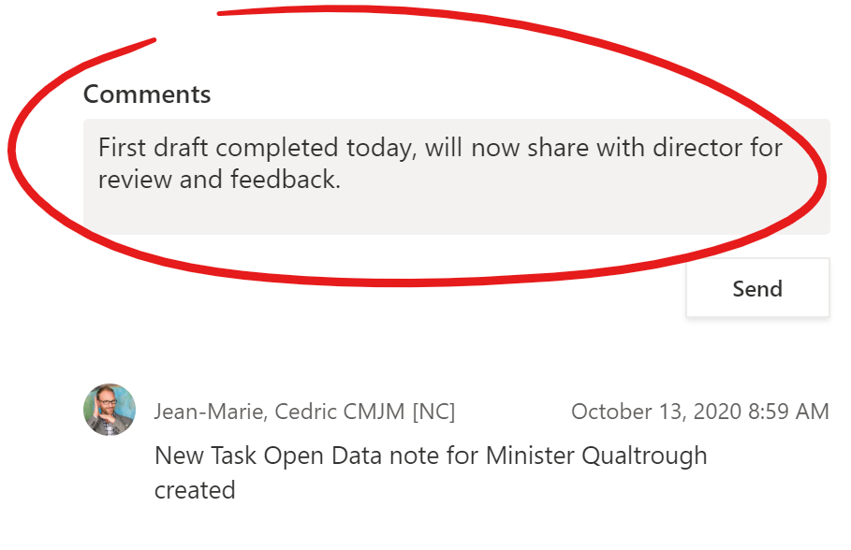
After the above comment was submitted by clicking on the Send button it can be seen by all directly beneath along with a timestamp of when it was captured:
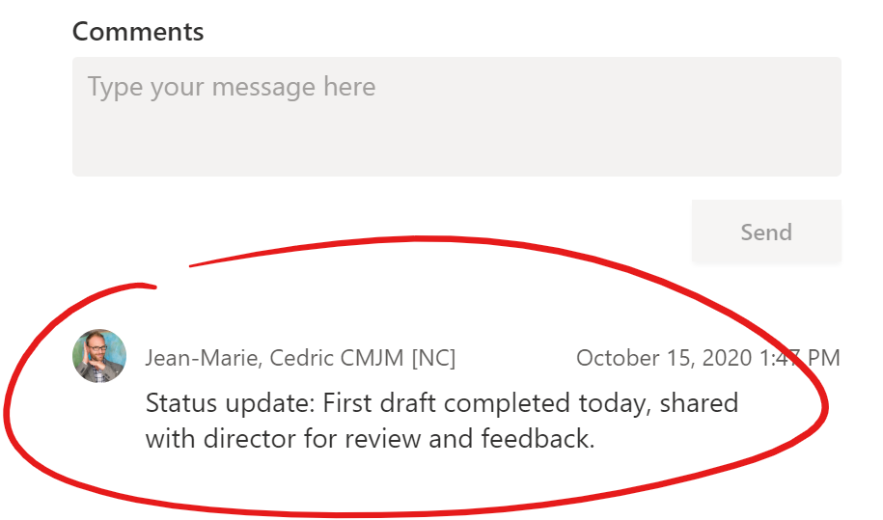
When comments are made on a task it can trigger a notification for all those who previously commented on the task. This is a design quirk that many have complained about and requested to change. To mitigate this issue, it is highly recommended that you comment on a task you are assigned to as soon as possible in order to get these notifications.
If anyone is looking for a status update on a task an effective way of checking on it is looking for one near the top of the comments’ history. If one does not appear submit a comment asking for an update, this will notify the assigned team member, so long as they have previously commented on their own task, to provide an update at their earliest convenience.
It is recommended that when doing a status update on a task to precede the update with Status update: to quickly help those looking for the latest news on a task to locate them, as was done in the above example. Timestamps are automatically added to every comment so no need to add a date and time of when you made the comment.

Copying tasks
As was hinted at in the label section with the mention of a Template label, tasks can be copied. Therefore, if a task is likely to be repeated on a regular basis it is best to design a task to act as a template to be copied whenever deemed necessary. The concept of a template task will be further elaborated on further below in the Templates section, so we will simply focus on how to copy a task.
You can quickly and easily copy a task you are viewing by opening the shish kebab menu in the upper right corner of the task by clicking on it and then selecting Copy task:
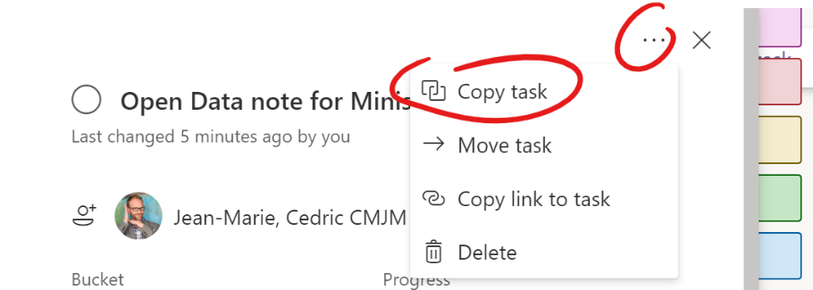
You can also do this directly from the board by also clicking on the shish kebab menu in the upper right corner of the task you want to copy and clicking on Copy task:
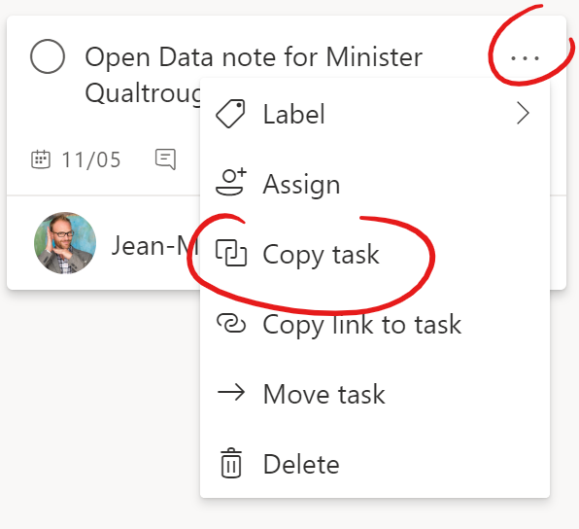
Selecting either option will present you with the Copy Task screen:
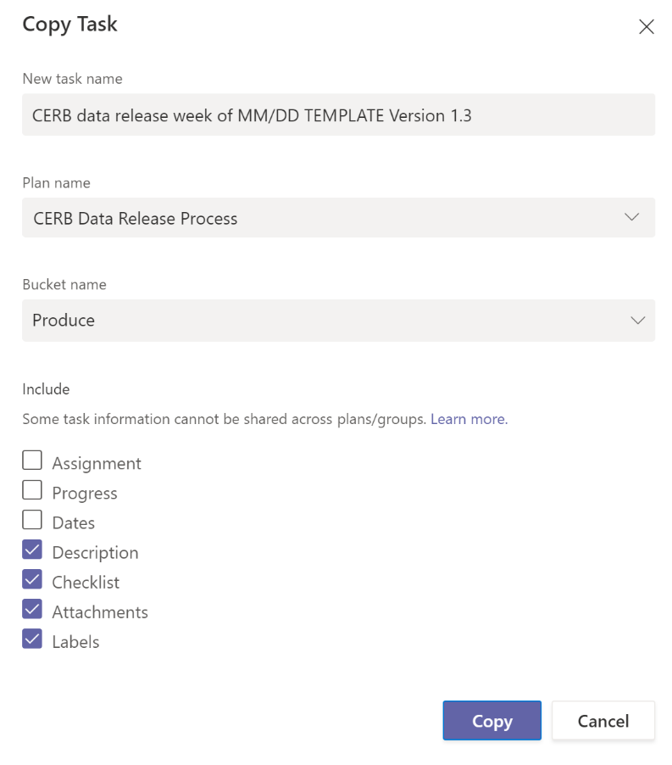
Let’s break down the above piece by piece to properly explain what exactly is going on here. The first thing you see is the opportunity to provide a New task name, by default it will auto populate this field with the task name you are currently copying, just click in the field and update the name accordingly this way when you are done copying the task it will already have the right name rather than having to do it after the fact:
Next you have the option of copying this task to another plan by choosing another Plan name, by default this field will be populated with the current plan that this task is being copied from. In most cases you will not touch this field:
The following field allows you to specify which bucket this task will get associated with upon creation, by default it is set to the same bucket that the copied task currently occupies. Click on the drop down and select the bucket you want this task to belong to:
Finally, you’ll have to choose which parts of the task you want to carry over to the new task.
- The Assignment option allows you to copy the team members currently assigned to the task being copied over to the new task.
- The Progress option allows you to copy the progress from the copied task, in most cases you will want this new task to start back at Not started so choose not to copy this.
- The Dates option will copy both the start and end dates from the task being copied, not something you will want but still possible if you desire.
- The Description is the Notes section from the task, if this has relevant information that needs to be carried over check this option, if not then turn it off.
- The Checklist option allows you to also copy the checklist from the current task being copied if there are any. Note that any items that are currently checked off on the original checklist will be copied over as is. It does not reset the checklist.
- The Attachments allows you to also copy any resources that were attached to the task. Check this option off if this is something you want.
- The Labels option allows you to copy all assigned labels from the task being copied to the new task.
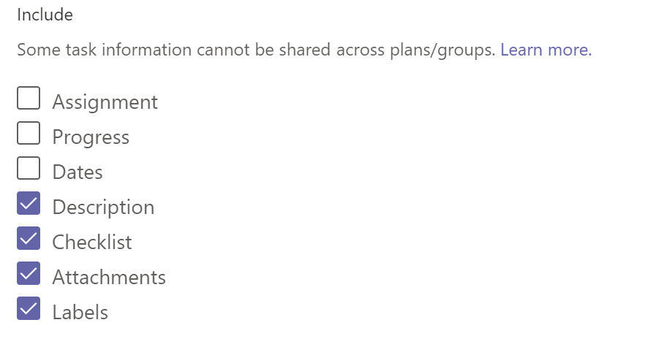
Once you’ve made your choice click on the Copy button to copy the task as you’ve set out to do. The new task will appear in the Plan you’ve selected, under the Bucket you’ve selected along with all the options you’ve chosen to carry over.

Moving Tasks
Sometimes you might need to move a task from one team’s board over to another, responsibility for that task is changing hands and you don’t want to lose any of the history on what’s been done so far. In these cases, you’ll want to use the Move task option.
Navigate to the task you want to move or simply hover over the target task and click on the shish kebab menu in the upper right corner and then select the Move task option.
This will present you with a Move Task window with two drop downs. The Plan name drop down allows you to pick the plan that this task should be moved to and the Bucket drop down will provide you with that plan’s buckets so that you may choose which bucket the task should belong to once copied over.
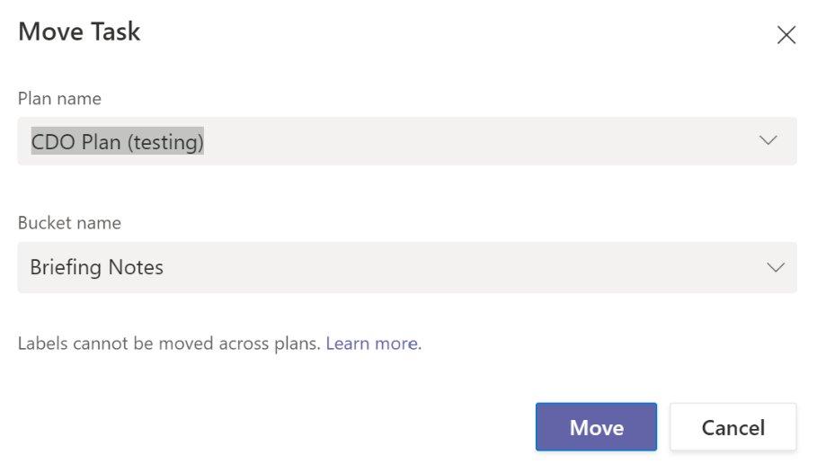
Once you’ve made your selections click on the Move button and watch the task disappear before your very eyes and be magically transported to the target plan and bucket you specified previously. Gotta love digital magic. If you have access you might want to navigate to that plan and assign the task to someone within that team to make sure it doesn’t fall through the cracks.

Notifications
In this day and age, we are all aware of what notifications are and quite possibly acutely bogged down by many of them. Well you aren’t going to like the fact that MS Planner also supports notifications, I suppose the good news here is that they are activated when it matters most:
- When a task is assigned to you (sent via email, Teams, and mobile); or
- When a task you are assigned to is either late, due today, or due in the next 7 days (email only).
You do have the power to turn these notifications off, however this is only recommended if you use your MS Planner board on a regular basis and absolutely don’t need the notifications. To access notifications, you will first need to navigate to the web-based version as you can’t access MS Planner notifications directly from within MS Teams. To do so from your MS Planner board in Teams click on the Go to website button in the upper right corner:
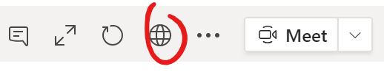
Once the page loads, you’ll want to click on the shish kebab menu near the top middle of the window and choose the Plan settings option in the sub menu that appears:
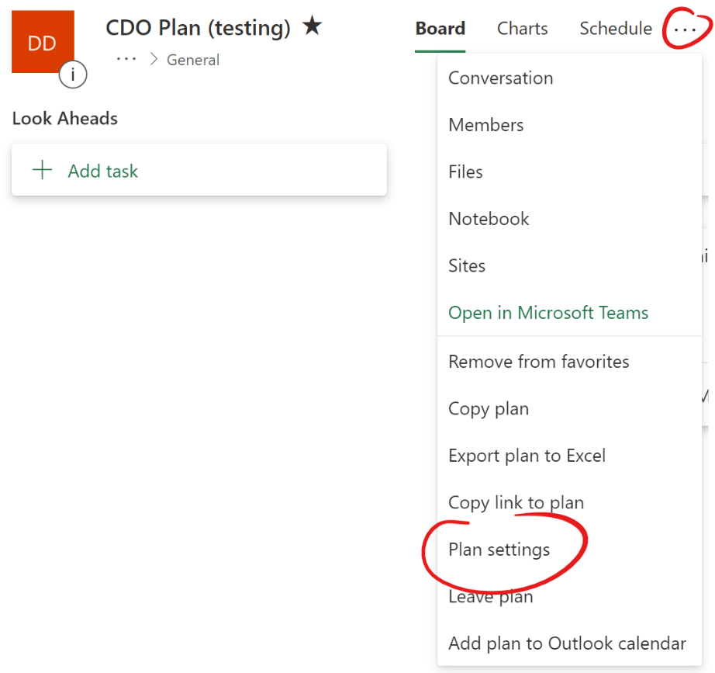
In the Plan settings window, you’ll want to click on the not so obvious notification settings link:
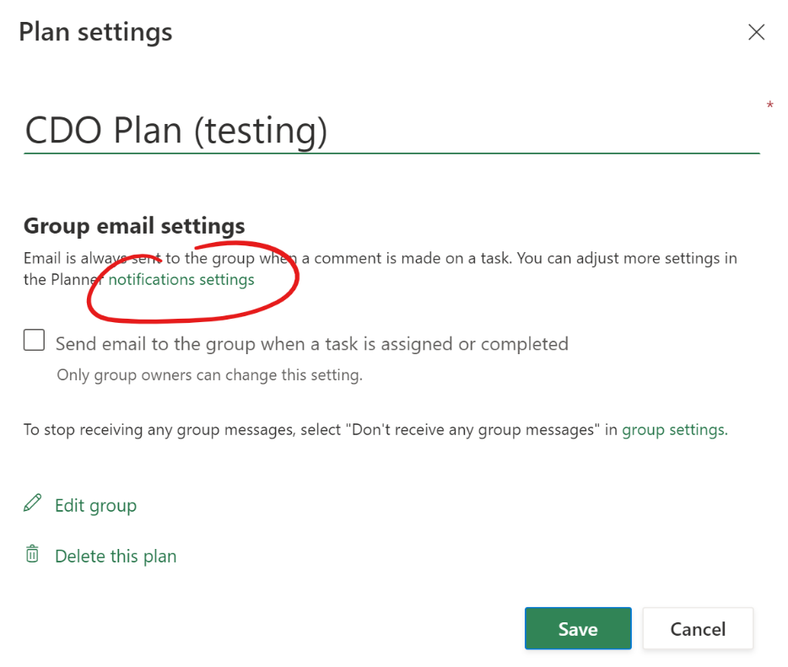
This will bring you the MS Planner Notifications controls for you within that specific board. You only have two options to turn on or off. The first turns on/off notifications when a task is assigned to you and the second turns on/off notifications when a task you are assigned to is late, due today, or due in the next 7 days. Once you have made your decision about what notifications to receive simply click on the Save button to make it so.
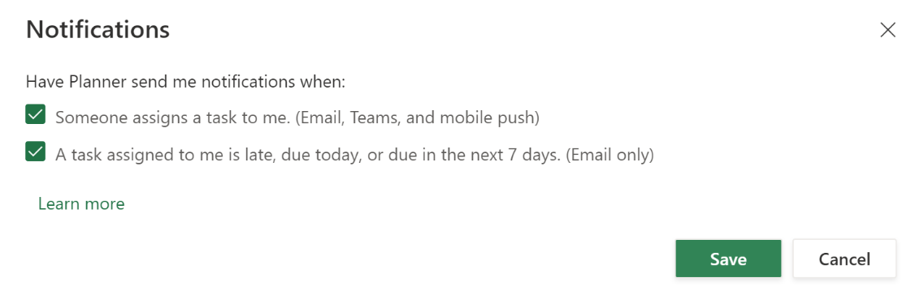

MS Planner views: Board, Schedule, List, and Charts
Now that we have covered all the individual components of an MS Planner plan it’s time to start looking at the broader features. Up until now you have been interacting with your plan entirely in the Board view, found near the upper right section of the screen:
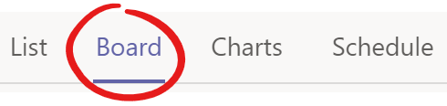
The other views allow you to view and sometimes interact with your tasks in diverse ways that might be more convenient in certain situations. The other views are:
- List – this view resembles an excel spreadsheet with all your tasks condensed into a vertical list you can scroll through and interact with.
- Schedule – this view is straight up a calendar view of your tasks; this allows you to see your tasks and their start and due dates plotted against a calendar.
- Charts – this view allows you to see several visualizations and charts that give you quick real-time metrics of your board’s tasks.

Board
The Board view visually displays your tasks as cards on what looks like a whiteboard. Think back to the Kanban board described at the beginning of this guide, this view mimics that look. You can group and filter the cards as you need but it will always present the tasks as cards that look like post it notes broken down by the grouping you have opted for. In the below example the tasks were grouped by Progress to showcase just how close it looks to the Kanban board:
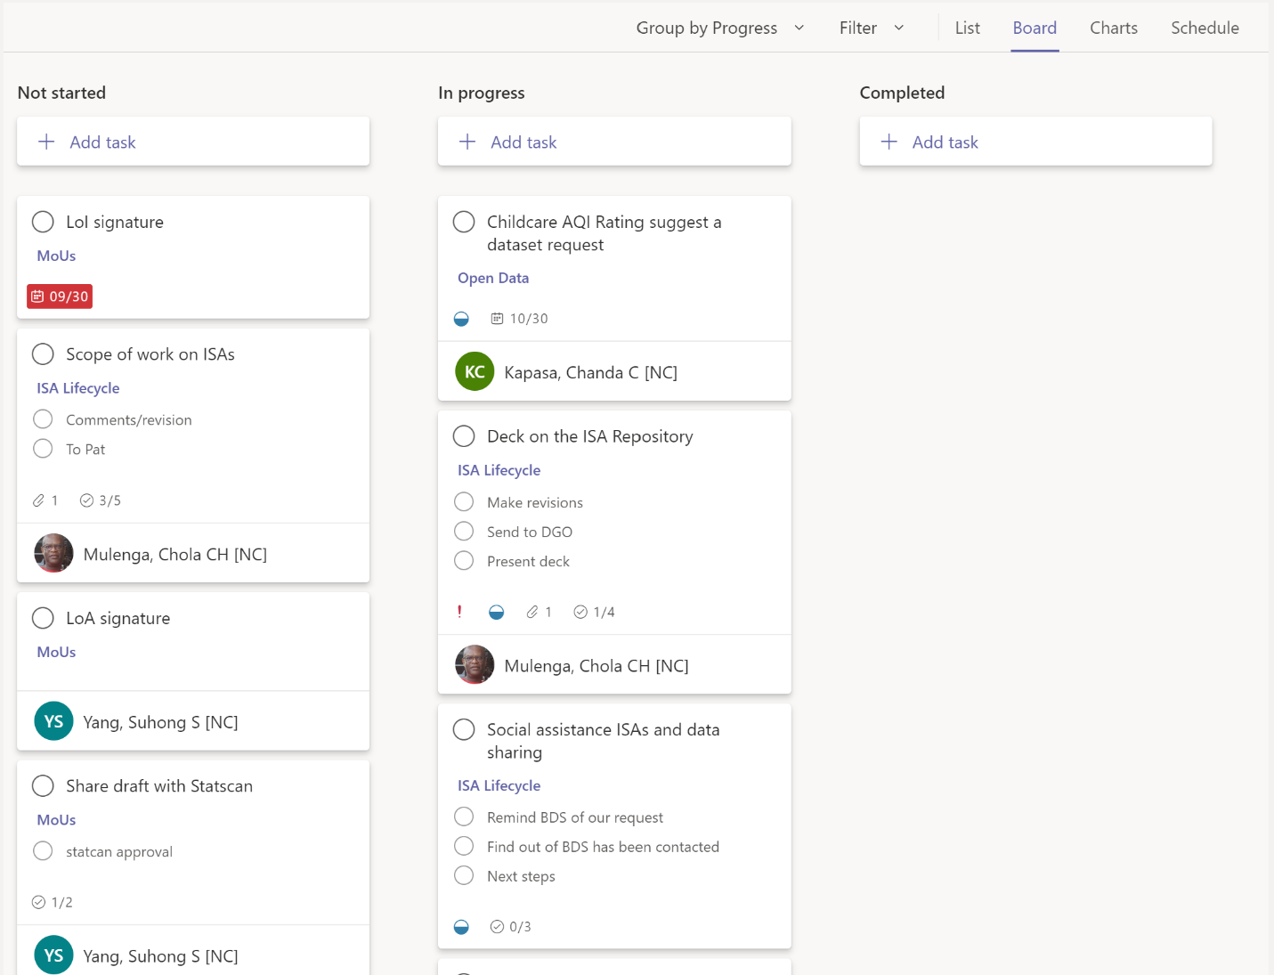

Schedule
The schedule is not only a way to see all your tasks plotted on a calendar in visual fashion but it also supports drag and drop functionality so you can quickly move tasks on the calendar which in turn adjusts the start and due dates within the task.
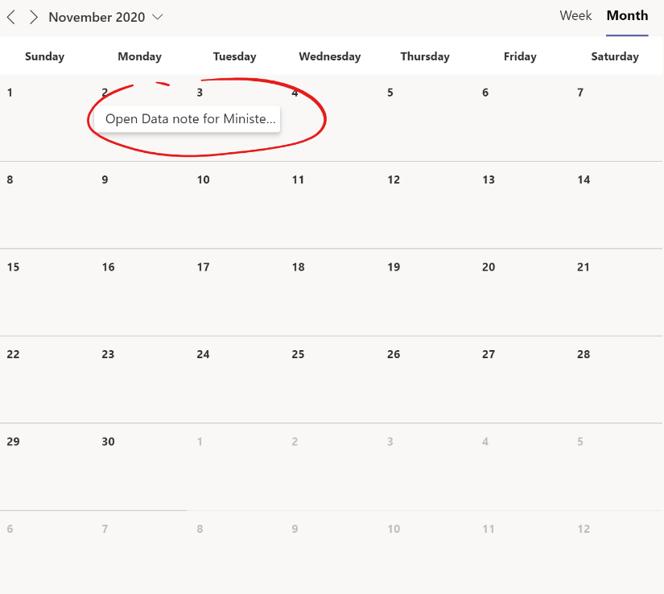
You can view your tasks on the calendar by Week or by Month. To switch from one to the other click on the desired option you want:
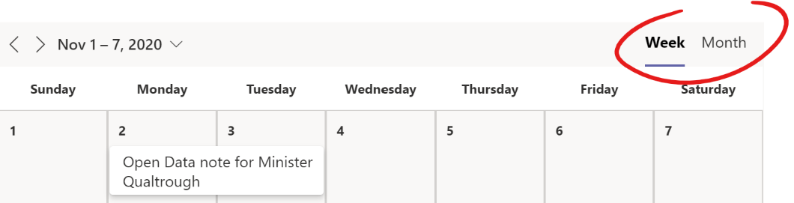
Notice in the above task that it spans multiple days visually. This is because the start date is set as November 2nd and the due date is set as November 3rd. Remember that these dates do not show level of effort in days, it is simply an indication that the task must be started at the earliest on November 2nd and is due for completion by November 3rd.
You can quickly and easily adjust these dates by dragging and dropping the task to the new dates. This will not change the length of time between the start and due date, this distance will always be respected when you drag and drop. If you wish to adjust that length of time you will have to go into the task by simply clicking on it like you would if you were in the Board view.
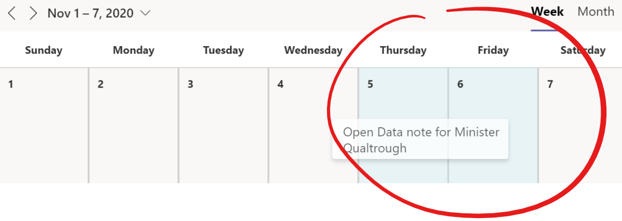
On the right side of the screen you will have quick and easy access to tasks on your board that have yet to be scheduled. Very handy for a manager looking to establish a team’s workload in a week. You will also be able to add tasks should you wish:
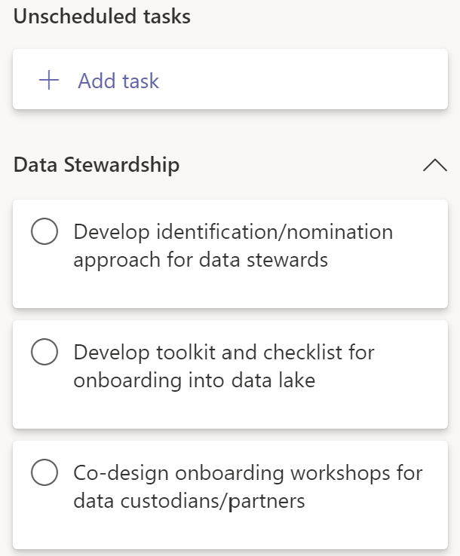
A wonderful way of using this view is by creating several tasks for your team and then using the schedule view to plot out the due date for each task by dragging and dropping it to the right date. This will afford you a visual way of seeing how everything lines up from a scheduling perspective.

List
The list view condenses a lot of what you see in the other views into a familiar spreadsheet look with rows being each task and the columns being the different values set for each task such as its title, who it is assigned to, priority, etc.
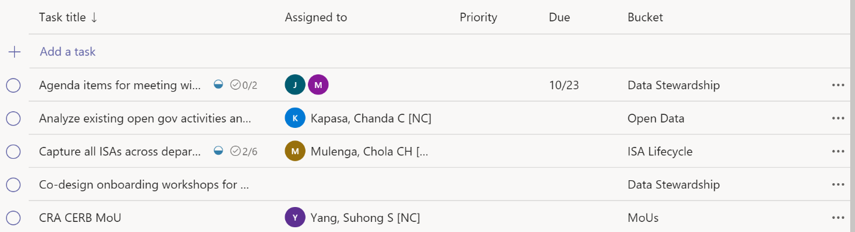
In this view you can sort the list of tasks by clicking on any of the column names at the top of the list. Currently in the below screen you can see it is sorted by the Task title:
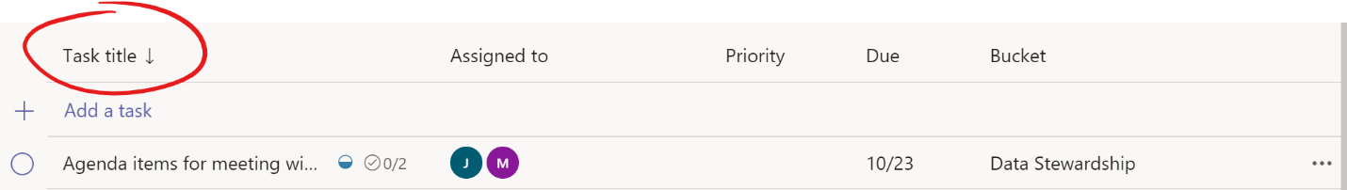
Like in most views you can also add new tasks by clicking on the Add a task link. Clicking on the link will place the cursor in the Task title column, after you enter a title you can Tab to the other columns you wish to also set, or you can always navigate and set them by mouse. If you tab to the next column and you wish to set it, you can hit Enter to explore your options. If you are in the Assigned to column it will allow you to search through your team members to assign the task to someone; in the Priority field it will drop down and show you the options you can select; in the Due field it will pop up the calendar picker, or you can hit the space bar here to type out the date; in the Bucket field the drop down will allow you to pick your value; and finally at the end you have the option of selecting either a checkmark or an X to either add the task or scrap it respectively. This approach is the fastest way to create many tasks and set their values at the same time. It certainly saves you a lot of clicking and mouse use.
To open a task and see all the details simply click on the title of the task. To quickly change the values of a card you can click on the shish kebab menu option at the end of the task you wish to modify:
This will allow you to set the Progress, Assign, Priority, and Due date fields as well as trigger the Move task, Copy link to task, and Delete functions.
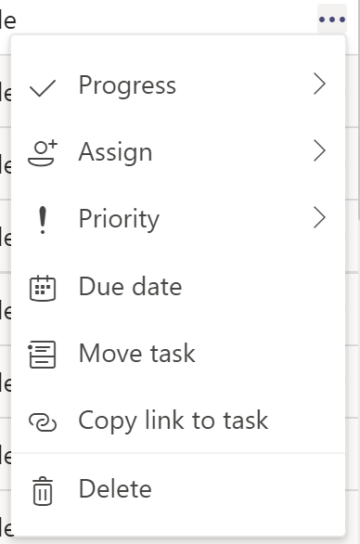
This view is only available through MS Teams so if you choose to work through the browser you won’t find this view in the options.

Charts
The Charts view is quite different than the other views covered so far because in the other views the purpose is always to allow you to interact with your tasks in diverse ways. The Charts view is more focused on reporting and giving you a visual way to see progress across all tasks.
The first two visual breakdowns you will see when clicking on this view is one by Status, this is the Progress field in a task, and the other by Bucket. As you will see in the image below the different Progress states are colour coded and quickly highlight where things are at in the different visualizations.

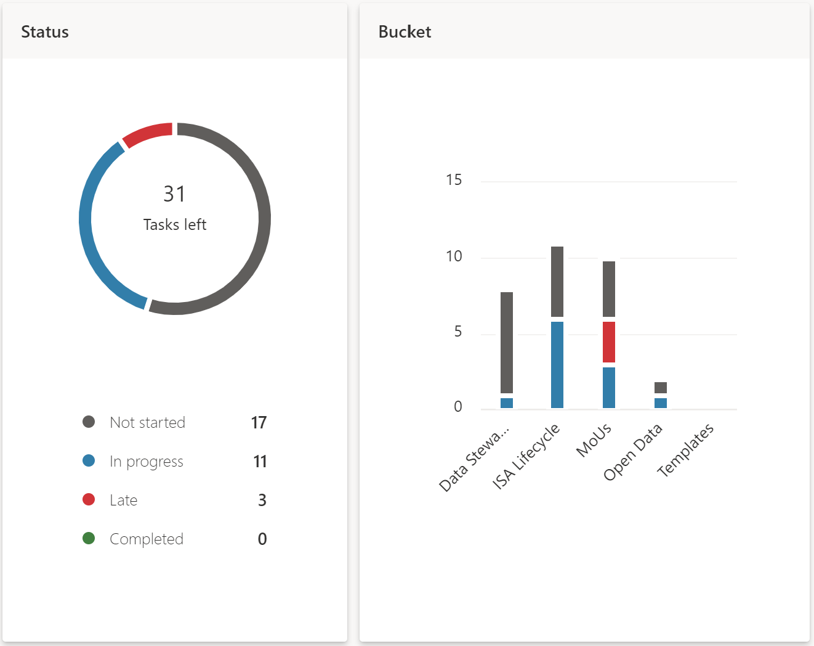
The Status chart shows you how many tasks are in each Progress state, in the above example you can quickly see not a lot has been Completed and actually a few tasks are Late. The Bucket chart shows you those same metrics but broken down by the Bucket categories you created for your board.
This view will primarily be of interest to managers, project managers and some senior executives as this birds eye view gives you a quick sense of how things are progressing in each team.
If you scroll down past the first two charts you will also see a similar breakdown by Priority:
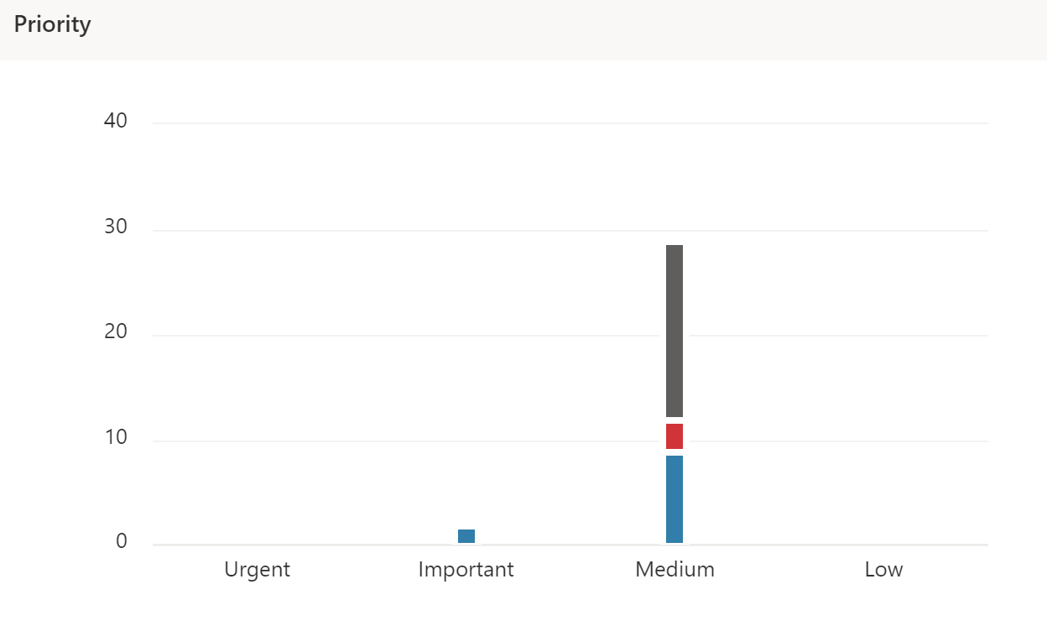
As well as a breakdown by Members, could be useful to quickly spot workload issues:
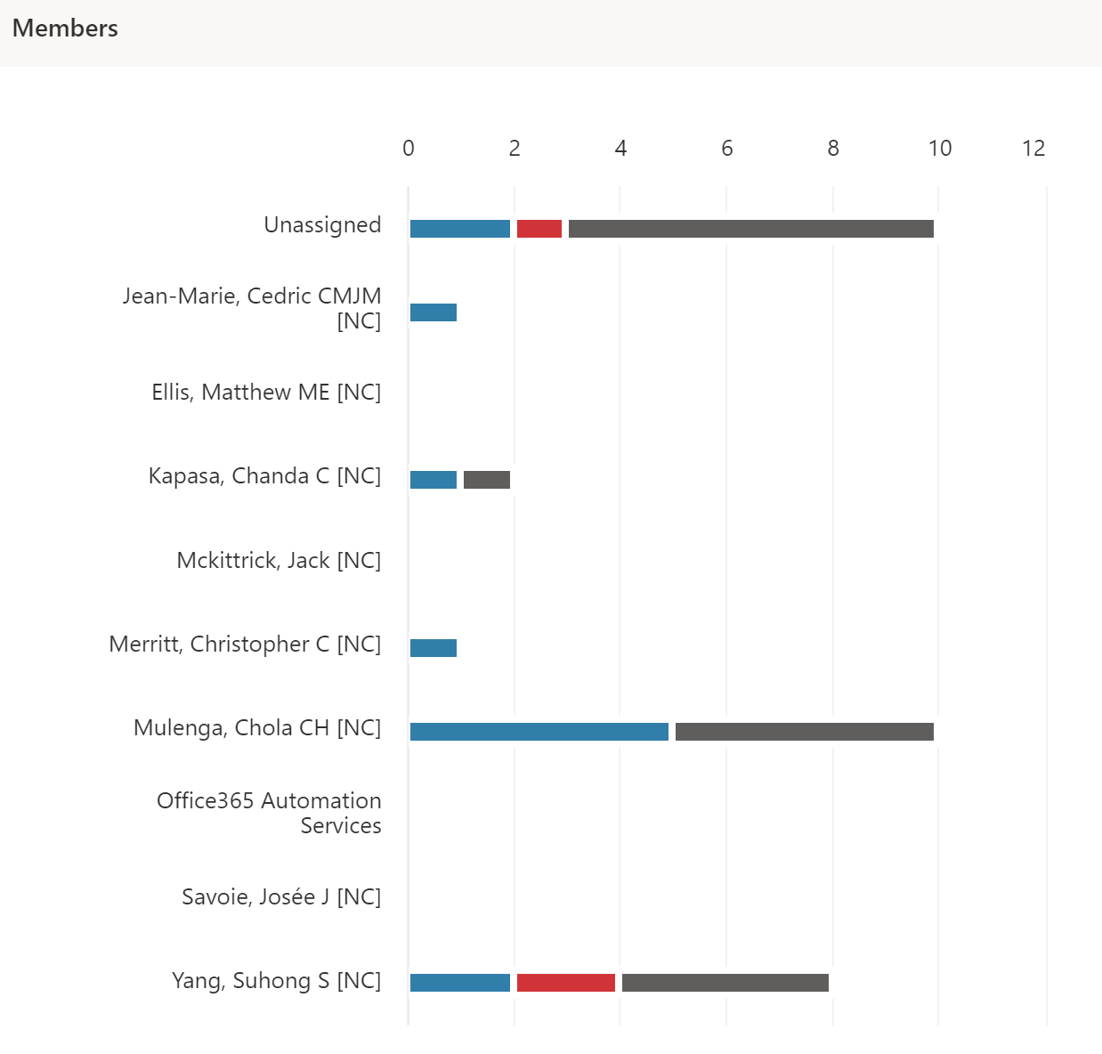
As with all other views you can still access all tasks on the board from the right-side panel as well as create new tasks. So, if you spot some things through the charts like one team member who seems to have too many tasks assigned to them you can easily shuffle things around from there:
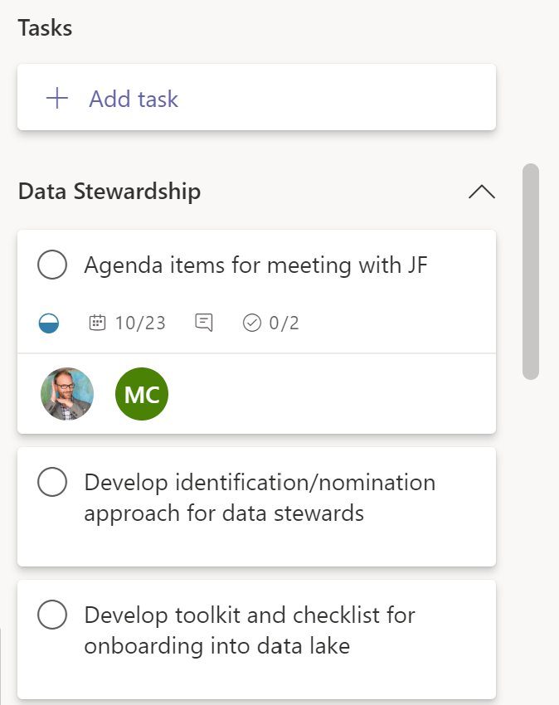

Grouping & filtering
In most views discussed above you always have the possibility to group and filter the tasks you are looking at. The Group by and Filter functions are found to the left of the views:
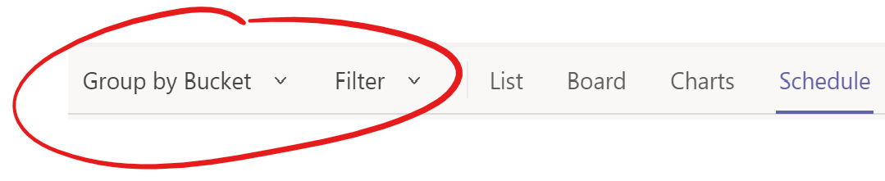
Combined they allow you to focus the tasks that appear in your view to the ones that you are currently interested in.

Group by
Grouping allows you to group tasks together based on a specific field such as by Bucket, Assigned to, Progress, Due date, Labels, or Priority.
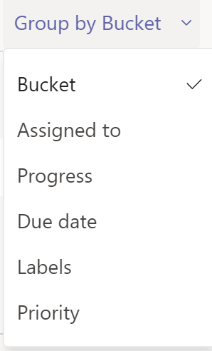
In the Board view this arranges the columns you see on the board according to the option you have selected. A very practical grouping that you will use often is by Progress:
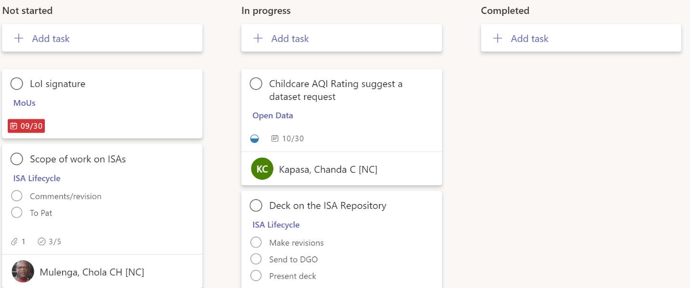
When grouping in Board view moving tasks from one column to another by dragging and dropping will change the value of that task based on the column you moved it to. For example, if you have grouped by Progress and you move a task from the Not started column over to the In progress column that task’s Progress will now be set to In progress. Remember this when you want to quickly move things around on a Board.
Another useful grouping is by Due date, this shows you tasks that are Late, due This week, and due Next week. If you are trying to plan out your week this could quickly allow you to see where your focus should be based on deadline.
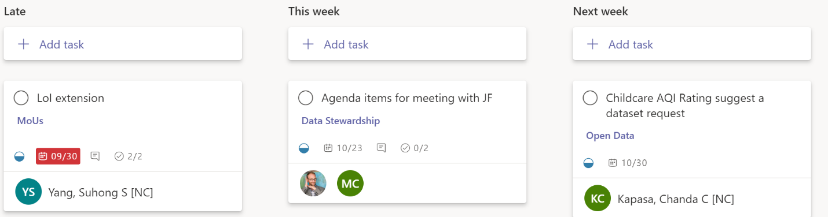

Filter by
Filtering the tasks that appear on a board allows you to see the tasks you are currently interested in. This can be handy if you are hosting a team meeting and want to get a status update for tasks that are late from members of your team that these tasks are assigned to. To do this just click on the Filter option and select the Late filter option:
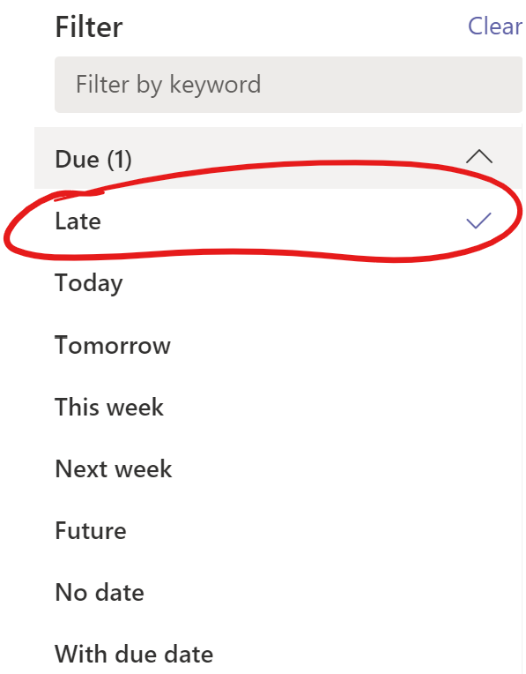
You will see that there are quite a few options under the Filter menu, they are grouped under these expandable and collapsible groupings: Due, Priority, Label, Bucket, and Assignment:
Filtering
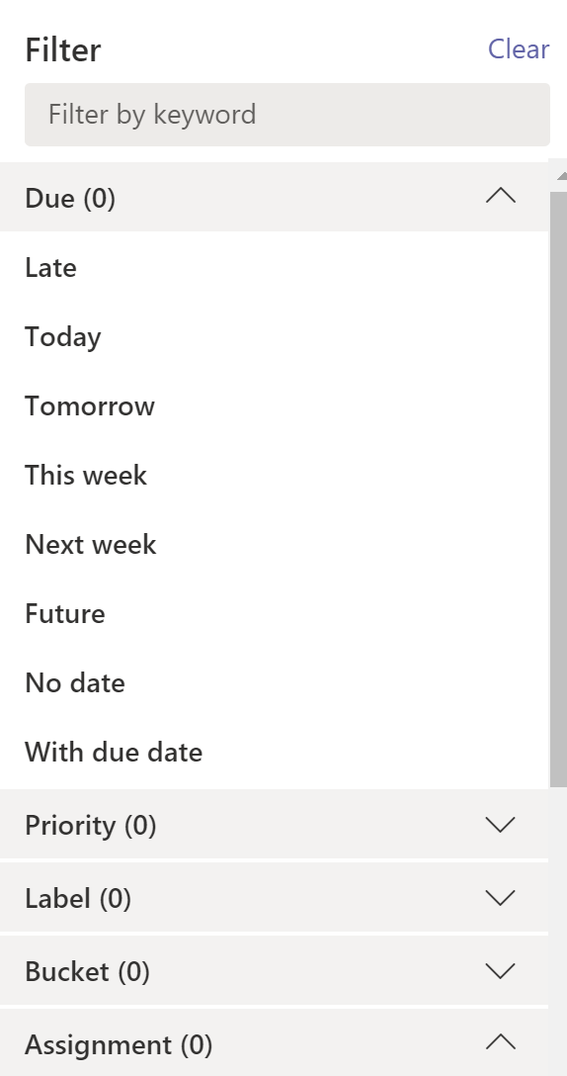
You can choose as many options as you want to narrow down your tasks. For example, filtering could be used if you are looking to see the status of any tasks due this week from a specific member of your team or yourself.

The MS Planner app
For the majority of this guide you have been interacting with MS Planner through MS Teams and this was deliberate, rather than be forced to bounce around from app to app this tight integration between MS Teams and MS Planner allows you to continuously communicate and collaborate with your team and your colleagues across the organization while also manage your work together seamlessly.
It might dawn on you at this point that with wide adoption of MS Planner across your organization you might find yourself with many tasks from different plans and that this might become somewhat burdensome for you to manage over time. To address this issue there is an MS Planner app you can add to your MS Teams app that allows you to focus on the tasks that are assigned to you and you alone no matter which plan they come from.
So, let’s get you set up with this sanity saving app and make you more productive at the same time. Go to your MS Teams desktop app and look to the left menu options that appear on vertical panel:
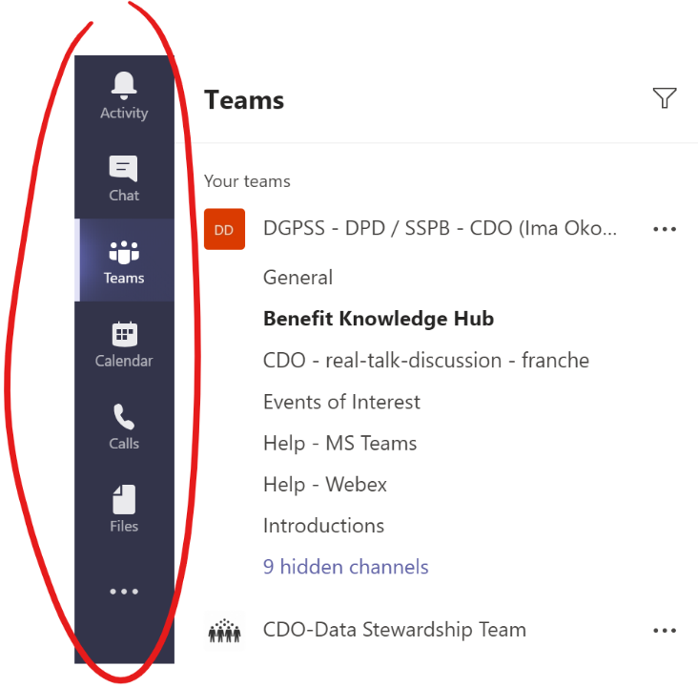
You likely spend a lot of time switching between the Chat and Teams options in this menu to chat privately with your colleagues or discuss with your team and colleagues openly. To add the MS Planner app you’ll want to click on the shish kebab menu found at the bottom of these options which will likely be after the Files option if you have no other apps installed:
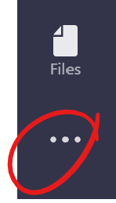
This will pop up a little window that allows you to either search or browse the available app integrations in MS Teams.
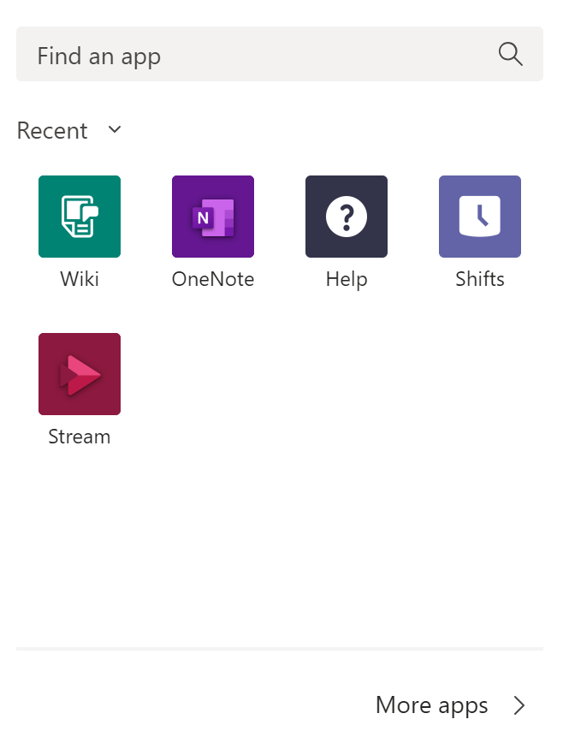
Click in the Find an app search box and type planner, this will narrow the apps available to the one we are currently interested in. You can either hit Enter or click on the Planner app option that appears directly below the search box to proceed:
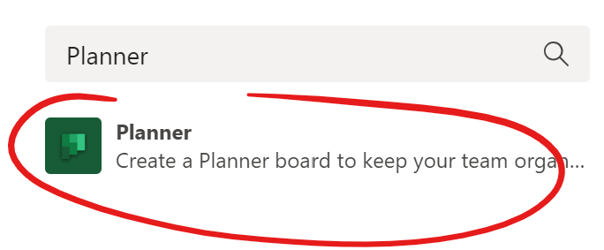
This will present you with an app installation screen. Click on the Add button in the upper left section to install the MS Planner app in MS Teams: 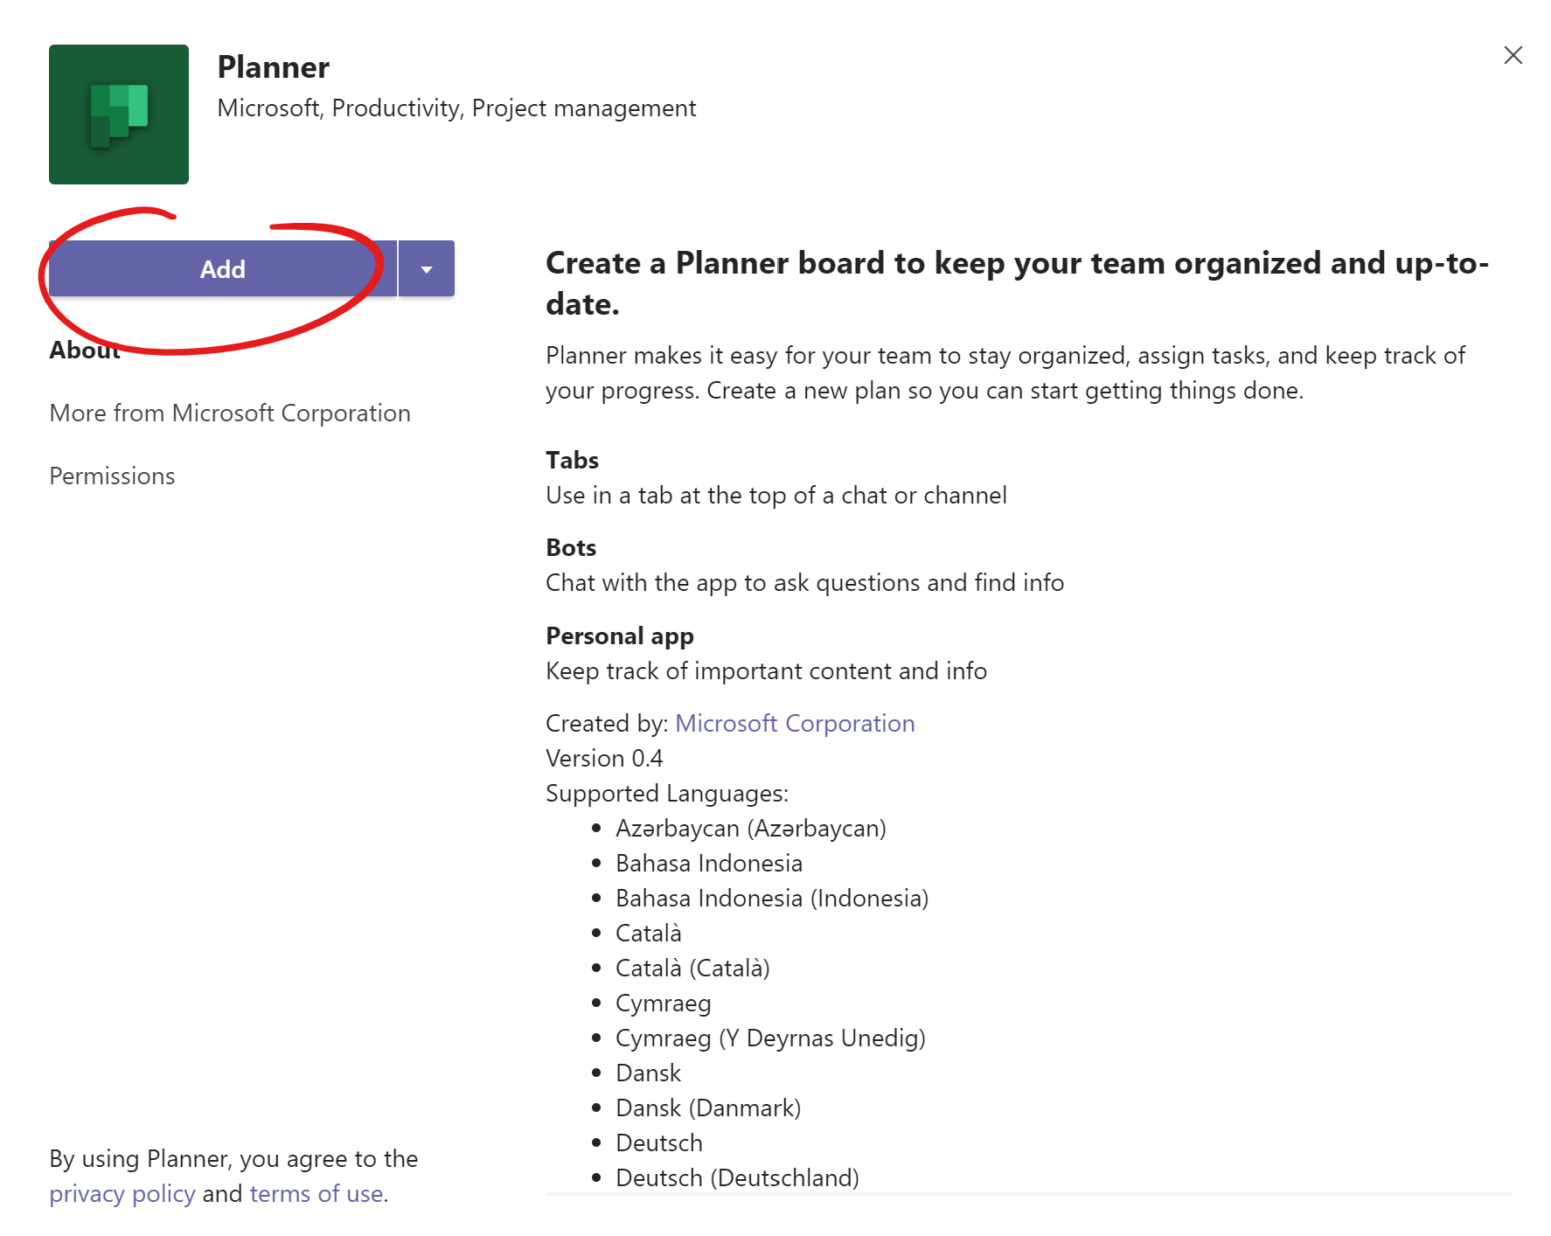
This will also add a new menu option in that left vertical menu panel, this is the MS Planner icon:
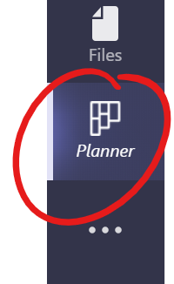
This alone will not ensure that it appears here each time you start up MS Teams so to not lose this icon in between your work shifts right click on the icon to be presented with a menu and choose to Pin this menu option to the vertical menu. This will ensure that this menu option stays there for you with each new work session:
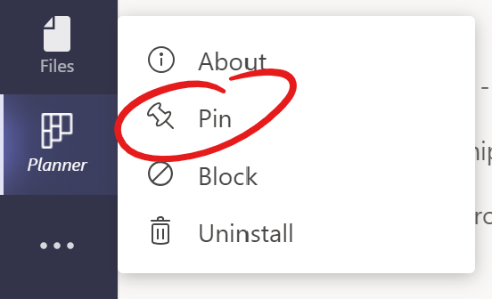
Ok, now that you’ve added the app, how does it help you? Well, this is like the one view to rule them all. It is a super focused screen that allows you to see all the tasks across any plans that have been assigned to you presented in a similar fashion to the List view covered above:
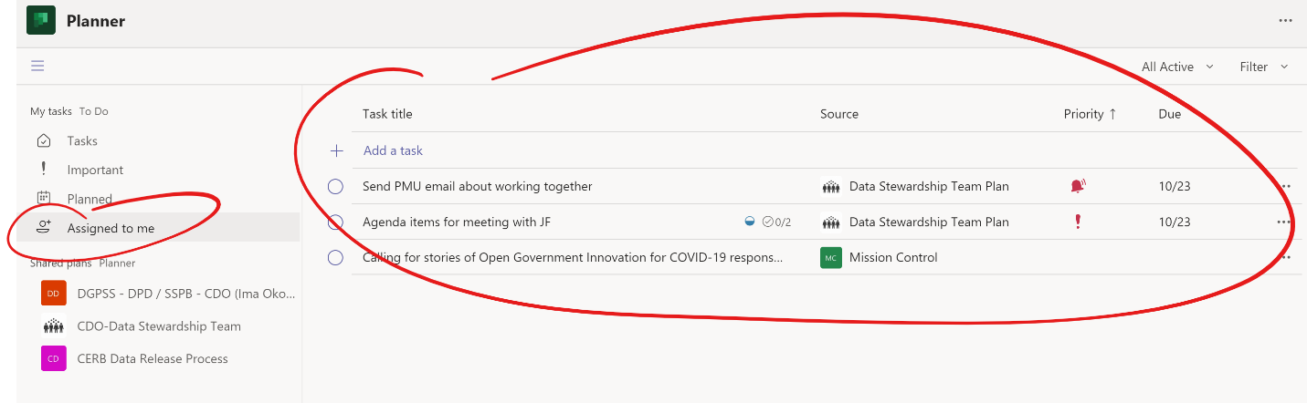
Where tasks come from can be seen by looking at the source column:
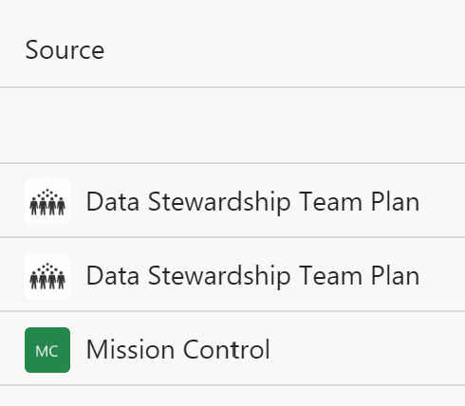
You can also see the priority and due date of each task. You also have access to some filters, in here you can only filter by Due date and Priority however:
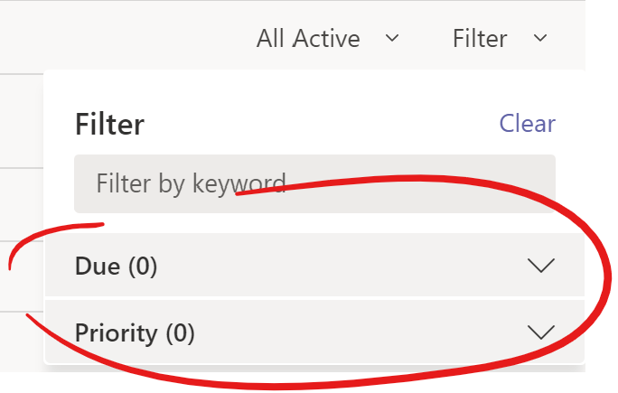
In the app menu on the left you can also change the focus of your tasks, two handy options are the Planned and Important views. In the Planned view it will surface all tasks assigned to you that have due dates assigned:
In the Important view it will surface all Tasks that have a priority of either Urgent or Important. This is a quick and easy place to see what you should be focusing your efforts on immediately:
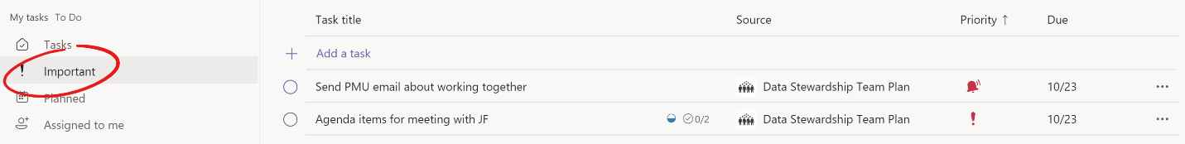
You can see the details of any tasks by clicking on the title of the task at any time and you can always add more tasks as well by clicking the Add a task link. The only difference here is that you’ll have to choose the source, the plan, this task will belongs to once created.

Reporting
The need to report on progress is necessary in all team-based work. It is much easier to carry out in small teams then it is in large teams or a team of teams. In this section we will explore a couple of ways you can track progress in MS Planner.

Export plan to Excel
We’ve already seen some basic ways to quickly gauge progress through the Charts view covered above but what if you want to create your own visualizations or feed into a larger project plan. In these instances, you’ll want to make use of the Export plan to Excel option that is only available from the browser-based version of MS Planner. To quickly get to your board in your browser from MS Teams, navigate to your board tab and then click on the Go to website button in the upper right section of the screen:
Once the site opens and is loaded, you’ll want to click on the shish kebab menu beside the board views and click on the Export plan to Excel option:
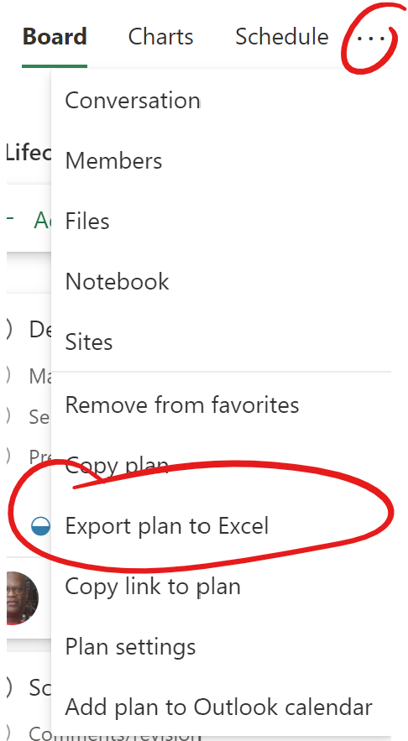
This will prompt you with a window that will allow you to navigate to where you would like to save this file on your computer. Choose a place you will remember and can easily access, name the file as you see fit and click on the Save button:

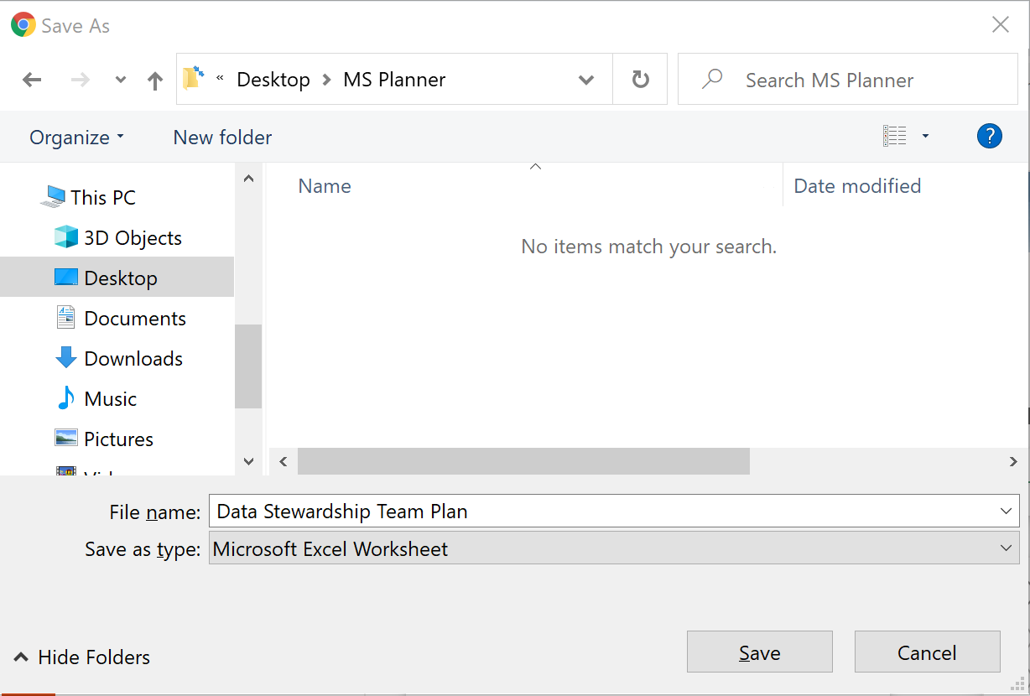
Once the file is saved when you open it you will be able to interact with your plan data as you would with any other excel file. Notice the 3 rows of metadata near the top which tells you which Plan this data comes from, the Plan ID, as well as the date of export. Separating this metadata from the plan data is also a blank row. If you want to turn on auto filtering in excel you will need to remove these 4 rows first. 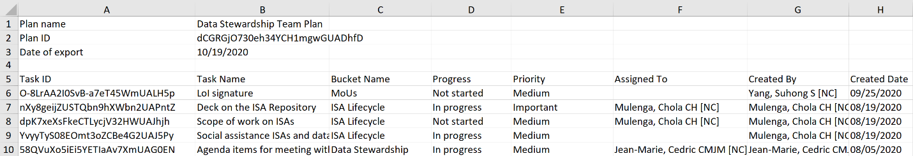
This way the first row will now be all the heading names, now if you turn on auto filter it should do so for each heading:
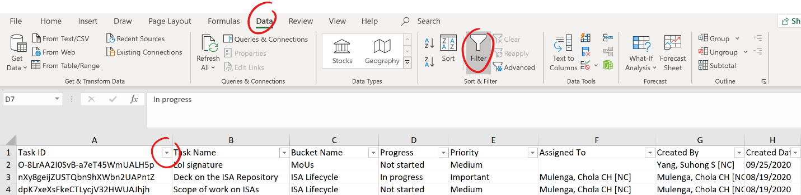
From a reporting standpoint there are few columns that should interest you most. The Completed column; which is a date automatically captured by the system when this task was marked as completed;, the Due Date column, and the Late column:
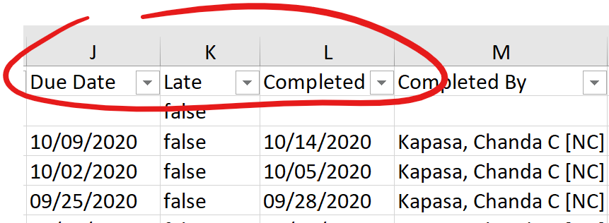
You should be looking to provide an update on all tasks that were completed since your last update, and whether some of these tasks were delivered behind schedule and why. For example, if you are reporting on your team’s activities during September you will want to filter out all other months and look at the tasks due and completed during September.
If you are looking to garner more details about a particular task you can always go back to your plan in MS planner and open the task to look at the Comments section for the latest status updates given by the assignee. If none are there you can prompt that team member to supply one ASAP.
You can also generate your own charts off this data using Excel’s capabilities on this front. With a year’s worth of data from multiple teams you can start to imagine many different possibilities when it comes to charts as this data is highly structured and even with the ability to define our own buckets across different teams it remains possible to combine all our data together to paint a horizontal picture of our activities over time.
This is the kind of data and possibilities we are losing out on when we are all left to our own devices to create our own trackers or manage our work through emails.

Planner Hub
It is possible that some people might be interested in seeing other team’s plans to see progress or the status of a particular task, such as a senior executive. If you find yourself in such a position you can always navigate to another team’s plan and check out the Charts view or inspect the task you are specifically interested in, so long as you have been granted access. If you do not have access just ask the team manager to give it to you. Remember that access is granted based on if you are a member of the MS Team the plan is created under, so adding you to the team will take care of granting you access to the plan.
Provided you have access to all plans you might be interested in a feature called Planner Hub in the web-based version of MS Planner that is not available from within MS Teams. To access it navigate to the web-based version through any MS Planner plan from MS Teams by clicking on the Go to website button in the upper right section of the screen:
Once within the plan in your browser you’ll see the Planner hub menu option in left side panel:
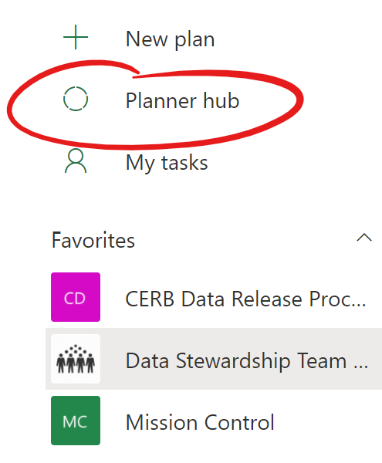
Click on Planner hub and you should see the Status visualization for all your favorite plans:
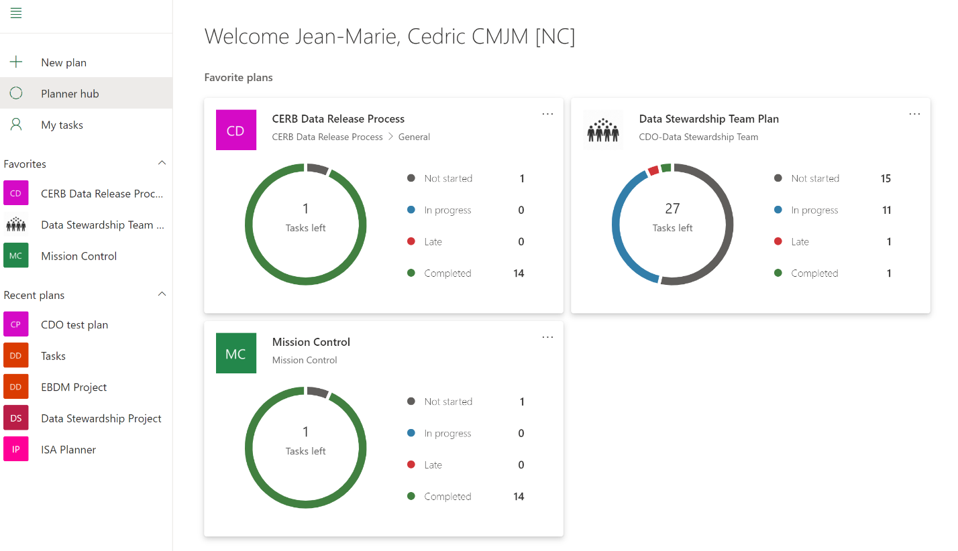
By clicking on a visualization, it will take you directly to that plan where you will be able to explore using all the views as well as the option to export that plan’s data to excel. Below this section you will also have access to any Recent plans you have visited as well as All plans you have access to:
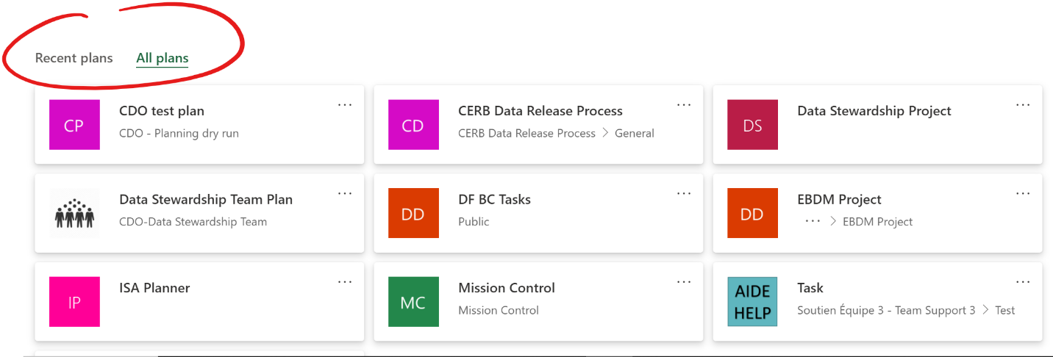

Tips and tricks
You’ve now just gone through all the major parts of MS Planner from creating your very own plan to managing and working on tasks assigned to you. In a few instances some best practices and unique uses of this tool were suggested above, in this section we will unpack some useful techniques that are recommended should they apply in your work.

Templates
It was suggested under the Labels section that one of the labels be titled as Template. The idea and purpose of doing so is to capture repeatable tasks that occur frequently in the work that we do and allow us to simply copy this template task to create an actual task with all the necessary details (notes section), steps (checklists), as well as resources (attachments) needed to complete the task.
A task that is labelled as a Template will never be assigned or completed but rather it is there to be copied as often as necessary to give assignees everything, they need to complete a task with as little help or supervision as necessary because everything they need to know or do is explained in the Template.
An actual example of this in action is the Template task that was created for the Canada Emergency Response Benefit (CERB) data release process over at ESDC. On every Friday during the CERB program, data was simultaneously released to the Canada.ca CERB statistics page and the open data portal. The process of doing this was very linear and was followed each week by several ESDCC team members across a few teams.
Rather than create a task for this work from scratch each week a template task was created and labelled as such so that no one accidentally mistook it for an actual task. The Notes section described what needed to be done to use the template but also what needed to be done to complete the task; the checklist detailed the steps to be completed by each team at each step of the workflow, and the attachments linked to the relevant resources to help team members accomplish the task with more detailed instructions.
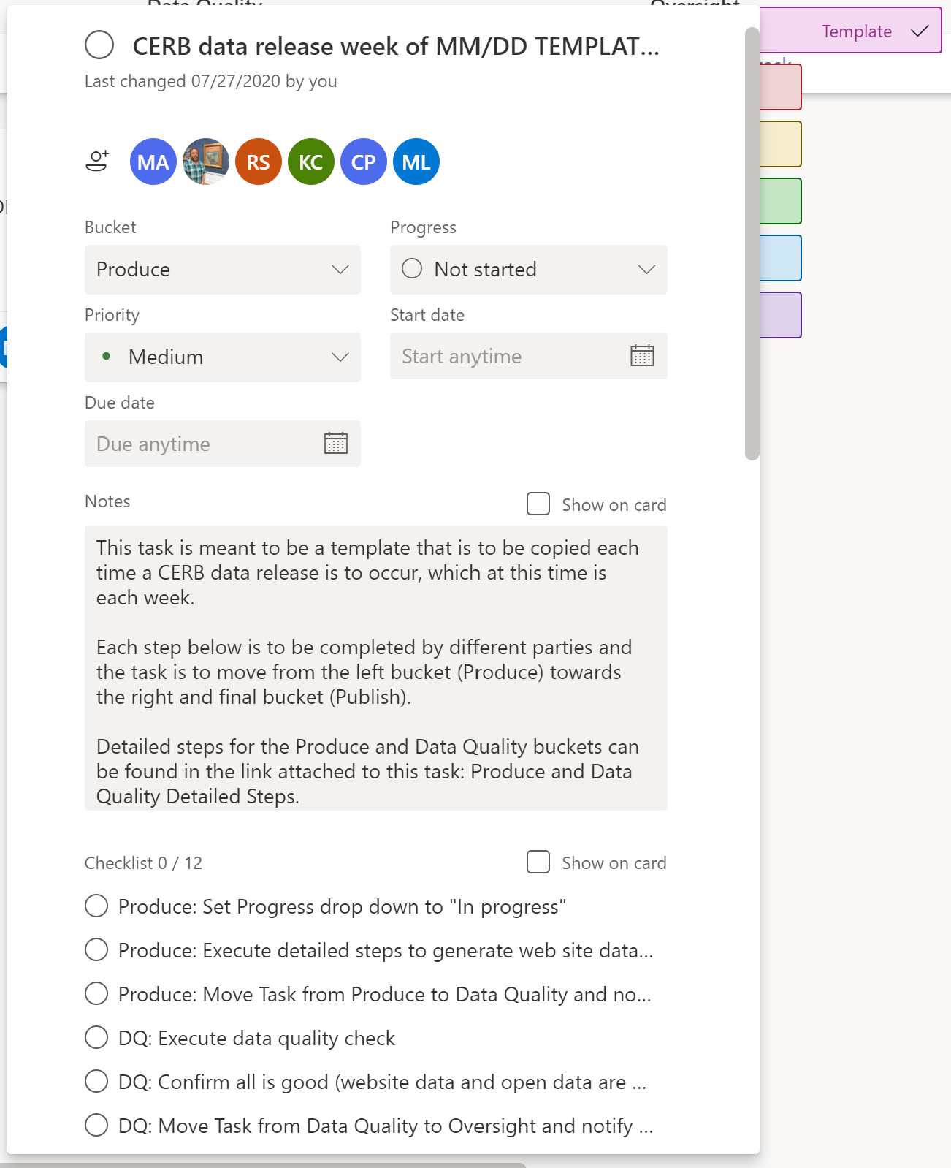
This can be applied to many other use cases such as drafting briefing notes, completing ATIP (Access to Information and Privacy) requests, and the list goes on. Take some time to think about your very own team’s work, are there instances that fit the pattern described above which could use this approach? If yes, then you should consider building your very own template. And remember that the template is free to evolve and improve over time so don’t worry about getting it perfect from the outset. Just be open to feedback over time and update the template when it makes sense.

Workflow buckets
In the above section on Buckets the primary use for them is to cluster similar tasks together so if you have 3 distinct projects in your team you would have 3 separate buckets to cluster the work by project.
Another less obvious use of buckets is to create a workflow that is to be followed in a process. In this approach tasks would be created in the left most bucket which would be equivalent to the start of the process and as work is completed against each gate in the process it would move from one bucket to the other from the left towards the right.
This approach was also used when creating the CERB data release process MS Planner plan. As explained previously data for the CERB program was released on a weekly basis to both the Canada.ca site and the open data portal. This activity could be divided into 4 discreet areas of work from a workflow perspective:
- Produce – this was the work required to produce this week's data;
- Data Quality – this was to check that the numbers produced in the previous step were accurate and contained no mistakes;
- Oversight – this step was to ensure that the prior steps were followed and once confirmed give the green light for the final part of the workflow; and
- Publish – this step takes the data that was produced and examined and publishes it externally once it has gotten the ok from the Oversight step.
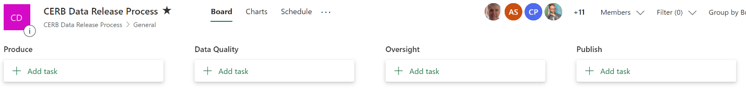
The use case for this approach is less frequent as not all work follows a well-defined process to completion. In instances where it does exist, and you want to have some form of traceability and some data to point to for audits or evaluations this can be a unique way to do just that.

Mobile
As is the case with most Office 365 apps MS Planner also has a mobile app which gives you access to all the functionality described above directly from your phone. This capability is incredibly useful for team members who are often on the go and not at their desk. This allows you to check in on your tasks, your team, and your progress no matter where you are. The guide will not go into details about how everything functions from a mobile device but if you are comfortable with MS Planner and how it all works either via MS Teams or your web browser than you will find it intuitive off your smartphone.
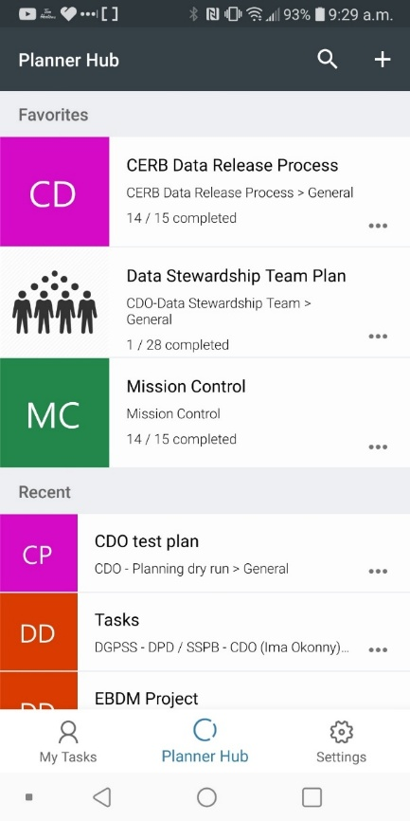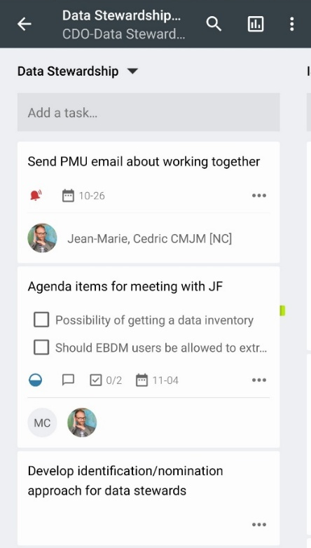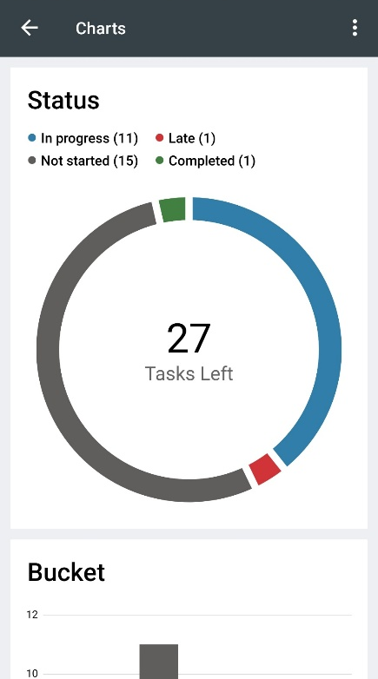

Additional resources
Can’t get enough of MS Planner? Well lucky for you below you will find a collection of resources that people have found useful with helping them learn MS Planner and how to best leverage it.

Description | Link
Collaboration Coach – Get the Best Out of MS Planner (Youtube Playlist) | https://www.youtube.com/playlist?list=PLvFpuOcSazL7pL0nbQBJnIecLk_Ish78k
MS Planner: A lightweight project management application for the Office 365 enterprise (Blog) | https://medium.com/@willkelly/microsoft-planner-a-lightweight-project-management-application-for-the-office-365-enterprise-e43b34413e48

