Access and action pending leave requests
(for SST Vice-Chairpersons)

- Log in to MyGCHR (consult the Logging in to MyGCHR for the first time job aid if this is your first time logging in).

- Use the following path: Main Menu > Manager Self Service > Time Management > Approve Time and Exceptions > Absence Requests
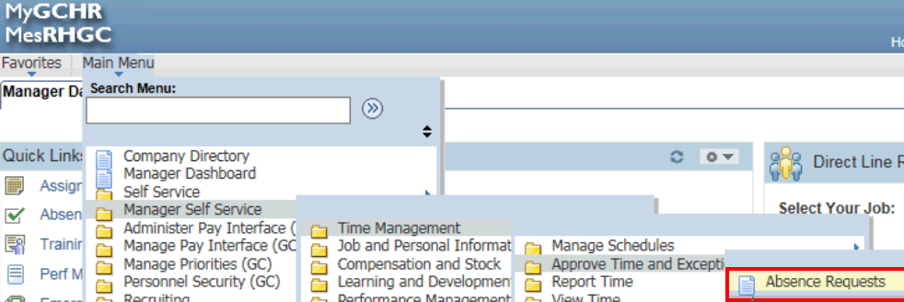

- Click on the member’s name in the Absence Requests table.
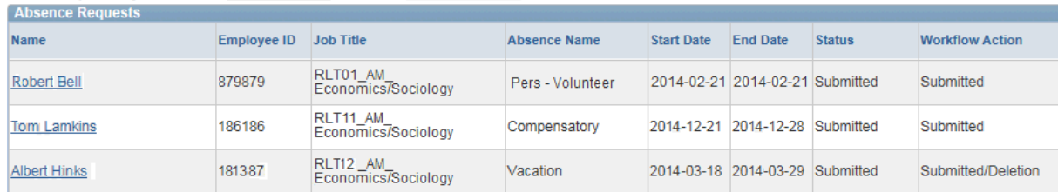

- Click on the Forecast Balance button to determine if your member is eligible to take the leave submitted.

- If the member is eligible, and if you approve the leave request, leave a comment in the comments section, e.g., “I approve”, then scroll down to the bottom of the page and click on “Forward”. If you do not approve, simply click on “Deny”.

- If you approve the request in principle, forward the request to an employee in Member Secretariat (see current list). Click on the look-up button to search the name. Select the appropriate name from the look-up list, then click “OK”.

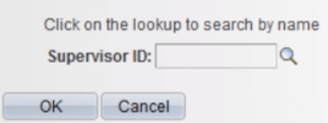

- Click on “Yes”
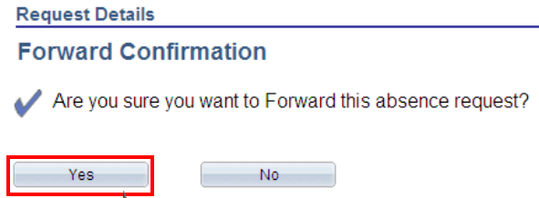

- Click “OK”
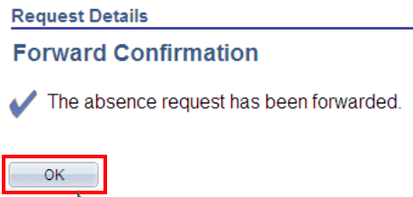

Note: By forwarding the request, it is understood your wish is for the Executive Director to certify (“Approve”) the leave.

