vExpo Kiosk Content Submission Form

General Instructions  After reviewing the vExpo Content and Design Guidelines, fill out the fields below with the final links and text to be used in the kiosk.  - You may need or want the kiosk to reflect your departmental branding and/or the program’s look and feel. If so, make sure to send us the required image source files in vector format (.ai, .eps, .svg, etc.), and branding guidelines along with this document (when available).  - Provide the content and material as soon as available, and no later than the agreed-upon deadline. Content sent past the deadline may result in our inability to include the kiosk in the events (where applicable).  - Once completed, submit this document and file attachments to csps.digitalacademyvexpo-vexpodelacademiedunumerique.efpc@csps-efpc.gc.ca.  Kiosk Anatomy  Before filling-out this form, please take a look at the image below. This is what a virtual kiosk design looks like. You can refer to this image while filling out the form.  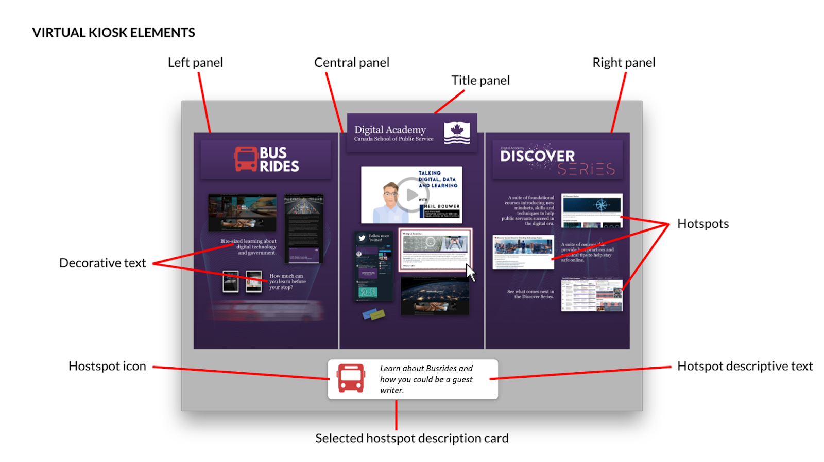 | Kiosk Information  Organization / Department :  Point of contact (name and email) : Name: Email:  Kiosk Title (EN and FR): EN: FR:  Visual Style Reference URL(s) :  (Visual Guides, Branding Norms, Comms Pieces, etc)  Content Accessibility  As per the vExpo content requirements, your content linked from the Hotspots in your kiosk must be available on the Web, in both official languages and be accessible. Please confirm the following: YES NO  Can the links to your kiosk content be accessed by the public (outside of your organization's firewall)?  Is your content accessible; readable using assistive technology, alt text, transcripts, closed captions, etc.?

How to Fill Out the Hotspot List
A hotspot is typically represented by an image or a decorative text, or both. If an image provided needs to be used as is, mark it as required in the field below. All text, images and URLs need to be provided in both official languages. | Once the final kiosk design is completed, it will be incorporated into the 3D kiosk. When a user interacts with that hotspot in the virtual kiosk, a description card appears at the bottom of the kiosk with an icon and description text (call to action). The text from this description card is the text that will appear on the accessible and mobile version of the kiosk. | When the user clicks on a hotspot, they will be directed to a website (using the URL provided in the fields below). The web content available through a hotspot should meet accessibility requirements and be available in both official languages.
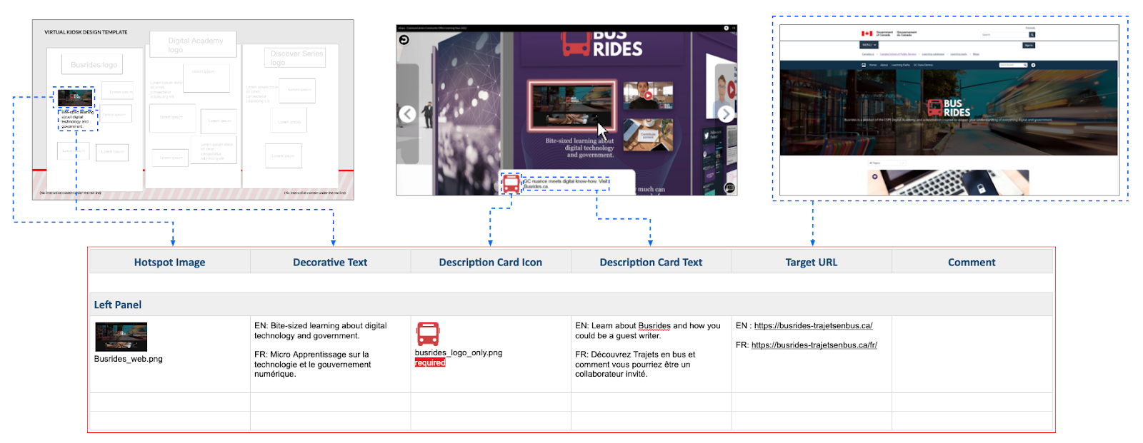
The image above represents how hotspot information fits in each column of the Hotspot List section below. Each row represents one hotspot inside each panel of your kiosk.

Hotspot List
Feel free to add more rows, as needed, to allow for additional hotspots on your kiosk panels.
Note: When visual assets are provided, we will assume they are just references so the designers may change them for similar or but better equivalents, if needed. If the images need to be used as is, mark it as required in the field below.

Hotspot Image | Decorative Text | Description Card Icon | Description Card Text | Target URL | Comment
ex:  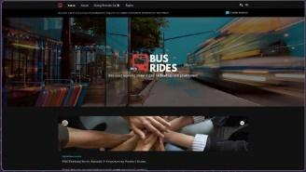  Busrides_web.png | ex:  EN: Bite-sized learning about digital technology and government.  FR: Micro Apprentissage sur la technologie et le gouvernement numérique. | ex:  busrides_logo_only.png  required | ex:  EN: Learn about Busrides and how you could be a guest writer.  FR: Découvrez Trajets en bus et comment vous pourriez être un collaborateur invité. | ex:  EN : https://busrides-trajetsenbus.ca/  FR: https://busrides-trajetsenbus.ca/fr/ | Comments are optional.
Left Panel
Image: | EN:  FR: | Icon: | EN:  FR: | EN:  FR:
Image: | EN:  FR: | Icon: | EN:  FR: | EN:  FR:
Image: | EN:  FR: | Icon: | EN:  FR: | EN:  FR:
Image: | EN:  FR: | Icon: | EN:  FR: | EN:  FR:
Image: | EN:  FR: | Icon: | EN:  FR: | EN:  FR:
Center Panel
Image: | EN:  FR: | Icon: | EN:  FR: | EN:  FR:
Image: | EN:  FR: | Icon: | EN:  FR: | EN:  FR:
Image: | EN:  FR: | Icon: | EN:  FR: | EN:  FR:
Image: | EN:  FR: | Icon: | EN:  FR: | EN:  FR:
Image: | EN:  FR: | Icon: | EN:  FR: | EN:  FR:
Right Panel
Image: | EN:  FR: | Icon: | EN:  FR: | EN:  FR:
Image: | EN:  FR: | Icon: | EN:  FR: | EN:  FR:
Image: | EN:  FR: | Icon: | EN:  FR: | EN:  FR:
Image: | EN:  FR: | Icon: | EN:  FR: | EN:  FR:
Image: | EN:  FR: | Icon: | EN:  FR: | EN:  FR:

