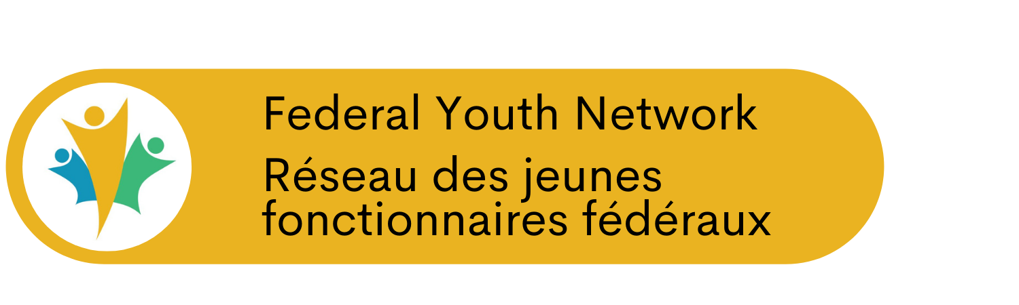
The Federal Youth Network is launching the FYN Virtual Learning Series, starting on March 23rd!
What is the FYN Virtual Learning Series?
The FYN Virtual Learning Series is a combination of workshops, webinars, and speakers who will share their expertise and take questions from participants across Canada using the Zoom Webinar platform.
What topics will you cover in the FYN Virtual Learning Series?
We will cover many topics that are key to public servants including how to build your virtual network, the do’s and don’ts of social media, the keys to successful telework, how to leverage the GCTools, virtual collaboration, interview tips & tricks, how to search for a new job, finding your why, appreciation languages and many other topics!
What is the format and duration of the FYN Virtual Learning Series?
Each session will be 60 minutes followed by a 15 minute question and answer period. We ask that participants log in 10 minutes prior to the session to avoid technical delays.
How will I find out what sessions are being offered at what time in this Series?
Follow the FYN on Twitter @FYN_RJFF and on Facebook to find out more and to get the links to the registration for a particular session. This Series will be promoted broadly in the public service so please share this with your friends and colleagues.
What is the frequency of these sessions and how long will the FYN Virtual Learning Series run for?
We’ll pilot the Series on March 23rd with an initial pilot period until April 10th. Based on demand we will continue to run this Series with 6-8 sessions per week, until further notice. This will ensure that public servants have learning offerings that can help them stay connected during this time, and make the most of the opportunity to connect and learn virtually.
What do I need to do to participate?
Follow the FYN on Twitter and Facebook to get the registration link for the Series. Register for the sessions that interest you and login to learn, develop and engage with your colleagues from across Canada!
Does the FYN Virtual Learning Series run on a Government of Canada network?
The FYN Virtual Learning Series is hosted on the Zoom Webinar platform and does not rely on any GC network. Participants are encouraged to login to the Series using a personal computer or mobile device, to ensure the GC network’s bandwidth is not being used.
March 2021 Update
On the 23rd of this month, the Virtual Learning Series celebrates its first anniversary! In the past year, we offered over 85 events with more than 5,400 learners in attendance. The topics covered ranged from on-boarding students to the Privy Council Clerk’s Report, and featured numerous partners

Topics

Networking
Social Media
GC Tools
GC Digital Standards
Beyond2020
Environment
Working From Home
Mindfulness
Mental Health
Student Onboarding
Public Service
Pride and Positive Space
Personal Brand
Mentoring
Second Language
Elevator Pitch
Work Boundaries
Revolutionizing the Public Service
Diversity and Inclusion
Anti-Racism
Self-Awareness
Emotional Intelligence
Smudging
Optimizing Career Boot Camp
Black History Month
Career Basics

Partners

FlexGC
LeadersGC
Digital Academy
Canada School of Public Service
GCTools
Policy Community Partnership Office
Institute of Public Administration
Environment and Climate Change Canada
National Managers Community
Canada’s Free Agents
National Capital Region YPN
Interdepartmental Student Committee
Regional Youth Networks
Office of the Commissioner of Official Languages
Talent Cloud
Public Service Pride Week
Privy Council Office
OneTeamGov
BodyBreak
Anti-Racism Ambassador Network
Federal Black Employee Caucus

Is your organization looking for ways to amplify messaging for new and young public servants? Get in touch with us and find out how we can help. We are always looking for partners to collaborate on delivering innovative and timely information to our audience.

Videos
Many of our past events are available on our YouTube channel. If you missed something you had hoped to attend or want to recapture important info, check them out!

