Health Canada
Organizational Structure

The document below will provide you with a chart of the branches and services provided by the many different aspects of Health Canada.

Minister of Health

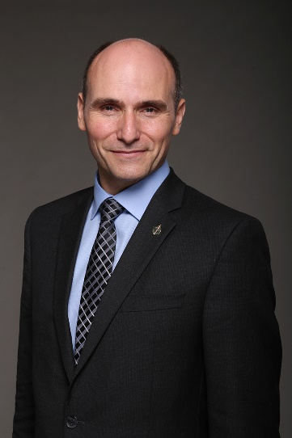
The Honourable Jean-Yves Duclos
Minister of Health
The Honourable Jean-Yves Duclos has been the Member of Parliament for Québec since 2015.
He has previously served as President of the Treasury Board and Minister of Families, Children and Social Development.
Minister Duclos is a well-published author, conference speaker, and economics expert. Prior to 2015, he was the Director of the Department of Economics and a tenured professor at the Université Laval.
In addition to his professorial duties, Minister Duclos held the former Industrial Alliance Research Chair on the Economics of Demographic Change (now the Research Chair in

Intergenerational Economics), served as President-Elect of the Canadian Economics Association, and was a member of the Institut sur le vieillissement et la participation sociale des aînés.
He was also Vice-President and Fellow of the Centre interuniversitaire de recherche en analyse des organisations, Senior Fellow of the Fondation pour les études et recherches sur le développement international, and Fellow-in-Residence at the C.D. Howe Institute. He is also the co-founder of the Poverty and Economic Policy Research Network (Partnership for Economic Policy).
Minister Duclos’ hard work has been recognized with prestigious grants, including the prix Marcel-Dagenais from the Société canadienne de science économique and the Harry Johnson Prize for best paper published in the Canadian Journal of Economics. In 2014, he was elected a Fellow of the Royal Society of Canada, the highest accolade bestowed on Canadian researchers.
Minister Duclos earned a Bachelor of Arts in Economics (First-Class Honours) from the University of Alberta, and master’s and doctoral degrees in Economics from the London School of Economics and Political Science.
Minister of Mental Health and Addictions and Associate Minister of Health
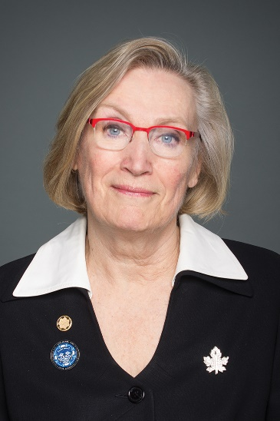
The Honourable Carolyn Bennett
Minister of Mental Health and Addictions and Associate Minister of Health
The Honourable Carolyn Bennett was first elected to the House of Commons in 1997 and was re-elected in 2000, 2004, 2006, 2008, 2011, 2015, 2019, and 2021 representing Toronto—St. Paul’s.
She previously served as Minister of Crown-Indigenous Relations, Minister of Indigenous and Northern Affairs, and Minister of State for Public Health.
Prior to her election in 1997, Minister Bennett was a family physician and a founding partner of Bedford Medical Associates in downtown Toronto. She was also an Assistant Professor in the Department of Family and Community Medicine at the University of Toronto. Her fight to save the Women’s College Hospital of Toronto inspired her to enter politics.
Minister Bennett is an active representative of Toronto—St. Paul’s. She has organized over 75 town halls, quarterly meetings, information sessions, and special activities for her constituents since 2000. She and her office have assisted hundreds of constituents with their immigration, tax, pension, or employment insurance concerns.
Minister Bennett speaks passionately about Canada and Canadians’ participation in the democratic process. She advocates for health, the environment, women’s involvement in politics, and persons with disabilities. She is also known for her strong support of Israel.
In 1986, she received the Royal Life Saving Society’s Service Cross – a Commonwealth Honour Award recognizing her more than 20 years of distinguished service. In 2002, she was the recipient of the coveted EVE Award for contributing to the advancement of women in politics, and in 2003, she received the first-ever Champion of Mental Health Award from the Canadian Alliance on Mental Illness and Mental Health. She was also the first recipient of the National Award of Excellence for Outstanding Leadership and Dedication to Injury Prevention and Safety Promotion in Canada, and is the co-author of Kill or Cure? How Canadians Can Remake Their Health Care System.
Minister Bennett and her husband, Peter O’Brian, a Canadian film producer, have two sons, Jack and Ben.
Deputy Minister
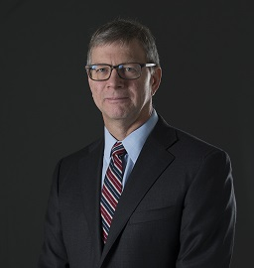
Stephen Lucas
Deputy Minister, Health Canada
Dr. Stephen Lucas was appointed Deputy Minister of Health on September 3, 2019.
Before joining the Department, Dr. Lucas served as Deputy Minister of Environment and Climate Change Canada (ECCC) since January 2017.
As Senior Associate Deputy Minister (Climate Change) from June 2016 to January 2017, Dr. Lucas led ECCC activities in support of the development and adoption of the Pan-Canadian Framework on Clean Growth and Climate Change.
Before joining ECCC, Dr. Lucas was Deputy Secretary to the Cabinet for Plans and Consultations and Intergovernmental Affairs at the Privy Council Office. From 2013 to 2014, he was Assistant Secretary, Economic and Regional Development Policy, at the Privy Council Office.
As Assistant Deputy Minister, Science and Policy Integration at Natural Resources Canada (NRCan) from 2009 to 2013, he was responsible for strategic policy development related to energy, mineral and forest resources, climate change and clean energy and international and intergovernmental relations. Prior to that, from 2007 to 2009, he was Assistant Deputy Minister, Minerals and Metals Sector, at NRCan, where he provided leadership on innovation, green mining and corporate social responsibility.
Dr. Lucas was a Director General in the Health Products and Food Branch (HPFB) at Health Canada from 2003 to 2007, Senior Director at NRCan for Science, Innovation, Regional and Aboriginal Affairs from 2000 to 2003, and Director of Policy Planning and Coordination in the Earth Sciences Sector at NRCan from 1998 to 2000.
Dr. Lucas started his career as a research scientist at the Geological Survey of Canada in 1988. He has a Bachelor of Science with Honours in Geological Engineering from Queen’s University and a Ph.D. in structural geology and tectonics from Brown University.
Associate Deputy Minister
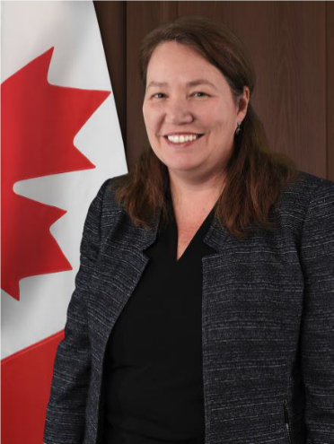
Heather Jeffrey
Associate Deputy Minister
Heather Jeffrey was appointed as Associate Deputy Minister of Health in October 2021. Prior to this appointment, she served as Assistant Deputy Minister (Strategy and Integration) within the COVID-19 Task Force at Health Canada. She also served as Assistant Deputy Minister for Consular, Security and Emergency Management from 2017 to 2020 and as Director General for International Humanitarian Assistance from 2015 to 2017 at Global Affairs Canada.
Heather joined the Department of Foreign Affairs and International Trade in 1996. Since that time, she has served at a variety of positions in Ottawa and abroad.
Heather has a MA in International Affairs from Carleton University, a Graduate Diploma in International Relations from Johns Hopkins University (Bologna) and a BA (Honours) in Political Science from Carleton University.

