GC Collaboration Microsoft Teams
Install Guide for Android Devices

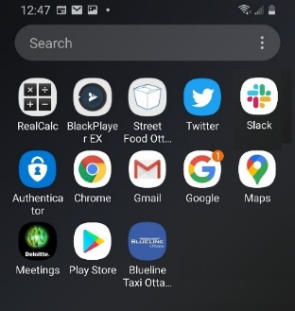

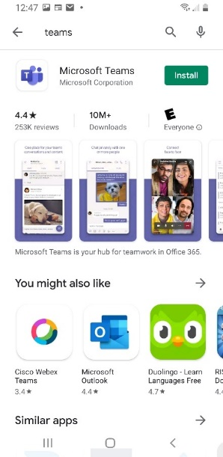

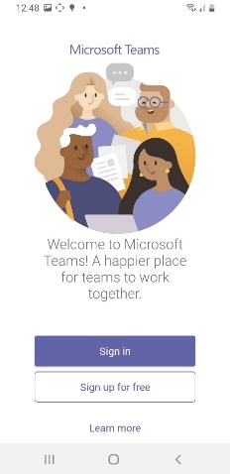
Step 1 – Download Teams
- Open the Play Store on your Android or tablet
- Search for “Microsoft Teams”

NOTE: Before installing, make sure you have found the correct app (see icon in the screen image on the left).
Click the install button.
After the install, click “Open” and make sure the Teams icon appears on your phone or tablet.

Step 2 – Sign in to Teams
- Launch the Teams app. You should get a sign-in page.
- Sign in with the @gccollaboration.ca username and password that were provided to you.

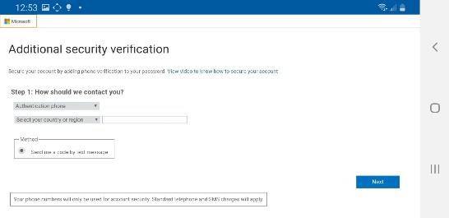
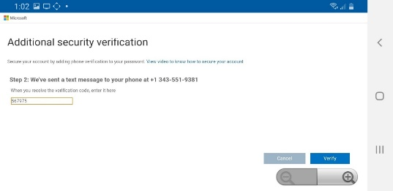
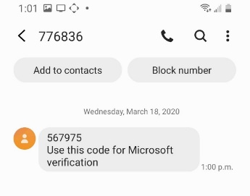

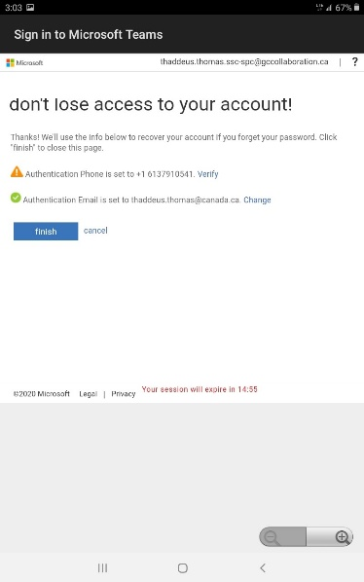
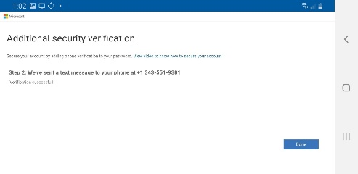
Step 3 – Additional security verification
- You will now be directed to a page that says “More Information required”
- Click Next

- Your phone number will be used to provide a second level of security
- Select “Authentication phone”
- Then select Canada under “Select your Country or Region”
- Enter your mobile phone number (it could be the same phone you are installing the app on or a personal cell phone)
- Make sure you select “Send me a code by text message”
- Click Next
- You will see a message that says “Step 2: We’ve sent a text message to” and the phone number you entered will appear. You now need to check your phone text messages to get the code
- Type in the code you received in your text message and click Verify

- You will receive a message confirming your phone number and email address. This is in case you need to recover your account at some point
- You need to verify your phone number
- You can also change the email address if you prefer to receive account recovery information at a different email address than the one you use for Teams.

When you see “Verification successful!” click Done”.

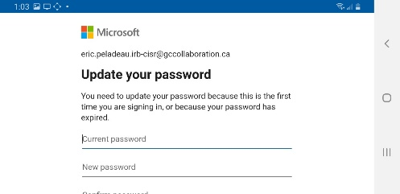

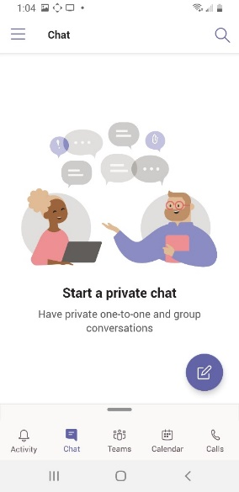

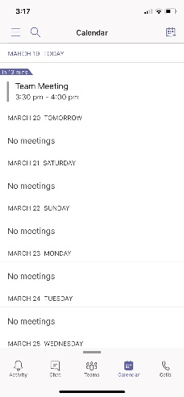

Step 4 – Update your password
You now need to update your password.
Type in your Current Password and then type in your New Password. Click “Sign in.”
Using Teams
You are now ready to use Teams.
NOTE: Most Teams functions are currently disabled. You are limited to collaborating in a group chat, video conference or audio conference meeting.
Use the menu items at the bottom of your home screen to choose what you want to do – Chat, Calendar, Calls.
Here’s some useful information on how to use Microsoft Teams on a Windows or Mac personal computer:
https://support.office.com/en-us/article/microsoft-teams-video-training-4f108e54-240b-4351-8084-b1089f0d21d7

NOTE: Some of the features shown in the training material may not be the same or available on mobile devices. We recommend you follow the training above even if you plan to use Teams on a mobile device only.

Chat
Chat is similar to Skype For Business. You can create a single chat or group chats by pressing the pen (compose) icon on the top right.
Calendar
You can schedule a meeting by accessing your calendar and pressing the calendar icon on the top right to set the date and invite participants. Participants will be sent an invitation through email with a link to launch video / audio conferencing.
Calls
You can call a co-worker by going on the call tab and searching the person you want to reach.

