Engagement plan
WORKPLACE MODERNIZATION PROJECT
[INSERT NAME OF PROJECT HERE]

VERSION 1.0
DATE:
PREPARED FOR:
DEPARTMENT:

Table of contents
1. Background 3
1.1 GCWORKPLACE 3
1.2 [INSERT PROJECT NAME] 3
2. Objectives 3
2.1 ENGAGEMENT OBJECTIVES 3
2.2 PROSCI METHODOLOGY AND ADKAR (include as applicable) 4
3. Stakeholders 4
4. Stakeholder engagement 5
5. Engagement activities 5
6. Feedback, monitoring and evaluating 6
7. Schedule and key milestones 6
8. Contacts 6
9. Engagement plan 6
Annexes 8
ANNEXE A: EXAMPLES OF ENGAGEMENT ACTIVITIES 8
ANNEXE B: COLLECTING AND MONITORING FEEDBACK 9
ANNEXE C: FEEDBACK STRATEGY OPTIONS 9

Background

1.1 GCWORKPLACE
GCworkplace principles were developed to align with the vision of creating a high-performing Government of Canada workplace that enables a balanced workforce. This new-age workplace is founded on the principles of flexibility, efficiency, (employee) health, collaboration, and digital capacity; all of which inform GCworkplace principles.
According to the GCworkplace vision, employees can choose where and how they want to work, thus creating a more efficient, healthy, and flexible workforce that also increases productivity. There is also a strong emphasis placed on mobility, recognizing that activity-based working is the way of the future and that there is no one-size-fits-all approach to office design.
The principles of GCworkplace were developed with the needs of today’s workforce, as well as those of tomorrow’s, in mind. One of the big questions facing the Government of Canada is how to attract and retain top talent, and GCworkplace takes a step towards answering that question.

1.2 [INSERT PROJECT NAME]
Insert information on your modernization project:
- Project scope
- Vision
- Key principals of the project
- Key components of your change management strategy
- Type of change and size
- Timeline

Objectives

2.1 ENGAGEMENT OBJECTIVES
Through effective engagement, stakeholders benefit from the opportunity to actively participate in the change. They will be able to have their issues heard, share insights or reactions to change, as well as participate in the design and decision-making process. At the enterprise level, [name of your organization] benefits from effective engagement that results in successful adoption of change with limited loss of productivity or disruption.
The strategic objectives of effective engagement will be to ensure:
- xxx;
- xxx;
- xxx.

PROSCI METHODOLOGY AND ADKAR (include if applicable)
Prosci is an independent research organization that has developed a comprehensive change management methodology based upon best practices identified through their research. As leaders in the field, their methodology is being used across multiple organizations.
Based on Prosci’s research, the foundation for organizational change is successful change at the individual level by building the elements of the ADKAR change model (Figure 1) in each individual. ADKAR stands for:
- Awareness–provides the “why” the change is happening
- Desire–environment that provides the motivation and willingness for the change
- Knowledge–is the information and learning needed to apply the change
- Ability–removes the capability obstacles that could prevent the change
- Reinforcement–sustains the change past the implementation phase
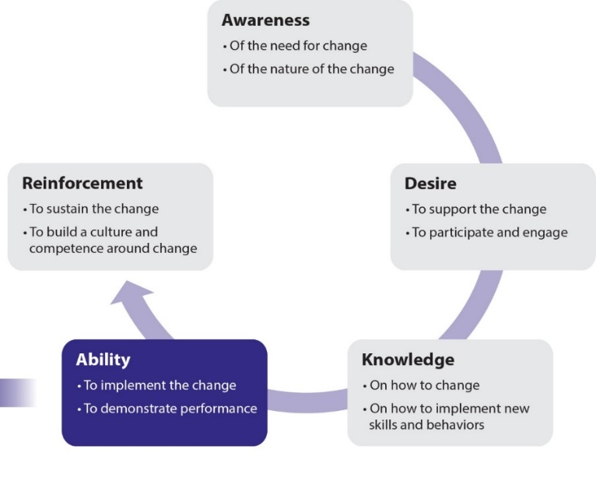
Figure 1. Prosci® ADKAR® Model
The ADKAR model is to be integrated into various tools that will be used by the team along with managers and employees, to manage change. The ADKAR model allows [name of your organization] to shape change management and engagement activities to support employees while facilitating [name of your project] implementation objectives.
Successful engagements with staff will be based on the ADKAR model to build the five elements of ADKAR needed for a successful change. When ADKAR is present in change management activities, the desired change happens.

Stakeholders

[Name of your project] engagement activities will be tailored to the needs of the various stakeholder groups, and targeted engagement methods to maximize the benefits of the interactions will be used.
[Include here your Stakeholder Impact Assessment that shows a list of key stakeholder groups within your organization.]

Stakeholder engagement

The [insert project name] change management and project integration team will leverage existing [insert organization name] engagement activities and develop a series of engagement programs that will be updated, refined and improved over the course of [insert project name]. As lessons are learned and stakeholders need are better understanding, the list of engagements will evolve to best meet the needs of the various groups and stakeholders.
Engagement processes will follow the ADKAR continuum and will be tracked for stakeholders, sectors and groups. Feedback data will provide a metric of how effective the engagement was, how well the changes are being integrated and what additional engagement vehicles will be required to ensure smooth transitions.
By identifying and tailoring engagement activities to all employees, as well as to the most impacted groups at [insert organization name], [insert organization name] will be able to more effectively manage change. Poorly planned and executed changes, with weak engagement, result in change fatigue, losses of productivity, longer periods of adjustment and fewer benefits realized in relation to investments made.

Engagement activities

[Name of your project] engagement activities will be inclusive and tailored to the needs of the various stakeholder groups, based on the timing of the workplace project implementation, and targeted engagement methods to maximize the benefits of the interactions will be used.
You can complete an ADKAR assessment for each stakeholders group to guide you in the development of the engagement activities and to ensure that the objectives defined earlier will be met.
See Annexe A for examples of engagement activities.

Feedback, monitoring and evaluating

Feedback will be tracked to assess the effectiveness of the [insert project name] change management approaches as well as to monitor the implementation of the integrated project. Feedback processes will provide the information needed to measure change adoption, integration, effectiveness of training, change saturation, as well as provide a means to continuously assess, adapt and improve the project implementation. Outputs from feedback channels may also be used to inform and guide ongoing decision making. In this section, it is important to monitor and evaluate continuously if the engagement activities have been valuable to build desire of the workplace change at all levels within the organization.
- Evaluate if the engagement activities have been valuable
- Data in this category are connected to the actual activities carried out by the change management team and included in the change management strategy.
See Annexe B for examples of tools and metrics for feedback collection.
See Annexe C for feedback strategy options.

Schedule and key milestones

[Include your project schedule here]
Keep in mind:
- Project milestones along the timeline
- List of changes per sector
- Showcasing the high-level workplace timeline and the employee change impact timeline is a great visual to look at from a user/receiver perspective

Contacts

[Include workplace change contacts here]

Engagement plan

Timing | Strategic objectives | Activities | ADKAR | Audience | Sender | Delivery mechanism | Feedback mechanism | Status
 |  |  |  |  | e.g. project sponsor, project team, managers, EXs, subject matter expert lead

Annexes

ANNEXE A: EXAMPLES OF ENGAGEMENT ACTIVITIES
Examples of possible engagement activities:
Engagement with senior management
- Meet with senior management to inform on project/plan
- Visioning session
Demonstrate
- Visit a demonstration space to visualize the key features of the new workspace
- Visit a GCcoworking site
- Host a pop-up GCworkplace to demonstrate the concept of a variety of workpoints that you can find in modern workplaces and in an activity-based working (ABW) environment
- Share links to virtual tours of GCworkplace environments
Present
- GCworkplace 101
- Employee-to-employee panels
- Expert panels
Consult
- GCworkplace Design Consultation Survey
- Workplace Performance Survey
- ADKAR Change-o-meter
Involve
- Artwork: Run a competition for employees to submit photos they have taken and commit to having the selected one printed and framed
- Plants: Do employees prefer green walls? A plant room where they can bring their personal plants? A choice of individual workstations with or without plants? Host informal drop-in sessions where they can cast their vote!
- Colour: If you are provided with multiple colour options for the space, allow employees to select their favorite.
- Room names: Ask employees to submit ideas on a topic that could be used for naming rooms. This could be tied to your organization’s mandate, geographic locations in Canada, etc. Then post a list of potential names and have people vote via an online poll.
- Design elements: Is there a location in your new space―the reception area for example―where there is an opportunity to introduce a feature wall, plant wall, or a meaningful art piece? Ask employees for their ideas!
- Employee wall: Some organizations find it beneficial to include an employee wall (where they can post personal photos for example) in order to customize their workplace and create a sense of community. It is typically located in an area frequented by all, like a kitchenette. Based on the group, some may decide to have a theme for the wall (e.g. small wins, family, pets, work accomplishments, etc.); engage employees to find out what they prefer!
- Etiquette: Establish a committee to create an etiquette guide for the new workplace.
- Super users: Identify “super users” for specific elements and tools that are being introduced (e.g. instant messaging platform, cloud printing, etc.). Provide them with training and ensure to promote them as “experts”!
- Clean-up/Move: Organize paper clean-up or packing/preparing for the move activities with employees—it will feel like less of a chore if it’s presented in a fun way!

ANNEXE B: COLLECTING AND MONITORING FEEDBACK
Tools to collect feedback
- Tracker
- Surveys
- Spot survey for events
- Observation
- Interaction with recipients
- Monitoring feedback through various channels and networks
- ADKAR Change-o-meter
Metrics
- Tracking of change management activities conducted according to plan
- Training participation and attendance numbers
- Communication deliveries
- Communication effectiveness
- Performance improvements
- Progress and adherence to plan
- Business and change readiness
- Project KPI measurements
- Adherence to timeline
- Speed of execution
- Number of clicks on a web page
- Number of visits to a modernized space

ANNEXE C: FEEDBACK STRATEGY OPTIONS
Mechanism | Lead | Description | Advantages
Surveys & user polls  (Qualtrics, survey monkey, etc.) | Project lead, middle management | Employee opinions matter! Use surveys and user polls to obtain the overall pulse of the change. Although user feedback is important – don’t overdo it. Be mindful of how many surveys and polls are sent throughout the modernization project. Obviously, this will vary dependent on the size and length of the project.  Keep in mind: you will need to vet the questions and test the tool selected prior to sending it off. | - A quick and easy way to get feedback  - Reaches a large number of employees  - Can be anonymous (optional)
Suggestion & comment box | Project lead, project team | An open discussion or private e-mail option on the intranet or GCconnex page. This option is beneficial post-implementation where the feedback goes directly to the process owner for continuous improvement.  Keep in mind: this option requires an individual or team who will monitor the feedback. | - Live URL available 24/7  - Can be anonymous (optional)  - May leave open indefinitely for ongoing input
1:1 meetings | Middle management & supervisors | Utilize 1:1 meetings to understand how the change is being received. Direct managers and supervisors are the best resources for this as they should already have trust and strong relationships with their employees.  Keep in mind: this option requires safety, trust and transparency amongst managers/supervisors and their employees. | - A comfortable setting that can enable vulnerability  - Gathers individual, in-depth feedback
Team meetings | Middle managers | Allows employees to surface feedback on the change in their current team environment.  Keep in mind: a strong facilitator will be required. | - Creates transparency  - Raises group issues
Focus groups (5-12 participants) | Integrated project team | Allows the project team to solicit specific feedback from key contributors on specific topics.  Keep in mind: a strong facilitator and real-time transparency of information captured will be required. | - A shared experience  - Participants react together and build off each other’s comments  - Option to curate audience based on topics
Townhalls | Project sponsor or champion | Use to summarize findings, celebrate successes and address opportunities related to the change across all key audiences. Great way to share the key objectives & vision of the project and how they are being met.  Keep in mind: a strong facilitator and prepared agenda are required. | - Reaches a large number of employees  - Creates transparency between senior management and employees  - Solicits community input

Source: This chart has been adapted from the Self-Service Feedback options in the Change Management Toolkit (page 38-39) by Berkeley, University of California.

