Virtual Tour Guide

Contents
Background 2
Equipment/technology requirements 2
Steps 2
Prep 2
Capture (if applicable) 3
Editing 3
Accessibility 5
Troubleshooting 5
Style de bureau pour séance photo ou visite vidéo à 360 degrés / 6
Office Styling for Photo Shoot or 360 Degree Video Tour 6

Background
Virtual tours can give users an idea of what to expect from each site, reduce anxiety and improve useability. Tagging of work points and boardrooms acts as a visual companion to the current booking system.

Equipment/technology requirements
- Matterport account
- If capturing the space in-house:
  - Matterport Axis mount and tripod package: Matterport Axis | Matterport
  - iPhone with LiDar Technology (any phone with laser technology will work)
    - The phone will have to have space to install the Matterport capture App (approx. 707.5 MB)
  - OR a camera with LiDar technology:
    - Matterport Pro2 | Matterport
    - Matterport Pro3 | Matterport
  - Stable Wi-Fi connection or an unlimited data plan

Steps

Prep
- Contact people responsible for the location that will be captured.
  - Plan to go to the space when it is unoccupied or mostly empty.
- Log in to Login (matterport.com) contact WTSE at TPSGC.SIMilieudeTravailGC-RPSGCWorkplace.PWGSC@tpsgc-pwgsc.gc.ca for log in credentials
OR
- Create a Matterport account and choose the plan that suits the project: Matterport pricing
  - If the Business plan is chosen, “automatic face blur” and other bonus features will be accessible. Go to setting > spaces > toggle “automatic face blur” button to turn it on.

- If capturing in-house:
  - Charge all batteries: phone and accessories
  - Pre-plan walkthrough with a floor plan.
    - Try to limit backtracking.
    - Start at an entrance.
    - Share the floor plan with the person responsible for the space the day the capture will take place, if possible.
- If hiring a third party for the capture:
  - Get a list of the spaces that will need to be captured.
  - Find the size of the spaces.
  - Provide floor plans, have them share their walkthrough plans afterwards, to make sure they are not going to walk in restricted areas.

Capture (with method for capture with phone)
- Ask onsite resource to stage the site or come in early to ensure optimal set-up (e.g. chairs placed appropriately in meeting rooms, desk cleaned/aligned). See best practices for staging here
- Log on Matterport app with your account.
- Install tripod.
- Assemble the Axis and mount phone.
- Turn on Axis and take remote in hand, follow instructions on the app to pair phone with the motor and remote.
- Capture:
  - Create new space and input name of the space.
  - Start capture at entrance if possible.
  - Take no more than 4 steps between captures.
  - Take more captures than what is needed.
  - When facing reflective surfaces, hide somewhere out of view of the camera with the remote.
  - When capture is over, click the upload button and follow the instructions. It is recommended to confirm “automatic face blur” at this stage. The upload may take a number of hours depending on the size of the space.
  - If unable to finish capture the whole space in a day, make sure the last capture is somewhere easy to remember. The tour will not end until the tour is uploaded, so it is possible to come back days later and continue where the last capture was taken.
- NOTE: some areas may not be captured in the tour (lack of space or not adjacent in the flow, e.g. external washroom, kitchen lounge, bike storage area). Take photos of these spaces and integrate them to a tag when editing.

Editing
- Contact WTSE for editing
OR
- When the space is done uploading an email will be sent.
- Access the space online via the Matterport website on notebook or computer.
- Click on the space to edit, click the Edit button on the top right corner of the screen. When editing is done, click the Upload button situated on the top right corner of the page.
- All editing tools are located on the right, view options are located on the bottom left.
- Most used tools:
  - Start location: define where the tour will begin.
  - Labels: define labels for general spaces, only visible when in floorplan mode (not in dollhouse mode or visit mode).
  - Tags: Write tags that visitors will be able to click on to get information. Links and pictures can be inserted in tags. Color coding the tags for ease of navigation is recommended.
  - Notes: write notes to collaborators while working on the tour, visitors will not see them.
  - 3D scans: select scans to keep or hide, remove scans that are too close together or confusing for the user.
  - Blur: digitally blur information such as security cameras, information of white boards and computer screens. Once added and integrated it can never be reversed.
- Sharing:
  - The virtual tour can be shared a number of ways: unlisted, to collaborators and publicly.
  - Unlisted: anyone with the link will be able to view, but not edit. It will be impossible to find the tour without the direct link.
  - Collaborators: will permit people of your choice to create a Matterport account, view the tour or edit the tour.
  - Public: public sharing is strongly discouraged as it will permit anyone with an internet connection to find the tour.

Accessibility
Contact: ADA Compliant Virtual Tours - Barnes Creative Studios
They have multiple package options. There will be a one time fee for the writing and programming and then a yearly fee for the hosting and maintenance. They are based in the US, so they will only provide English tours but will be able to copy the tours and will insert French content as needed.

Troubleshooting
Problem | Possible solution
I am a new user and need more detailed help | Visit the New user section of the Matterport FAQ, these articles contains detailed walkthroughs:  Matterport Knowledge Articles
Unable to pair Axis to phone  Or  Unable to pair Axis remote to phone | Log out of the app, turn the Axis and remote off. Disconnect from Wi-Fi.  Turn Wi-Fi back on, log back in and turn everything back on.
When inserting media in a tag;  Link to media is not available | Make sure the link to the media is publicly available. Host the media on a public Google drive, GCcollab, GCwiki or other.

Sources:
- 3D Camera and Virtual Tour Platform - Matterport
- Shop Matterport Subscription Plans and 3D Cameras
- ADA Compliant Virtual Tours - Barnes Creative Studios
- Support | Matterport
- Matterport Help Center
- Matterport Knowledge Articles

Style de bureau pour séance photo ou visite vidéo à 360 degrés /

Office Styling for Photo Shoot or 360 Degree Video Tour

Pour les visites vidéo et la photographie, vous voulez que l’espace de bureau soit soigné, professionnel, organisé et à l’air nouveau. Pensez à une photo promotionnelle d’une chambre d’hôtel, d’un hall d’entrée, ou à une maison bien présentée à vendre. Il est plus facile et se traduit par une meilleure vidéo si le travail peut être fait avant l’ouverture de l’espace ou hors des heures. Voir les directives ci-dessous.

For video tours and photography, you want the office space to look neat, professional, organized and new. Think of a hotel room, lobby promotional photo, or a well-presented house for sale. It is easier and results in a better video if the work can be done before the space opens or off hours. See guidance below.

Sujet / Subject | Conseils / Guidance | Oui / Yes | Non / No
Notification | - Secure advance permission and suggest that users of the space be notified in advance in case they would prefer to not be on site.  - Day of, alert anyone onsite that you will be taking photos/video. They can step away from the space while you take the shots.  - You may require a photo release if they are in the photo or video.  - For 360 degree videos done with Matterport, the system can blur faces and computer screens, removing the need for a release.
Propreté / Cleanliness | - Clean and straighten the space, hiding storage boxes, putting team coats/backpacks outside of the photo/video view, and move other visual clutter.  - Cropping/editing is not possible for 360 degree videos but can be done for standard photos. | 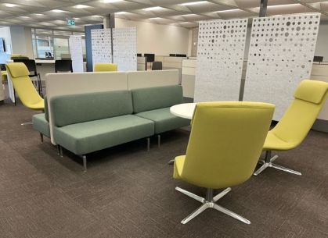 | 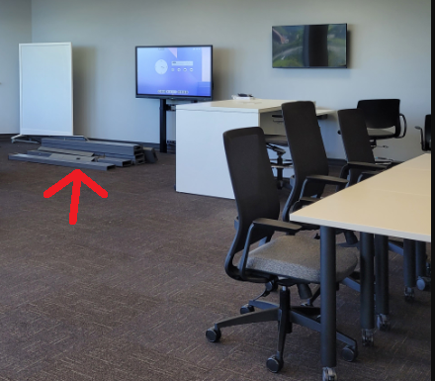
Chaises / Chairs | - Align all chairs to the same height (lowest is easiest, sit and use the lever) and push them into the table or angle them all to the door welcoming users to sit.  - Try to not overcrowd the table with chairs.  - Opt to leave a chair-free space at one table and indicate that this is to accommodate wheelchair users. | 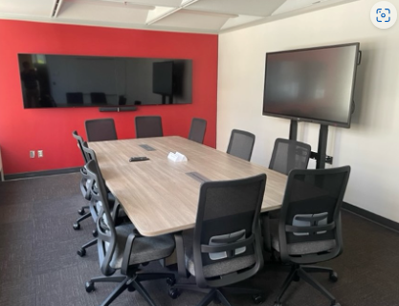  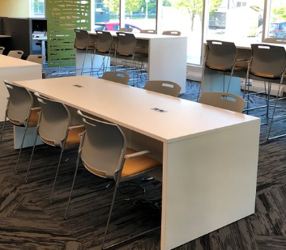 | 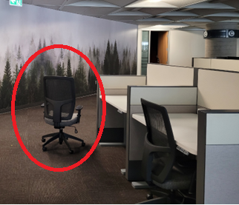  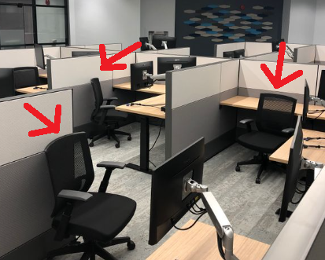
Bureau / Desks | - Align most height adjustable desks to the same height for a clean, unified view.  - Exception: in one or two areas show 2 ergonomic height adjustable desk options and their range with one high and one low. | 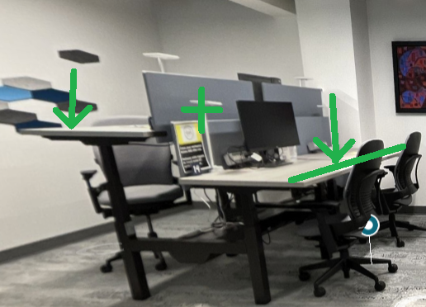  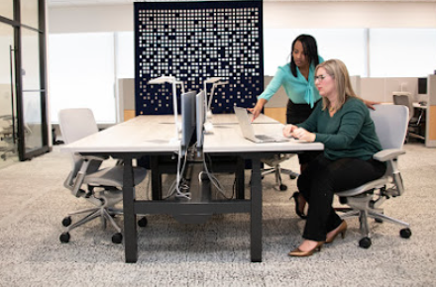 | 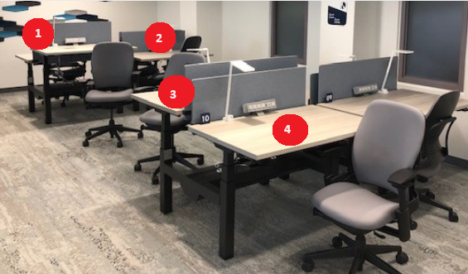
Écrans / Monitors | - Adjust monitors in view to be about the same height and angle. | 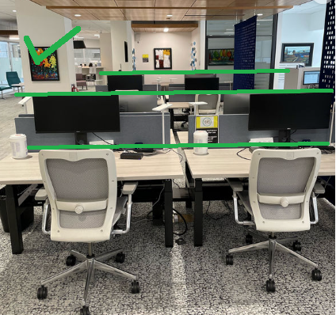  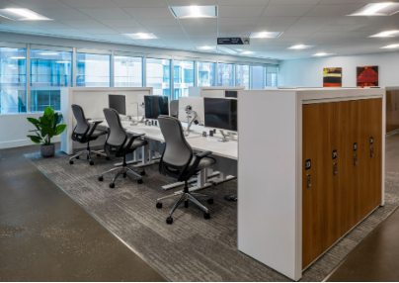
Câbles / Cords | - Tuck away or align power/connector cords. | 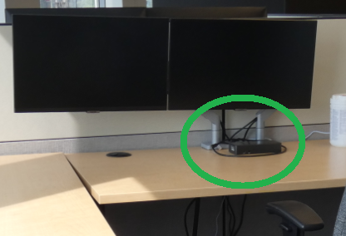 | 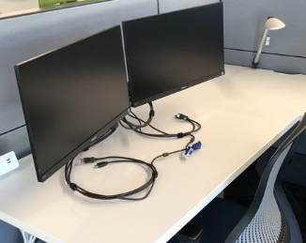
Table tops | - Align any support items neatly (e.g. TV remote, whiteboard markers/erasure, cleaning wipes, etc.). | 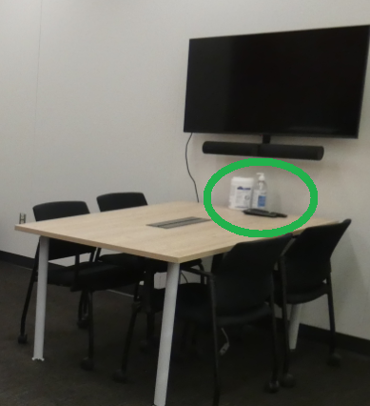
Cuisine / Kitchen | - Put away any dishes, cups, etc.
Allumer les lumières / Turn lights on | - Turn the lights on to show the space at its best.  - For spaces with timer or motion-activated lights, you may need to turn them on repeatedly, for example with the smaller standalone phone booths.  - Turn lights off when done. | 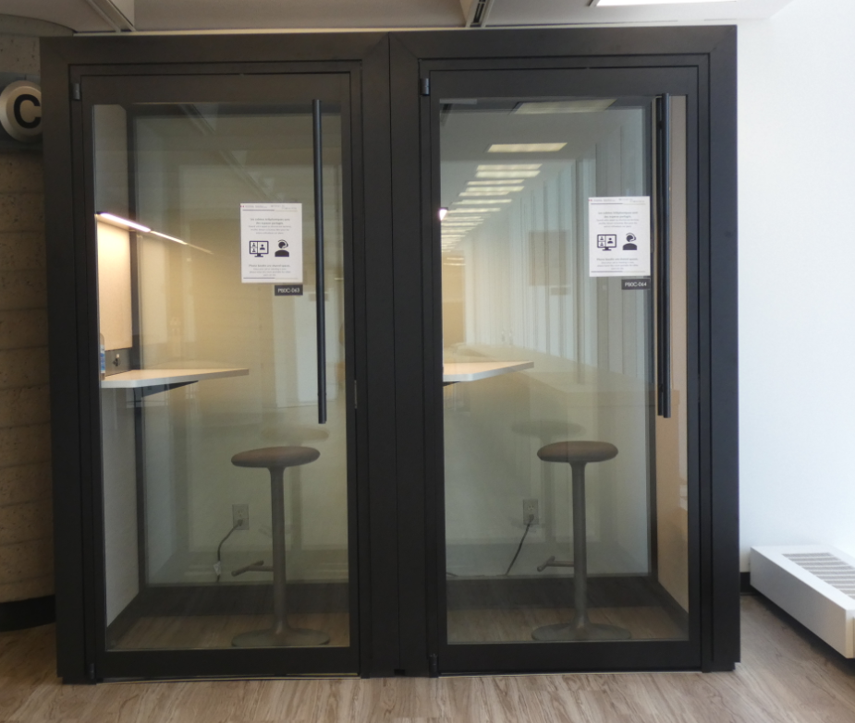  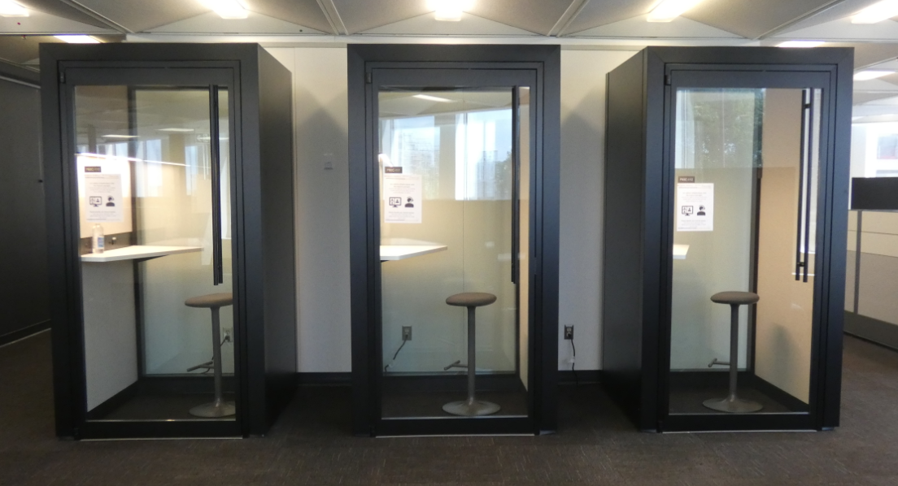  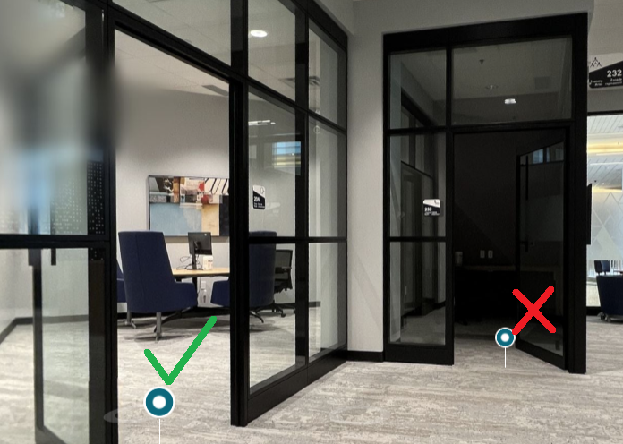 | 