Mentor Biographies

Employment Opportunity for Students with Disabilities
2023-2024

Table of Contents
AMANDA SHAW (SHE/HER) 4
ANUJAN KUMARANATHAN (HE/HIM) 5
BETTINA KRAUS (SHE/HER) 6
BOMA JUMBO (SHE/HER) 7
CATHERINE [CATH] DUCHASTEL DE MONTROUGE (SHE/THEY) 8
CHRISTIANE BRITO UHEREK (SHE/HER) 9
DANIEL PATTERSON (HE/HIM) 10
DARRIN ANTLER (HE/HIM) 11
DAVID ALLISON (HE/HIM) 12
ERICA MORISSETTE (SHE/HER- NON-BINARY) 13
FALLON MULUMBA (SHE/HER) 14
GABRIEL DUGUAY (HE/HIM) 15
JALANA MORTON (SHE/HER) 16
JEFFREY STARK (HE/HIM) 17
JESSICA SERVICE (SHE/HER) 18
KAREN KENNIPHAAS (SHE/HER) 19
KATHLEEN REYNOLDS (SHE/HER) 20
KENNETH AQUIN-ABBOUD (HE/HIM) 21
KRIS BANOVIC DA SILVA (THEY) 22
KYLE ARSENAULT (HE/HIM) 23
LAURA SMALLWOOD (SHE/HER) 24
LAUREN SAPIC (SHE/HER) 25
LEE GRENON (HE/HIM) 26
LOTHLORIEN FARLEY (SHE/HER) 27
MARTIN ANDERSON (HE/HIM) 28
MARYAM SHAHEEN (SHE/HER) 29
MARYROSE RODGER (SHE/HER) 30
MEGAN LE STUM (THEY/THEM) 31
MEIKA NOONAN(SHE/HER) 32
MERCEDES MUELLER (SHE/HER) 33
MEREDITH RICHMOND (SHE/HER) 34
MICHAEL MOHAMMED 35
MICHAEL SIDAROSE (HE, HIM, THEY) 36
MICHELLE ADDESA (SHE/HER) 37
MYRIAM LAMONTAGNE (SHE/HER) 38
MYRIAM REEVES (SHE/HER) 39
NAN ZHANG (HE, HIM) 40
NANCY OLDFORD (SHE/HER) 41
NOOR SIDDIQI (SHE/HER) 42
NUBA ILHAN 43
MEGAN OTU (SHE/THEY) 44
PAMELA LAHEY 45
PRAVDEEP SAHOTA (SHE/HER) 46
RACHEL BOUTIN (SHE/HER) 47
ROCK BISSON PICARD 48
SARAH CHAYTOR (SHE/HER) 49
STACY MUISE (SHE/HER) 50
STEFAN SIMARD (HE/HIM) 51
TESS MACMILLAN (SHE/HER) 52
TOM WESTLAKE (HE/HIM) 53
TRISTAN READMAN (HE/HIM) 54
VINCENT TAILLEFER 55
WILLIAM (JOEL) SERSON (HE/HIM) 56
ZOË CREGO (SHE/HER) 57

AMANDA SHAW (SHE/HER)

Current Position and Department
Client Services Manager, Human Resources Branch
Department of Justice

Location of Work
Toronto

Language of Communication
English

Areas of Expertise
- The staffing and recruitment processes, how to apply and prepare for government jobs
- Working on a national team
- Organization/Time management

Availability to Mentor
Every two weeks

Contact Details
amanda.shaw@justice.gc.ca
416-648-4784

ANUJAN KUMARANATHAN (HE/HIM)

Current Position and Department
GST/HST Litigation Officer, Appeals
Appeals Branch

Location of Work
Toronto

Language of Communication
English

Areas of Expertise
- Career development or Career Advancement
- Development of Leadership/Soft Skills/Interpersonal Skills
- Advice related to post-secondary.
- Advocacy and self-advocacy on topics related to accessibility in the workplace.
- Navigation of workplace accommodation and equipment required to perform job tasks.

Availability to Mentor
Once a week

Contact Details
Anujan.Kumaranathan@cra-arc.gc.ca
905-706-8722

BETTINA KRAUS (SHE/HER)
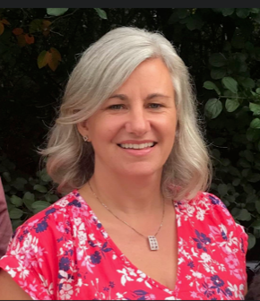

Current Position and Department
Executive Assistant, Personnel Psychology Centre
Public Service Commission

Location of Work
Ottawa

Language of Communication
English and French

Areas of Expertise
- Orientation for new employees in the Federal Government
- Employee health & wellness as well as disability & inclusion
- Soft skills: empathetic, active listening, supportive, encouraging, emotional intelligence, work-life balance (social services background)
- Navigating challenges faced with an invisible disability

Availability to Mentor
Weekly basis

Contact Details
Bettina.Kraus@cfp-psc.gc.ca

BOMA JUMBO (SHE/HER)

Current Position and Department
Litigation Officer, Appeals Programs Operations Directorate
Appeals Branch

Location of Work
Ottawa

Language of Communication
English

Areas of Expertise
- Soft skills such as socializing with others at work, emotional intelligence, and building boldness in work relationships.
- Organizational and communication skills such as having tough conversations, setting boundaries, workflow planning, and data gathering and/or data analysis.

Availability to Mentor
Bi-weekly or monthly basis

Contact Details
boma.jumbo@cra-arc.gc.ca
613-619-1683

CATHERINE [CATH] DUCHASTEL DE MONTROUGE (SHE/THEY)

Current Position and Department
HR Advisor in the Programs and planning team
Public Services and Procurement Canada in the Ontario region

Location of Work
Toronto

Language(s) of Communication
French and English

Areas of Expertise
- Navigating how to negotiate informal accommodations with your supervisors/managers and finding information on how to request accommodations.
- The Accessible Canada Act and how furthers accessibility within the Public Service
- Getting organized to keep on top of work expectations.

Availability to Mentor
Once a month for a session of an hour, schedule permitting.

Contact Details
catherine.duchasteldemontrouge@tpsgc-pwgsc.gc.ca
(Prefers written communication or video call)

CHRISTIANE BRITO UHEREK (SHE/HER)
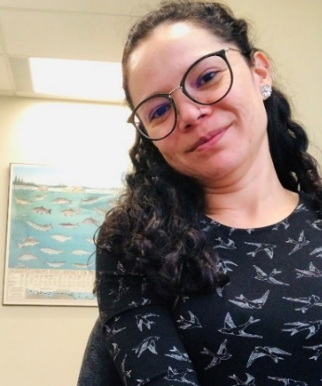

Current Position and Department
Biologist, Species at Risk Program, Aquatic Ecosystems, Ontario and Prairie Region
Fisheries and Oceans Canada

Location of Work
Edmonton

Language(s) of Communication
English, Portuguese, and Spanish

Areas of Expertise
- Working as a New Government Employee
- Networking and Career Path and Development
- Applying to Committees and Working Groups
- Requesting Accommodation
- Working with Visible and Invisible Disabilities

Availability to Mentor
Once a month

Contact Details
Christiane.BritoUherek@dfo-mpo.gc.ca
306-515-1476

DANIEL PATTERSON (HE/HIM)

Current Position and Department
Project Officer, Branch Operational Support Services
Health Canada

Location of Work
Ottawa, Dartmouth (NS)

Language(s) of Communication
English

Areas of Expertise
- Accessibility, navigating work with your disability.
- Feeling included (or excluded) on the job.
- Networking – how to network, tips, and coming up with approaches together
- Making and discussing accessible documents

Availability to Mentor
Once a week

Contact Details
daniel.patterson@hc-sc.gc.ca

DARRIN ANTLER (HE/HIM)

Current Position and Department
Policy Officer, Federal Workers’ Compensation Service
Labour Program – ESDC

Location of Work
National Capital Region

Language(s) of Communication
English

Areas of Expertise
- Labour relations, including accommodations, management and colleague relationships, diversity equity and inclusion
- Time and stress management
- Writing and presenting for success

Availability to Mentor
Once a week

Contact Details
darrin.antler@labour-travail.gc.ca
(819) 654-6515

DAVID ALLISON (HE/HIM)
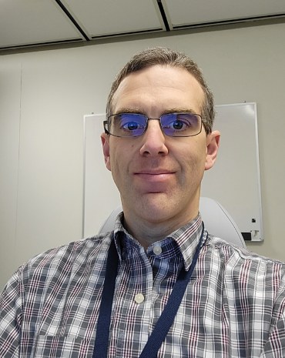

Current Position and Department
Director, Professional Practices, Internal Audit Directorate
Fisheries and Oceans Canada

Location of Work
Ottawa

Language(s) of Communication
English and French

Areas of Expertise
- Applying the experiences, lessons and challenges from having a disability to your work
- Innovative and critical thinking
- Accessing the resources, supports and accommodations available

Availability to Mentor
Every two weeks

Contact Details
David.Allison@dfo-mpo.gc.ca
613-297-9070

ERICA MORISSETTE (SHE/HER- NON-BINARY)

Current Position and Department
Information Management Compliance Officer
Department of National Defence

Location of Work
National Capital Region

Language(s) of Communication
English

Areas of Expertise
- Growing your leadership skills
- Navigating work as a neurodivergent person
- Juggling work-life balance

Availability to Mentor
Once a month, able to meet more frequently as needed.
Contact Details
erica.morissette@cse-cst.gc.ca

FALLON MULUMBA (SHE/HER)

Current Position and Department
Senior Program Advisor, EI Business Optimization and Strategic Services (EIBOSS)
Service Canada

Location of Work
Gatineau

Language(s) of Communication
English and French

Areas of Expertise
- Work planning and organization
- Staffing process, how to apply for a government job and how to write a resume.
- How to excel in administrative support exams and interviews and showcase your talents.
- How to be an excellent executive assistant
- How to develop good and healthy relationships with colleagues and superiors and be a good team player
- Networking and social skills and how to get out of your comfort zone

Availability to Mentor
Once every two weeks

Contact Details
fallon.mulumba@servicecanada.gc.ca
819-962-3683

GABRIEL DUGUAY (HE/HIM)

Current Position and Department
Policy Analyst, Nòkwewashk
Natural Resources Canada

Location of Work
Halifax, NS

Language(s) of Communication
English and French

Areas of Expertise
- Planning a career in the public service
- Public Speaking
- Inclusion, Diversity, Equity and Accessibility

Availability to Mentor
Every two weeks

Contact Details
Gabriel.duguay@nrcan-rncan.gc.ca
609-874-4999

JALANA MORTON (SHE/HER)

Current Position and Department
Administrative Officer, Quality and Strategic Management Office
Procurement Canada

Location of Work
Halifax

Language(s) of Communication
English

Areas of Expertise
- Onboarding and resources
- Working as a new employee in the Government
- Honesty, support, and dedication to the mentee for a rewarding career

Availability to Mentor
Bi-weekly or monthly basis

Contact Details
jalana.morton@pwgsc-tpsgc.gc.ca
343-596-6303

JEFFREY STARK (HE/HIM)
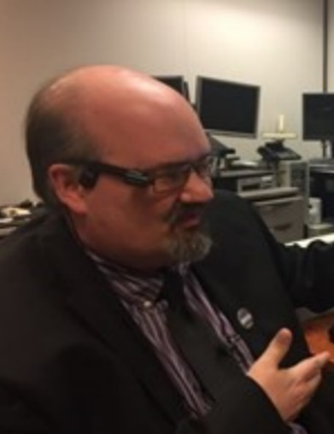

Current Position and Department
Manager, Accessibility, Accommodation and Adaptive Computer Technology Program
Shared Services Canada

Location of Work
National Capital Region

Language(s) of Communication
French and English

Areas of Expertise
- Advocacy, self-advocacy, and public speaking on topics in the disability space
- Inclusive, accessible information and communications technology
- Accessibility standards, guidelines, and best practices to ensure the elimination of systemic barriers.
- Navigating challenges faced by persons with disabilities in the Government of Canada and beyond, including job accommodation and best practices across the Government of Canada and abroad.

Availability to Mentor
Weekly or monthly basis

Contact Details
jeffrey.stark@ssc-spc.gc.ca

JESSICA SERVICE (SHE/HER)

Current Position and Department
Manager of Performance Management, OCIO – Chief Data Office
Treasury Board of Canada (TBS)

Location of Work
Ottawa

Language(s) of Communication
English

Areas of Expertise
- Dyslexia and navigating and preparing for hiring and selection processes including understanding the accommodation process.
- Working in the data and performance domain (policy research, data framework development, regulatory policy, program policy) as well as planning, reporting and evaluation
- Connection and networking with relevant experts to help you gain a more thorough understanding of the topic of data and performance in the public sector.

Availability to Mentor
Once a month

Contact Details
Jessica.service@tbs-sct.gc.ca

KAREN KENNIPHAAS (SHE/HER)

Current Position and Department
Chair, Persons with Disability Advisory Committee (PDAC), Equity, Diversity & Inclusion / Workforce Planning, Policies and Programs
Canada Border Services Agency (CBSA)

Location of Work
Ottawa

Language(s) of Communication
English and French

Areas of Expertise
- 26 years experience in the public service in corporate and operations, with an intersectional lens
- Specialty in accessibility, accommodations and inclusivity
- Persons with Disabilities Advisory Committee (PDAC) Chair & Accessibility Ambassador, Accessibility Office

Availability to Mentor
Once a month or bi-monthly for 1 hour each, max

Contact Details
Karen.Kenniphaas@cbsa-asfc.gc.ca
613-415-9721

KATHLEEN REYNOLDS (SHE/HER)
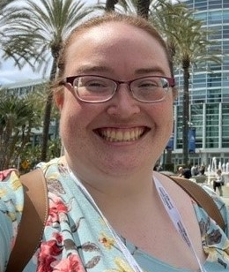

Current Position and Department
Program Officer, CIO Directorate, Enterprise IT Procurement and Corporate Services Branch
Shared Services Canada

Location of Work
Ottawa

Language(s) of Communication
English

Areas of Expertise
- Organizing & procuring accommodation for employees with disabilities
- University-work transitions; working in the GC as a new employee.
- Information analysis & professional writing (reports, briefing notes, proposals, presentations)

Availability to Mentor
Every two weeks

Contact Details
Kathleen.reynolds@ssc-spc.gc.ca
873-455-4252

KENNETH AQUIN-ABBOUD (HE/HIM)

Current Position and Department
Senior Program Analyst, Accessibility Readiness Team
Health Canada

Location of Work
Ottawa and Montreal

Language(s) of Communication
French and English

Areas of Expertise
- The Grants and Contributions process and the delivery of programs and services
- Policy development and stakeholder relations
- Employee network activities and leveraging those experiences to build necessary competencies to reach career objectives.

Availability to Mentor
Bi-weekly basis

Contact Details
kenneth.aquin-abboud@hc-sc.gc.ca
343-549-6037

KRIS BANOVIC DA SILVA (THEY)
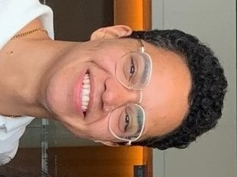

Current Position and Department
Regulatory Affairs Officer, Biologic and Radiopharmaceutical Drugs Directorate (BRDD)

Health Canada

Location of Work
Ottawa

Language(s) of Communication
English (fluent), French (Elementary Proficiency), Serbian/Bosnian/Croatian (fluent)

Areas of Expertise
- Self advocacy for invisible disabilities – ADHD and Mental Health
- Navigating government as a trans person
- Navigating government as a student and new hire
- Career planning and networking
- Self organization and motivation

Availability to Mentor

Once to twice a month depending on availability.

Contact Details
kris.banovicdasilva@hc-sc.gc.ca

KYLE ARSENAULT (HE/HIM)

Current Position and Department
Income Tax Auditor, Audit Division
Canada Revenue Agency

Location of Work
Halifax

Language(s) of Communication
English

Areas of Expertise
- Knowledgeable in the accommodation process within the Federal Government
- Identifying strengths and areas of improvement
- Motivation, self-confidence, and building a positive mindset.
- Navigating career paths that are aligned with your passions and limitations.
- Assist in developing a plan to overcome obstacles and reach your career goals.

Availability to Mentor
One hour biweekly

Contact Details
Kyle.Arsenault@cra-arc.gc.ca
902-266-8653

LAURA SMALLWOOD (SHE/HER)
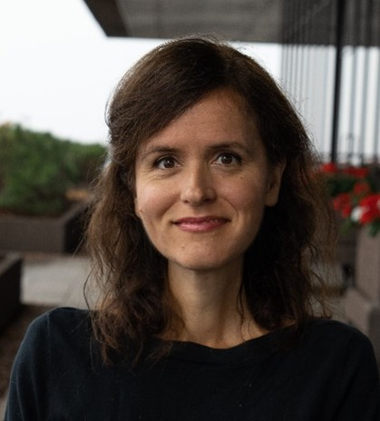

Current Position and Department
Director General, Corporate Planning, Performance and Risk
Global Affairs Canada

Location of Work
Gatineau

Language(s) of Communication
English

Areas of Expertise
- Working on international issues and employee management
- Accessing accommodations
- Growing your career and leadership

Availability to Mentor
Monthly Basis

Contact Details
laura.smallwood@international.gc.ca

LAUREN SAPIC (SHE/HER)

Current Position and Department
Articling Student, Department of Justice, Prairies
Department of Justice

Location of Work
Edmonton

Language(s) of Communication
English

Areas of Expertise
- Law
- Negotiating your disability at work.
- Being your own best advocate

Availability to Mentor
Once a month

Contact Details
lauren.sapic@justice.gc.ca

LEE GRENON (HE/HIM)

Current Position and Department
Regional Manager, Data Access Division
Statistics Canada

Location of Work
Vancouver

Language(s) of Communication
English

Areas of Expertise
- Career development and working in a region outside the NCR
- Managing projects, and effectively working with people
- Data development and analysis

Availability to Mentor
Up to a couple times each month

Contact Details
lee.grenon@statcan.gc.ca
(778) 984-0360

LOTHLORIEN FARLEY (SHE/HER)

Current Position and Department
Maritime Security Officer, Marine Security Operations Centre – East, Maritime Security
Canadian Coast Guard

Location of Work
Halifax, NS

Language(s) of Communication
English and French (oral only)

Areas of Expertise
- Maritime program management and maritime domain awareness
- Accessibility adaptation in operational environments
- Former FSWEP participant

Availability to Mentor
Shift worker, so hours during workdays vary week to week: 2 meetings a month.
Email responses will also be delayed as the schedule includes days off of 4 days or more.

Contact Details
Lothlorien.farley@dfo-mpo.gc.ca

MARTIN ANDERSON (HE/HIM)

Current Position and Department
General Counsel, Ontario Region
Department of Justice Canada

Location of Work
Toronto

Language(s) of Communication
English and Spanish

Areas of Expertise
- Constitutional law
- Immigration law
- Administrative law
- Litigation

Availability to Mentor
Once per week

Contact Details
Martin.Anderson@justice.gc.ca
641-256-0879

MARYAM SHAHEEN (SHE/HER)

Current Position and Department
Taxpayer Relief Officer, Taxpayer Relief Division, Atlantic Region
Canada Revenue Agency

Location of Work
St. John’s

Language(s) of Communication
English and Urdu

Areas of Expertise
- Leadership/soft skills
- Building meaningful work connections
- Informal accommodations; Communicating them to the supervisors/managers

Availability to Mentor
Bi-weekly

Contact Details
Maryam.Shaheen@cra-arc.gc.ca
782-641-4865

MARYROSE RODGER (SHE/HER)

Current Position and Department
Executive Director, Reconciliation, Treaties and Engagement, Community and Identity
Heritage Canada

Location of Work
Ottawa

Language(s) of Communication
English and French

Areas of Expertise
- Digital transformation / change management / project management
- Preparing for selection processes / developing your brand / emotional Intelligence
- Program development, policy research and development, planning, reporting and evaluation

Availability to Mentor
Once a month-the possibility of more frequent meetings, schedule permitting.

Contact Details
maryrose.rodger@pch.gc.ca

MEGAN LE STUM (THEY/THEM)

Current Position and Department
Junior Human Resources Advisor for the Accessibility Secretariat
Statistics Canada

Location of Work
Montreal

Language(s) of Communication
French and English

Areas of Expertise
- How to find the right accommodations and how to ask for accommodations.
- How to equip yourself for work as a neurodivergent person
- How to network in government as a neurodivergent person
- How to navigate the public service as a disabled and trans employee
- Autism and public service work
- ADHD and public service work

Availability to Mentor
1 or 2 times a month for a 30-60-minute session, schedule permitting.

Contact Details
Megan.lestum@statcan.gc.ca

MEIKA NOONAN(SHE/HER)
I am an active ally, who wanted to become a mentor to share my passion for the public service. There is so much to learn when starting a career, I would love to help future employees navigate the through working in the public service.

Current Position and Department
Objections Officer, Appeals, Taxpayer Relief
Canada Revenue Agency

Location of Work
Summerside

Language(s) of Communication
English

Areas of Expertise
- Navigating the Government of Canada as a new employee/ networking
- Phone and customer service skills
- Supporting mentee for a rewarding career

Availability to Mentor
Once a week

Contact Details
Meika.noonan@cra-arc.gc.ca
782-324-2429

MERCEDES MUELLER (SHE/HER)
Current Position and Department
Special Advisor, Human Resources Branch
Innovation, Science and Economic Development Canada

Location of Work
Ottawa

Language(s) of Communication
English
Areas of Expertise
- Navigating the workplace as an employee with disabilities and troubleshooting common challenges
- Working in the policy domain (e.g., strategic policy, program policy, policy development), in equity, diversity, and inclusion, and accessibility, and in stakeholder engagement and consultation
- Interpersonal relationships (e.g., navigating difficult conversations, building networks, emotional intelligence) and organizational skills (e.g., time management, work planning, etc.)

Availability to Mentor
Every two weeks
Contact Details
mercedes.mueller@ised-isde.gc.ca
613-410-7035

MEREDITH RICHMOND (SHE/HER)
Current Position and Department
Ontario Regional Lead – National Managers’ Community
Canada School of Public Service

Location of Work
Remote – Kingston. Office – NCR

Language(s) of Communication
English
Areas of Expertise
- Career development
- Leadership development
- Mental health and wellness
- Duty to accommodate process and how to talk to managers about your needs (accessibility passport); self-advocacy
- Building a career with a mental health disability and neurodivergence
- Finding your support network/self-care and compassion
- Employee Resource Groups

Availability to Mentor
Once a month but able to answer email and messages always
Contact Details
Meredith.richmond@csps-efpc.gc.ca
705-977-4142

MICHAEL MOHAMMED
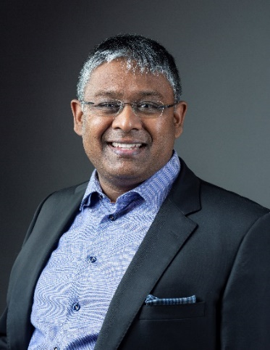

Current Position and Department
Manager, Policy and Legislation, Information and Data Governance
Treasury Board of Canada Secretariat

Location of Work
Ottawa

Language(s) of Communication
English

Areas of Expertise
- Building a career (with a disability) in science and technology
- Navigating the public service
- Advancing interests versus rights
- Working with a disability in an “Isolated Post” or field office environment
- Thinking and communicating strategically

Availability to Mentor
Bi-weekly

Contact Details
Michael.mohammed@tbs-sct.gc.ca

MICHAEL SIDAROSE (HE, HIM, THEY)

Current Position and Department
Junior Project Officer, Pension Centre
Public Services and Procurement Canada | Government of Canada

Location of Work
Ottawa

Language(s) of Communication
English

Areas of Expertise
- Remote working
- Accessible Testing
- Creating summary reports

Availability to Mentor
Bi-weekly

Contact Details
Michael.Sidarose@tpsgc-pwgsc.gc.ca
416-433-4380

MICHELLE ADDESA (SHE/HER)
Current Position and Department
Equity, Diversity, and Inclusion Advisor, Workplace Programs, Human Resources Branch
National Research Council Canada

Location of Work
Toronto

Language(s) of Communication
English and French
Areas of Expertise
- Soft skills including leadership, people management, emotional intelligence, and working with others (including through a EDI lens)
- Time management skills including work planning, task delegation/prioritization.
- Job-related skills including communication, project management, and organization.

Availability to Mentor
Once a week/every two weeks
Contact Details
Michelle.Addesa@nrc-cnrc.gc.ca

MYRIAM LAMONTAGNE (SHE/HER)
Current Position and Department
Accessibility Expert
Immigration, Refugees and Citizenship Canada

Location of Work
Gatineau

Language(s) of Communication
French and English
Areas of Expertise
- How to use or develop your leadership as young public servant, Effective Networking & Career planning
- Knowing and understanding my rights and resources as a person with a disability in the federal government
- Areas of expertise: Digital Accessibility, Learning, Stakeholder Engagement, Communications, Diversity and Inclusion, Team Management, Accommodation, Briefing high executives (DM& President level), Public Speaking and Teaching

Availability to Mentor
Bi-weekly
Contact Details
Myriam.lamontagne@cic.gc.ca

MYRIAM REEVES (SHE/HER)
Current Position and Department
Human Resources Advisor/ Learning Advisor, Enterprise Change and Learning Academy (ECLA)
Immigration, Refugees and Citizenship Canada

Location of Work
Sydney, Nova Scotia

Language(s) of Communication
French and English
Areas of Expertise
- Navigating and preparing for hiring and selection processes including the accommodation process
- Help people to identify their skills and their career goals
- Helping to identify available training and development opportunities

Availability to Mentor
Every two weeks
Contact Details
myriam.reeves@cic.gc.ca
902-565-9790

NAN ZHANG (HE, HIM)

Current Position and Department
Senior Project Officer, Health Canada, Corporate Services Branch (CSB)
Health Canada

Location of Work
Ottawa

Language(s) of Communication
English, French (written only) and Mandarin Chinese (Oral only)

Areas of Expertise
- Being a jack of all trades
- Compensation
- SAP

Availability to Mentor
Bi-weekly

Contact Details
nan.zhang@hc-sc.gc.ca
613-402-1937

NANCY OLDFORD (SHE/HER)

Current Position and Department
HR Director
Public Service and Procurement Canada

Location of Work
Halifax, Nova Scotia

Language(s) of Communication
French and English

Areas of Expertise
- How to apply to government jobs
- Excelling in job interviews
- Managing your career

Availability to Mentor
Monthly basis

Contact Details
nancy.oldford@tpsgc-pwgsc.ca
902-478-8509

NOOR SIDDIQI (SHE/HER)
Please note, Noor does not have a lived experience with a disability. She is an active ally. She has in the past worked with organizations that serve persons with print disabilities and continues to volunteer with other organizations.
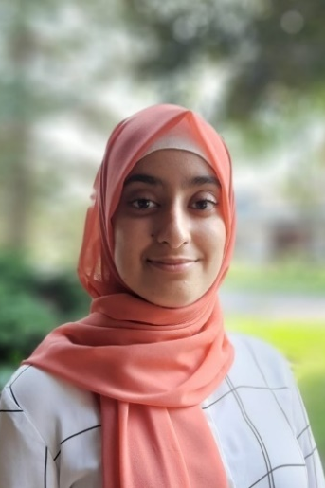

Current Position and Department
Application Development Analyst Programmer
Justice Canada

Location of Work
Ottawa, NCR

Language(s) of Communication
English

Areas of Expertise
- Technologies
- Post-secondary advice
- Working in the public service and the applying for government jobs

Availability to Mentor
Montly basis

Contact Details
noor.siddiqi@justice.gc.ca
613-410-2504

NUBA ILHAN

Current Position and Department
Spectrum Management Officer
Innovation, Science and Economic Development Canada

Location of Work
Oshawa, Ontario

Language(s) of Communication
English and Hindi, Urdu

Areas of Expertise
- Radio Licensing (Authorization and Compliance)
- Resume optimization for federal government positions
- Networking skills, social/life skills, work-life balance, accessibility in the workplace (guidance only), empathy and respect in the workplace, collaboration in the workplace

Availability to Mentor
Monthly basis

Contact Details
nuba.ilhan@ised-isde.gc.ca
250-301-3795

MEGAN OTU (SHE/THEY)
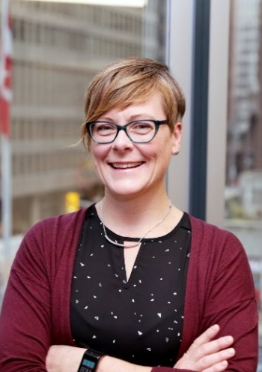
Current Position and Department
Senior Advisor of Employment Equity, Diversity and Inclusion, Employment Equity, Diversity and Inclusion
Fisheries and Oceans Canada

Location of Work
Ottawa

Language(s) of Communication
English
Areas of Expertise
- Experience networking and building support systems.
- Building creativity into your work objectives
- Bringing your whole self to work and 2SLGBTQIA+ inclusion.

Availability to Mentor
Every two weeks for one hour
Contact Details
megan.otu@dfo-mpo.gc.ca

PAMELA LAHEY

Current Position and Department
Senior Policy Analyst, Accessible Canada Directorate (ACD)
Employment and Social Development Canada

Location of Work
Gatineau

Language(s) of Communication
English

Areas of Expertise
- Mental health
- Work-related skills: data skills, writing, contracting, presentations
- Networking
- Time management and work-life balance
- Navigating government processes as a new employee or as a PWD

Availability to Mentor
Once a week; either Mondays or Fridays

Contact Details
pamela.lahey@hrsdc-rhdcc.gc.ca
819 968-7747

PRAVDEEP SAHOTA (SHE/HER)
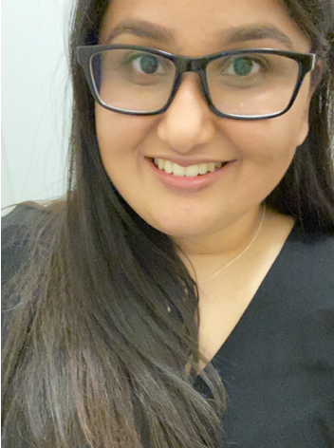
Current Position and Department
Diversity and Inclusion Team Lead, Integrated Business Management Services
Canadian Coast Guard – Arctic Region

Location of Work
Burlington, Ontario

Language(s) of Communication
English
Areas of Expertise
- Growing your career and working towards a fulfilling and successful career as a public servant
- Advocating for yourself in the process of requesting accommodations in the workplace and during staffing competitions
- Working in areas such as mental health and wellness; accessibility; diversity, equity, and inclusion in federal government agencies and departments

Availability to Mentor
Once a month with the possibility of more frequent meetings depending on work schedule
Contact Details
pravdeep.sahota@dfo-mpo.gc.ca
365-341-0534

RACHEL BOUTIN (SHE/HER)

Current Position and Department
Manager, Accessibility
Statistics Canada

Location of Work
Remote location, close to Montreal

Language(s) of Communication
French and English

Areas of Expertise
- Employment of People with Disabilities
- Accessibility
- Career

Availability to Mentor
Bi-weekly basis

Contact Details
rachel.boutin@statcan.gc.ca
514-234-9879

ROCK BISSON PICARD
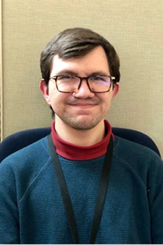

Current Position and Department
Information Management Business Analyst
Justice Canada

Location of Work
Gatineau (remote meetings only)

Language(s) of Communication
French and English

Areas of Expertise
- Time management
- Planning
- Note-taking

Availability to Mentor
Weekly basis

Contact Details
rock.bisson-picard@justice.gc.ca
343-551-3678

SARAH CHAYTOR (SHE/HER)
Current Position and Department
Analyst, Scientific equipment team, Science Delivery
Public Services and Procurement Canada

Location of Work
Guelph (Remote), office in Ottawa

Language(s) of Communication
English
Areas of Expertise
- Public speaking confidence! How to more confidently present, engage and answer questions for both large and small audiences.
- How to be an effective problem solver.
- Dexterity impairments and working online – what accommodations are available, how to ask for them, and how to advocate for the tools you need.
- Advocating for invisible disabilities.
- Job applications, student bridging process, and how to highlight unique backgrounds to hiring managers.

Availability to Mentor
Bi-weekly
Contact Details
sarah.chaytor@tpsgc-pwgsc.gc.ca
519-400-5046

STACY MUISE (SHE/HER)
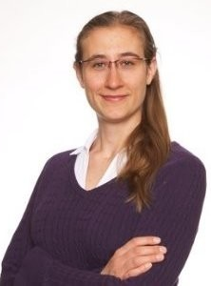

Current Position and Department
Policy Analyst, External Relations and Engagement Division
Impact Assessment Agency of Canada

Location of Work
Ottawa

Language(s) of Communication
English and French

Areas of Expertise
- Accessibility and accommodations in the public service
- Public participation and Indigenous consultation
- Non-directive coaching

Availability to Mentor
Every three weeks or once a month

Contact Details
stacy.muise@iaac-aeic.gc.ca
343-553-8751

STEFAN SIMARD (HE/HIM)

Current Position and Department
Senior Taxpayer Relief Officer, Western - Appeals and Service Feedback Operations Division, Appeals Programs Operations Directorate Appeals Branch
Canada Revenue Agency

Location of Work
Winnipeg

Language(s) of Communication
English

Areas of Expertise
- Professional life and neurodivergence
- Self-acceptance and building confidence
- Self-care and work-life balance strategies

Availability to Mentor
Once per week

Contact Details
Stefan.Simard@cra-arc.gc.ca
204-430-2286

TESS MACMILLAN (SHE/HER)

Current Position and Department
Analyst, Conservation & Protection
Fisheries and Oceans Canada

Location of Work
Capital National Region

Language(s) of Communication
English

Areas of Expertise
- Time Management Skills
- Work-Life Balance
- Navigating the Government of Canada as a new employee.
- Accessing Accommodations

Availability to Mentor
1 or 2 times a month.

Contact Details
Tess.Macmillan@dfo-mpo.gc.ca

TOM WESTLAKE (HE/HIM)

Current Position and Department
Team Leader, Integrity Services Branch
Service Canada

Location of Work
London Ontario

Language(s) of Communication
English

Areas of Expertise
- ADHD
- Strategic & Analytical Thinking
- Process development

Availability to Mentor
Bi-weekly or monthly basis for up to 1 hour per individual

Contact Details
tom.westlake@servicecanada.gc.ca
519-317-5785

TRISTAN READMAN (HE/HIM)
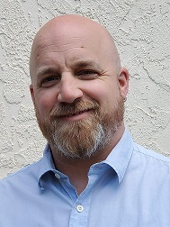

Current Position and Department
Regional Director, Integrated Technical Services
Canadian Coast Guard

Location of Work
Victoria

Language(s) of Communication
English

Areas of Expertise
- Helping people showcase their abilities and career goals.
- Hiring process and how to navigate through them.
- Technologies (use, tips and tricks)

Availability to Mentor
1-2 times a month for a session of 30 minutes to an hour, schedule permitting.

Contact Details
Tristan.Readman@dfo-mpo.gc.ca
250-418-1412

VINCENT TAILLEFER

Current Position and Department
Business Improvement Officer, Human Resources
Infrastructure Canada

Location of Work
Ottawa

Language(s) of Communication
English and French

Areas of Expertise
- Leadership
- Self-Improvement & Character development
- Business

Availability to Mentor
Once per week, 1-2 students

Contact Details
vincent.taillefer@infc.gc.ca
343-552-4499

WILLIAM (JOEL) SERSON (HE/HIM)

Current Position and Department
Change Management Officer, Office of Public Service Accessibility
Treasury Board Secretariat

Location of Work
Ottawa

Language(s) of Communication
English and French

Areas of Expertise
- The accessibility landscape of the public service
- Advancing disability and inclusion
- Network Persons with Disabilities

Availability to Mentor
Bi-weekly

Contact Details
William.serson@tbs-sct.gc.ca

ZOË CREGO (SHE/HER)

Current Position and Department
Communications Advisor, Strategy and Engagement Branch
Shared Services Canada

Location of Work
Ottawa

Language(s) of Communication
English

Areas of Expertise
- Building and maintaining a network
- Self-advocacy in the workplace including requesting formal/informal accommodations.
- Transitioning from a student to an indeterminate employee, including applying for government job processes

Availability to Mentor
Every two weeks

Contact Details
zoe.crego@ssc-spc.gc.ca
613-295-4484

