Table of Contents
April 2023 1
Capsule #4: The language of supervision 1
February 2023 4
Capsule #3: The simultaneity of official languages in training and service offers 4
December 2022 5
Capsule #2: Communications in working groups 5
November 2022 8
Capsule #1: Bilingual meetings 8

To open the French version click here.

April 2023

Capsule #4: The language of supervision
Hello:

For this edition of the Official Languages Co-champions’ Capsule, the focus is on the rights and obligations with regards to language of supervision.

What the Act says
According to the Directive on Official Languages for People Management (6.1.2), managers and supervisors are responsible for supervising employees who occupy bilingual or either/or positions in bilingual regions in the employees’ preferred official language.
Employees who occupy unilingual positions in bilingual regions can also choose the official language in which they want to be supervised provided that their manager occupies a bilingual position in a bilingual region. Otherwise, the language of supervision is the language of an employee’s position.
In unilingual regions, the language of supervision is the region’s language of work, that is French in Quebec and English elsewhere in Canada, regardless of the linguistic identification of an employee’s position.

Tips and tricks

How do I determine my employees’ preferred official language?
- By asking them what their preference is when meeting with each of them for the first time.
- Employees’ preferred official language applies to both written and verbal communication. They have the right to choose the same official language for both modes of communication or a different official language for each mode.

How do I supervise employees in their preferred official language?
- By ensuring that all communication aimed at each employee, whether verbal or written, is in their official language of choice.

  - Communication may include, but is not limited to:
    - Assigning tasks;
    - Providing advice, guidance and feedback to employees;
    - Approving training, leave;
    - Completing employee performance evaluations.

Which official language should be used when assigning tasks that require answering a client?
- Managers must assign tasks based on employees’ preferred official language, if applicable. (Refer to the section called What the Act says for more details.)

**Managers are not responsible for translating clients’ request into employees’ preferred official language.
Clients’ right to receive services in the official language of their choice outweighs employees’ right to work in their preferred official language.

Resource corner
- See the eager beavers for depictions of issues that could arise if the official language for supervising employees is not known or respected. Please note that the text version of the image below is available on the web page.
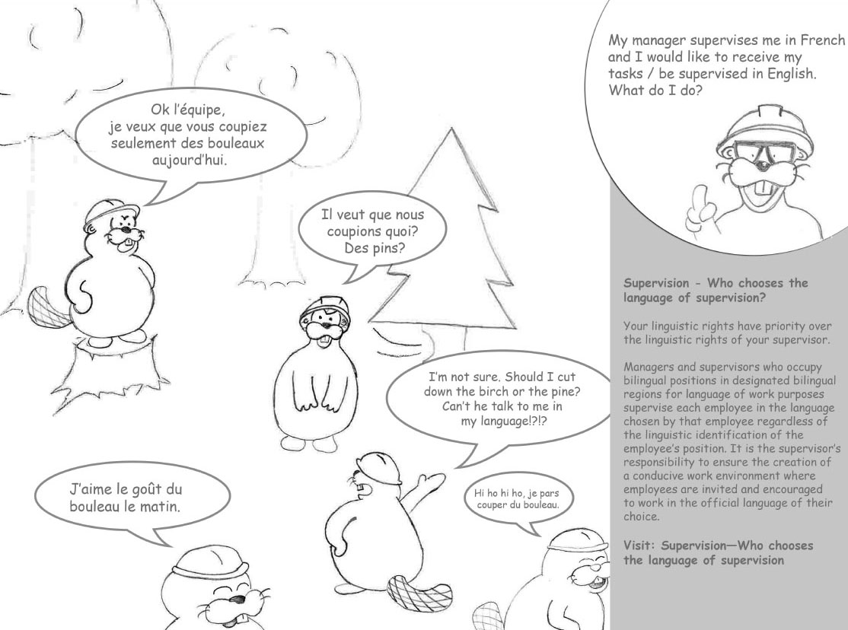

- To understand the six supervision scenarios possible, see Who Chooses the Language of Supervision on the intranet.
- For more information on Public Services and Procurement Canada’s language of work guidelines, including language of supervision, see the Official Languages Guidebook.

Challenge yourself!
As a manager, have you taken the time to ask each of your employees in which official language they want to be supervised?
As an employee, have you had the opportunity to tell your manager or supervisor in which official language you want to be supervised?
The Official Languages Program is here to help you. Please send your questions or comments to tpsgc.questionslo-olqueries.pwgsc@tpsgc-pwgsc.gc.ca.
You can also contact the email address above for an accessible version of this capsule.

Stéphan Déry & Lucie Séguin
Official Languages Co-champions
TPSGC.ChampionsLO-OLChampions.PWGSC@tpsgc-pwgsc.gc.ca
________________________________________________________________________

February 2023

Capsule #3: The simultaneity of official languages in training and service offers
Hello,
For the first Capsule of 2023, we would like you to be aware of what we mean by the simultaneity of official languages in training and service offers.

What the Act says
In Section 6.2.2 of the Policy on Official Languages, it is stated that designated bilingual offices must respect the equal status of both official languages by making communications and services available to the public in both official languages simultaneously.
The Policy on Official Languages (6.3.3) also states that in all designated bilingual regions, all measures must be taken to enable the institution’s employees to work and receive personal and central services, as well as training and professional development, in the official language of their choice.

Tips and Tricks

Members of the public
The way to indicate that services and communications are available in both official languages is through an active offer. Did you know that this is a requirement of the Official Languages Act? (section 28)
Whether it is by a verbal “Hello/Bonjour” or visual
the simultaneity of the offer enables members of the public to exercise their right to receive the service in the official language of their choice.

Federal public servants
A simultaneous offer is also an effective measure to enable employees to work and receive personal and central services, as well as training and professional development, in the official language of their choice. It’s important to remember that in addition to being simultaneous, the versions must be of equal quality in both official languages.

Consider the following scenario
A message in both official languages is sent to employees in a sector where some of them hold a position located in a designated bilingual region for language-of-work purposes. The purpose of this message is to inform them of a training session/service and it specifies the date and the language in which it will be provided. Regarding the availability in the other official language, the message indicates that the information will be provided at a later date.

Question
- Does this training/service offer allow employees to exercise their right to receive the training/service in the official language of their choice?

- The absence of a simultaneous offer imposes one official language to the detriment of the other official language and thus infringes on the employees’ rights to work in and choose the official language of their choice for training and services. Note that the absence of equal quality in both official languages will have the same repercussions.

Resource corner
- To confirm whether your office has linguistic obligations toward members of the public, please visit the Burolis site.
- To be aware of the designated bilingual regions, aside from the National Capital Region, please refer to the List of Bilingual Regions of Canada for Language-of-Work Purposes.
- Learn about the various services of the Translation Bureau that can help you strengthen the simultaneity of training/service offers while ensuring the equal quality of both official languages.
- Use one of PSPC’s MsTeams backgrounds or one of the Office of the Commissioner of Official Languages to illustrate the simultaneity of services in both official languages. Simply download the image to your computer and follow these steps.

Challenge yourself!
How will you plan your training/service offers so that they are produced simultaneously? Please share your ideas with us at tpsgc.questionslo-olqueries.pwgsc@tpsgc-pwgsc.gc.ca.

For an accessible version of the Official Languages Co-Champions’ Capsules, please contact us at tpsgc.questionslo-olqueries.pwgsc@tpsgc-pwgsc.gc.ca.

Stéphan Déry & Lucie Séguin
Official Languages Co-champions
TPSGC.ChampionsLO-OLChampions.PWGSC@tpsgc-pwgsc.gc.ca

December 2022

Capsule #2: Communications in working groups
Hello:
On November 10, we shared the first edition of the Official Languages Co-champions’ Capsule on bilingual meetings.
Today, we’re introducing the theme of communications in working groups.
- What the Act says
- Tips and Tricks
- Resource corner
- Challenge yourself!

What the Act says
The Directive on Official Languages for People Management (6.1.6) states that managers and supervisors are responsible for “taking all possible measures to create and maintain a work environment that allows employees to use the official language of their choice in bilingual regions for both oral and written communication purposes.”
Did you know that this means that employees whose positions are located in regions designated as bilingual have the right to communicate in the official language of their choice when participating in working groups?

Tips and Tricks
To establish a working group that respects employees’ linguistic rights, here are some questions employees should ask themselves:
- Are the members of the working group employees from a bilingual region?
- Yes. The members of the working group must establish a language of work. See question 2.
- No. The language of work is that of the region, meaning French in Quebec and English elsewhere in Canada.
- Some of them. All communications must be bilingual and for written documents, distributed simultaneously and of equal quality.

- Is the preferred official language the same for all members of the working group?
- No. All communications must be bilingual and for written documents, distributed simultaneously and of equal quality.
- Yes. An agreement among members of the working group to use one official language for communications and drafts is possible.
- I don’t know. All communications must be bilingual.

3. Will consultations take place with individuals outside of the working group?
- Yes. All communications must be bilingual and for written documents, distributed simultaneously and of equal quality.
- No. Communication follows the rules in question 1.

- Is the preferred official language for the individuals consulting the working group’s final products already known?
- Yes. The products should be sent in the recipient’s preferred official language.
- No. The products should be available simultaneously in both official languages, and of equal quality.
Think about it! “All communications” includes discussions among members of the working group and written documents.
Just like when holding bilingual meetings, communication in both official languages offers advantages to all participants:
- Optimal contribution from all participants, as most are more productive in the official language of their choice.
- An inclusive and respectful work environment.
- Opportunities to improve official second language proficiency by being exposed to both official languages.

Resource corner
- Check out the official languages fact sheet on working groups.
- Refer to the Treasury Board Secretariat’s Communication between regions table (see scenario C).
- The Treasury Board Secretariat has answers to your questions on creating a work environment conducive to the use of both official languages.

Challenge yourself!
The next time you’re in a working group, what will you do to make the work environment conducive to the effective use of both official languages? If you want to share your experiences with us, send us an email at tpsgc.questionslo-olqueries.pwgsc@tpsgc-pwgsc.gc.ca.
Stéphan Déry & Lucie Séguin
Official Languages Co-champions
TPSGC.ChampionsLO-OLChampions.PWGSC@tpsgc-pwgsc.gc.ca

November 2022

Capsule #1: Bilingual meetings
Hello:
We are pleased to present to you the first edition of the Official Languages Co-champions’ Capsule: an initiative that shines a spotlight on official languages requirements.
Each capsule will be divided into four sections:
- an explanation of the official languages requirements
- tips and tricks
- a resource corner
- a challenge to take up
The topic for this inaugural edition is bilingual meetings.

What the Act says
In regions designated bilingual, a work environment that is conducive to the effective use of both official languages must be created. This means, among other things, that meetings must be bilingual.
Consequently, the Directive on Official Languages for People Management (6.1.3) states that managers and supervisors are responsible for taking all necessary measures to enable employees to use the official language of their choice in meetings.
In unilingual regions, meetings are held in the language of work of the region, meaning French in Quebec and English elsewhere in Canada. However, even if the meeting is organized by a team located in a unilingual region, if there are participants from a bilingual region, they must be invited to use the official language of their choice.

Tips and tricks

Before the meeting
- Send the invitation in both official languages stating that the meeting will be bilingual.
- Attach all documents needed for the meeting simultaneously in both official languages.
- Appoint a co-chair if the person chairing the meeting would like some support to facilitate a bilingual meeting.
- If you are planning a presentation during the meeting, make sure the person in charge of the presentation knows their official languages obligations.
  - This includes the obligation to simultaneously provide documentation of equal quality in English and French.
  - If the person giving the presentation is unable to fulfill their language obligations, steps must be taken to ensure participants’ rights are respected. For example, they can use a co-presenter or ask the person chairing the meeting to help.

During the meeting
The person chairing the meeting must do the following:
- Make the opening remarks in both official languages.
- Tell participants at the start of the meeting that they can speak in the official language of their choice.
- Summarize what participants say throughout the meeting in the other official language.
- Switch from one official language to the other and ensure a balance between the two languages.

As participants:
- Speak in the official language of your choice: it’s your right!
  - The presence of unilingual individuals does not take away your right to use the official language of your choice.

After the meeting
- Provide meeting minutes of equal quality in both official languages simultaneously.

Resource corner
- Meet our eager beavers!
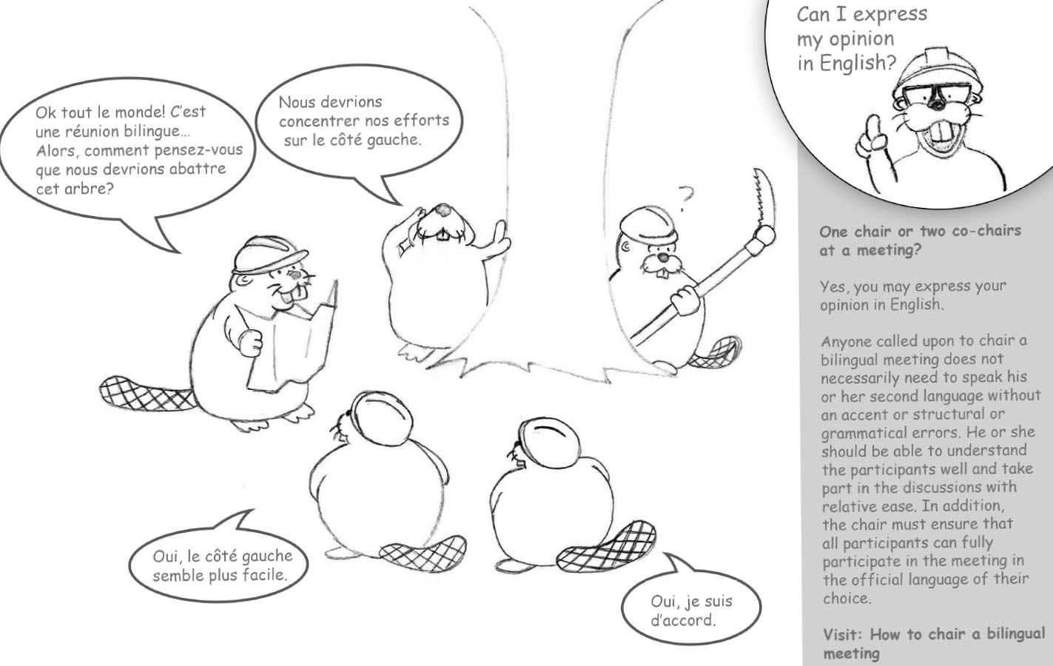

- Consult the intranet page: How to chair a bilingual meeting
- Want to see an example of a bilingual meeting? Watch this video from the Office of the Commissioner of Official Languages, Effective practices for chairing bilingual meetings - YouTube.

Challenge yourself!
Now it’s your turn! What are you going to do to ensure that your next meetings, when they must be, are bilingual from start to finish? Share your experiences with us at tpsgc.questionslo-olqueries.pwgsc@tpsgc-pwgsc.gc.ca.
Stéphan Déry & Lucie Séguin
Official Languages Co-champions
TPSGC.ChampionsLO-OLChampions.PWGSC@tpsgc-pwgsc.gc.ca

