August 2019
Contact : open-ouvert@tbs-sct.gc.ca
Guidance on Uploading Non-Standardized Proactive Disclosure Types on Open.canada.ca
Briefing packages for new or incoming ministers or deputy heads, Briefing packages for Parliamentary Committee appearances for ministers or deputy heads, Question Period binders, or Reports tabled in Parliament

Contents
1. Introduction 2
1.1 Authorization 2
2. Creating your Account 4
3. Using the Registry 4
3.1 Creating your Metadata Record 5
3.2 Adding Resources 10
3.3 Adding Related Items 14
4. Releasing the record on Open.Canada.ca 16
5. Editing your Record 17

Introduction
The Government of Canada’s Open Government Portal, Open.Canada.ca, provides access to open datasets, open information, Access to Information (ATI) Summary Requests, and Proactive Publication (also known as Proactive Disclosure - PD) Reports produced by federal departments and agencies. The Open Government Registry is the platform where government of Canada employees add and manage these various documents and resources as well as input relevant metadata. Metadata is information about your information asset, in order to support search and discovery, as well as to inform the user what the information asset is about.
Bill C-58 will create five new proactive disclosures types that will be required to be released by departments. Of these five, one (briefing note titles) will be standardized in a template format. However, due to their complexity, the other four will not be standardized. These non-standardized types include: briefing packages for new Ministers and Deputy Ministers, Parliamentary Committee binders, Question Period binders, and Reports tabled in Parliament. You will be uploading the metadata associated with these PD types on the Open Government Registry. The metadata will be submitted under the category of open information records.
This document will walk you through how to:
- Request an account in the Open Government Registry
- Add and modify records in the Registry
- Publish your metadata record on Open.Canada.ca

1.1 Authorization
Before releasing your Ministerial Transition Binders metadata on Open.Canada.ca, you are required to receive approval from your Information Management Senior Official (IMSO). To support institutions and Information Management Senior Officials (IMSOs) in managing the risks related to the release of data and information assets, the Treasury Board of Canada Secretariat (TBS) has developed a ‘Release Checklist’ that consolidates common release exceptions. It is the responsibility of IMSOs to ensure that an answer of ‘True’ can be given for each criteria before any series of data and information resources are released.
Please note that this checklist has been developed to help with the release of data and information and it is not necessary to submit this checklist to TBS. However, by responding yes “IMSO Approval” (see below) it is assumed that the checklist has been completed.

Release Checklist | True | False
Access to Information  The data or information resource is not subject to any exemptions or exclusions under the Access to Information Act. | ☐ | ☐
Authority to Release  The institution has the mandate, legislative authority or permission from a third party provider to publish the data or information resource under the Open Government Licence – Canada. | ☐ | ☐
Formats  The data or information resource is in an open and accessible format that complies with the Standard on Web Accessibility.  For an example of accessible templates please see our resource. | ☐ | ☐
Privacy  The data or information resource is not subject to any exemptions or exclusions under the Privacy Act. | ☐ | ☐
Official Languages  The data or information resource is available in both official languages and conforms to the requirements of the Official Languages Act. | ☐ | ☐
Security  The data or information resource does not increase security risks to the institution, to other institutions, or to the government as a whole and conforms to the requirements of the Policy on Government Security and its related instruments. | ☐ | ☐
Other - Legal / Regulatory / Policy / Contractual  The release of data or other information resource complies with all other relevant legal, regulatory, contractual, and policy requirements (e.g., it is confirmed that there are no relevant legal, contractual, or third party, policy restrictions or limitations). | ☐ | ☐

Creating your Account
Before you can create a record for the non-standardized PD types you will need an account for the Open Government Registry - https://registry.open.canada.ca.
To request an account for the Open Government Registry, please populate the ‘Request an Account’ form on the homepage
Once your account has been approved by the Open Government team and the Open Government Coordinator for your organization, you will receive an email confirming the creation of your account. The email will also provide your username and password so you can log into the registry.

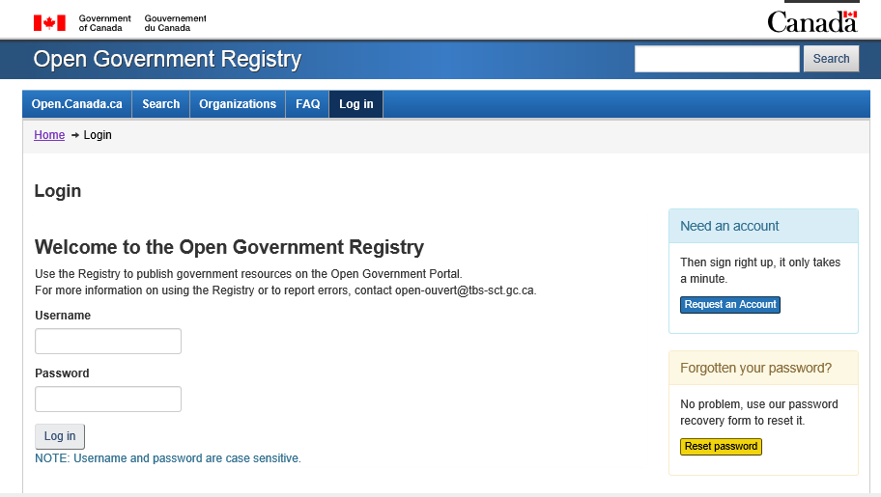

Once your Open Government Registry account is linked to your organization (this is done by TBS as part of account creation), you are able to search, add, edit and delete records for your organization.

Using the Registry
Once you have logged into the registry, you will arrive at the home page. The ‘Quick Links’ home page of the registry contains links where you can add various different types of data, information and proactive disclosures. From here you select the Open Information Records link to add your record. You can also use the Add to Portal dropdown menu above Quick Links menu.
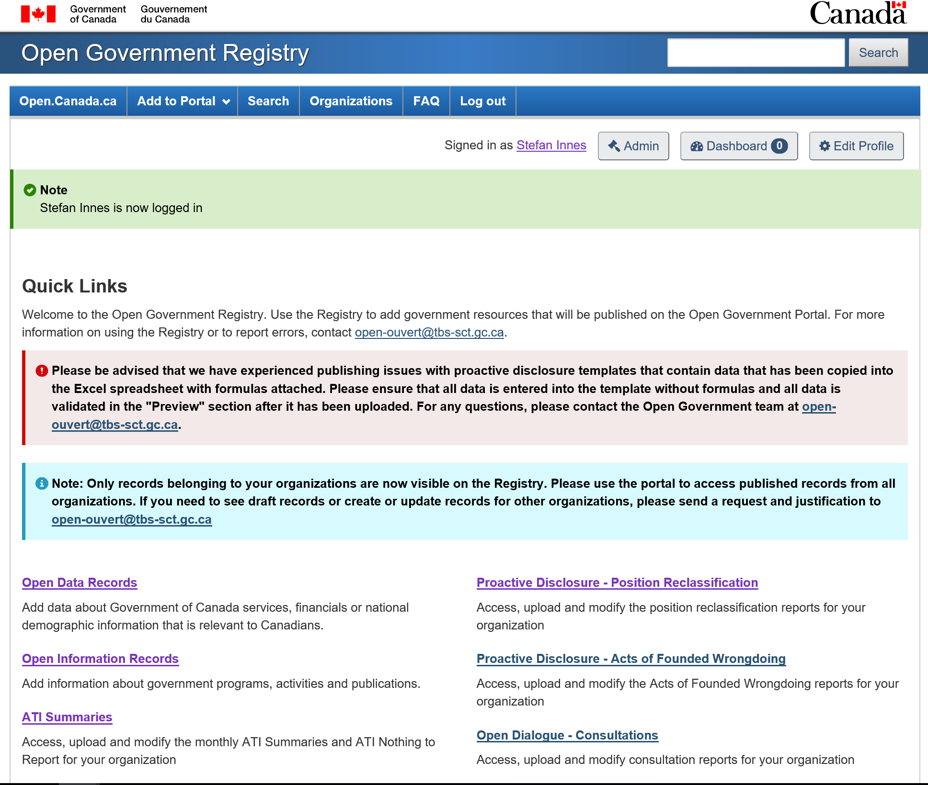

3.1 Creating your Metadata Record
The first step in linking a non-standardized PD type to open.canada.ca is to add the relevant metadata in the Registry.
Once you have selected Open Information Records, you will be redirected to the metadata form to populate. Filling out this form is the first step to adding your resource to the portal. Metadata is information about your information asset, in order to support search and discovery, as well as to inform the user what the information asset is about. Below are the mandatory fields, elements that you are required to populate, a description of what each should contain as well as screenshots of each element populated. The form does have additional fields that are not seen below, however, these fields are optional.

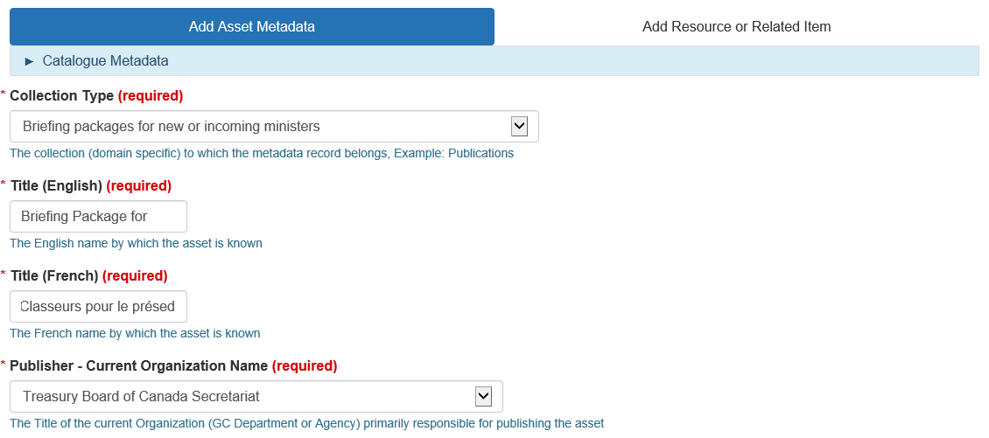
1
2
3
4
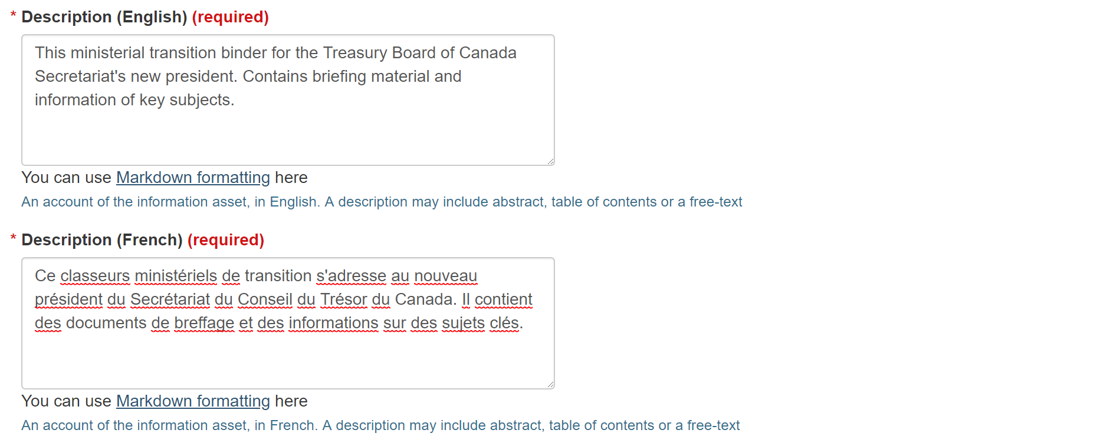
5
6
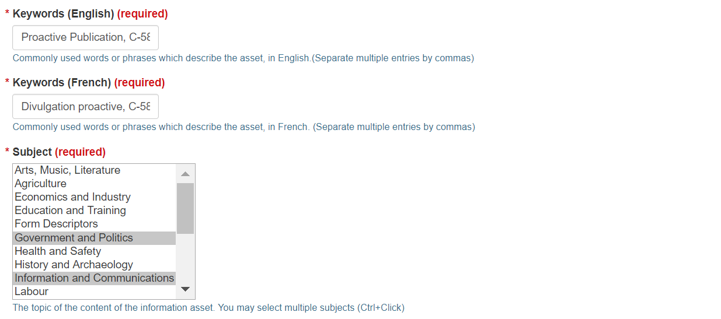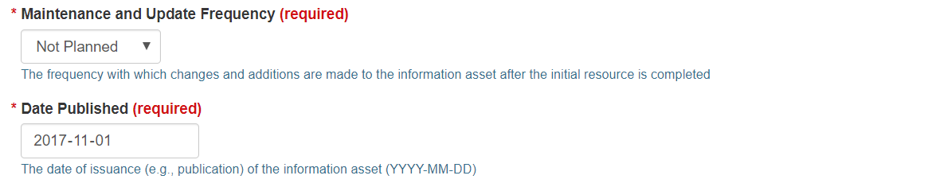
10
11
9
8
7

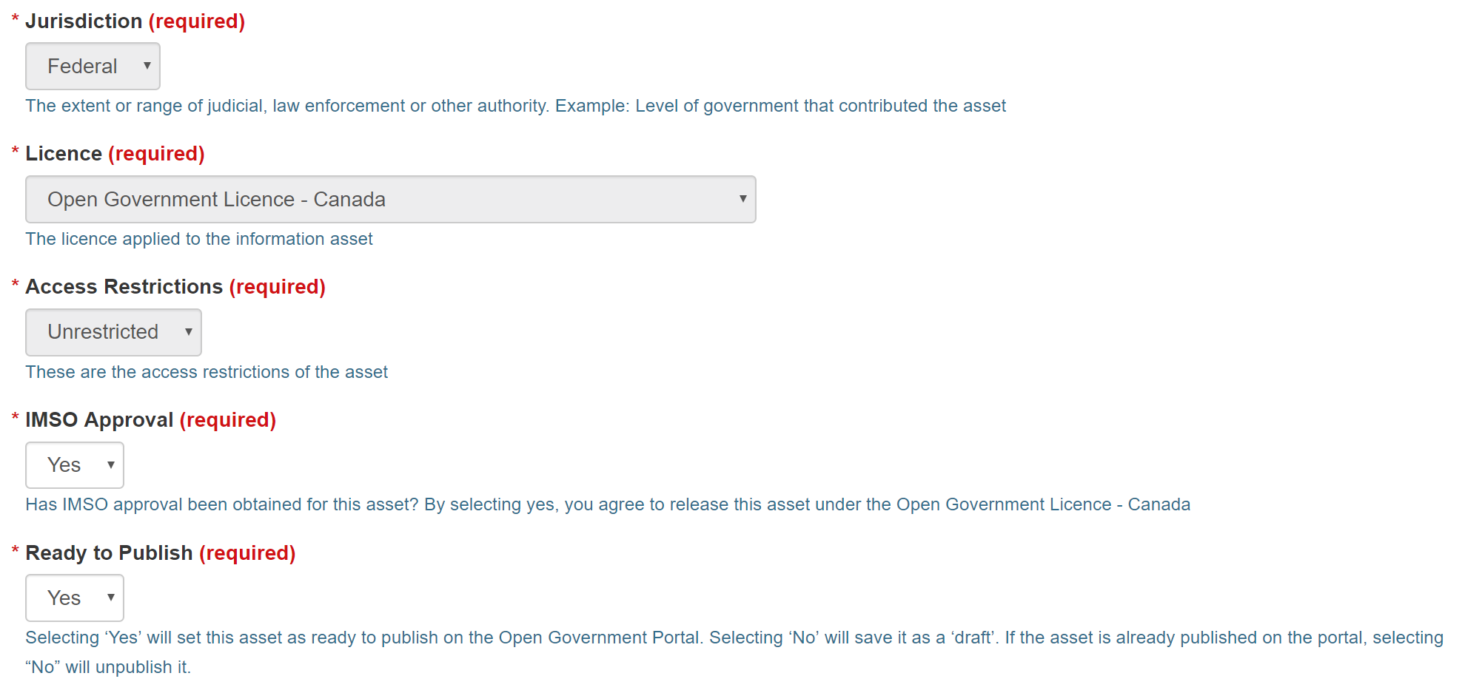
12
13
14
15
16

# | Element Name | Description | Type | Example
1 | Collection Type | The collection (domain specific) to which the metadata record belongs, Example: Publications. Note, this element should be populated with the relevant PD type from the drop down menu. | Dropdown | Briefing packages for new or incoming ministers or deputy heads, Briefing packages for Parliamentary Committee appearances for ministers or deputy heads, Question Period binders, or Reports tabled in Parliament
2 | Title (English) | The English name by which the asset is known, the title must include the departmental name and the Month/Year of the briefing period (YYYY-MM). | Free Text | Briefing Book for the President of the Treasury Board of Canada – 2017-11
3 | Title (French) | The French name by which the asset is known. | Free Text | Cahier pour le président du Secrétariat du Conseil du Trésor du Canada – 2017-11
4 | Publisher | The Title of the current Organization (GC Department or Agency) primarily responsible for releasing the asset | Dropdown | Treasury Board of Canada Secretariat
5 | Description (English) | A description of the asset, in English. The description may include abstract, table of contents or any free-text. | Free Text | This is the ministerial transition binder for the Treasury Board of Canada Secretariat’s new President.
6 | Description (French) | A description of the asset, in French. The description may include abstract, table of contents or any free-text. | Free Text | Ce classeur ministériel de transition s’adresse au nouveau président du Secrétariat du Conseil du Trésor du Canada.
7 | Keywords (English) | Commonly used words or phrases which describe the asset, in English.(Separate multiple entries by commas) | Free Text | Proactive Publication, C-58, Access to Information, ATI,
8 | Keywords (French) | Commonly used words or phrases which describe the asset, in French.(Separate multiple entries by commas) | Free Text | Divulgation proactive, C-58, l’accès à l’information,
9 | Subject | The topic of the content of the information asset. You may select multiple subjects (Ctrl+Click) | List | Government and Politics, Information and Communications
10 | Maintenance and Update Frequency | The frequency with which changes and additions are made to the asset after the initial resource is completed. | Dropdown | As Needed; Not Planned
11 | Date Published | The date of publication of asset. (YYYY-MM-DD) | Date | 2018-06-01
12 | Jurisdiction | Federal (this field is non-editable) | Non-editable | Federal
13 | Licence | Open Government Licence – Canada (this field is non-editable) | Non-editable | Open Government Licence – Canada
14 | Access Restrictions | Unrestricted (this field is non-editable) | Non-editable | Unrestricted
15 | IMSO Approval | Has IMSO approval been obtained for this asset? By selecting yes, you agree to release this asset under the Open Government Licence – Canada. Note, “Yes” must be selected before the information is published. | Dropdown | Yes/No
16 | Ready to Publish | Selecting ‘Yes’ will set this asset as ready to publish on the Open Government Portal. Selecting ‘No’ will save it as a ‘draft’. If the asset is already published on the portal, selecting “No” will unpublish it. | Dropdown | Yes/No

As seen above, a description of what should be entered is included below each field. Should you require more information concerning the details of each field, please see Open Government Metadata Application Profile (GCConnex)
Mandatory fields are indicated by a red asterisk and the word (required) while non-editable fields are greyed out. All other fields are optional. To improve Open Government Portal search results, you are encouraged to fill out as many fields additional fields as you can.
If there are values missing in any required fields, an error message (see below) will be displayed listing the fields that should be reviewed for completion.
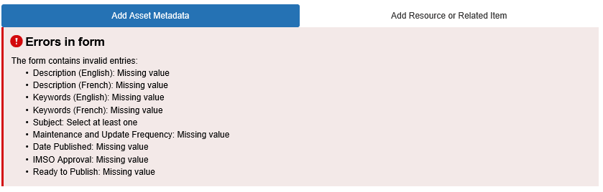
When you are finished entering the metadata, click on Next: Add Resource or Related Item. This will be the page where you will add or link to your document or HTML page.
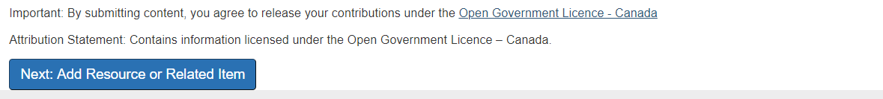

3.2 Adding Resources
The second step in adding a non-standardized PD type is to add the link to where the document itself (also referred to as resource) is published.
The resource refers to the actual document that you are adding to the portal. Here you may either directly upload the file to the open.canada.ca portal or add a link to where the resource is published if it is to be published on your institutional webpage. In the case of these non-standardized PD types, the primary resource should be linked to the institutional webpage. While additional resources and related items are added separately in each language (see next section), resources are added once, in bilingual format. The documents may also be uploaded directly to the portal as an Additional Resource (see below) if desired.
On the Add Resource or Related Item page you will be able to upload or link your files. The following captures the required elements, as well as a description and example for each.
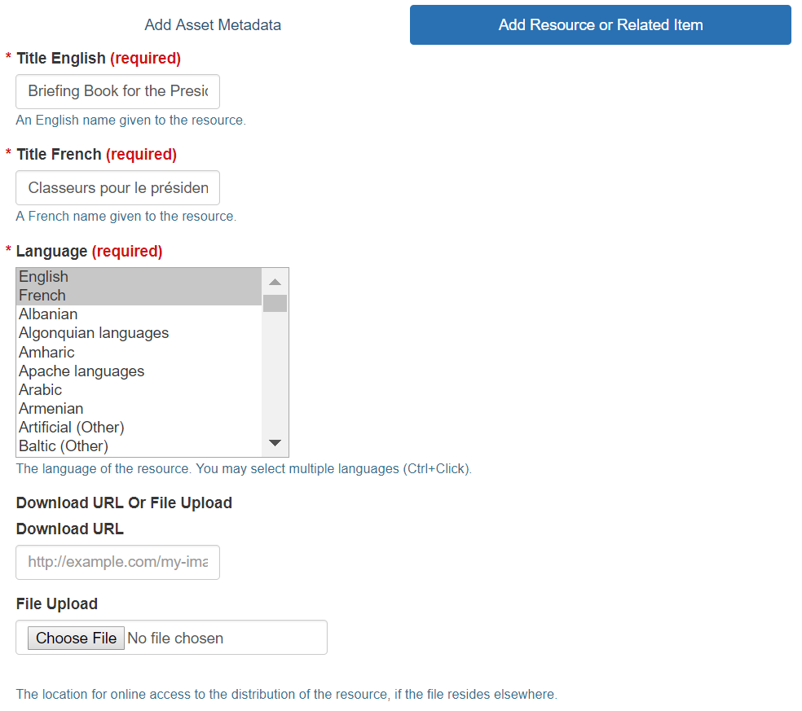
3
5
4
2
1
# | Element Name | Description | Type | Example
1 | Title English | An English name given to the resource | Free text | Briefing Book for the President of the Treasury Board of Canada – 2017-11
2 | Title French | A French name given to the resource | Free text | Classeurs pour le président du Secrétariat du Conseil du Trésor du Canada – 2017-11
3 | Language | The language of the resource | List | French, English
4 | Download URL | Add a link to an external URL where the document is hosted | Web Address | -
5 | File Upload | Choose a file to upload to be hosted on the Open Government Cloud | File upload | -

Fill out the title in English and French, the language of the resource, and then add the document or resource, entre the download the URL (this is the URL link to the document) or upload your file. As previously mentioned, in the case of the non-standardized PD types, you should link to an external URL using the Download URL field. By doing this, you are linking the record to an external URL hosted on your departmental website.
If you choose to upload your file, you are submitting your documents to be hosted on the Open Government Cloud. The Open Government Cloud is able to host information, however departments should keep a copy within their internal system.
After adding or linking to your resource, expand the section titled “Metadata Fields for Resources Only,” and enter relevant fields (see below). Do not enter any information in the section titled “Metadata Fields for Related Items Only”
You can also add additional links / resources to your metadata record. These could be background or supplementary information. For example,
- Link to the Minister’s profile on your internal website
- Link to the Minister’s mandate
- Link to your major projects page
These links will be added as resources, and will follow the steps captured above.

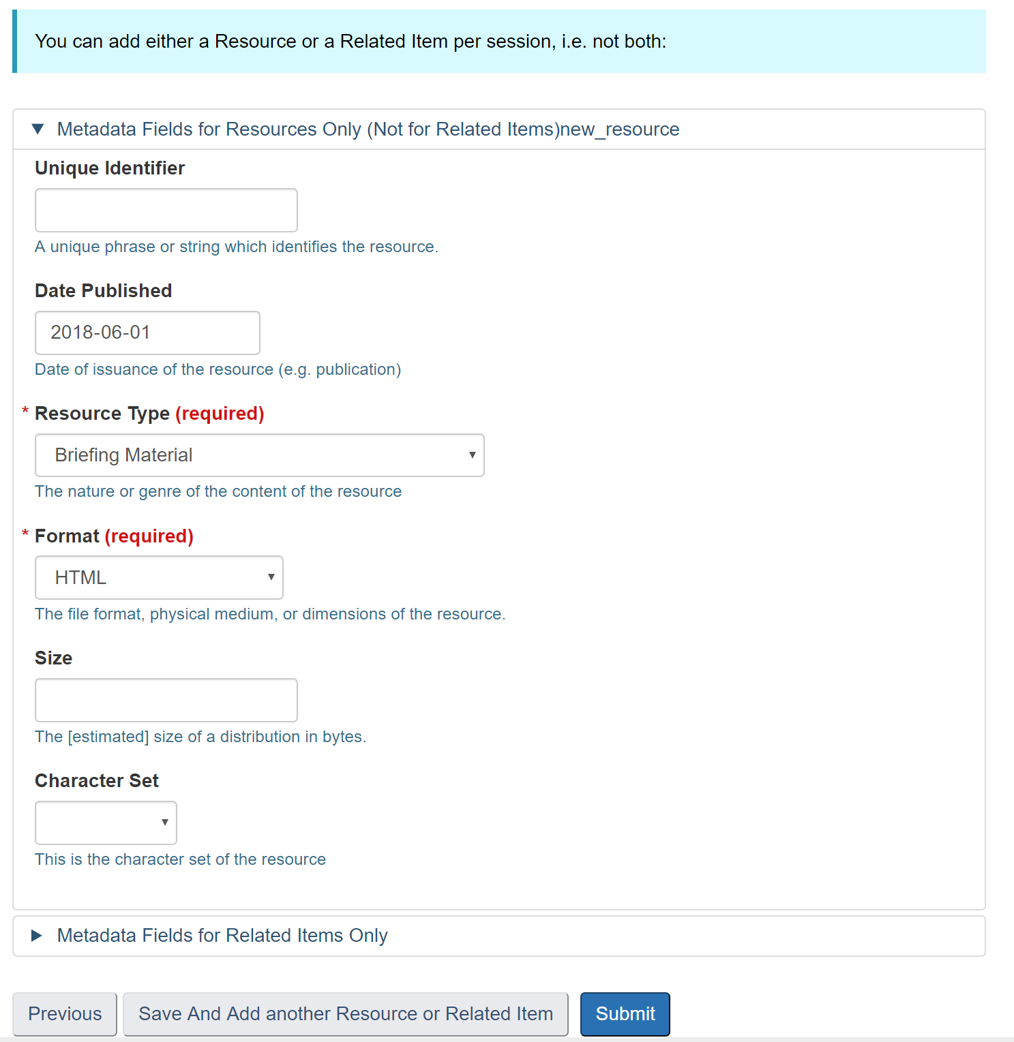
1
2
3
4
5
6
# | Element Name | Description | Type | Example
1 | Unique Identifier | A unique phrase or string of your choice which identifies the resource (examples include a URI or ISBN number). | Free text | 978-3-16-148410-0
2 | Date Published | The date the resource was published | Date | 2017-11-01
3 | Resource Type | The genre of the content of the resource. | Dropdown | Briefing Material
4 | Format | The file format of the resource | Dropdown | HTML
5 | Size | The estimated size of the document (if known) | Free text | 5M
6 | Character Set | The character set of the resource. | Dropdown | UTF-8 or US-ASCII

Click Submit to finish adding your related item or Save and add Another Resource or Related Item if you need to upload more than one file.

3.3 Adding Related Items
This step only applies if you would like to add a related item to your PD entry.
Once you have uploaded or linked to your resource, you will also be able to add any items that are related to this resource. Related Items are links or other items that are related to the PD asset. Note, related resources should only link to other records found on the Open Government Portal. Therefore, these links should not link off to an external page. You add a related item the same way you added resources. You can do this while creating your record or you go back later and add related items. However, you can only add one item at a time.
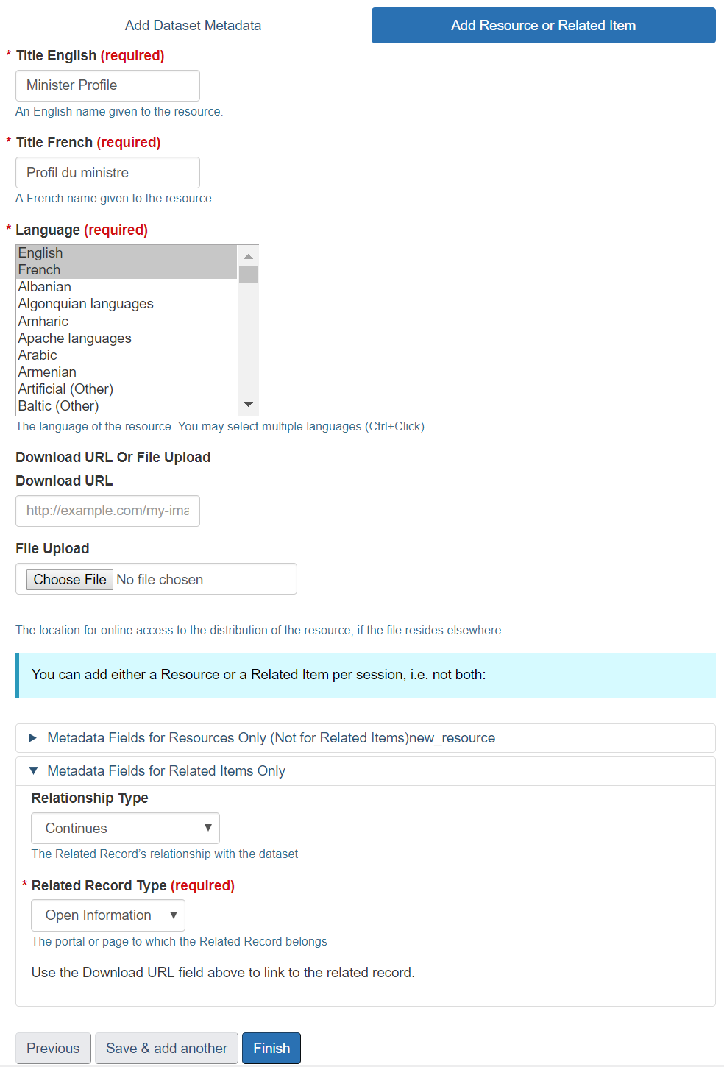
3
6
7
5
4
1
2
# | Element Name | Description | Type | Example
1 | Title English | An English name given to the resource | Free text | Minister Profile
2 | Title French | A French name given to the resource | Free text | Profil du ministre
3 | Language | The language of the resource | List | French, English
4 | Download URL | Add a link to an external URL where the document is hosted | Web Address | -
5 | File Upload | Choose a file to upload to be hosted on the Open Government Cloud | File upload | -
6 | Relationship Type | The Related Record’s relationship with the original resource. | Dropdown | Continues
7 | Related Record Type | The portal or page to which the Related Record belongs. | Dropdown | Open Information

To add your related item, fill out the title in English and French, the language of the related item, and its URL.
The ‘Download URL’ should be captured for related records, and this should be populated with the URL of the record in the Open Government Portal.
Do not enter any information in the section titled “Metadata Fields for Resources Only (Not for Related Items).” Expand the section titled “Metadata Fields for Related Items Only,” and choose the related record type from the drop down menu. You can also choose a related record relationship type (e.g. continues, supersedes, merged with…, etc.).Click Submit to finish adding your related item or Save and add another resource or Related Item.

Releasing the record on Open.Canada.ca
In order for your PD asset to be released on open.canada.ca, the “IMSO Approval” checkbox on the Add Asset Metadata page must be populated with “Yes”. It is expected that when “Yes” has been selected, Information Management Senior Official (IMSO)/ Chief Information Officer (CIO) approval has been obtained and the organization takes full responsibility for the asset’s release.
If your disclosure is ready to be released, select “Yes” from the “Ready to Publish” drop down menu on the Add Asset Metadata page, the Open Government team will then ensure completion and release the resource to open.canada.ca. If your record is not final then please select “No” and it will remain a draft record.
It is your responsibility to ensure your document is released correctly on the Open Government Portal, so it is good practice to check your record on the portal a few days after it has been submitted for publication.

Editing your Record
If there are issues or you need to make updates, you can edit your record on the registry. Log into the registry and locate your record either through your organization, or general search.
Once you have located your record, click to bring up the record view. Click on the Edit button to edit information about the record itself.
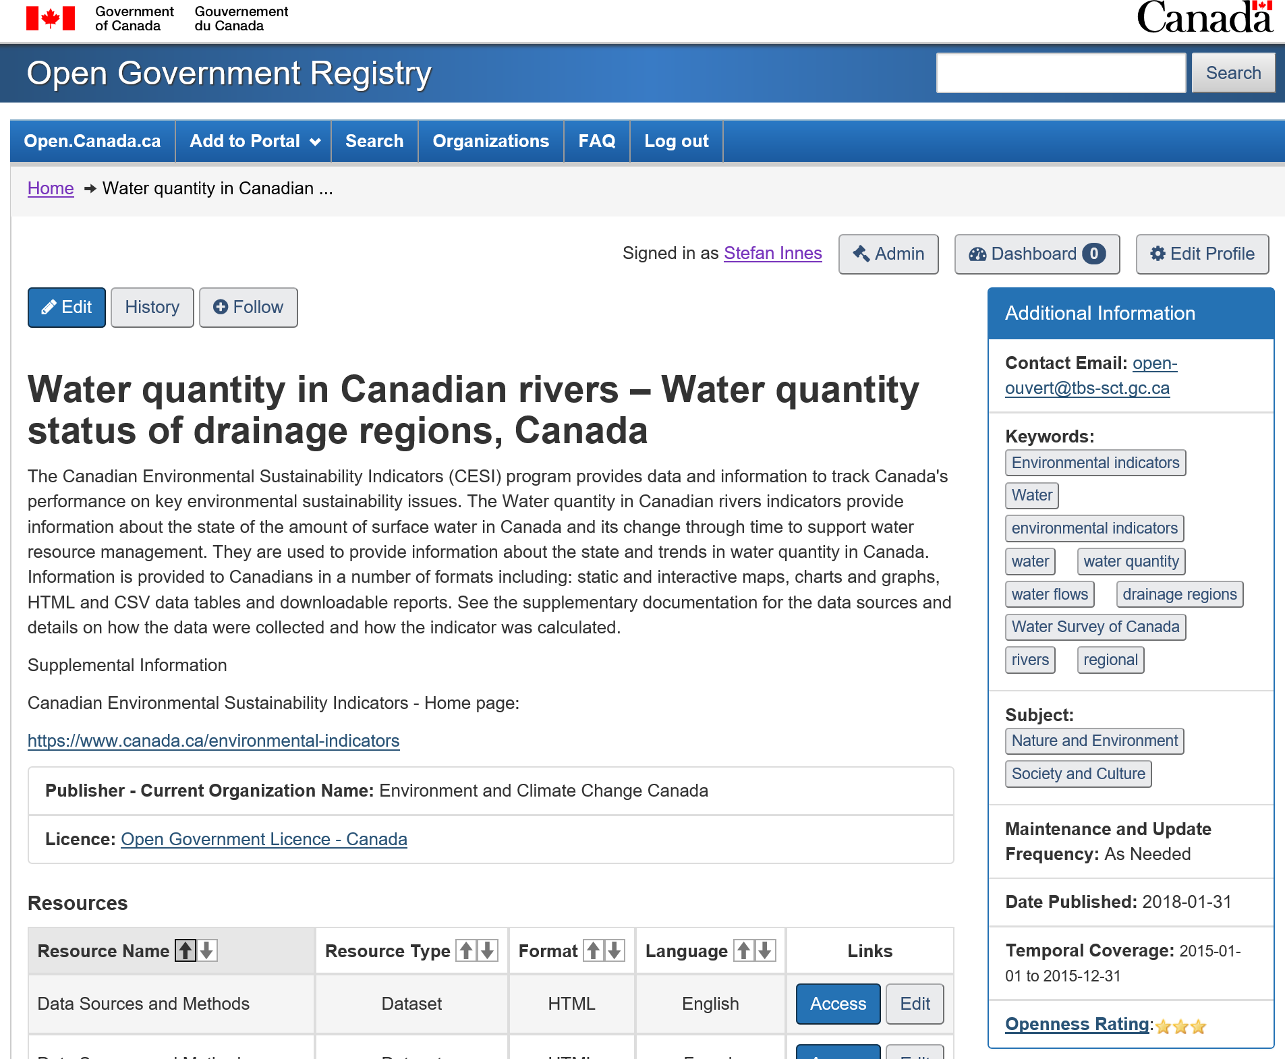
When you are finished updating metadata fields, click the Update Record button to save your changes.
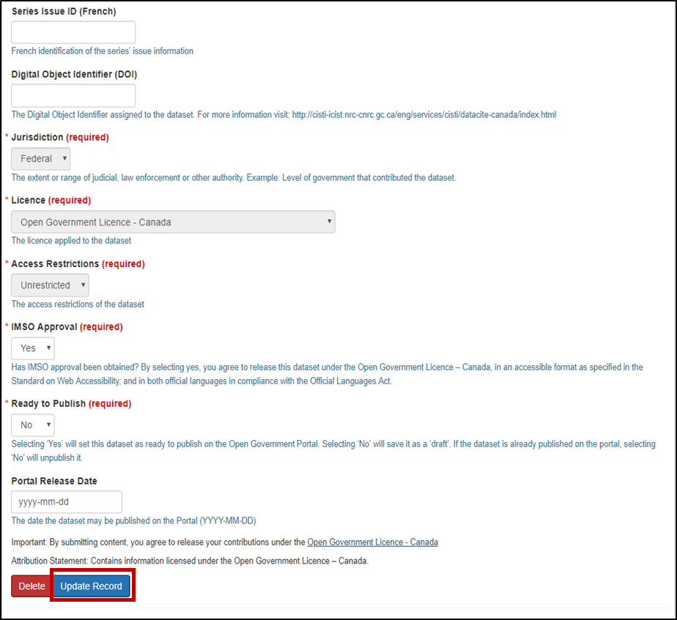
You can also choose to edit individual resources by clicking on the associated Edit button. When you are finished, click the Update Resource button to save your changes.

If you encounter difficulties during any of the aforementioned steps or have questions about this process, feel free to contact the Open Inbox, open-ouvert@tbs-sct.gc.ca, and the Open Government Portal team will be happy to assist you.
For more detailed information on the Open Government Registry and to access subject specific resources, check out our Open Government Guidebook.

