Sponsorship Roadmap

VERSION 1.0
Date:
Prepared for:
Department:
Table of contents
1. Background 3
1.1 GCWORKPLACE 3
1.2 [INSERT PROJECT NAME] 3
2. Objectives 3
2.1 SPONSORSHIP ROADMAP 3
2.2 PROSCI METHODOLOGY AND ADKAR (include if applicable) 4
2.3 SPONSOR GUIDANCE FROM PROSCI BEST PRACTICES 5
3. Sponsorship roadmap 5
3.1 SPONSORSHIP DIAGRAM 5
3.2 Plan to address conditions in the Sponsorship diagram 6
3.2.1 Preparing the sponsor 7
3.2.2 Preparing the champions 8
3.3 SPONSOR PLAN 8
3.3.1 Sponsor activity model 8
3.3.2 Sponsor plan: Build the foundation checklist 8
3.3.3 Sponsor plan: Assess, imagine & plan checklist 10
3.3.4 Sponsor plan: Implement & operate checklist 11
4. Sponsorship roadmap implementation 12
4.1 CHANGE MANAGER AND SPONSOR’S COACH 12
4.2 MEASURING SPONSOR AND CHAMPIONS’ EFFECTIVENESS 13
4.2.1 Accountability for sponsor and champion effectiveness 13
4.2.2 ADKAR change-o-meter 13
ANNEXE A: Sponsorship diagram 14
ANNEXE B: Sponsorship checklist 15

1. Background

1.1 GCWORKPLACE
GCworkplace principles were developed to align with the vision of creating a high-performing Government of Canada workplace that enables a balanced workforce. This new-age workplace is founded on the principles of flexibility, efficiency, (employee) health, collaboration and digital capacity; all of which inform GCworkplace principles.
In GCworkplace, employees can choose where and how they want to work, thus creating a more efficient, healthy and flexible workforce that also increases productivity. There is also a strong emphasis placed on mobility, recognizing that activity-based working is the way of the future and that there is no one-size-fits-all approach to office design.
The principles of GCworkplace were developed with the needs of today’s workforce, as well as those of tomorrow’s, in mind. One of the big questions facing the Government of Canada is how to attract and retain top talent, and GCworkplace takes a step towards answering that question.

1.2 [INSERT PROJECT NAME]
Insert information on your modernization project:
- Project scope
- Vision
- Key principals of the project
- Key components of your change management strategy
- Type of change and size
- Timeline

2. Objectives

2.1 SPONSORSHIP ROADMAP
The purpose of this document is to outline the key activities and responsibilities of the sponsor and champions who are needed to support the change at each phase of the project. The Sponsorship roadmap is vital to help individuals and the organization transition through the change in order to realize the desired organizational benefits and project objectives.
Overarching objectives:
- Preparing a plan for the sponsor.
- Providing the sponsor with this plan and the sponsor checklists (organized by target audience and timing for the change).
- Assisting the sponsor in completing the sponsor plan and completing items on the checklists.

PROSCI METHODOLOGY AND ADKAR (include if applicable)
Prosci is an independent research organization that has developed a comprehensive change management methodology based on best practices identified through their research. As leaders in the field, their methodology is being used across multiple organizations.
Based on Prosci’s research, the foundation for organizational change is successful change at the individual level by building the elements of the ADKAR change model (Figure 1) in each individual. ADKAR stands for:
- Awareness–provides the “why” the change is happening
- Desire–environment that provides the motivation and willingness for the change
- Knowledge–is the information and learning needed to apply the change
- Ability–removes the capability obstacles that could prevent the change
- Reinforcement–sustains the change past the implementation phase
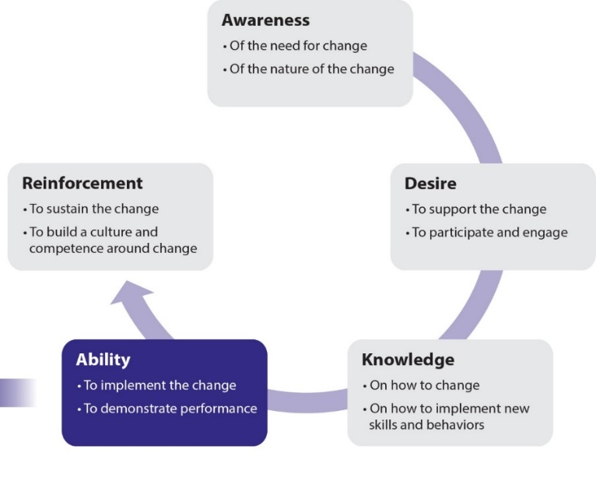

Figure 1. Prosci® ADKAR® Model
The ADKAR model is to be integrated into various tools that will be used by the team along with managers and employees, to manage change. The ADKAR model allows [name of your organization] to shape change management to support employees while facilitating [name of your project] implementation objectives.

Sponsors play a large role in building awareness, desire and reinforcement (their role is important but less a factor when developing knowledge and ability):
- Awareness of how the change aligns with the vision of the organization including why the change is needed and the risks of not changing.
- Desire is created through coalition building and the management of resistance from managers, and by addressing the gaps in the sponsorship diagram (which you can obtain by following the Guide to assessing the sponsor and champions).
- Reinforcement of the change is achieved through visible recognition and rewards that come directly from the leadership of the organization.

2.3 SPONSOR GUIDANCE FROM PROSCI BEST PRACTICES
The Sponsorship roadmap leverages findings from the Prosci Best Practices in Change Management benchmarking research with responses from over 6,000 participants from 84 countries. In regards to sponsorship, the top two findings include:
- #1–The number one obstacle to success for major change initiatives is ineffective sponsorship.
- #2–Project teams ranked 50% of their sponsors as having only a moderate to low understanding of their role in managing the people side of the change and graded them an “average to poor” in terms of sponsorship activities.

In addition, the top findings regarding the “most common executive sponsor mistakes” include:
- failing to remain active and visible throughout the life of the project
- underestimating or misunderstanding the people side of change
- failing to communicate messages about the need for change
- delegating the sponsorship role and responsibilities

Consideration will be given to each of these findings in the details that follow.

3. Sponsorship roadmap

3.1 SPONSORSHIP DIAGRAM
NOTE: Due to the sensitive nature of the information contained in the Sponsorship diagram, the information in this section should only be shared with the sponsor.
The Sponsorship diagram (ANNEXE A) was prepared during the
Strategize phase of the Workplace Change Management Playbook and was reviewed with the sponsor to obtain concurrence. The purpose of this diagram is to identify:
- the sponsor and champions
- their position relative to the change (A=openly supports the change and B=openly opposes the change or neutral)
- their change management (CM) competency level (1=high, 2=moderate, and 3=low)
The Sponsorship diagram can be used for:
- guidance on the overall health of the sponsorship coalition
- determining if the sponsor is at the right level
- identifying potential sponsorship issues and challenges
- identifying natural coalitions that could be capitalized on for this project

3.2 Plan to address conditions in the Sponsorship diagram
In the table below:
- list the sponsor, as well as all the champions that obtained a red or yellow rating in the Sponsorship diagram
- list the champions in order of priorities to be addressed
In the “Condition” column:
- for each individual, indicate name, position, letter/number designation and who they report to
- for a visual representation of the letter/number designation, use the image provided and move the arrow to the appropriate line
In the “Key activities” column:
- Describe briefly the results of the assessment for that specific individual. E.g. “All of the IT employees that will help introduce the change as well as be impacted by the change report to [name of champion]. This champion currently opposes the change and has a low level of sponsor competencies.”
- List concrete actions on how to address specific challenges. E.g. “[Name of sponsor] needs to meet with [name of champion] and find out why the champion opposes the change. It is most likely due to the overwhelming number of projects the champion is currently leading in the organization. Sponsor needs to emphasize the strategic importance of this project both from the perspective of the organizational benefits and project objectives, but also as a showcase project to demonstrate the value of applying a structured and intentional approach to change.”

Condition | Results and key activities
SPONSOR
name, title, alpha-numerical rating, reports to:  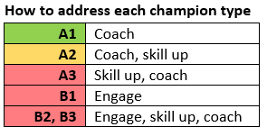 | [brief description of results followed by concrete action]  - …  - …  - …
CHAMPIONS
name, title, alpha-numerical rating, reports to: | [brief description of results followed by concrete action]  - …  - …  - …
Add as many lines as required for all the champions that obtained red or yellow rating.
Right arrow

3.2.1 Preparing the sponsor
Include this section if you have one of the following conditions in place:
- The sponsor is a B: neutral or opposed to the change
  - Lay out educational/learning elements that the sponsor should be familiarized with. E.g. provide information on the project, on its benefits for the organization and for employees. Provide information on how the outcomes of this project are directly aligned to the organizational strategic objectives.
- The sponsor is not at the right level
  - Include strategies to mitigate this. E.g. try to identify a co-sponsor at the right organizational level that could be used strategically to perform specific activities.
- You have identified natural coalitions that could be capitalized on
  - Use information obtained during the assessment, identify champions that could be used strategically to help turn an “A” into a “B” or to increase CM awareness in champions that scored a 2 or 3. E.g. John and Sue have shown to be a tremendous positive influence on some of their colleagues who sit on the XYZ committee, including champions Tim and Renée who are both “B”. Schedule a meeting for the sponsor to meet Tim and Renée along with John and Sue.

3.2.2 Preparing the champions
In addition to the key activities listed above, the following actions are recommended to prepare the champions:
- Courses in change management: Change management training sessions targeted at senior management are available from various providers. Consider offering a session or workshop to the sponsorship coalition. Check with your procurement officer what might be available via the Standing Offer). [Insert information on the sessions that are planned on being offered]. This session will provide senior leaders with the knowledge and ability to improve change outcomes by becoming more effective change leaders. It will not only increase the probability of success for [insert name of project], it will help build competencies for future projects and change initiatives within the organization.
- External data to build awareness: Information in the Sponsorship checklist (ANNEXE B) will be used as “bite-size” snippets of information and sent with each of the project status reports to the sponsorship coalition. Example: Did you know effective sponsorship is the #1 indicator of project success?
- Direct coaching: The sponsor will continue to engage personally with select champions in the coalition to provide direct coaching and intervention, as required.

3.3 SPONSOR PLAN

3.3.1 Sponsor activity model
The Sponsor activity model is used to show the responsibilities of the sponsor in each project phase with each audience. This framework, along with the Sponsor plan items listed below, form the foundation of the Sponsorship roadmap.
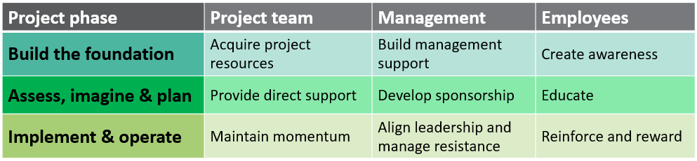

3.3.2 Sponsor plan: Build the foundation checklist
Audience | Activity | Notes
Project team | ACQUIRE PROJECT RESOURCES  - Select the best project leader and team members, including resources with change management expertise  - Provide necessary funding for the team, including training for all team members on change management  - Set priorities related to day-to-day work versus project work to allow adequate team member participation  - Help the team understand critical business issues or opportunities that must be addressed  - Provide clear direction and objectives for the project; describe what success will look like  - Jointly develop a high-level view of the future and link change to the business strategy  - Be directly involved with the project team; set expectations; review key deliverables and remove obstacles  - Take ownership for success of the project while holding the team accountable for results  - Establish a commitment to change management; talk about change management and ensure required roles are filled | Include concrete actions for the sponsor on how they will accomplish these activities.  - …  - …  - …
Management | BUILD MANAGEMENT SUPPORT  - Establish the support of senior management and create a support network  - Identify or create a steering committee to monitor progress  - Educate senior management about the business drivers of change (the WHY) and the risks of not changing  - Work directly with managers who show early signs of resistance  - Create change champions within the leadership team; build support and enthusiasm for the change  - Define accountabilities for managers; solicit and listen to management feedback  - Connect project to the organization’s strategy and goals  - Provide training on change management to senior management  - Determine and communicate priorities between this change and other change initiatives  - Resolve conflicting operational objectives with senior leaders  - Establish change activities that the leadership group is responsible for completing
Employees | CREATE AWARENESS  - Explain WHY a change is needed; share the risks or not changing and repeat key messages  - Share the vision of the future; explain the nature of the change and show how change will address business problems or opportunities  - Answer “How will this change affect me?” and “What’s in it for me?” (WIIFM)  - Be proactive, vocal and visible; communicate frequently, including face-to-face conversations  - Listen and be open to dialogue and resistance  - Tell employees what they can expect to happen and when; show project milestones and provide updates  - Understand the organizational culture and beliefs to communicate effectively with employees  - Communicate clearly and honestly about aspects of the project that are still unknown  - Share plans with clients, suppliers and all impacted stakeholders

3.3.3 Sponsor plan: Assess, imagine & plan checklist
Audience | Activity | Notes
Project team | PROVIDE DIRECT SUPPORT  - Stay involved; attend key project meetings, review project status and hold the team accountable for the results  - Provide necessary resources and funding, including ensuring the right people are made available  - Be accessible to the team; be a sounding board, provide ideas and constructive criticism and ask “what if”?  - Remove roadblocks; make timely decisions on project issues and help manage conflicts and political issues  - Communicate expectations and feedback from other managers  - Keep the team on track and manage “scope creep”  - Reward success and achievements  - Take the time to understand the solution  - Make sure that the project team knows that your door is open and you are available to support their work  - Play a role in all critical decisions  - Identify conflicts with other projects that might impact this team | Include concrete actions for the sponsor on how they will accomplish these activities.  - …  - …  - …
Management | DEVELOP SPONSORSHIP  - Continue to build support and sponsorship among senior management; reinforce key messages, resolve differences in perception and address areas of resistance  - Let senior management know how they can support the change; provide them with tools for sponsoring change with their direct reports  - Conduct or attend steering committee meetings; keep managers informed, use this forum to resolve critical issues  - Use public and private conversations to reinforce leadership support; recognize outstanding managers  - Communicate project progress to all senior management  - Hold managers accountable; do not tolerate resistance or allow managers to opt out of change and be clear on expectations  - Ensure that a consistent message is being sent by managers to impacted employees
Employees | EDUCATE  - Communicate frequently with employees; make your personal commitment visible, including face-to-face conversations  - Reinforce the reason for change, the risk of not changing and evolving details about the future state  - Show employees how the change aligns with the direction and strategy of the business  - Answer “What will this change mean to me?”  - Listen to what employees have to say; take the pulse of the organization and collect feedback  - Share project progress and provide updates regularly; update on “what you can expect to happen when”  - Enable employee participation and involvement  - Recognize good work employees have done  - Ensure adequate time is allocated for training and skills-building prior to implementation

3.3.4 Sponsor plan: Implement & operate checklist
Audience | Activity | Notes
Project team | MAINTAIN MOMENTUM  - Secure resources necessary for implementation  - Stay engaged with the team: attend meetings, reward successes, hold them accountable for results and build enthusiasm  - Remove roadblocks and help the team overcome obstacles  - Stay on course; avoid shifting priorities to early  - Attend frequent project status meetings and track progress  - Resolve issues and conflicts; respond to escalation | Include concrete actions for the sponsor on how they will accomplish these activities.  - …  - …  - …
Management | ALIGN LEADERSHIP AND MANAGE RESISTANCE  - Continue to meet in public and private with senior management; align sponsorship, provide progress updates and resolve issues  - Communicate expectations to senior management for their support of change; provide activities they can do and messages they can communicate to the organization  - Manage resistance from managers; consider corrective measures for managers who will not support the change  - Model change through personal examples and hands-on involvement  - Stay involved throughout the entire; stay visible  - Hold managers accountable for support
Employees | REINFORCE AND REWARD  - Reinforce key messages; align business strategy with project objectives and increase personal communications  - Reinforce why the change is being made and the risk of not changing (some employees might be ready to hear this message only when change is near implementation)  - Listen to employees and encourage feedback; be willing to answer tough questions  - Set expectations for employees; clearly communicate consequences of not changing  - Identify the additional work and difficulties that might be experienced during implementation  - Enforce application of new processes and behaviors  - Look for quick wins; share successes and build enthusiasm for change  - Celebrate success stories in person; be present and visible  - Acknowledge challenges and obstacles honestly

4. Sponsorship roadmap implementation

4.1 CHANGE MANAGER AND SPONSOR’S COACH
The change manager will take on the role of coach for the sponsor throughout the project. In this role, the change manager will be responsible for:
- Working with the sponsor to monitor the health of the sponsorship coalition
- Coaching the sponsor to be effective
- Preparing communications for the sponsor and the rest of the sponsorship coalition (in coordination with the communications lead from Corporate Communications)
- Working with the sponsorship coalition administrative assistants to schedule and get on their calendars the activities needed to perform as effective champions of change (for both the communication plan and Sponsor roadmap activities)
- Monitoring and engaging the necessary resources at each phase of the project according to the Sponsor checklists (in Section 3)

4.2 MEASURING SPONSOR AND CHAMPIONS’ EFFECTIVENESS

4.2.1 Accountability for sponsor and champion effectiveness
The change manager will add a “sponsor effectiveness” standing item to their regular meeting with the sponsor. The sponsor should also add a standing item to the meetings they have with the champions, either via the steering committee, one-on-one meetings, etc., to confirm continued support of the change and ensure the champions are still engaged. These check-in times and discussions should also be used to reiterate why effective sponsorship is critical, “train” on sponsorship roles, and make sure sponsorship actions were completed:
- Being present at public forum events
- Communicating about the change
- Taking action with employees
- Visibly embracing the change

4.2.2 ADKAR change-o-meter
The ADKAR change-o-meter tool can be used to gauge and measure sponsor and champions’ effectiveness throughout the project. This tool measures an individual’s level of awareness, desire, knowledge, ability, and reinforcement on a change with real-time scoring to determine where they are in the Prosci ADKAR model. Sponsor and champions’ effectiveness will be assessed at the critical elements of awareness, desire and reinforcement.
In addition, the Sponsorship checklist (ANNEXE B) will be used as an audit tool to ensure best practices are being taken into consideration in the Sponsorship roadmap.

ANNEXE A: Sponsorship diagram
NOTE: Due to the sensitive nature of the information contained in the Sponsorship diagram, the information in this section should only be shared with the sponsor.
Insert here the results of your Sponsorship diagram created with the Guide to assessing the sponsor and champions during the Strategize phase of the Workplace Chance Management Playbook.

ANNEXE B: Sponsorship checklist
The Sponsorship checklist* draws upon benchmarking research conducted by PROSCI©

Are your sponsor and champions aware of the importance they play in making change successful?
In Prosci benchmarking studies, the number one response by participants when asked what was the greatest overall contributor to project success in each of the studies was active and visible sponsorship.
Do your sponsor and champions know their three biggest roles in supporting organizational change?
The three key roles for senior leaders: (1) Participate actively and visibly throughout the project, (2) Build a coalition of sponsorship with managers and peers; and (3) Communicate directly with employees. Nearly 50% of study participants ranked their sponsor as having a moderate to poor understanding of their role.
Are your sponsor and champions active and visible throughout the project?
Effective sponsors cannot stand on the side-lines—they must be involved in more than just signing their names on the project charter. They must stay active and visible throughout the project.
Are your sponsor and champions building coalitions that are needed for the change to be successful?
Effective sponsors and champions interact with the other leaders necessary to make the change successful. They must build relationships and commitment with these other key leaders.
Are your sponsor and champions communicating directly and effectively with employees?
The leaders of change are one of the two preferred sender of communication messages. Your sponsor and champions need to directly communicate with employees about the business reasons for change, risks of not changing and why the change is happening now.
Do your sponsor and champions know that the biggest mistake cited by study participants was failing to personally engage as a leader of change?
Failure to engage personally, abdicating their role to lower level managers or the project team and failing to communicate reasons for change with immediate employees are the biggest mistakes cited by study participants. Project teams face tremendous difficulties when they have a sponsor and champions who do not personally engage in the change.
Is your sponsor prepared to manage resistance?
Managing resistance is a key role of senior leaders, managers and supervisors. Your sponsor needs to be prepared and ready to deal with resistance in the organization—especially from other senior leaders and managers. Change managers need to coach senior leaders on how to identify root causes of resistance and how to engage and manage resistance when it happens.
Is your sponsor prepared to celebrate success?
Celebrating success—even small, short-term success—is an important part of building support and momentum for change. Sponsors play a key role in recognizing employees both publicly and privately.
Is your sponsor setting clear priorities regarding this initiative, other initiatives and day-to-day work?
Sponsors influence priorities through their behaviors, actions and the communications they send. Sponsors must show both their own and the organization’s commitment to change if they expect employees throughout the organization to become engaged.
Is your sponsor avoiding the “flavour of the month” syndrome?
“Flavour of the month” describes a situation where organizations are constantly introducing and abandoning initiatives. When this occurs, it makes it more difficult to create meaningful change. Sponsors are responsible for launching new initiatives and ensuring new projects are not just the next “flavour”.

*adapted from the PROSCI Sponsorship Checklist

