Introduction to Strategic Foresight
Human Resources Innovation Team (HRI)
Human Resources Management Branch (HRSB)
August 2021

What is Foresight?
Foresight is a critical activity that involves analyzing the future. The objective of conducting foresight activities is to examine plausible, alternative futures and identify the challenges and opportunities that may arise. Foresight gives us the opportunity to understand the various forces that shape a system, how the system may evolve and what unanticipated circumstances may come about. Within the context of the Public Service, foresight helps governments adjust to a quickly changing world. It can be applied to policy development, strategic planning, decision-making, auditing and evaluating as a mechanism to promote proactive governance.

Foresight is not to be confused with forecasting. Forecasting refers to the process of trying to predict the future using past data; whereas foresight helps us prepare for a wider range of futures.

The Steps in Foresight
The Horizons Foresight Method is the preferable approach within the Canadian Government because it has been created to consider the uncertainty and complexity of public policy. It is not until after the entire team understands the process that a foresight study can take place; this can take anywhere from 2 to 12 months. The HRI team follows an iteration of Policy Horizon’s strategic foresight process.

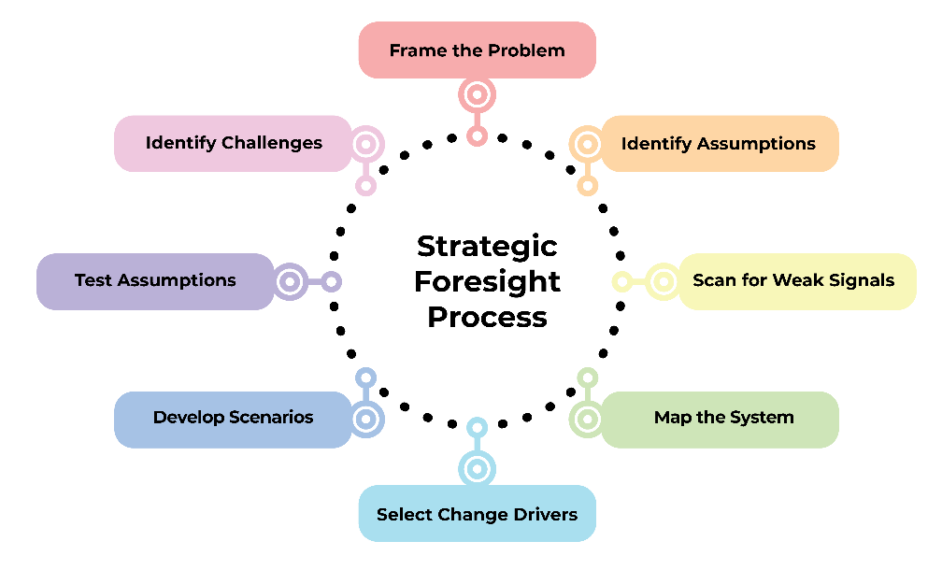
Figure 1 - The Strategic Foresight Process.

Step 1a: Frame the problem
Framing is subject to changes as you continue to learn new pathways that drivers may impact the system.

Step 1b: Identify assumptions
Surface the “current, commonly held assumptions” about the topic. The assumptions that shape a given public policy area are collected through interviews and research, and will be used later in the process to test the robustness of the strategy developed in the foresight process.

Step 2: Scan for weak signals of change
Scanning identifies possible shifts that may have significant implications on the issue and the system. Scanning can include literature reviews and interviews that aim to uncover the mentalities of people who have knowledge in the system. Groups of related weak signals are later developed into insights.

Step 3: Map the System
Participants of the study draw a picture of their mental model of the system. The objective is to develop a group system map that identifies where participants think meaningful change is possible. This can be done through a variety of diagrams such as process diagrams or casual loop diagrams.

Step 4: Select Change Drivers
All the insights from the scanning phase are reviewed and the ones that hold significant potential to disrupt are chosen as change drivers for the scenario activity. Cascade diagrams are used to identify the possible second, third, and fourth order implications, or knock-on effects, of the drivers. Additionally, a cross-impact analysis is conducted to assess how the given drivers and insights may interact with one another and how the system may evolve.

Step 5: Develop Scenarios
Scenarios are stories that explore different possible futures based on the insights and change drivers developed through the earlier stages of this foresight process. The aim is to allow participants to see what the system could look like under the specific conditions. The method undertaken by HRI generally develops four scenarios: muddling through, incremental progress, incremental decline, and transformation.

Step 6: Test Assumptions and Identify Challenges
Participants are asked to immerse themselves into each scenario. Then they are asked to identify challenges and opportunities within each scenario that current policies and systems are not prepared for. The last step is to test the current assumptions from step 1 against each scenario.

The Results from the Horizons Foresight Method:
- Clarifies and tests the assumptions that decision-makers use to shape the future.
- Identifies emerging policy challenges and opportunities.
- Develops more robust policy and strategy.
- Helps individuals and organizations prepare for change.

The Importance of Foresight in Government:
- Government needs to ensure anticipatory capacity to be able to prepare and respond to new opportunities and challenges that may emerge in the future.
- Foresight allows for the best innovative policies that address the opportunities and challenges.
- It is a mechanism that future-proofs existing or new policies against a variety of future scenarios.

Bibliography
Policy Horizons Canada. (2018). Foresight vs Forecast. Retrieved from
http://canadabeyond150.ca/blog/2018/03/foresight-vs-forecast/

Policy Horizons Canada. (2021). Module 1: Introduction to Foresight. Retrieved from
https://horizons.gc.ca/en/our-work/learning-materials/foresight-training-manual-module-1-introduction-to-foresight/

OECD (Organization for Economic Cooperation and Development). Strategic Foresight for Better Policies. (2019). Retrieved from https://www.oecd.org/strategic-foresight/ourwork/Strategic%20Foresight%20for%20Better%20Policies.pdf

Additional Resources
Learn more about the strategic foresight process at Policy Horizons Canada - Resources.

GOV.UK. Features of effective systemic foresight in governments around the world. Retrieved from https://foresightprojects.blog.gov.uk/2021/05/12/features-of-effective-systemic-foresight-in-governments-around-the-world/

GOV.UK. Futures thinking and foresight: a brief guide. Retrieved from https://www.gov.uk/government/publications/futures-thinking-and-foresight-a-brief-guide

The Finnish Innovation Fund Sitra. Futures Frequency. Retrieved from https://www.sitra.fi/en/projects/futures-frequency/

Wilner, Alex; Roy, Martin (2020). Canada’s emerging foresight landscape: observations and lessons. Foresight, Volume 22 (5/6): 12 – Dec 10, 2020. Retrieved from https://www.emerald.com/insight/content/doi/10.1108/FS-03-2020-0027/full/html?skipTracking=true

Policy Horizons Canada. (2021). Module 1: Introduction to Foresight. Retrieved from https://horizons.gc.ca/en/our-work/learning-materials/foresight-training-manual-module-1-introduction-to-foresight/
Ibid.
Ibid.
Policy Horizons Canada. (2018). Foresight vs Forecast. Retrieved from http://canadabeyond150.ca/blog/2018/03/foresight-vs-forecast/#:~:text=Foresight%20does%20not%20predict%20the,and%20the%20analysis%20of%20trends.
Policy Horizons Canada. (2021). Module 1: Introduction to Foresight. Retrieved from https://horizons.gc.ca/en/our-work/learning-materials/foresight-training-manual-module-1-introduction-to-foresight/
Ibid.
Policy Horizons Canada. (2021). Module 1: Introduction to Foresight. Retrieved from https://horizons.gc.ca/en/our-work/learning-materials/foresight-training-manual-module-1-introduction-to-foresight/
Policy Horizons Canada. (2021). Module 1: Introduction to Foresight. Retrieved from https://horizons.gc.ca/en/our-work/learning-materials/foresight-training-manual-module-1-introduction-to-foresight/
Ibid.
Ibid.
Ibid.
Ibid.
OECD. Strategic Foresight. (2019). Retrieved from https://www.oecd.org/strategic-foresight/ourwork/Strategic%20Foresight%20for%20Better%20Policies.pdf

