Workplace Transformation Program
Consultation on locker area
VERSION 1
Date: December 2023
Consultation on locker area – Workplace Transformation Program
To be removed before sending
Objective: Gather data to better understand staff needs for personal storage in the workplace.
Target audience for this document: All staff affected by the modernization.
When to use: This consultation should be done early enough in the project to integrate the information gathered into the floor plans. Consult your SPAC project team for the best timing.
Who should send it: The project sponsor.
Expected outcome: The data collected will be useful in developing the strategy for the locker area, and will help prepare appropriate communications when presenting the adopted strategy.
The French version of this document is available here : FR version

Communication
Object: Use of Lockers at (Project’s location): We Want Your Opinion!
As part of the (address) workplace modernization project, you will have access to lockers for personal storage during your days at the office. To better address your needs, we’re seeking your input to guide us in the development of our organization’s locker strategy.
Insert context specific to your organization if required.
Here are some points to consider before responding to the survey:
- The number of lockers is based on the target occupancy rate. This means that there are enough lockers for the number of people who can physically be in the workplace (which does not necessarily equal the number of employees in the organization).
- The locker area includes closets for coats. There will be separate areas for non-smokers and smokers.
- Closets have rails of different heights to meet accessibility standards.
- The locker area includes benches.
- There will be space under the benches and elsewhere in the locker area for winter boots.
- The design incorporates different locker sizes to meet accessibility standards and different needs. Here are the proposed sizes: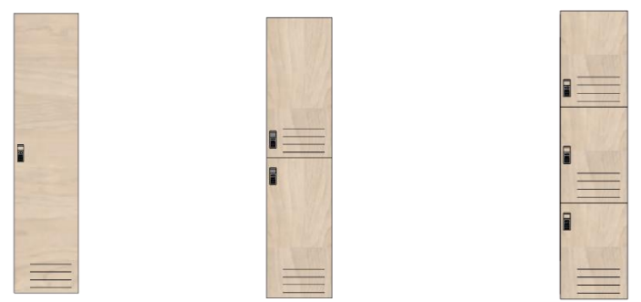
Full height Half height Third of height

Now you’re ready to take the survey! The deadline to respond is (insert date).
- Link to the survey (insert link)
If you have any questions, please feel free to connect with our project team at (insert email address).
Thank you for your participation.

Survey questions
      - Which statements best describe the items you’d like to store in your locker? (multiple choice)
- Personal belongings (for example: purse, backpack, spare shoes)
- Ergonomic equipment (for example: keyboard, mouse)
- Specialized work equipment (for example: reference documents)
- Kitchen items (for example: coffee mugs, bowls, utensils)
- Alternative transport equipment (for example: helmet, bicycle shoes)
- Other

- If you answered “other‟ please specify.

- Which locker format do you expect to use most often?
- Full height
- Half height
- Third of height

- On average, how many days a week do you work in the office?
- 1 day
- 2 days
- 3 days
- 4 days
- 5 days

- How often would you need to use the locker?
- Daily (for daytime office use only)
- Extended (2 or 3 consecutive days)
- All the time (assigned locker)
- Punctual (from time to time)
- Never

- If you answered “all the time (assigned locker)” please indicate why:

