Statement of Work

Expansion of ISSF Electrical Supply & Communications Ducts
From ICAN to Phase 3

Rev. 2

SW 1.0 OBJECTIVE

The objective of this requirement is to support the expansion of the electrical and communications capacity from the ICAN Operations Building to a location on the Phase 3 land parcel at its Canada Centre for Mapping and Earth Observation’s (CCMEO) Inuvik Satellite Station Facility (ISSF) in Inuvik, Northwest Territories (NT).

SW 2.0 BACKGROUND

  - Canada Centre for Mapping and Earth Observation (CCMEO) owns and operates a remote sensing satellite station near Inuvik, NT.
  - The station is referred to as the Inuvik Satellite Station Facility (ISSF), and is comprised of 3
Parcels of land, some of which are not adjacent to another, totalling over 600 hectares.
  - Phases 1 & 2 were the first to be built upon, with future focus on extending operational capacity to the Phase 3 parcel to the north.
  - The station is host to multiple satellite receiving antennas and their supporting infrastructure.
  - This site is protected for security and only escorted visits are allowed.
  - At this site, there is an operations building on the Phase 2 land parcel, designated as ‘ICAN’, which houses electronic equipment used in satellite reception operations.
  - The operations at ISSF require the extension of additional electrical and communications capacity from ICAN to a designated location on the Phase 3 parcel. More specifically:
    - Extending two 100kVA electrical connections from its existing redundant power circuit within the ICAN building - which is a circuit that utilizes an Eaton 9390 Uninterruptable Power Supply (UPS) and 500kVA diesel generator as backup power in an event where utility power is lost - to a location approximately 950m to the north on the Phase 3 parcel. This will be accomplished through herein specified cabling. Step-up and step-down transformers will be the responsibility of the client post project completion.
    - Installation of one 4” communications duct between the ICAN building, the Distribution Shelter and a location approximately 950m to the North on the Phase 3 parcel.
      - Installation of ducts are to support extension of fibre cabling to enable future communications between remote assets.
    - Installation of another 4” communications duct between the ICAN building and the Distribution Shelter, approximately 700m to the North, to support redundant capacity requirements.
    - Installation of electrical cabling between the utility’s transformer serving the ICAN building and the Distribution Shelter location approximately 700m to the North on the Phase 3 land parcel to accommodate Northwest Territories Power Corporation (NTPC) transformers that will provide service to future assets across the Phase 3 land parcel.
  - Burial of electrical cables and communications ducts continues to be the preferred method of extending power and communications to remote areas around the site to minimize disturbance to wildlife and maintain safety and security of personnel and assets.
  - Permafrost is present in all areas!
  - Trenching in the Inuvik region occurs in cooler months before winter, or in early spring before the thaw to avoid wet weather, disturbance to the underlying permafrost and critical habitat for migratory birds and birds that may be nesting.
  - For efficiency and to limit disturbance to habitat, CCMEO requires that the extension of the electrical utility (NTPC) from ICAN to the location on the Phase 3 land parcel be installed in the same trench that will house one 4” communications duct and in parallel and close proximity to the trench that will house two electrical cables extending ICAN emergency power circuit and the additional 4” communications duct.
  - Figure 1, provides the basic layout of the Inuvik Satellite Station Facility Phases 1 & 2
  - Figure 2 depict the trench path and estimated endpoints
  - Figure 3 depicts the existing gate shed
  - Figure 4 provides a view of typical pull box, trenching and naturalization
  - Figure 5 provides a view of the estimated location of the endpoint
  - Figure 6 Location of existing pull box to accommodate 4-way connection
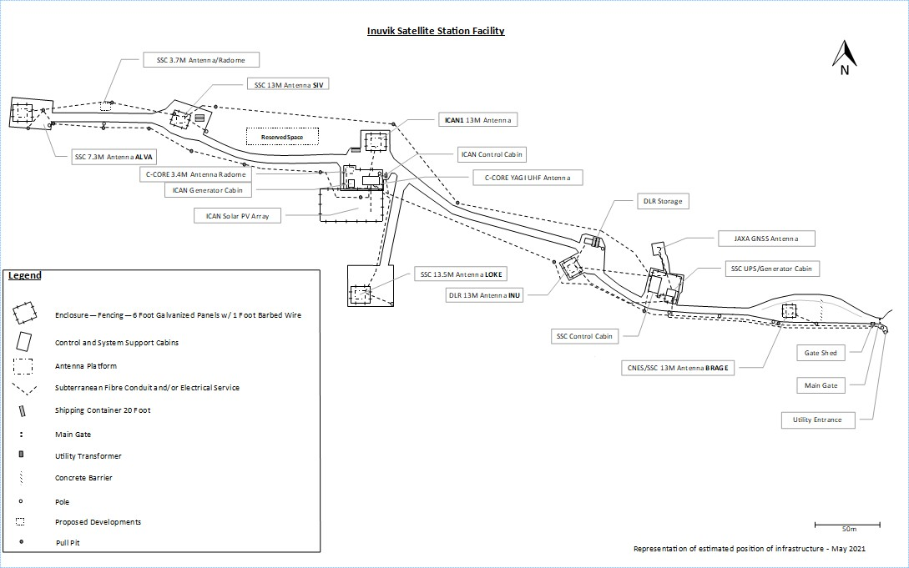

Figure 1: Inuvik Satellite Station Facility Phase 1 & 2 Layout

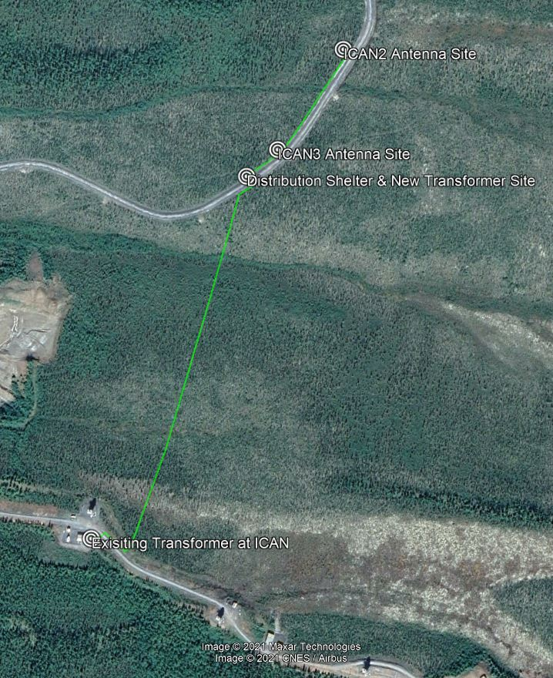

Figure 2: Trench Path and Estimated Endpoints

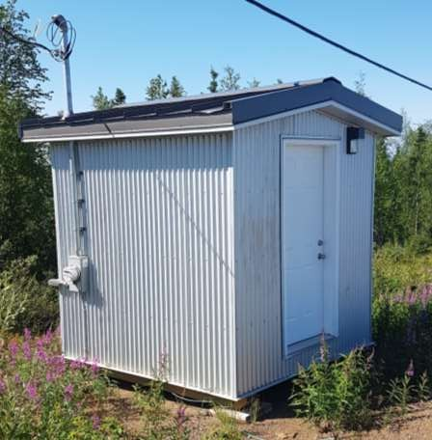

Figure 3: Existing Gate Shed

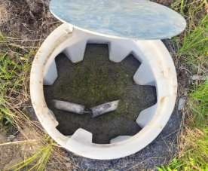
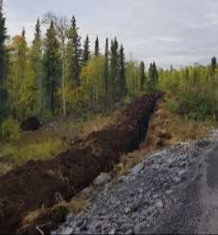
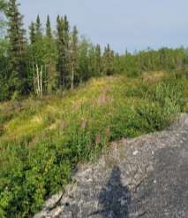

Figure 4: View of Typical Pull Box, Trenching and Naturalization

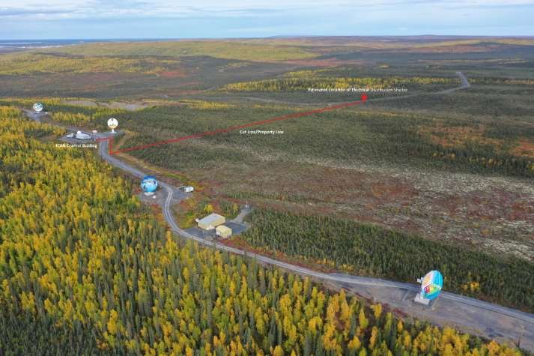

Figure 5: Estimated Location of Distribution Shelter
Latitude 68.324378° Longitude -133.544809°

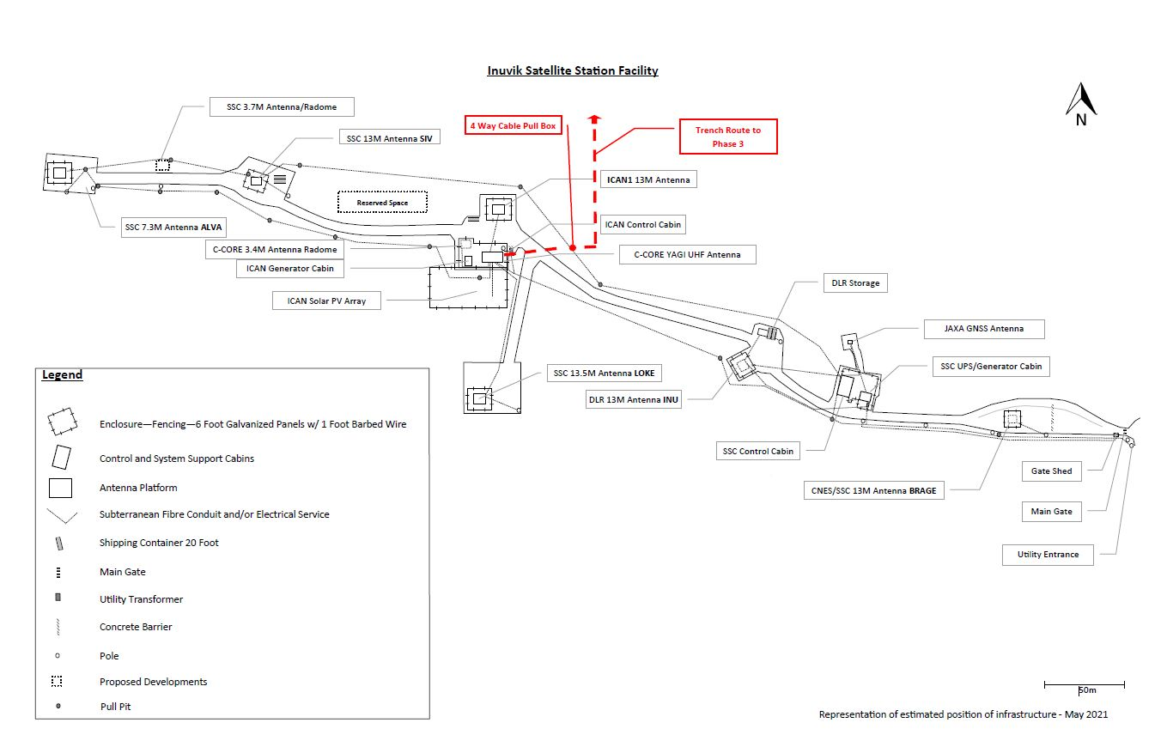
Figure 6: Location of Existing Pull Box to Accommodate 4-Way Connection

SW 3.0 PROJECT REQUIREMENTS

The work required involves the extension of UPS capacity, communications, and electrical utility supply from the ICAN Operations Building to a location on the Phase 3 parcel approximately 1 kilometre away. The installation of electrical cables and communications duct will require trenching across tundra through permafrost conditions.

Supply and installation of a shelter at the end-point location will be required to house the cables and ducts in addition to accommodating spaces for electrical service, fibre patch panels, workspaces and operational equipment. The contractor will be responsible for the supply and installation of this capacity as specified in the Work Requirements (Section 4) and in liaising with the utility provider to ensure that approved cabling, installation methods, best practices and locations where cables will be accessed above grade are identified and carried out.

SW 3.1 Tasks, Deliverables and Schedule

SW 3.1.1 Task #1: Determine Route Logistics & Map Route
The work required to be completed by the Contractor is as follows:
3.1.1.1 Contractor must conduct a thorough field assessment of the entire proposed route that will be trenched, noting any obstacles and risks. The proposed route is depicted in Figure 2 and 5. The route stretches across tundra, down a slope, across two gravel roads, one by the ICAN Control Building and the other in the Phase 3 land parcel, and along an existing cut line that demarcates a property line. NRCan is working with the Government of the Northwest Territories and the department of Environment and Climate Change Canada to establish an easement to allow for the trenching to take place along the property line that separates the respective owner’s properties.

3.1.1.2 Contractor must deliver a report to Project Authority on field assessment and provide mitigation strategies for identified risks and solutions to overcome obstacles during trenching.
3.1.1.3 Contractor must prepare a trench route map using Google Earth, providing estimated locations of junctions, pull boxes, and termination points. The Project Authority can assist with this requirement.

SW 3.1.2 Task #2: Liaise with Northwest Territories Power Corporation & Schedule Work
The work required to be completed by the Contractor is as follows:
3.1.2.1 Contractor must liaise with Northwest Territories Power Corporation (NTPC) on the extension of utility electrical supply from the mains transformer housed adjacent to ICAN to the location on Phase 3 that will house the Electrical Distribution Shelter (located at Latitude 68.324378° Longitude -133.544809°).
3.1.2.2 The Contractor must ensure that the required specifications for the cabling and subsequent pre-installation requirements between transformers to support the extension of utility electrical supply as set by NTPC are met, ideally through organizing an NTPC inspection of the installed cable.
3.1.2.3 NTPC has stated that their cable requirement is: WPA125-800 1C #1 SOL 07346-01-010 25KVAL CU CN URD XLP.
3.1.2.4 The Contractor must procure the required cabling and install it in the same trench that will house the cables supplying UPS and the communications ducts as detailed hereafter in this scope of work.

SW 3.1.3 Task #3: Conduct Trenching Program
The work required to be completed by the Contractor is as follows:
      - The Contractor will select the most appropriate equipment to excavate the required trench to code compliant specifications and best practices in a permafrost zone. It is recommended that a small excavator be used for this activity (ex. John Deere 60-75G, Caterpillar 306-307, Case CX 75-80) in order to traverse over the cut line/property line in a manner that will not be detrimental to underlying permafrost and to minimize destruction of habitat. NOTE: NRCan and its contractors are bound to conduct activities in a manner that is compliant with the Species At Risk Act. Failure to observe the stipulations under the Act and of any development approvals issued thereunder can result in fines and prosecution under the Act.
3.1.3.2 The trench must be able to accommodate at minimum the space required for the placement of two Teck #3 AWG 3 conductor stranded copper cables rated to handle 5kV, a utility cable as per specification from NTPC to connect future utility electrical supply, and two 4” HDPE communications ducts that will house fibre optic cabling. All of these cables and ducts must be rated for direct burial and installed according to industry standards to prevent damage and water intrusion.
3.1.3.3 Excavation must be done in a manner that is respectful to the surrounding environment, where excavated material must be carefully staged so that replacement back into the trench can be completed without damage to the surrounding ground or vegetation. It is recommended that fill be packed into trenches and built up above original grade in a manner that accounts for subsidence of the disturbed area.
3.1.3.4 At each of the two road crossings, excavation and replacement of excavated material must be completed in the shortest time possible to ensure that road passage is restored for safety, operational use and security.
3.1.3.4i Excavation of existing road sections must be completed after the majority of the trench route and cable installation is completed to alleviate emergency access risks.
3.1.3.4ii Roads consist of blast rock, shale and gravel layers.
3.1.3.5 Should trenching activities encounter runoff paths or pooling water, a system of carefully excavated small runoff pits and water extraction pumps must be deployed while the trench is open. All pits must be in close proximity to the trench path to minimise disturbance and subsequently filled-in carefully with additional topping to allow for quick naturalization and account for subsidence.
3.1.3.6 Pull box locations must be accessible by small All Terrain Vehicles and spaced according to industry best practices to support smooth installation of communications cabling throughout the year. Pull box locations must be elevated and sealed to eliminate water intrusion. Deployment heights for pull boxes must account for natural subsidence due to impact of trenching on permafrost.
3.1.3.7 Attention to buried communications and power cabling close to the ICAN Control Cabin is required. A line locate is necessary to ensure that the trenching activity does not impact existing operations. Junctions will be required for the communications ducts at the point where the trenching path intersects with existing communications ducts to allow for one 4-way interconnection. An existing pull box that houses operational fibre optic cables will need to be carefully excavated by hand so that a 4-way pull box can be set to rest overtop in effort to provide the existing duct access to one of the new ducts that are being installed. Location of this existing pull box is depicted in Figure 6.

SW 3.1.4 Task #4: Install 4-Way Pull Box Junction, Pull Boxes, Ducts & Cables
The work required to be completed by the Contractor is as follows:
3.1.4.1 Supply and install two Teck #3 AWG 3 conductor stranded copper cables rated for 5kV and direct burial in the trench between the ICAN Control Building and the identified endpoints where antennas will be installed so that each cable supplies UPS capacity to each antenna location: ICAN2 Latitude 68.326207° Longitude -133.541784° & ICAN3 Latitude 68.324773° Longitude -133.543813°.
3.1.4.1i Cable slack must be accounted for at each end, providing a minimum of 6 meters to allow for small changes in subsequent installation of transformers or entry into buildings or antenna foundations.
3.1.4.1ii The contractor must ensure that the deployed cable lengths can meet these requirements without addition of extra cable or splices, understanding that each cable has a specified purpose and future tie-in location and to ensure that the cables and ducts serve these purposes without compromise to these future developments.
3.1.4.2 Supply and install electrical cable as per specification from NTPC for subsequent connection of utility electrical supply from the utility transformer adjacent to the ICAN Control Building to the proposed location of the new NTPC transformer adjacent to and North of the new Electrical Distribution Shelter located at Latitude 68.324378° Longitude -133.544809°.
3.1.4.3 Supply and install two 4” HDPE ducts suitable for direct burial in permafrost zones between the ICAN Control Building and the location of the Distribution Shelter to be located at Latitude 68.324378° Longitude -133.544809°.
3.1.4.3i These ducts must be extended from a point 36” above ground and underneath the ICAN Control Building to a point ~60” above ground and through the gravel pad that supports the Distribution Shelter in a manner that allows for each duct to easily be integrated into their own exterior mounted 24” by 24” weatherproof enclosure (both enclosures to be supplied and installed – see Task #6: Supply & Install Distribution Shelter).
3.1.4.4 Supply and install one 4” HDPE duct suitable for direct burial in permafrost zones between the location of the Distribution Shelter and the location of the proposed ICAN2 antenna (Latitude 68.326207° Longitude -133.541784°) to facilitate the extension of fibre optic cabling between the Distribution Shelter and the ICAN3 and ICAN2 antennas.
3.1.4.4i This duct must be extended from a point ~60” above the gravel pad that supports the Distribution Shelter so that the duct can be integrated into one of the two exterior mounted 24” by 24” weatherproof enclosures (enclosures to be supplied and installed – see Task #6: Supply & Install Distribution Shelter).
3.1.4.4ii This duct must be routed via trench to a location adjacent to each antenna location to efficiently enable subsequent routing from a pull box at that location and over this duct to an antenna foundation in the future.
3.1.4.5 Attention to the prevention of water intrusion in all ducts is of utmost importance due to the underlying permafrost conditions. The contractor must implement best practices in the installation of ducts to prevent water intrusion at any time during the construction and commissioning of their installation.
3.1.4.6 Supply and install pull boxes over 4” HDPE ducts along the trenched route at intervals where required to safely and efficiently pull fibre communication cables through from the beginning of the duct at the ICAN Control Building to the proposed fibre optic cable demarcation points (Distribution Shelter, ICAN3, ICAN2) without risk of damaging the fibre optic cables. Best practices employed by the telecommunications and electrical installation and service industries must be followed.
3.1.4.7 Supply and install a pull box to support a 4-way junction at the perpendicular intersection of the trenched path and existing cable and ducts that run from the SSC Control Building and their SIV antenna directly to the west of ICAN1 antenna and the ICAN Control Building
3.1.4.7i This 4-way junction is to allow interconnectivity from both SSC and ICAN Control Buildings and to the Phase 3 Electrical Distribution Shelter.
3.1.4.7ii The replacement of the existing pull box may be necessary to accommodate the existing ducts into the new pull box.
3.1.4.7iii Careful excavation is required at this junction as operational electrical and fibre cables have been buried in this area.
3.1.4.7iv Careful attention must be placed on preventing water intrusion into existing, operational ducts.
3.1.4.7v Location is depicted in Figure 7 and can be identified precisely on site by the Project Authority .

SW 3.1.5 Task #5: Construct Distribution Shelter Pad & Transformer Pad
The work required to be completed by the Contractor is as follows:
3.1.5.1 Construction of the Shelter pad and transformer pad must be located at Latitude 68.324378° Longitude -133.544809°
3.1.5.2 24’ (foot) by 24’ (foot) pad consisting of 12” (inch) of 6” (inch) minus atop of geogrid, capped with 6” (inches) of ¾” (inch) crushed rock atop of geotextile
3.1.5.2i Geogrid must extend past the terminus of the pad’s toe to allow for future expansion and to alleviate loss to spill-over
3.1.5.3 Pad must be built adjacent to the existing road embankment to accommodate ease of access to the shelter. The shelter and pad will reside next to the termination point of the main trench to allow for ducts and cables to enter the pad and subsequently the Distribution Shelter through exterior wall-mounted, lockable and waterproof enclosures on the East side of the shelter (along the 12’ long wall). See Annex B for Distribution Shelter Trenching Layout for guidance on the preferred layout of the pad, shelter and trenching areas.
3.1.5.4 Transformer pad section must be built according to NTPC requirements. The contractor must liaise with NTPC to ensure that the gravel pad will meet their requirements. The transformer’s installation must be in close proximity to the distribution shelter and positioned on the North side of the distribution shelter.

SW 3.1.6 Task #6: Supply & Install Distribution Shelter
The work required to be completed by the Contractor is as follows:
3.1.6.1 The Contractor must supply and install a 12’ (foot) by 18’ (foot) shelter onto crushed rock pad at Latitude 68.324378° Longitude -133.544809°
3.1.6.1i See Annex C for preferred Distribution Shelter layout.
3.1.6.2 Shelter construction practices must meet/exceed Territorial and National building codes and include the following requirements:
3.1.6.2i Wood frame, 6”x 10’ stud walls 24” OC
3.1.6.2ii Pressure treated foundation resting atop of skids;
3.1.6.2iii Floor joists installed 16” OC using mechanical fasteners;
3.1.6.2iv Metal siding, roofing, flashing and trim;
3.1.6.2v Insulated floor, walls and roof with fibreglass or similar batting with vapour barrier;
3.1.6.2vi Primed and painted G1S ¾” plywood interior walls and ceiling overtop of strapping;
3.1.6.2vii Double 32” steel doors, primed and painted, positioned either on the left or West side of the road-facing 18’ long wall, complete with heavy-duty weather stripping, commercial-grade stainless steel deadbolt, hinges and handle hardware;
3.1.6.2ix Loading ramp from grade to lip of double doorway constructed from pressure treated wood and accommodating the width of the double door frame for its entire running length;
3.1.6.2x Exterior photo-sensor activated LED area lighting at doorway;
3.1.6.2xi Primed and painted G1S ¾” plywood overtop of subfloor;
3.1.6.2xii ½” thick rubber matting floors, laid seam to seam/edge to edge, but not affixed permanently to the floor;
3.1.6.2xiii One L-shaped work bench capable of holding 200lb of equipment, constructed with dimensional lumber, with G1S ¾” ply hardwood sheeting for the table top; and,
3.1.6.2xiv Interior electrical components (can be surface mounted, inclusive of conduit) consisting of: A) 16 circuit utility electrical panel with 20A breakers feeding:
B) Four ceiling mounted LED lights and one exhaust fan with timer switch on one
circuit (including the exterior LED light)
C) Three 120V receptacles 18” off floor on one circuit
D) Two 120V receptacles at table top work bench height on one circuit
E) Two 4’ electric baseboard heaters on one circuit
F) Two circuits for small security surveillance equipment rack

Schedule
All work and deliverables must be delivered and/or completed by August 1, 2022.

SW 3.2 Method and Source of Acceptance

All deliverables and services rendered under any contract are subject to inspection by the Project Authority. The Project Authority shall have the right to reject any deliverables that are not considered satisfactory, or require their correction before payment will be authorized.

SW 4.0 OTHER TERMS AND CONDITIONS OF THE SOW

SW 4.1 Contractor’s Obligations

In addition to the obligations outlined under Sections 1-3 of the Statement of Work, the Contractor must:

    - Perform the work on a scheduled basis agreed upon between the Project Authority and the Contractor.
    - If required, request for on site support and component specifications be made to the Station Manager/Project Authority.
    - Clean up and dispose of installation debris, packing material and surplus installation and integration materials.
    - Perform the work in accordance with applicable local codes and requirements including permits, and site practice.
    - Ensure they are escorted by designated persons holding site-specific security clearance AT ALL TIMES.

SW 4.2 Location of Work, Work Site and Delivery Point

Work is to be completed at the Contractor’s place of business and at NRCan’s Inuvik Satellite Station Facility (ISSF) in Inuvik, NT X0E 0T0. All deliverables will be delivered to the project authority by email.

SW 4.3 Language of Work

All work is to be conducted in English.

