MyGCHR

Manager Self-Service User Guide
(An extension to the MyGCHR Self-Service Employee User Guide)

April 2024
Table of Contents

1. MyGCHR 4
1.1 What is MyGCHR? 4
1.2 Manager’s Role as a Leader of Change 5
1.3 What does MyGCHR mean for me, as a manager? 5
2. About this Guide 6
3. Navigation Overview 7
3.1 Accessing MyGCHR 7
3.2 Login and Logout of MyGCHR 7
4. Help Functionality – User Productivity Kit (UPK) 8
4.1 What is UPK? 8
4.2 How to Access 8
4.3 My Roles 9
4.4 Manager Self Service 9
5. Manager Dashboard 11
5.1 Quick Links 12
5.2 Pending Approvals 16
5.3 Expected Completion Date 17
5.4 Driver’s Licence Expiry 17
5.5 Security Clearance Expiry 17
5.6 Casual Tracking 17
5.7 Expected Return Date 18
5.8 Probation End Date 18
5.9 HR Service Requests 18
5.10 Direct Line Reports 19
5.10.1 Select Your Job 19
5.10.2 Employee Information 20
5.10.3 Position Information 21
5.10.4 View My Organization 21
5.11 Mandatory Cashout 21
5.12 Position Information 22
6. Manager Self Service 23
6.1 Manage Employee Schedules 23
6.1.1 Predefined Work Schedule 24
6.1.1.1 Default Predefined Work Schedules 26
6.1.1.2 Modify a Predefined Work Schedule 27
6.1.1.3 Assign a New Predefined Schedule 28
6.1.2 Personal Schedules 29
6.1.2.1 As and When Required Schedules 31
6.2 Manage Employee Absences 32
6.2.1 View Absence Balances 33
6.2.2 Approve Employee Absences 34
6.2.3 Request Absence on behalf of an Employee 36
6.2.4 Employee Requests Requiring Section 34 Delegation 39
6.2.4.1 Compensatory Banked Time (Compensatory time earned) 40
6.2.4.2 Leave Without Pay (LWOP) 40
6.2.4.3 Additional Hours (for part-time employee) 41
6.3 Mandatory Cash Out 41
6.4 Transfer In / Transfer out 42
7. Manage Delegation 44
7.1 Create Delegation Request 45
7.2 Review My Proxies 47
7.3 Review My Delegated Authorities 47
7.4 FAQ on Delegation 48
8. Position Management 49
8.1 View Position Info 49
8.2 View Job Code Table (Work Description Information) 50
8.3 View Position - Official Language (GC) 53
8.4 View Position - Labour Relations (GC) 55
8.5 View Position - HR/FIN Delegation (GC) 56
8.6 View Position Summary 57
9. Profile Management 58
9.1 View Current Team Profiles 58
9.2 View Employee Personal Information 62
10. Manager Self Service - MyGCHR vs. Phoenix 65

MyGCHR

What is MyGCHR?
MyGCHR is the Government of Canada’s common Human Resources (HR) system designed to support transactional HR activities across the federal public service. The changeover from multiple stand-alone systems and internal procedures to a single, shared, enterprise-wide system with standardized processes built-in allowing for greater self-service by managers and employees, is a whole new approach to people management across government - it is a fundamental change to how we manage HR.
MyGCHR standardizes and automates many routine HR management tasks in areas such as staffing, classification, labour relations and learning, enabling more consistent people management across the Public Service. Managers and employees will play a much larger role in managing HR as self-service functionality allows them to conduct many of basic HR transactions. Employees can do such things as update their own personal information at any time; automatically submit requests such as leave directly to their manager; and view their leave balances. Managers can conduct transactions such as scheduling employees’ work, and approving employee leave, all from the online Manager Dashboard. Because the system automates many HR transactions, HR advisors have timely access to more consistent, up-to-date information and the ability to track the progress of transactions, freeing them from the burden of everyday transactions, allowing them to focus on more strategic advice and guidance to clients.
The system is based on a commercial system called PeopleSoft version 9.1. Departments and agencies of the Government of Canada are moving to MyGCHR in a process called “onboarding”.

Manager’s Role as a Leader of Change
This initiative is about more than just a new HR system – it is about ensuring all employees are prepared, equipped, and supported to successfully adopt the changes stemming from a new HR system. Managers are crucial in leading their teams through the transition to MyGCHR.
As a manager, you will:
- understand and communicate the need for change;
- lead by example and demonstrate your commitment to the transition to MyGCHR;
- provide ongoing coaching and support to employees; and
- manage employee resistance.
Managers provide effective leadership that will ensure a smoother process and maximize the benefits of MyGCHR for the organization and its employees.

What does MyGCHR mean for me, as a manager?
The Manager Self-Service functionalities offered in MyGCHR allow you to have a consolidated view of your employees’ leave (called ‘absence’), job, and personal information.
As a manager, you can:
- review and approve absence requests;
- create employee work schedules; and
- access critical information on your workforce.
This guide will help you better understand how to use MyGCHR to effectively manage your workforce and to make timely decisions based on available HR data.

About this Guide
As a manager, you have both roles in MyGCHR: Employee and Manager. This guide specifically focuses on your role as Manager. It is intended to be read in conjunction with the MyGCHR Employee Self-Service User Guide.
The purpose of this guide is to assist you, as a manager, in:
- Understanding your role in MyGCHR
- Using the Manager Self Service, and Manager Dashboard functionalities to:
  - View your employees’ monthly schedules,
  - Review and approve absence requests (Leave),
  - Delegate some of your HR system responsibilities to another Manager, when you are away,
  - Etc.
This guide aims to assist you in utilizing the system functionalities. For any inquiries related to HR policies and business processes, please direct your questions to the Human Resources unit within your organization.

Note: This guide is most effective when used on-screen due to the numerous links it contains, which facilitate finding the information you need.

Navigation Overview

Accessing MyGCHR
MyGCHR is accessible through the GCintranet using your myKEY for user authentication.
Please refer to the MyGCHR Employee Self-Service User Guide for instructions on How to Obtain a myKEY for New Employees.

Login and Logout of MyGCHR
Employees will be informed of where the link to MyGCHR is located for their organization. The link for managers to access MyGCHR is the same as the one provided to employees.
Details on how to login and logout of MyGCHR can be found in:
- the UPK - Login and Logout of MyGCHR; and
- the MyGCHR Employee Self-Service User Guide.

REMINDER: For security purposes, the application has an automatic time-out feature after 20 minutes of inactivity. Two minutes prior to the session timeout, the system provides a warning message that your session is about to expire.
If no activity is detected in the application, such as clicking in a field, your session will expire within a few minutes of receiving the message and you will need to sign in again. Any data you have entered that was not saved before the session expired will be lost and need to be re-entered.

Help Functionality – User Productivity Kit (UPK)

What is UPK?
The User Productivity Kit (UPK) is an e-learning and online support tool. UPK is used for training purposes and provides step-by-step instructions on various processes.
Link: User Productivity Kit (UPK)
Video: Introduction to help modules and training
You can find step-by-step instructions for various manager self-service processes,
such as:
- Manager Dashboard
- Manage Employee Leave and Schedules
- Manage Employee Personal and Job Data (not all functionality is used by your organization)
- HR Service Requests for Managers and Assistants (this functionality is not used by your organisation)

How to Access
To launch the UPK Player, click the Help link (top right corner) in MyGCHR.
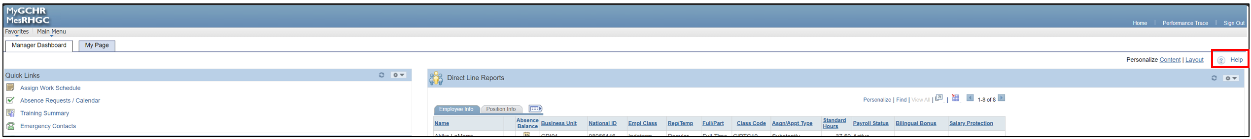

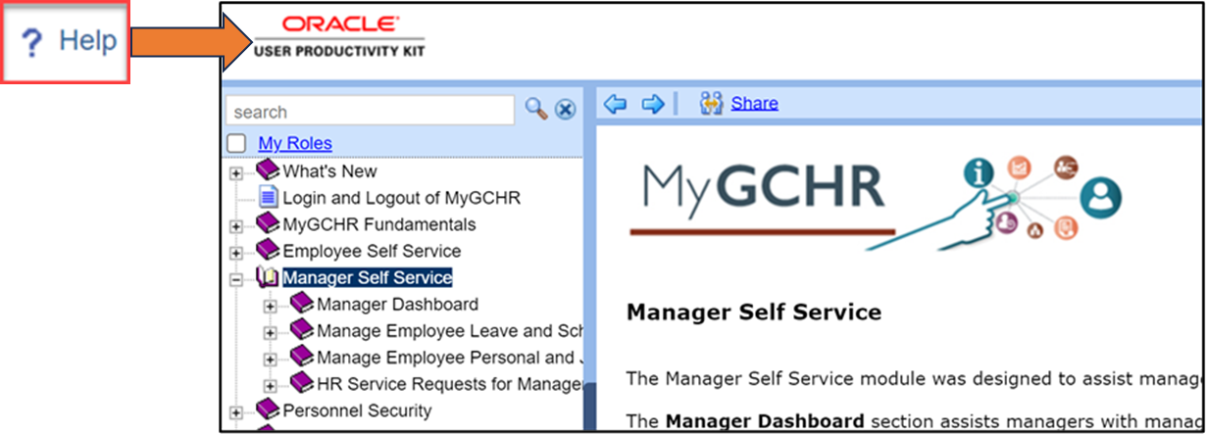

My Roles
To tailor the outline to your Manager role(s) within your organization, you have the option to customize the list of UPK Sections and Topics. This way, only topics that are relevant to your managerial responsibilities will be displayed.

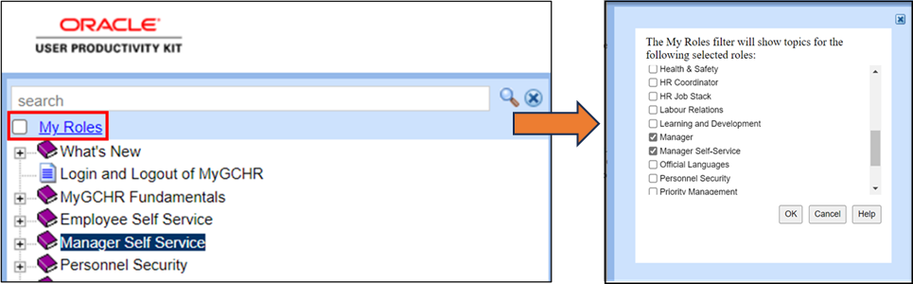

Manager Self Service
This module was designed to assist managers with their day-to-day activities in MyGCHR.

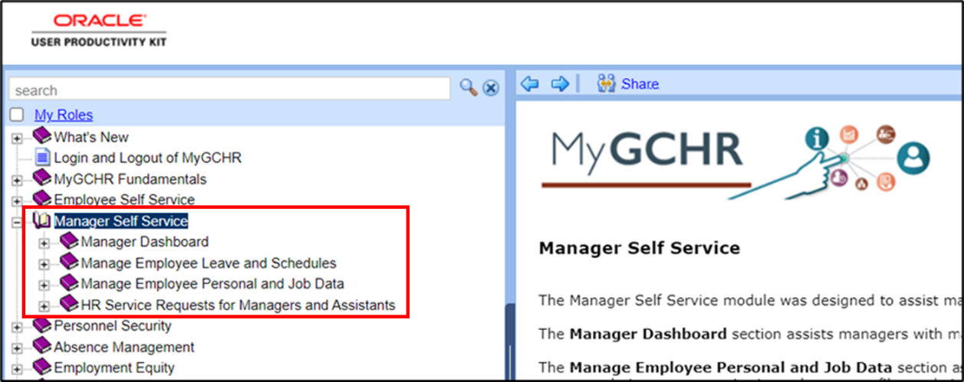

You can find the step-by-step instructions for the following Manager Self-Service processes:
- Manager Dashboard: This section guides managers in viewing and managing information on the Manager Dashboard.
- Manage Employee Leave and Schedules: This section guides managers in requesting and approving employee leave, forwarding leave requests, viewing leave request history, and creating personal schedules for employee work hours and days. It also assists managers in designating a representative to handle leave transactions on their behalf.
- Manage Employee Personal and Job Data: This section guides managers in viewing employee personal information, reviewing and responding to employee accommodation requests, accessing volunteer profiles, and viewing current team profiles. It also guides managers to request training enrollment, verify the status of training requests, approve training requests, and view employee training summaries. Furthermore, it assists managers in approving, denying, and reviewing employee Telework arrangements.
- HR Service Requests for Managers and Assistants: This section aids managers and assistants in creating, finding, and viewing HR Service Requests related to Staffing and Classification.
Please consult the MyGCHR Employee Self-Service User Guide for more detailed information on navigating UPK.

Manager Dashboard
The Manager Dashboard appears upon logging into MyGCHR. It provides a summary of information on a manager’s direct reports.
Path in MyGCHR: Main Menu > Manager Dashboard
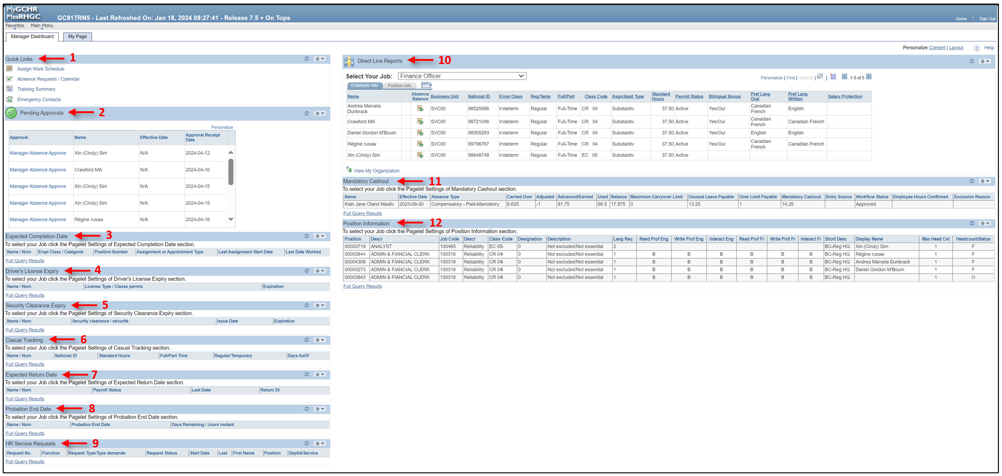
From the dashboard, you can action items related to your direct reports and easily access additional information via quick links to other pages within the application.
The Manager Dashboard includes the following sections:
- Quick Links – shortcuts to key features, such as: Assign Work Schedule; Absence Requests/Calendar; Training Summary; and Emergency Contacts.
- Pending Approvals – a list of Employee Requests that require action.
- Expected Completion Date – a list of employees that have an expected end date within 28 days of their acting, assignment, or term.
- Driver’s License Expiry – a list of employees whose driver’s license is set to expire within the next 6 months. Note: This function is only used for employees have driving as a task in their job, i.e., chauffeurs.
- Security Clearance Expiry – a list of employees whose security clearance is set to expire within the next 12 months. Note: This function is not used by your organization.
- Casual Tracking – a list of active casual workers, as well as those categorized as "As and When required," who report directly to the Manager.
- Expected Return Date – a list of employees who are currently on either a Leave of Absence or a Paid Leave of Absence. It also includes the anticipated date on which they are expected to return.
- Probation End Date – a list of employees with less than 3 months remaining in their probationary period.
- HR Service Requests – manager’s HR Service Requests for staffing and classification initiated in MyGCHR, along with the status of each request. Note: This function is not used by your organization.
- Direct Line Reports – employee and position information and absence balances for a manager’s direct reports.
- Mandatory Cashout – a list of employees who must be cashed out and the status of the mandatory cashout.
- Position Information – information about the positions reporting to the manager, including the linguistic profile, security, exclusion, and whether there is an incumbent in each position.
UPK - Navigate the Manager Dashboard

Quick Links
This section serves as a navigation hub, offering you convenient links to access and update information about your direct reports. It provides shortcuts to key features, such as: Assign Work Schedule; Absence Requests/Calendar; Training Summary; and Emergency Contacts.

- Assign Work Schedule  - Absence Requests /Calendar  - Training Summary  - Emergency Contacts | 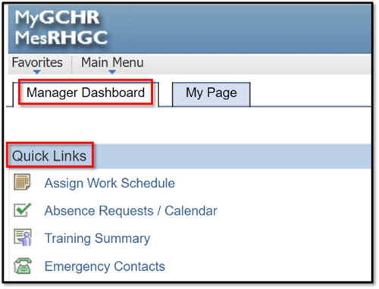

Assign Work Schedule:
The Assign Work Schedule quick link provides managers with easy access to the work schedules of their direct reports.
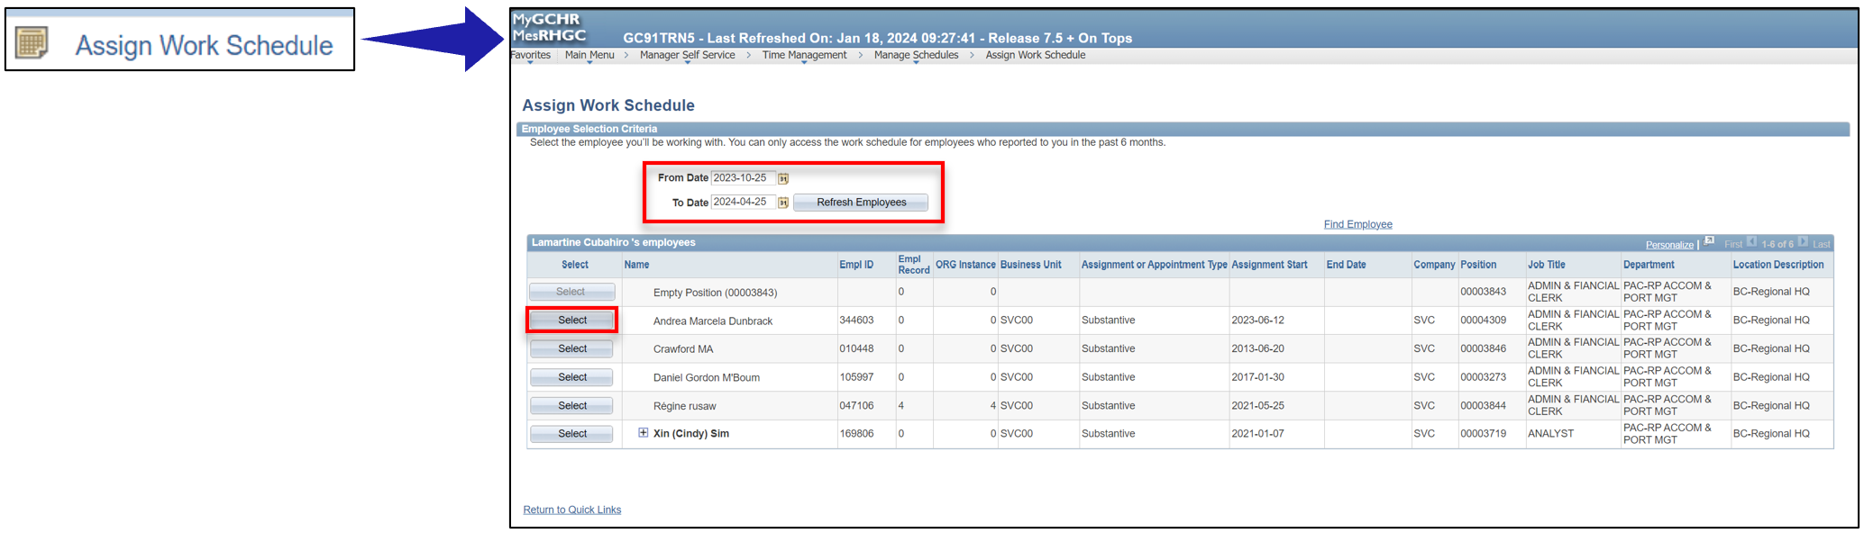

Refer to the Manage Employee Schedules section of this guide for more details.

Absence Requests / Calendar:
The Absence Requests/Calendar quick link provides managers with easy access to their employees' pending absence requests.
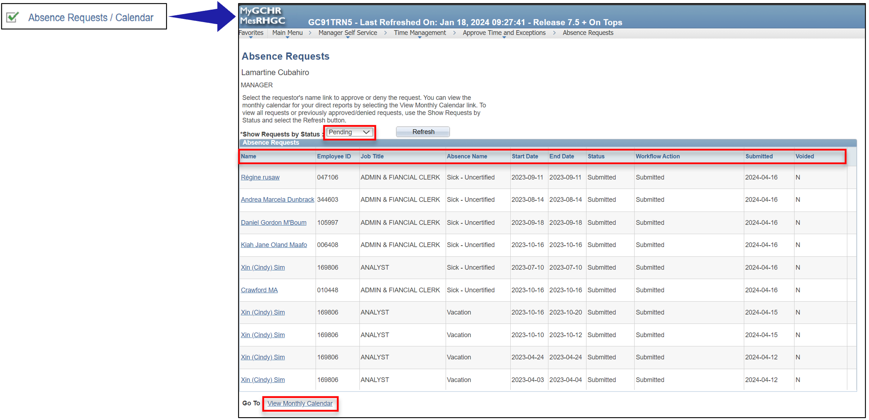
Refer to the Manage Employee Absences section of this guide for more details.

Training Summary:
The Training Summary quick link provides managers with easy access to their employees' training information.
Note: This is only available to organizations who use the Enterprise Learning module in MyGCHR to create and manage student enrollment. Not used by your organization.
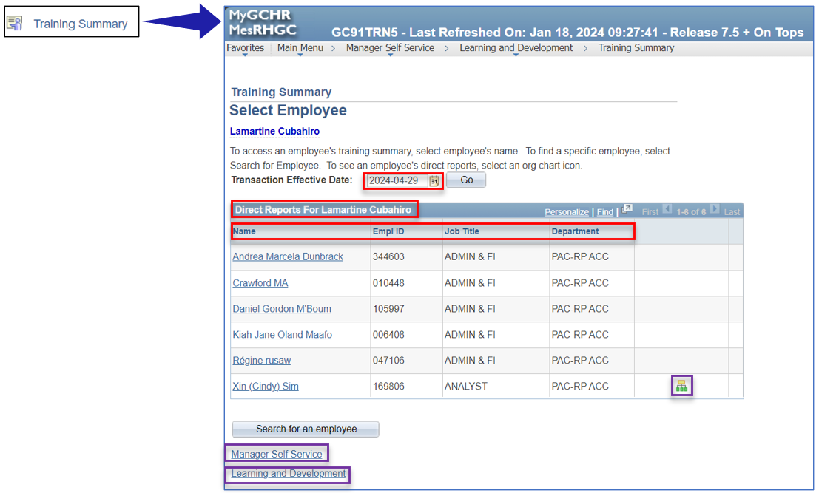
Refer to the Learning and Development section of this guide for more details.

Emergency Contacts:
The Emergency Contacts quick link provides managers with easy access to their employees’ emergency contact information.
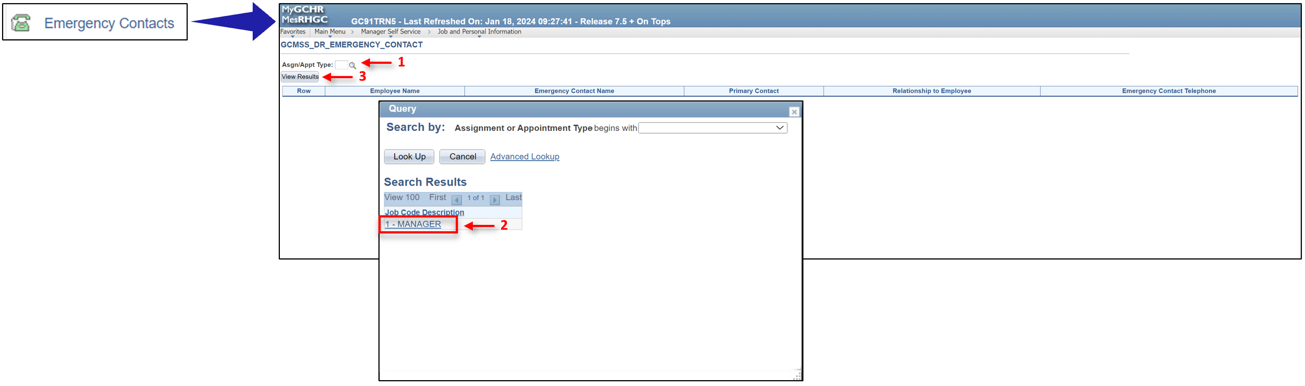
To obtain a list of your direct reports and their emergency contacts, you will need to select the active job in which you are currently working (refer to the screenshot above).
- Click on the magnifying glass next to the Asgn/Appt Type field. This will open a Query window with a list of your active positions.
- Select the position for which you wish to retrieve the list of direct reports.
- Click on the View Results button. A list showing the direct reports for the selected position and their emergency contact information will be displayed.
From this page, you can download the list in various formats, such as Excel Spreadsheet, CSV Text, or XML file.
Alternatively, you can access an individual's emergency contact information through Manager Self Service. Refer to the View Employee Personal Information section of this guide for more details.

Pending Approvals
This section allows managers to easily access, review and approve pending employee requests in a centralized location. This can include absence requests and mandatory cash-out requests, etc.
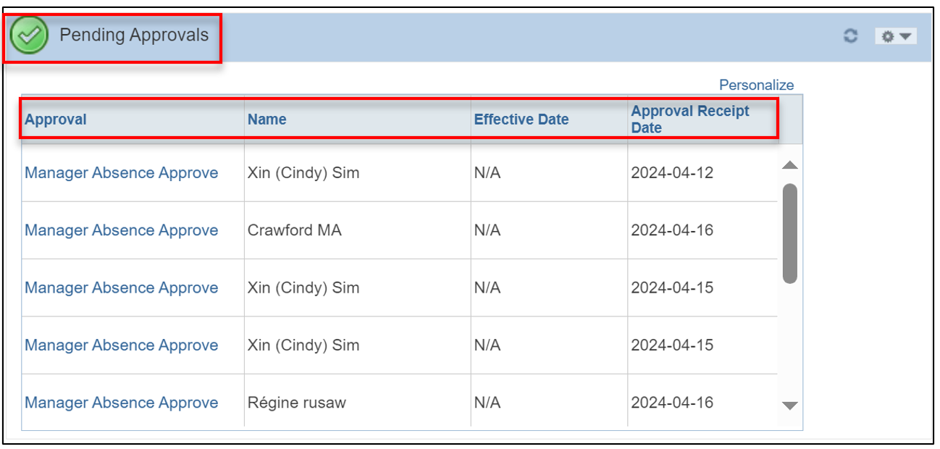

Clicking on the Manager Absence Approve link next to an employee’s name, opens the Request Details page for that employee. On this page, managers can choose to Deny, Approve, or Forward the submitted request.
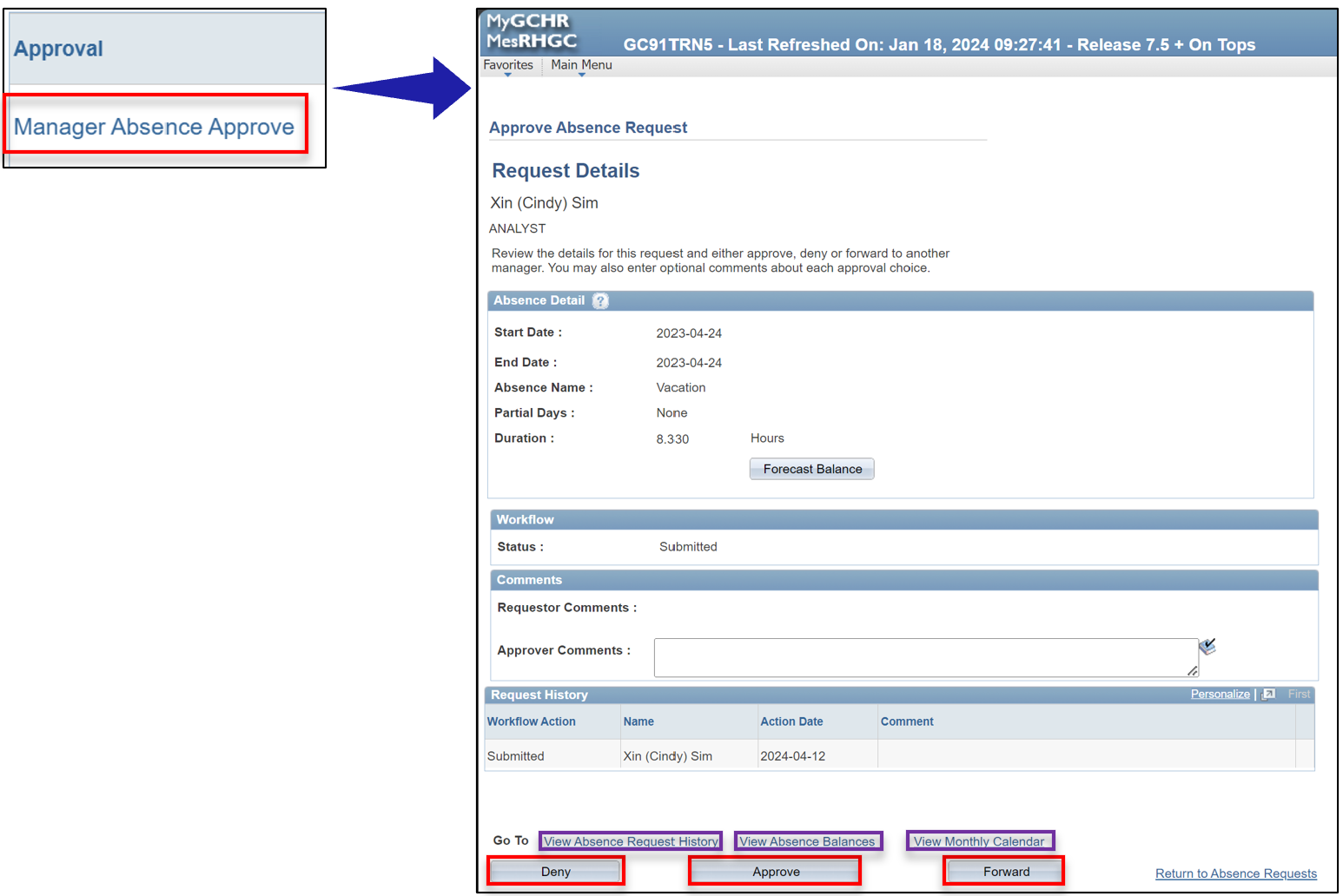

Expected Completion Date
This section displays a list of students, casual workers, and employees whose actings, assignments or term appointments are set to end within the next 28 days.
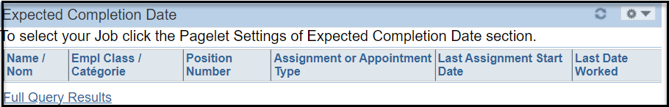

Driver’s Licence Expiry
This section displays a list of employees whose driver’s licenses are set to expire within the next 6 months.
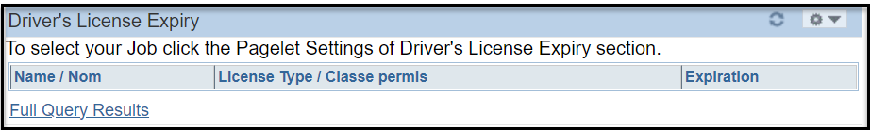
Note: This functionality is used by specific organizations, and this information may not be available in all organizations. Not used by your organization.

Security Clearance Expiry
This section displays a list of employees whose security clearances are set to expire within the next 12 months.
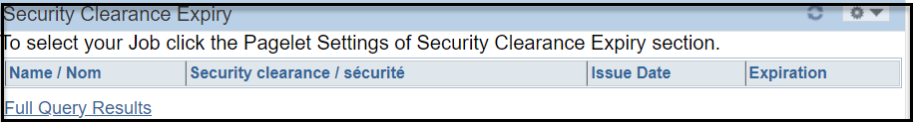
Note: This functionality is used by specific organizations, and this information may not be available in all organizations. Not used by your organization.

Casual Tracking
This section displays a list of active casual workers, as well as those categorized as "As and When required" who report directly to the Manager.
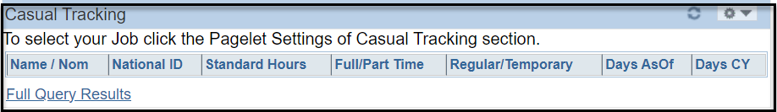
Note: This functionality is used by specific organizations, and this information may not be available in all organizations.

Expected Return Date
This section displays a list of employees on Leave of Absence and Paid Leave of Absence and their expected return date.
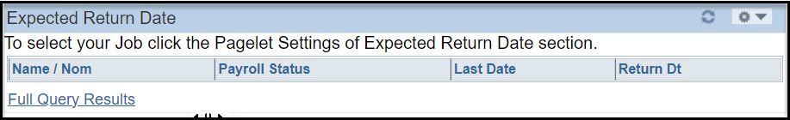

Probation End Date
This section displays a list of employees with less than 3 months remaining in their probationary period.
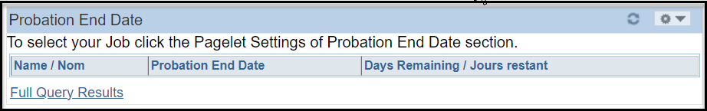

HR Service Requests
In this section, managers can view their HR Service Requests for staffing and classification, which were initiated in MyGCHR. The section provides details about the type and status of each request.
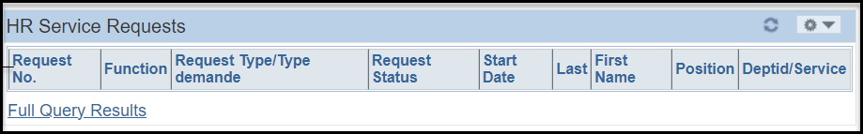
Note: This is only available to organizations who use the HR Service Requests functionality in MyGCHR. Not used by your organization.

Direct Line Reports
This section provides employee and position information and absence balances for a manager’s direct reports.
In MyGCHR, your Direct Line Reports refers to employees who occupy one of your subordinate positions.
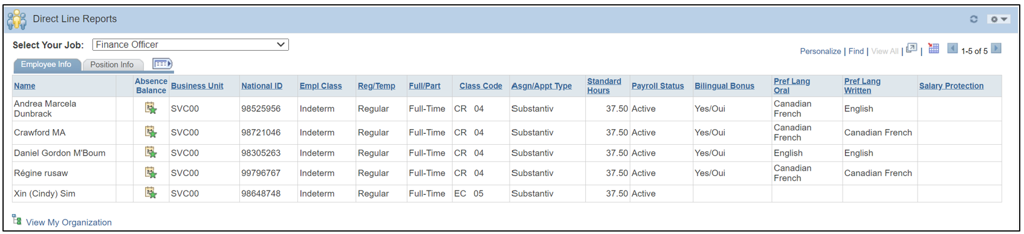
Note: Ensuring accurate reporting relationships in MyGCHR is crucial when the staffing unit assigns an employee to one of your subordinate positions.

Select Your Job
The Select Your Job field becomes visible only when a manager is in an active acting or assignment in MyGCHR. When logging in, the manager will see the employees that report to them in their substantive job. If they are acting, they would then select the appropriate acting position to see the list of employees that report to them in their acting job.
Once you select a specific job from the drop-down menu, the system filters the information displayed in the Direct Line Reports and Position Information pagelets to show only the information that is relevant to that selected job.
Note: This field will not appear if the manager is not on an active acting or assignment.

Employee Information
The Employee Info tab displays core employee information entered by staffing when adding the job information to the employee. This tab also enables managers to conveniently access and view their employees' absence balances.
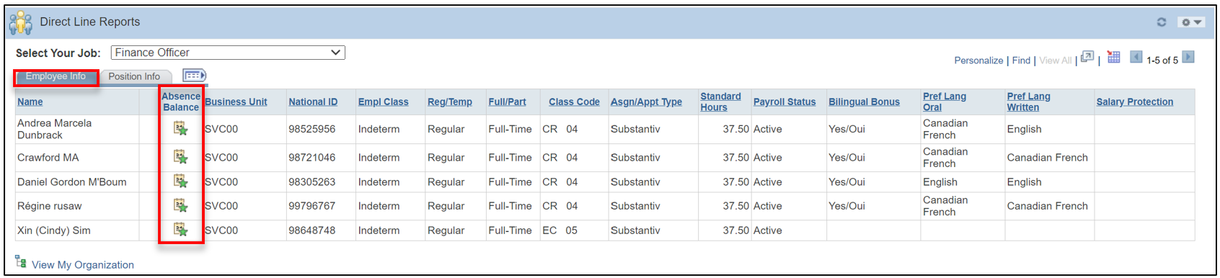
Clicking on the Absence Balance icon next to an employee’s name opens the Absence Balances (GC) page. On this page, you can view the breakdown of an employee's accumulated, used/paid, and remaining leave balance by absence type.
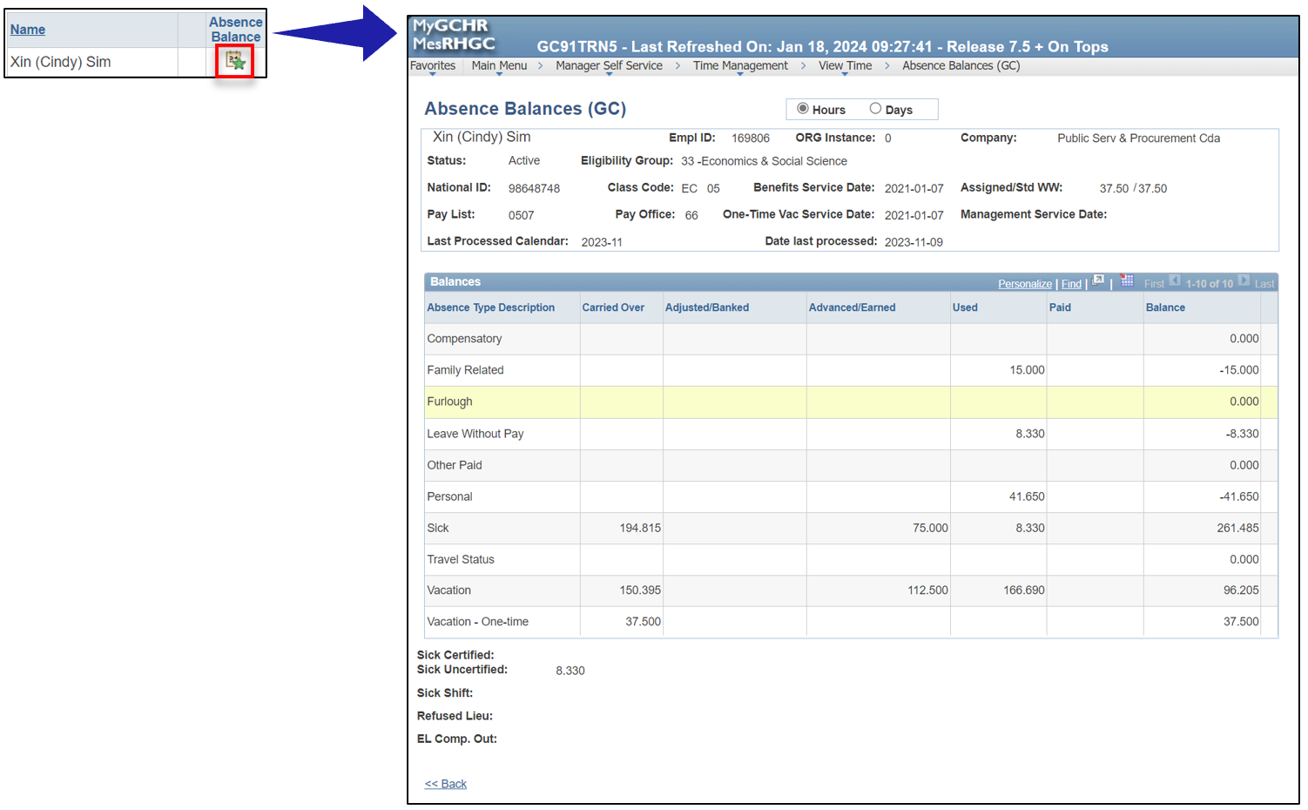

Position Information
The Position Info tab allows managers to easily access details about the positions occupied by their employees. These details are entered by staffing when adding job information to the employee.
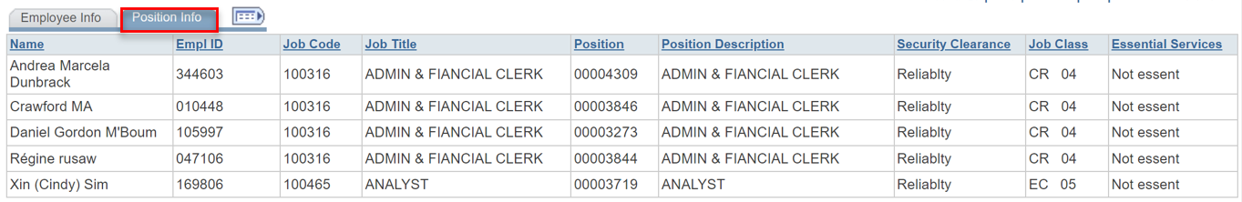

View My Organization
The View My Organization icon displays a hierarchical grid of a manager's direct and indirect reports.
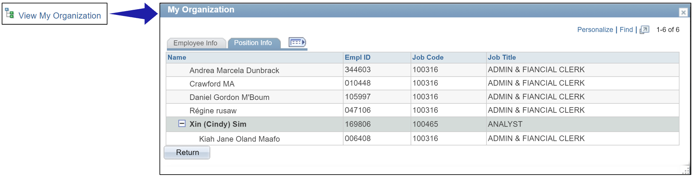

Mandatory Cashout
This section provides managers with a list of their employees who must be cashed out and the status of the mandatory cashout.
The Entry Source column displays the source of the confirmation and approval.
- Employee self-service
- Manager self-service
- Administrator (Compensation)

The Workflow Status column displays the status of the request.
- Approved
- Denied
- Submitted

The Employee Hours Confirmed column identifies if the employee has confirmed their cash out amounts.
- Y – Yes, the employee agrees with the calculated mandatory cashout amount.
- N – No, the employee does not agree with the calculated mandatory cashout amount.

The Exclusion Reason column identifies the employee’s exclusion reason. An employee can be excluded for the following reasons:
- Employee LWOP & benefits
- Leave balance inaccurate.
- Transfer not completed.
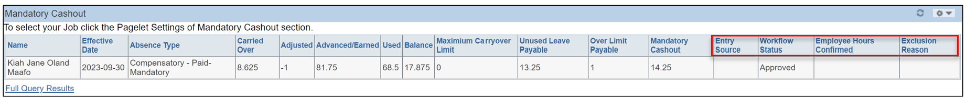

Position Information
This section shows a list of positions that report directly to the manager, entered in MyGCHR by the classification unit. It includes details about each position, such as Position Number, Description, Security Clearance, Classification Code, and Essential Services.
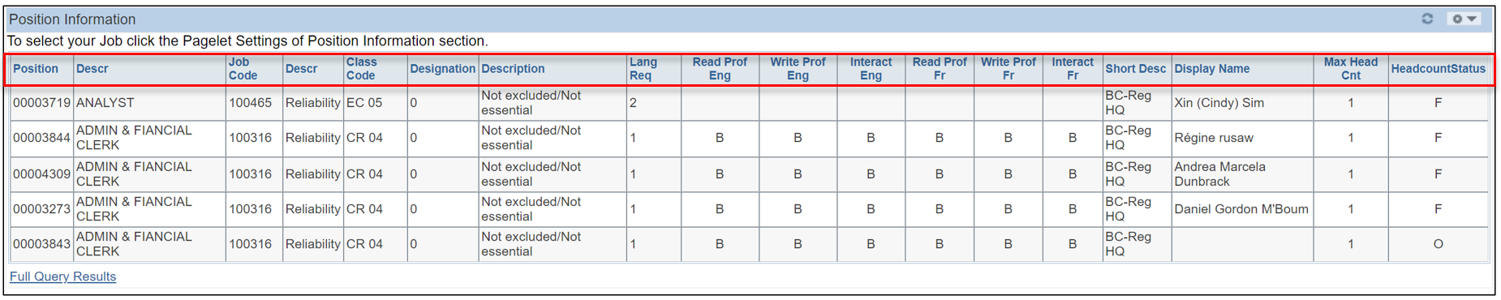
By clicking on the Full Query Results link, you can access the complete list of positions that directly report to you in MyGCHR.
From this page, you can download the list in various formats, such as Excel Spreadsheet, CSV Text, or XML file.
Note: If this list is not correct, you should contact your HR unit.

Manager Self Service
Manager Self Service allows managers to efficiently handle various tasks related to their employees. This includes managing work schedules (Manage Schedules), handling pending absence requests, submitting requests on behalf of employees (Report Time), and viewing employee absence histories and balances (View Time). Additionally, managers can access profiles and personal information of both direct and indirect employees.
Path in MyGCHR: Main Menu > Manager Self Service

Manage Employee Schedules
A Work Schedule MUST be assigned to all employees in MyGCHR. They are used to manage and communicate the attendance expectations of employees. They also facilitate the absence process by determining whether an employee's absence coincides with their scheduled workday.
In MyGCHR, two work schedule types exist: predefined and personal. Managers can view, update, or correct both employee schedule types in Manager Self Service.
Path in MyGCHR: Main Menu > Manager Self-Service > Time Management > Manage Schedules
The Work Schedule is used for calculating absence duration. Therefore, the hours in an employee's work schedule must match the Standard Hours in Job Data which is entered by your Human Resources unit.
Path in MyGCHR: Main Menu > Workforce Administration > Job Information > Job Data
Any changes to the employee's tenure, (full-time / part-time) must first be recorded in Job Data by your HR unit before the employee's schedule can be updated.
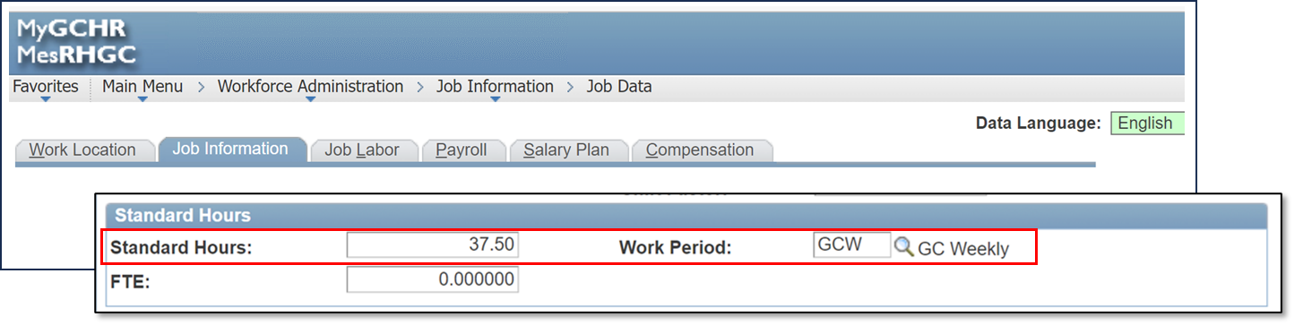

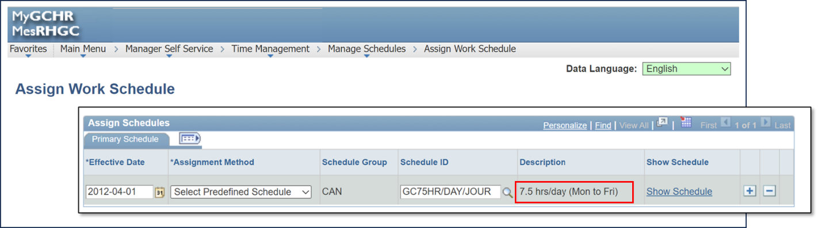
If a manager or leave administrator tries to modify an employee's Work Schedule that does not correspond to the employee's Standard Hours, an error message will appear, and the schedule change will not be processed.
Note: If the Standard Hours need to change in Job Data contact your Human Resources unit before you update the schedule in MyGCHR.
Note: Some organizations use leave administrators to manage schedules.

Schedules and Employee Records:
Each employment record requires its own schedule. When HR performs actions on an employee record in Job Data, certain transactions can affect the schedule. This might lead to an automatic assignment of a default schedule.
Path in MyGCHR: Main Menu > Manager Self-Service > Time Management > Manage Schedule > Assign Work Schedule
It is your responsibility, as the manager, to ensure that the work schedule in MyGCHR accurately represents the employee's situation after HR's adjustments.
For instance, if an employee is in an acting role and maintains compressed hours, the predefined schedule should be changed to a compressed schedule.
UPK - View, Update or Correct an Employee's Work Schedule
Video: Managing work schedules

Predefined Work Schedule
Predefined Work Schedules are standard schedules pre-established in MyGCHR that can be assigned based on the Standard Hours and the full-time/part-time fields entered by HR in the Job Data information.
A PREDEFINED work schedule SHOULD BE USED if one exists that matches your employee's work situation. Refer to the list of Predefined Schedules to find a schedule that meets your employee's work situation.
Predefined work schedules are available for commonly used full time, compressed and part-time schedules.
Note: If an employee's schedule differs from one of the predefined options, a personal schedule must be created
When a full-time employee is hired, the system automatically assigns a default predefined work schedule based on job information entered by the HR professional.
- For employees with a compressed schedule upon hire, managers must adjust the predefined schedule to reflect the compressed work schedule.
For part-time employees or when a full-time employee transitions to part-time, the system assigns a default predefined part-time schedule.
- If the employee has a schedule different from the predefined part-time schedule, managers must modify it to reflect the actual part-time schedule.
Note: Always verify the effective date when assigning a predefined or personal schedule. If the effective date of the schedule change differs from the current assigned schedule, a new Work Schedule with a new effective date must be assigned. These rules also apply to Acting and Assignments.
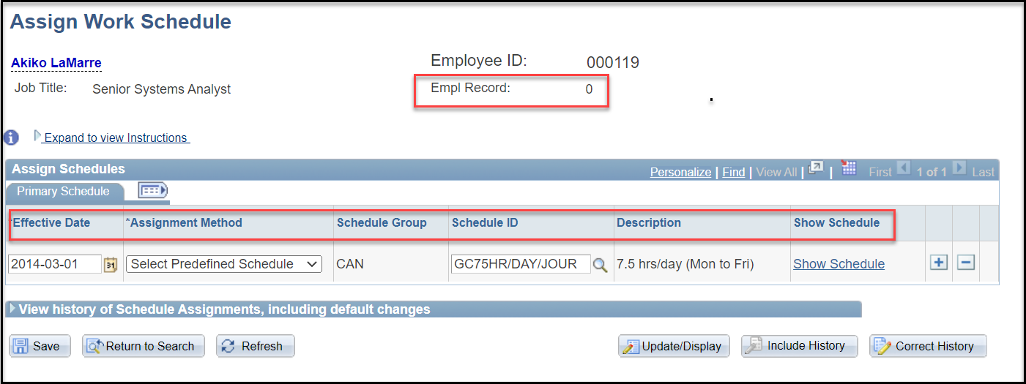
Empl Record: A default Predefined Schedule will be allocated for each employee record created: substantive, acting, assignment, dual employment or dual renumeration.
Effective Date: When an employee is hired or rehired, a default schedule will be created with the effective date of the hire or rehire.
Assignment Method: There are two types of schedules: predefined and personal. When the default predefined schedule is set, the assignment method will automatically appear as “Select Predefined Schedule”.
Schedule Group: will default to CAN.
Schedule ID: A list of schedules already created in MyGCHR. When staffing enters a job to an employee file, the Standard Hours will determine the predefined Schedule ID.
For instance, if the Standard Hours is set at 37.5 hours (per week), the predefined schedule would default to Schedule ID: GC75HR/DAY/JOUR – 7.5 hrs/day (Monday to Friday).
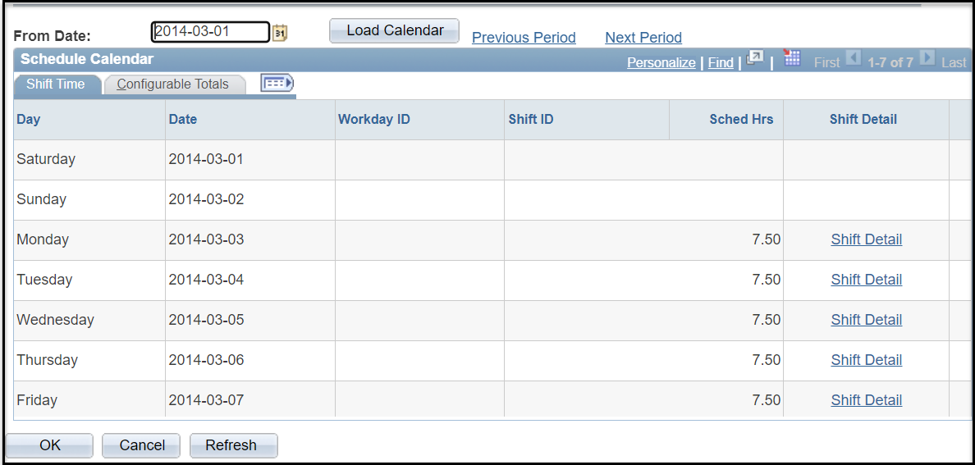

Default Predefined Work Schedules
A Predefined Work Schedule is assigned by default based on certain information populated in Job Data by HR, such as the Standard Hours and the full-time/part-time fields or schedules that are pre-populated with predefined characteristics, such as different compressed work week schedules, or different days-off.
When an employee is hired or an existing employee changes positions, MyGCHR automatically attaches a Predefined Work Schedule based on the employee's Standard Hours identified in MyGCHR.
A default predefined schedule is assigned to an employee record when:
- There is a Hire, Rehire, or Assignment added to an employee record in Job Data,
- There is a change in the Standard Hours on the employee record in Job Data,
- The Effective Date is changed on a Job Data row and the row associated to the change has a default schedule, then the schedule is assigned with the new Effective Date.
Managers are responsible to review the default work schedule to ensure it reflects the employee's hours worked, and make any changes as required.
- If the actual hours worked differ from the default work schedule, another Predefined schedule SHOULD BE USED if one exists that matches your employee's work situation. Refer to the list of Predefined Schedules to find a schedule that meets your employee's work situation.
- A Personal work schedule should ONLY be used as an EXCEPTION when no predefined schedule matches the employee's work situation.

Modify a Predefined Work Schedule
Managers can change an employee’s predefined work schedule initially established upon hiring with an alternative schedule that matches the employee's work situation and has been mutually agreed upon with the employee.
Scenario:
- A default predefined schedule was established at 37.5 hours per week, 7.5 hours per day, from Monday to Friday.
- It needs to be changed to a compressed work schedule at 8.33 hours per day, with every second Monday as a non-working day (day off).
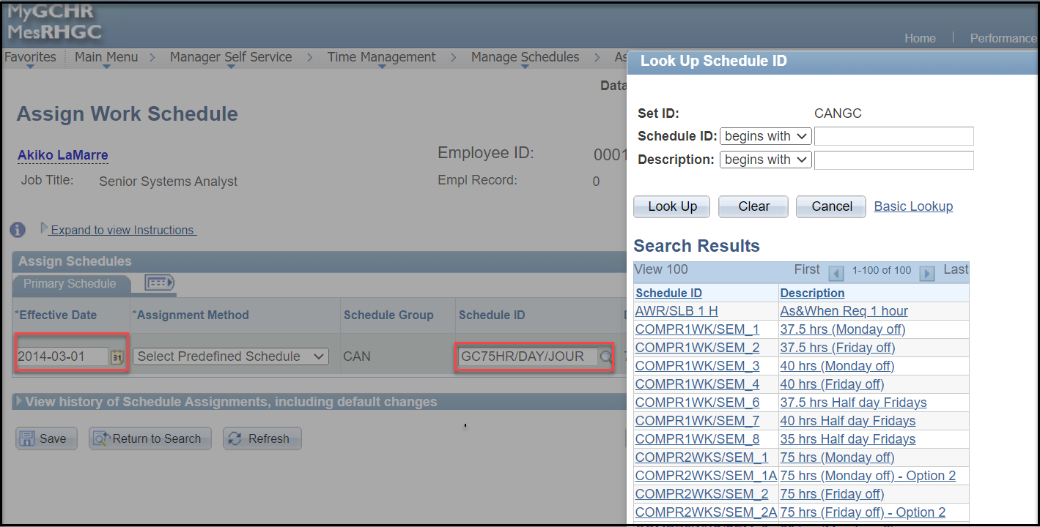
- Select the row for which you want to change the work schedule.
- Use the Schedule ID look-up button to find the appropriate Predefined Schedule from the list.
- Use the Show Schedule link to view and confirm you selected the correct schedule.
- Press the OK button to return to the Assign Work Schedule page.
- Click the Save button.

Important: If a modification is applied to an existing row (with the same effective date), any leave requests for that date and beyond will require re-approval due to the altered work hours.
In the scenario mentioned above, the daily work hours shifted from 7.5 hours to 8.33 hours. The employee balance will be automatically adjusted.

Assign a New Predefined Schedule
Managers can assign a new predefined work schedule for their employees with a new effective date.
Scenario:
- A current employee previously had a predefined schedule of 37.5 hours per week, 7.5 hours per day, from Monday to Friday.
- Effective 2019-02-05, the employee’s predefined schedule needs to be changed to a compressed work schedule at 8.33 hours per day, with every second Monday as a non-working day (day off).
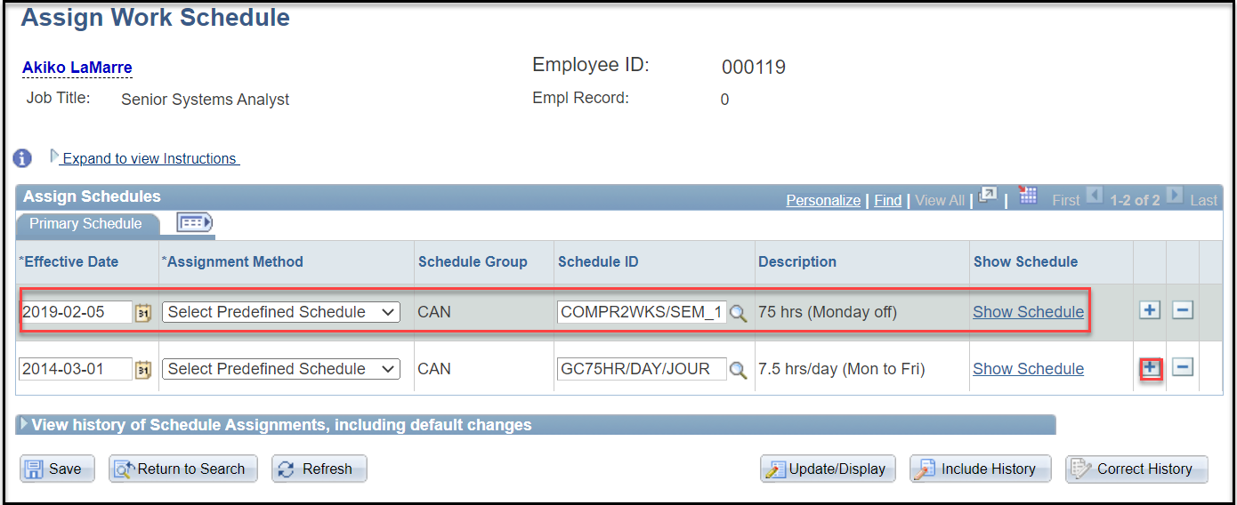
- Click the Add a New Row (Alt+7) button
- Enter the date the employee is to start the new schedule in the Effective Date field.
- Accept the Assignment Method of Select Predefined Schedule
- The Schedule Group value defaults to CAN and cannot be changed.
- Use the Schedule ID look-up button to find the appropriate Predefined Schedule from the list.
- Use the Show Schedule link to view and confirm you selected the correct schedule.
- Press the OK button to return to the Assign Work Schedule page.
- Click the Save button.
This warning message will appear if the employee has submitted a leave request that may be affected by the changes to the schedule.
“Warning” – A change in schedule may affect absence balances. (28050.101) A change in schedule may affect absence balances. The employee has absence requests that may need to be adjusted to reflect the new schedule. Leave requests that were previously approved with a start date later than the effective date of the schedule will be re-submitted for approval.”

Note: If you select a schedule that does NOT meet the employee's Standard Hours, a message will appear stating the average weekly hours on the schedule do not match the standard hours of XX on Job Data. Select another schedule that matches the employee's Standard Hours.

Personal Schedules
A Personal Work Schedule is a customized schedule that is not covered by any predefined schedules available in MyGCHR. It is an agreement between an employee and a manager that is personalized, to respond to specific operational needs.
It should ONLY be used as an EXCEPTION when no predefined schedule matches the employee's work situation. Managers MUST review the PREDEFINED schedules available in MyGCHR before creating a PERSONAL schedule.
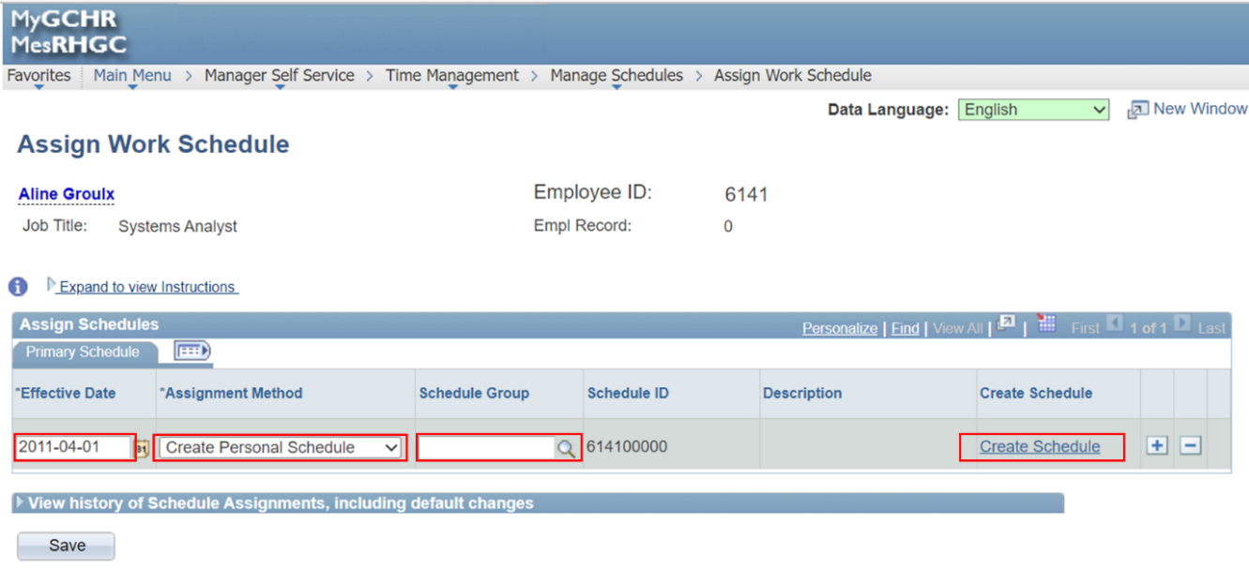
When creating a Personal Schedule, NEVER select CAN from the Schedule Group field. This has an impact in Phoenix. Select a value that best describes the employee schedule. For example: COMP for compressed work schedule.
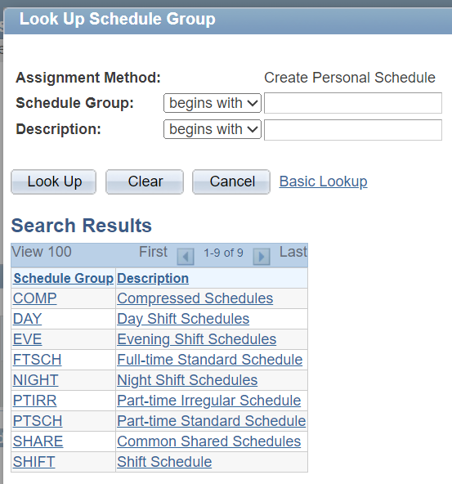
A Personal schedule can be created for the following cycles:
- 7 Days: Employee will have the same schedule every week.
- 14 Days: Employee will have an alternating schedule every other week.
- 21 Days: Employee will have a varied schedule every three (3) weeks.
- 28 Days: Employee will have a varied schedule every four (4) weeks.
- Etc.
Note: The number of days in the schedule must be a multiple of 7.
Once the chosen cycle is finished, the schedule will start over again (Day 1), and the same pattern of varying schedules will repeat in subsequent cycles. Every Staffing action, including acting appointments or changes to work hours may have an impact on the employee’s schedule.
Note: Managers are responsible to review the default work schedule and ensure it reflects the employee's hours worked. An employee's schedule is linked to the Phoenix pay system. If a manager amends the schedule in MyGCHR, the updated information is sent to Phoenix, thereby affecting the pay of employees who must enter time reporting (timesheet).
Deleted Schedule – When a Job Data row associated with a change in Standard Hours (regardless of the action reason) is deleted, then the schedule with the matching Effective Date of the change in Standard Hours is also deleted.
Note: Future Effective Dated schedules that have been previously assigned and no longer match the employee’s retroactive change in Standard Hours will be removed.
Acting – When an employee is in an Acting appointment, create the work schedule for the Acting record only.
Assignment – When an employee is on Assignment, create the work schedules for both the Substantive record (for the period covering the Assignment) and the Assignment record.
Compressed Schedules – Managers must ensure that employees on compressed schedules account for the extra hours not covered by the holiday. If leave is submitted for this time, the employee must submit the leave on the next business day after the statutory holiday. For example, if an employee works a compressed schedule of 8 hours per day and is off on January 1 (7.5 hours of statutory leave), the employee must enter the additional half-hour of leave that was not covered by the statutory holiday on the next business day, e.g., January 2.

As and When Required Schedules
Employees and casual workers who are hired on an "As and when required" basis are called into work when they are required and work for varied hours without following a fixed work schedule. These employees enter their time in Phoenix and have their time approved by their manager. In Job Data, these employees and casual workers are identified with a number of standard hours that represent the minimum hours they work. If “1” hour is defined as the standard hours, the predefined schedule AWR/SLB 1 H defaults in. Otherwise, a personal schedule matching the minimum hours will need to be created by a Leave Administrator or the Manager.
Notification
The current managers are notified as soon as the information is saved in MyGCHR when their direct reports have a Job Data entry transaction that could impact the assigned schedule. The transactions which notify managers are Hire, Rehire, Add Additional Assignment, data changes like change of status, change in part time hours, as well as change to the Standard Hours field, and Transfers. These data elements have a scheduling impact and managers need to validate if the system default schedule represents the true situation of the employee’s work arrangement.
A notification is sent to the current manager entered in the Reports To or Supervisor ID field, or a manager with schedule administration delegation. The current manager is the only person who can access and apply changes to the employee’s schedule. If your employee is in an Inactive Status, contact your Service Desk for schedule modifications, if required.
Impact on Pay
A schedule must be assigned to all employees in MyGCHR in order for them to be paid. All corrections and updates to schedules are sent to the pay system during an overnight process.
Impact on Leave
The work schedules impact leave transactions recorded in MyGCHR. For instance, if an employee seeks to submit a leave request for hours coinciding with a scheduled day off or a statutory holiday, MyGCHR will prevent the employee from submitting the leave request.
Employee's submitting leave for an entire day, must submit a leave request for the number of hours in their work schedule for that day.
For example:
- If the employee has a work schedule that shows the work hours are 7.5 hours per day, a leave request is submitted for 7.5 hours,
- If the employee has a compressed work schedule, and the work hours for that day indicate 8.33, a leave request is submitted for 8.33 hours.

Manage Employee Absences
Manager Self-Service provides managers with the ability to access, review, and approve pending employee leave requests. Alternatively, managers can also perform these tasks directly from the Manager Dashboard.
Path in MyGCHR: Main Menu > Manager Self-Service > Time Management
In Manager Self-Service, you can:
- View absence balances;
- Approve employee absence requests;
- Approve employee requests that require a Section 34 delegation;
- Request absences on behalf of an employee;
- Request compensatory banked time on behalf of an employee;
- View absence request history;
- Forward absence requests; and
- View monthly calendars.
Video: Managing employee absence requests

View Absence Balances
The Absence Balances (GC) functionality in MyGCHR enables managers to access and review their employees' leave balances, as per the entitlements or eligibility outlined in their collective agreement.
Path in MyGCHR: Main Menu > Manager Self-Service > Time Management > View Time > Absence Balances (GC)
You will find a comprehensive list of your employees, with today's date set as default. To view the list of your employees on a different date, you can easily modify the date in the ‘Employee Report as of’ field and then select Refresh Employees.
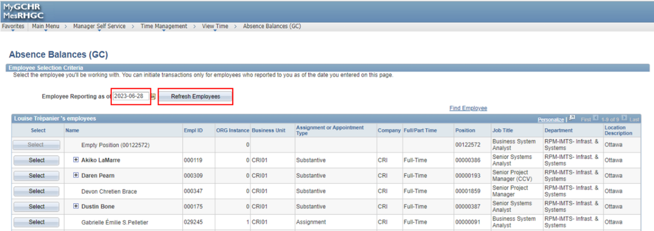
To view a specific employee’s leave balances, use the Select button next to the employee's name to navigate to the Absence Balances page.
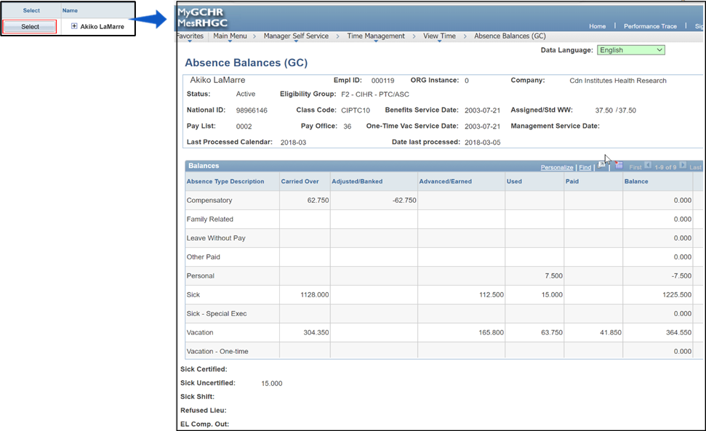
Note: The displayed balances do not include any leave requests for the next fiscal year or those pending deletion.
UPK - View an Employee's Leave Balances
Please refer to the Absence Balances section of the MyGCHR Employee Self-Service User Guide for information on the various categories of absence balances.

Approve Employee Absences
When an employee submits an absence request, a system generated email is sent to you to review it. When you approve or deny the absence request, a system generated email is sent to the employee indicating your decision.
Path in MyGCHR: Main Menu > Manager Self Service > Time Management > Approve Time and Exceptions > Absence Requests
The Absence Requests page displays all your employees’ pending leave requests that require your decision. To view previously approved or denied requests, simply select the corresponding option from the Show Requests by Status drop-down menu and click Refresh.

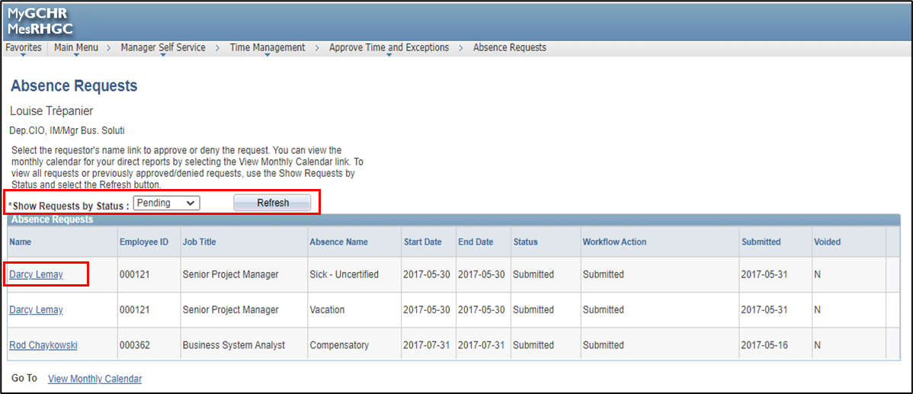

After clicking on an employee's name, you will be directed to the Approve Absence Request page.

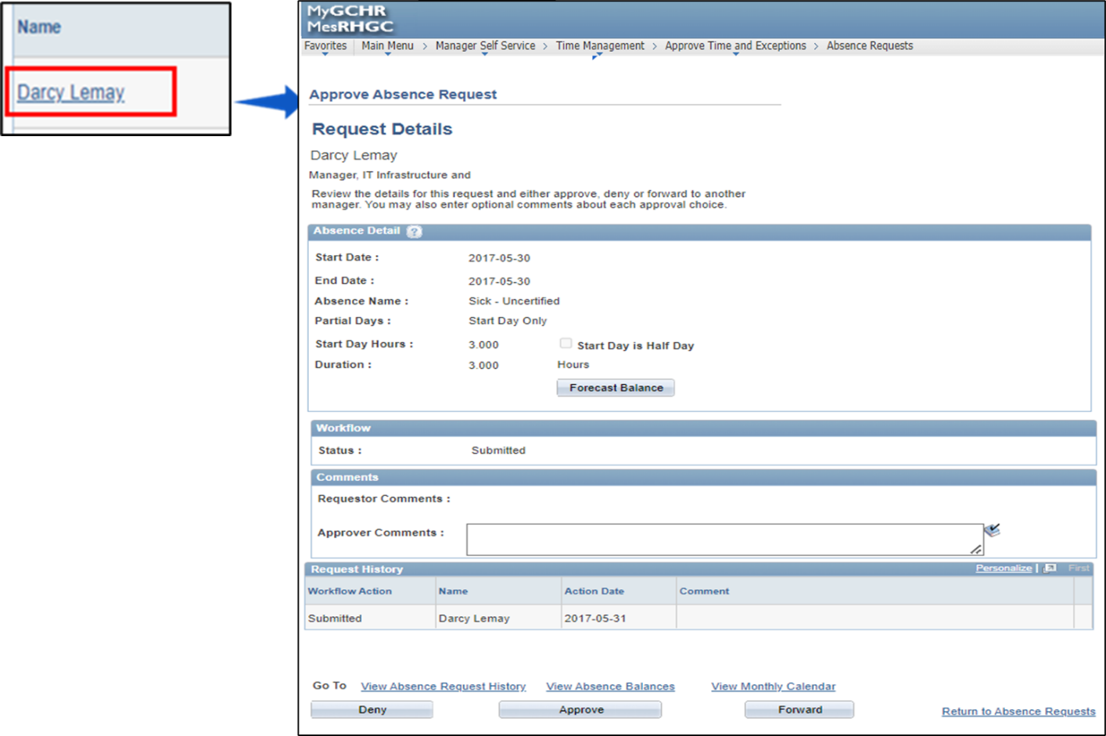
Before making a decision, it is important to verify if the employee has enough hours for the requested absence. To do this, you can click on the View Absence Balances link.
From this page, you can also access the View Absence Request History and the View Monthly Calendar pages for the employee. The Monthly Calendar provides a visual representation of employee schedules, absences, and holidays.
Note: If the employee has enough hours in their balance to cover the requested absence, the request will be considered eligible. However, if the employee is NOT eligible, a message will appear explaining the reason, and you will be unable to approve the transaction. You must deny it instead.
UPK:
- View an Employee's Leave Balances
- View an Employee's Leave History
- View a Monthly Calendar for Your Employees
- Approve, Deny or Forward a Leave Request
Once you have reviewed the balances, you can proceed to either Deny, Approve, or Forward the Absence Request using the buttons at the bottom of the page.

Request Absence on behalf of an Employee
Managers can request an absence in MyGCHR on behalf of a direct report who is unable to access MyGCHR. By using this functionality, the transaction is automatically marked as approved.
Path in MyGCHR: Main Menu > Manager Self Service > Time Management > Report Time > Absence Request
UPK - Enter a Leave Transaction for an Employee

Employee Selection Criteria page
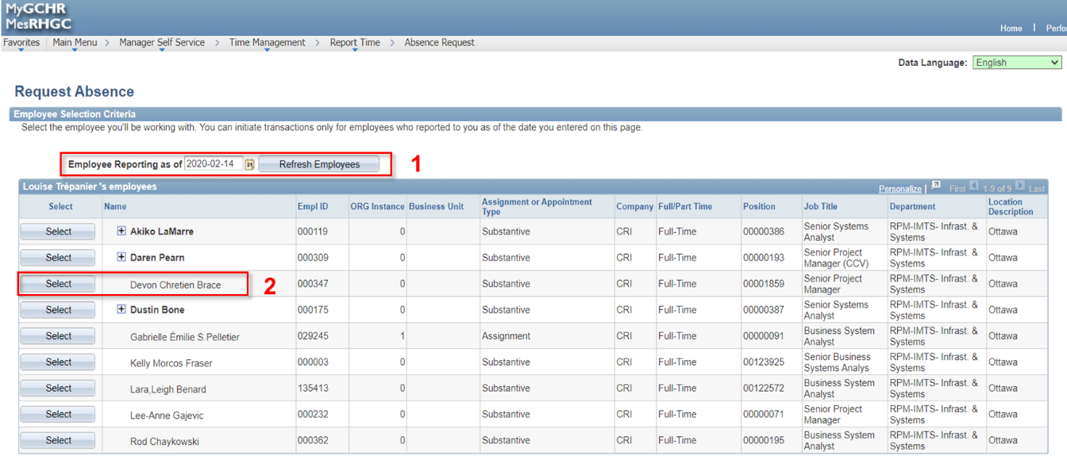

- Employee Reporting as of field:
- By default, the date is set to today, displaying the current employees and positions reporting to you.
- To view a list of employees and positions as of a different date, simply modify the date. Then, click the Refresh Employees button to update the list according to your selection.
- Select employee button:
- Find the employee for whom you need to enter a leave request on their behalf.
- Use the Select button next to the employee's name to access the Absence Request page.

Request Absence page
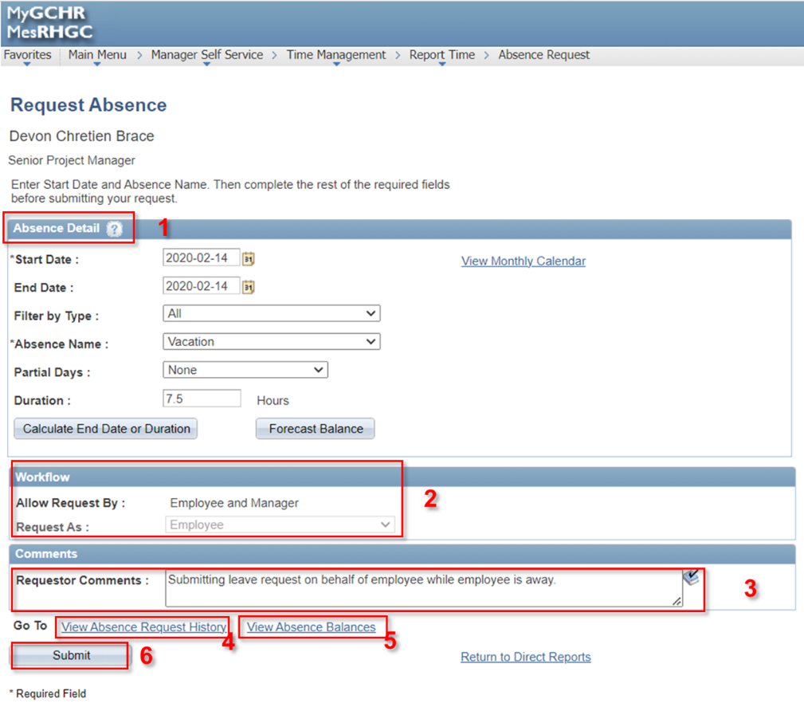
- Absence Detail: The process for this section is the same as when entering your own absence request in MyGCHR. For further information, please refer to the Submitting an Absence Request section in the MyGCHR Employee Self-Service User Guide.
- Workflow: This section is automatically pre-populated and cannot be modified.
      - Allow request by: This field indicates the individuals authorized to enter leave requests. It confirms that both the employee and the manager have permission to submit a leave request on behalf of the employee.
      - Request as: Employee value is greyed out.
- Requestor Comments: If necessary, provide any pertinent information or additional details in this field.
- View Absence Request History: This link gives you access to view the employee's absence records for the current fiscal year.
- View Absence Balances: This link gives you access to view the employee's current leave balances for the current fiscal year.
- Submit: Save the transaction by clicking the Submit button. A confirmation page will appear, asking you to confirm your request. Click the Yes button.

Note: Failure to click the Yes button will result in the absence request NOT being saved, requiring you to re-enter the transaction.
Note: If the system times out before completing the absence request, the transaction will NOT be saved, and you will need to re-enter the transaction.
IMPORTANT: Leave Without Pay (LWOP) transactions that are five days or fewer in duration require dual entry. More information is available in the Leave Without Pay (LWOP) section of this Guide.

Employee Requests Requiring Section 34 Delegation
In MyGCHR, the approval of a Section 34 Delegated manager is required for certain transactions, such as:
- Compensatory Banked Time (Compensatory time earned)
- Leave Without Pay (LWOP)
- Additional Hours (for part-time employees)
Absence requests that require Section 34 approval can be found on the regular page for all absence requests. Simply click on the name of the employee who submitted the request, just like you would for a regular absence request.
Path in MyGCHR: Main Menu > Manager Self-Service > Time Management > Approve Time and Exceptions > Absence Requests
From there, you can review the employee's leave details and access the View Absence Request History, View Absence Balances, and View Monthly Calendar links as needed.

Once you have reviewed the request and are prepared to submit your decision, you will find the options to either click on the Deny or Approve button.

If you receive a request that requires a Section 34 approval, and you do not have the necessary delegated authority, a message will appear indicating that this transaction requires the approval of a Section 34 delegated manager. To proceed in such cases, simply use the Forward button to send the request to the appropriate Section 34 delegated manager.
UPK - Approve or Deny Employee Request Requiring Section 34 Delegation
To enter the transaction in Phoenix, refer to the Phoenix procedure entitled Manager Self Service - Section 34 Payable Time.

Compensatory Banked Time (Compensatory time earned)
Managers with Section 34 Delegation can approve or deny an employee's request to accumulate compensatory time earned in MyGCHR for future leave.
Managers can also record an employee’s time as compensatory time earned in MyGCHR when an employee is not able or available to enter their time to be banked for future leave in MyGCHR.
Path in MyGCHR: Main Menu > Manager Self Service > Time Management > Report Time > Absence Request
In MyGCHR, the terms:
- Compensatory Banked is used when an employee wants to bank time, such as Overtime, Travel Status time, Call-back and/or Standby time for future leave.
- Compensatory is used when an employee has accumulated compensatory time, and they are ready to take the time as leave.
Note: Separate transactions are required for each day the employee worked.
IMPORTANT - Do NOT enter time in MyGCHR if the employee wants to receive payment in lieu of taking leave. If that is the case, a request must be submitted directly in the Phoenix pay system. Refer to the Client Contact Centre web site for more information and a link to the pay system.
UPK - Enter Employee Time as Compensatory Banked Time

Leave Without Pay (LWOP)
IMPORTANT: Approved Leave Without Pay (LWOP) transactions that are less than or equal to five (5) days in duration require dual entry.
It is the responsibility of the manager to ensure that LWOP transactions of less than or equal to five (5) days are maintained in both the MyGCHR and Phoenix applications. This is important in order to ensure that employee leave and pay information is maintained accurately.
- First, enter them in MyGCHR to ensure accurate calculation of leave entitlements and balances; and
- Then, enter them in Phoenix for accurate pay calculation. Please note that LWOP transactions of five (5) days or less entered only in MyGCHR will not be processed by Phoenix.
For a list of LWOP transactions that require entry in both MyGCHR and Phoenix systems, please refer to the List of LWOP Transactions.
For instructions on entering the transaction in Phoenix, please consult the Manager Self Service: Timesheet procedures.

Additional Hours (for part-time employee)
Managers with Section 34 Delegation can approve or deny a part-time employee’s request in MyGCHR for any hours worked above their part-time hours.
Managers approve or deny the requests and enter comments as required.
Note: If your Department does not track Section 34 Delegation for employees in MyGCHR, you will see a message and the request must be forwarded to a supervisor with Section 34 Delegation.
UPK - Approve or Deny Employee Request Requiring Section 34 Delegation
To enter the transaction in Phoenix, refer to the Phoenix procedure titled Manager Self Service - Section 34 Payable Time.

Mandatory Cash Out
Managers must approve the Mandatory Cash Out hours for their employees in MyGCHR.
Path in MyGCHR: Main Menu > Manager Self-Service > Time Management > Approve Time and Exceptions > Mandatory Cashouts (GC)
Note: Managers can also access their employees Mandatory Cashout information through the Manager Dashboard.
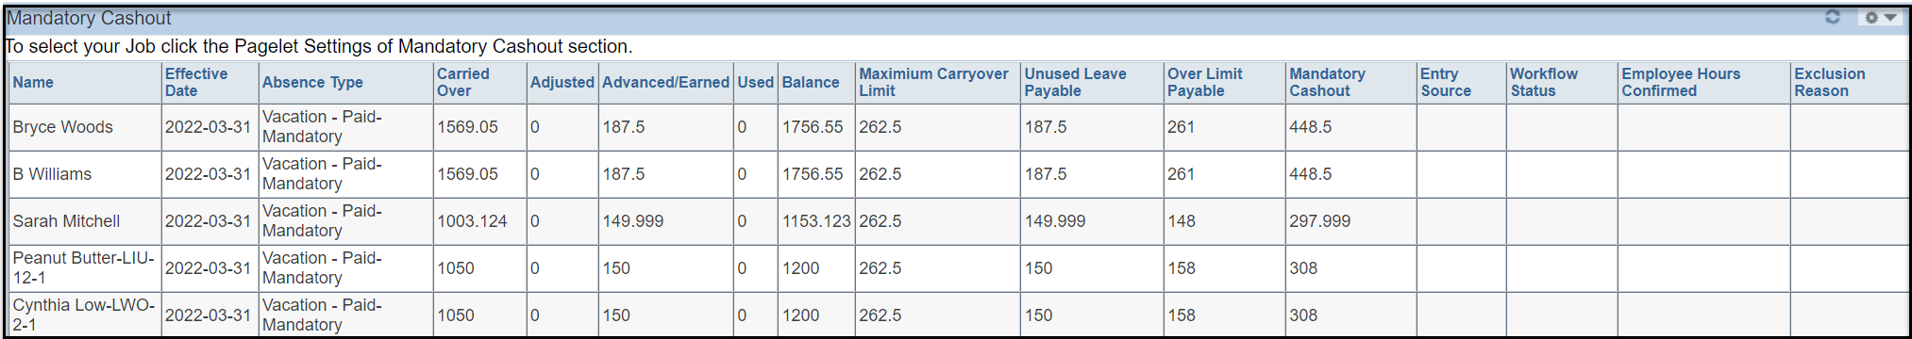
Managers can access detailed instructions on the mandatory cash-out process in MyGCHR by referring to the Mandatory Cashout at MyGCHR for Managers reference document.
All requests to exclude an employee from the mandatory cash out process require Section 34 delegated approval. If you do NOT have a valid Section 34 delegation, you must forward the request to the appropriate manager with the authority to review and approve Section 34 transactions.
For more information about Mandatory Leave Cash-Out, including details on timelines for the Lift of Moratorium and permitted exclusions of employees from the mandatory cash-out process, please refer to the Managers Toolkit, or contact your Departmental Corporate Labour Relations or Corporate Compensation Official.
UPK:
- Submit and Approve a Mandatory Cashout Confirmation Request for an Employee
- Approve, Deny or Forward an Employee Mandatory Cashout Confirmation Request
- Approve or Deny Employee Exclusion from Mandatory Cash Out Process as a Section 34 Manager

Transfer In / Transfer out
When an employee transfers from one government organization to a MyGCHR client organization, HR specialists can now record in MyGCHR the ‘transfer in’ without waiting for the ‘transfer out’ to be completed in the previous organization.
In the past, the integration between MyGCHR and Phoenix required the ‘transfer out’ process to be finished before starting the ‘transfer in’ process in MyGCHR. However, with the new approach, HR specialists can enter a "Pending transfer in" in MyGCHR, which does not integrate with Phoenix until the ‘transfer out’ process is actioned.
This allows MyGCHR organizations to initiate the 'transfer in' sooner, granting employees timely access to necessary work tools for their new roles, and managers to relevant information on their direct reports.
This includes, but is not limited to:
Approving requests for:
- Leave.
Managing:
- Timely extensions for determinate employment, acting appointments and assignments; and
- Employee work schedules.
Viewing employee information on:
- Second language evaluations; and
- Education.

Note: Until all leave balances from the 'transfer out' organization are entered in MyGCHR, leave requests should be submitted and approved using an alternate format, such as a paper or PDF form.

Manage Delegation
The Manage Delegate functionality enables managers to delegate some of their Manager Self Service transactions to one or more individuals during their absence. These delegates (referred to as Proxy in MyGCHR) can then act on their behalf to initiate and/or approve transactions for their employees.
Path in MyGCHR: Main Menu > Self Service > Manage Delegation
For example, you may choose to delegate some or all of your transactions for the following reasons:
- You know that you will be away from the office for an extended period of time.
- You prefer to have an assistant process all of your transactions.
When delegating transactions, you can specify whether you're delegating the employee to initiate or approve a transaction, and whether the delegation is for an indefinite period or a specific time frame.
There are three links on the Manage Delegation home page:
- Create Delegation Request - To create a delegation request so that your transaction(s) can be taken care of by a proxy.
- Review My Proxies - To view a list of transactions that you have delegated to proxies and to revoke the delegated authority of proxies. This link will appear if you have delegated to proxies.
- Review My Delegated Authorities - To view a list of transactions that have been delegated to you. You can either accept the request or reject the request. This link will appear if you have been selected as a delegated proxy.
Video: Manage delegations

Create Delegation Request
Choose the From Date and To Date to specify the period of the delegated authority for the individual.
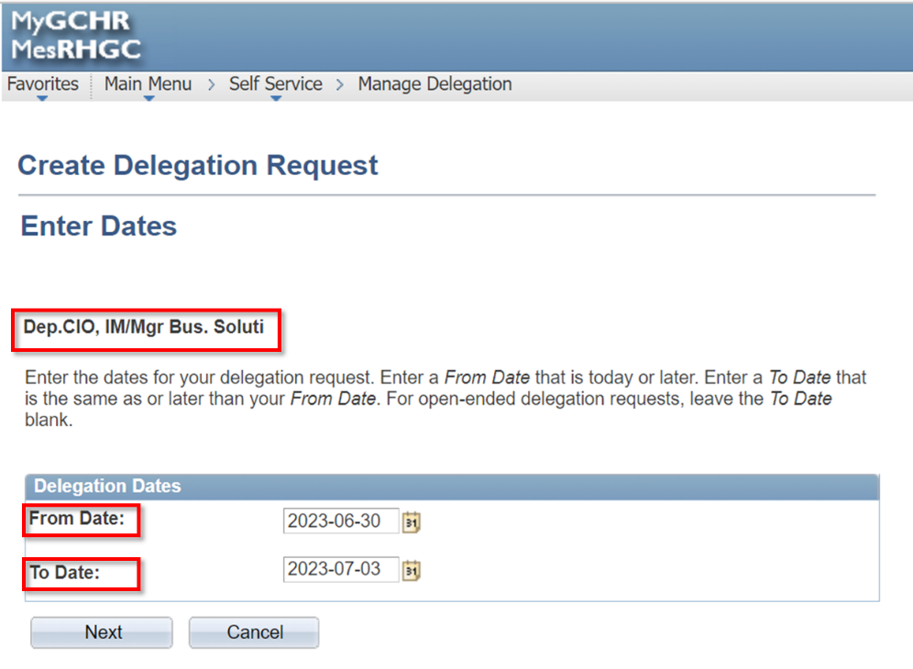
Select the type(s) of transaction that the delegated individual will have the ability to view or action.
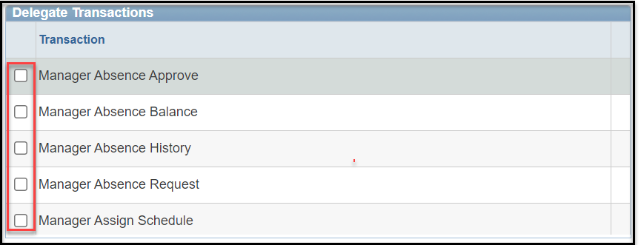
- Manager Absence Approve: Ability to approve Employee Absence requests.
- Manager Absence Balance: Ability to view Employee Leave Balances.
- Manager Absence History: Ability to view Historical Leave Requests in the current fiscal year.
- Manager Absence Request: Ability to enter Leave Requests on behalf of an employee.
- Manager Assign Schedule: Ability to create/modify employee predefined or personal schedules.
On the Select Proxy by Hierarchy page, you can either choose a person from the list or use the "Search by Name" link to find and select the individual you want to delegate your approval authority for manager self-service transactions or activities.
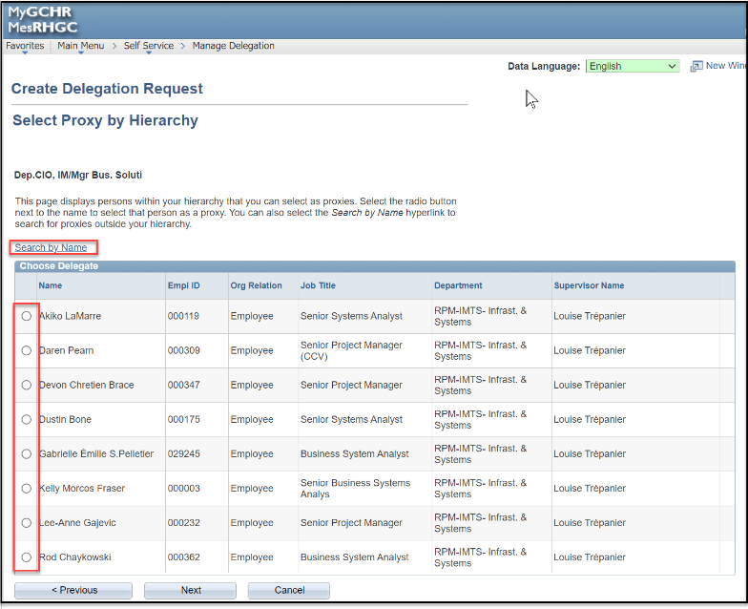
UPK - Delegate My Self-Service Approval Authority

Review My Proxies
Review the list of transactions that you have delegated to proxies for each transaction. You can also revoke the delegation.
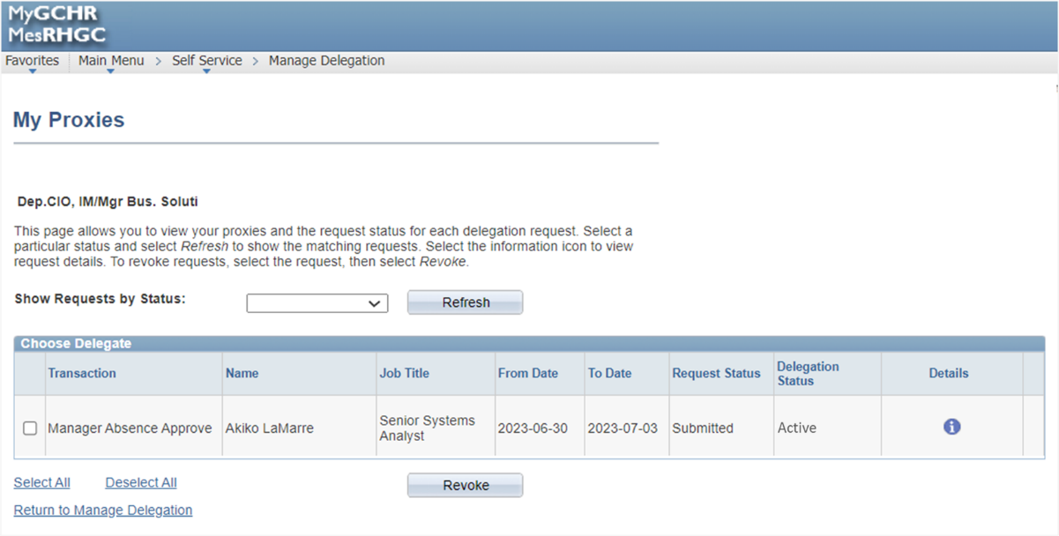

UPK - Review Proxies with My Self-Service Approval Authority

Review My Delegated Authorities
View a list of transactions that have been delegated to you. You can either accept or reject the request.
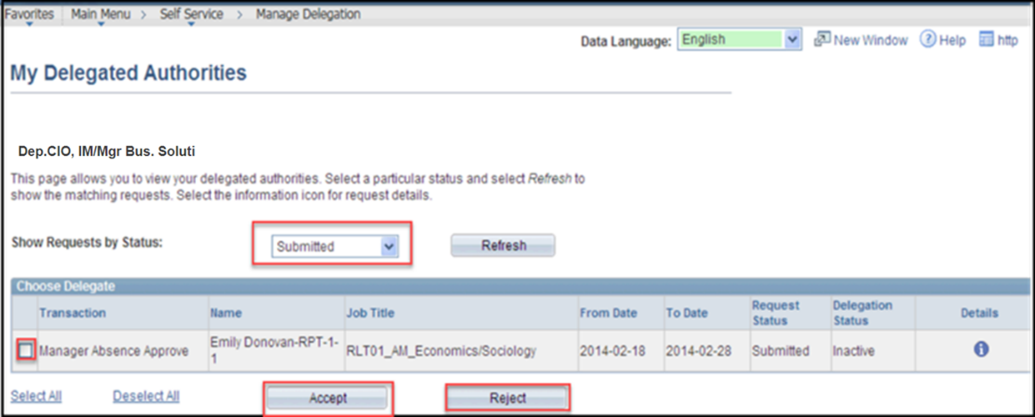

Note: To access the delegated transactions, the Proxy must accept the delegation request.
UPK - Accept or Reject a Self Service Delegation Request

FAQ on Delegation
Who can I delegate transactions to?
A transaction can be delegated to any active employee within your hierarchy.

What happens when I delegate Approval authority to someone?
When you delegate transactions to a proxy, this person acts on your behalf to action pending transactions. The proxy will receive system generated email notifications when a transaction is initiated. In the event that the transaction must go up another level in the organization hierarchy, the next level approver(s) will be determined based upon your position in the hierarchy - not the proxy's.

Can I delegate a single transaction to more than one person?
No, you cannot delegate the same transaction to more than one proxy for the same delegation period.

How do I specify a window of time for delegating transactions?
When you create a delegation request, you'll need to specify a From Date and a To Date. Leaving the To Date blank indicates that the delegation is indefinitely. A populated From Date indicates that the delegation is in effect from that date forward, until the To Date.

Can I remove myself as a delegate for someone else?
When you receive a delegation request, you can accept it or reject it. If you accept the request, you have to contact either the delegator or the system administrator to revoke the request.

If someone has delegated a transaction to me, can I then delegate it to someone else?
No, cascading delegation is not permitted.

Position Management

The Position Management module is used by the Classification unit to create and manage classification job codes and associated positions, including language requirements. This module is also used to manage designation/exclusion information related to positions.

Managers have access to VIEW all position data and work descriptions of the positions reporting to them.

View Position Info
Path in MyGCHR: Main Menu > Organizational Development > Position Management > Maintain Positions/Budgets > Add/Update Position Info
The Add/Update Position Info page allows managers to VIEW information on the positions reporting to them. The information is entered and updated in MyGCHR by the Classification unit.
To generate a list of positions that report to you, enter your own manager position number in the Reports to Position Number field and click on the Search button. Then, select the position from the Search Results for which you wish to view the information.
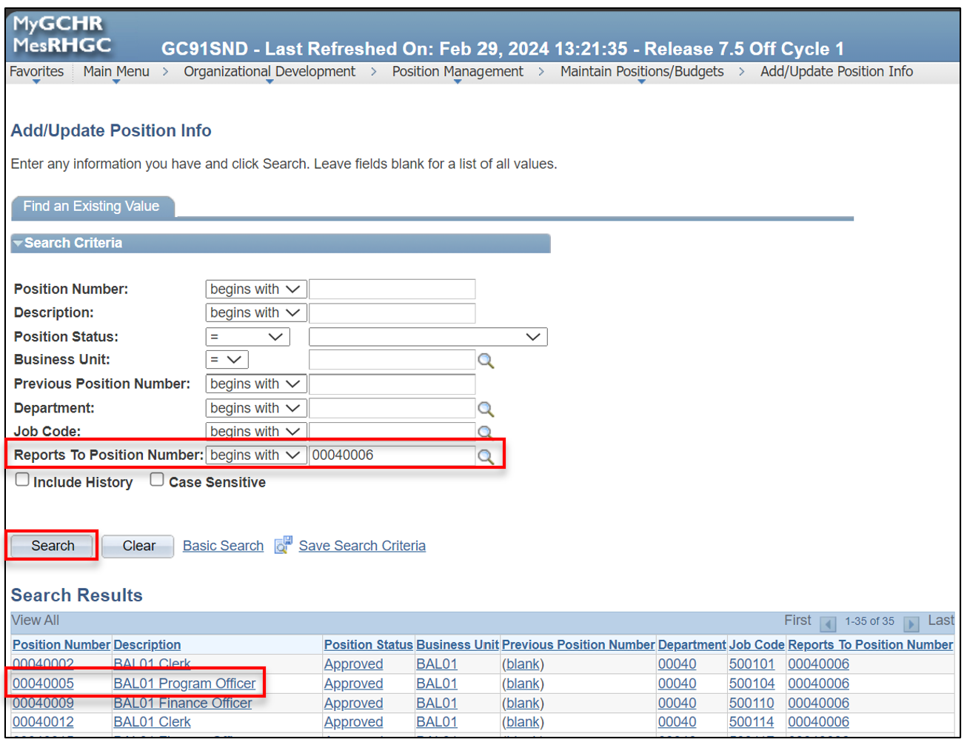
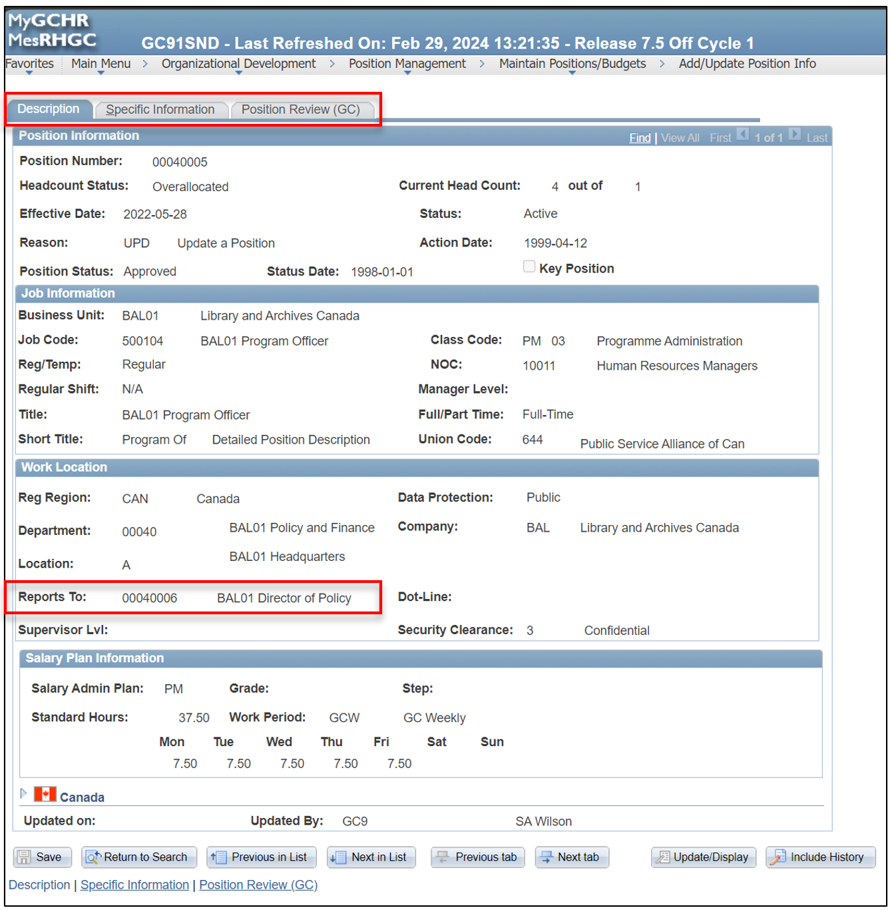
UPK - View Position Information

View Job Code Table (Work Description Information)
In MyGCHR, Job Codes are used to create general groupings of common jobs. It includes elements of the Work Description and the Classification Decision.
Path in MyGCHR: Main Menu > Organizational Development > Position Management > Maintain Positions/Budgets > Job Code Table
The Job Code Table page allows managers to VIEW information about the work descriptions of the positions reporting to them. The information is entered and updated in MyGCHR by the Classification unit.

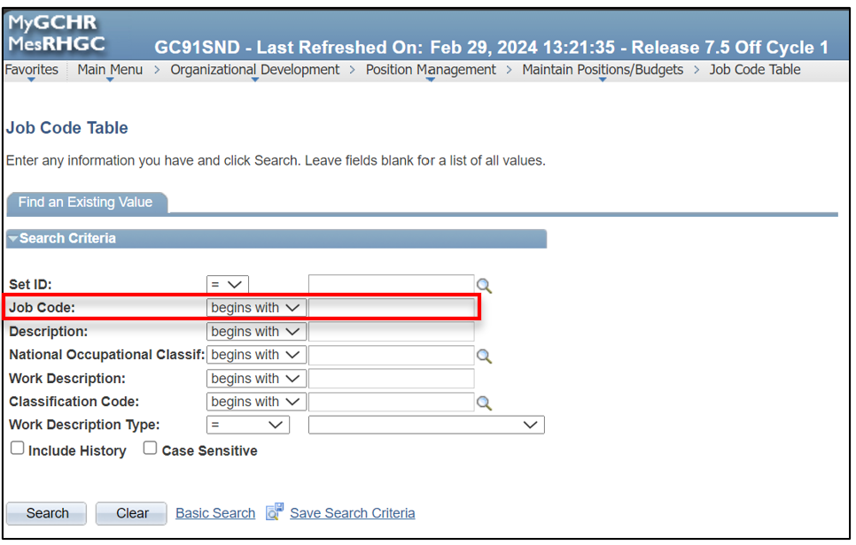
If you are unsure of the Job Code linked to the position you are searching for, you can use another field to narrow down the list of job codes. For instance, you can enter either a portion or the entire title of the position in the Description field. This will generate a list of all job codes associated with that description within your organization.
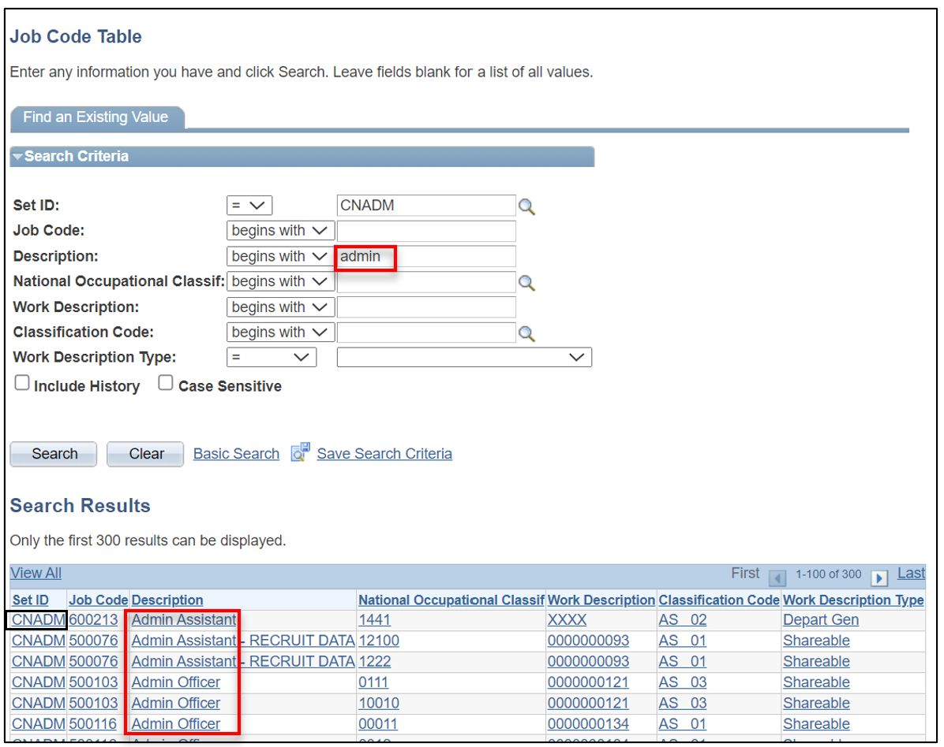

You also can view the job code when you're reviewing the position under the “Position Review” by clicking on the job code link (refer to screenshot below).
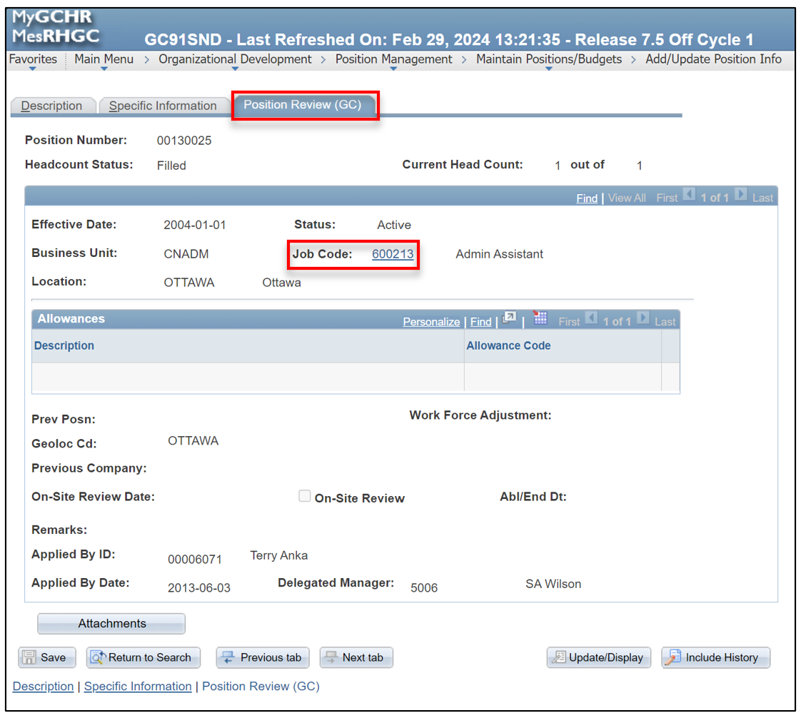

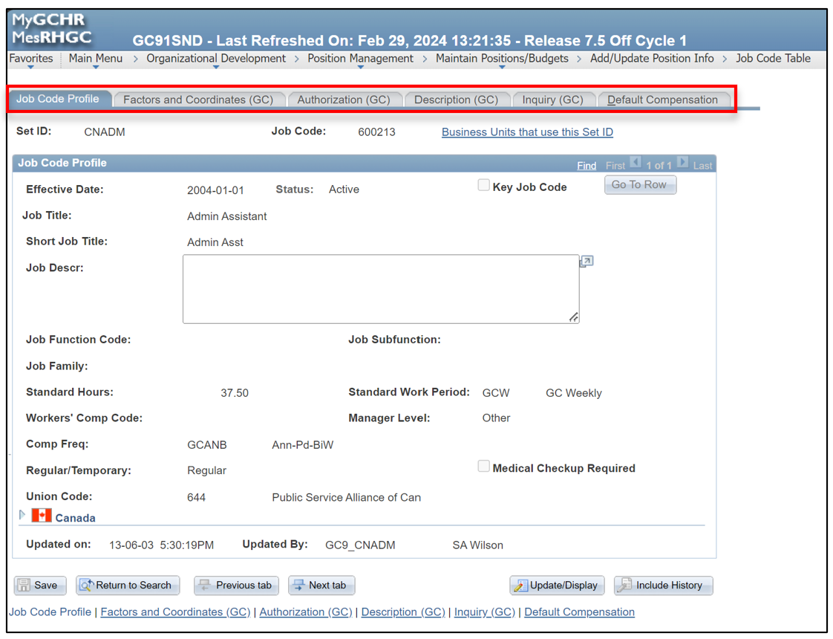
UPK - View Job Code Information

View Position - Official Language (GC)
The Position - Official Lang (GC) page provides managers access to view the Communications Requirements and Linguistic Profile of the positions that report to them.
Path in MyGCHR: Main Menu > Organizational Development > Position Management > Maintain Positions/Budgets > Position - Official Lang (GC)
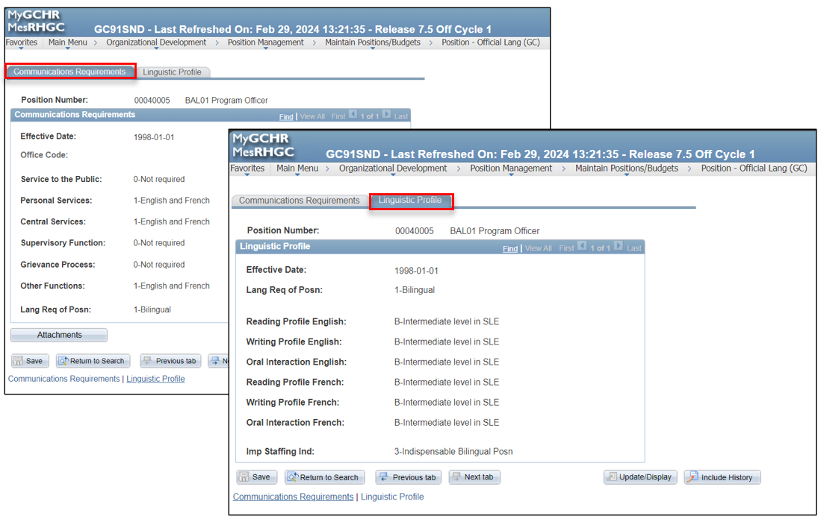
The Communications Requirements tab provides details on the rational for designating the linguistic profile of the position.
The Linguistic Profile tab indicates whether the position is designated unilingual, bilingual or “either French or English”. For a position designated as bilingual, this page indicates the proficiency level of the position to provide the services and functions as specified in the Communications Requirements tab.
UPK - View Official Language Information of a Position

View Position - Labour Relations (GC)
The Position - Labour Relations (GC) page provides managers access to view whether a position reporting to them is deemed essential or excluded, along with relevant information, if applicable.
Path in MyGCHR: Main Menu > Organizational Development > Position Management > Maintain Positions/Budgets > Position - Labour Relatns (GC)
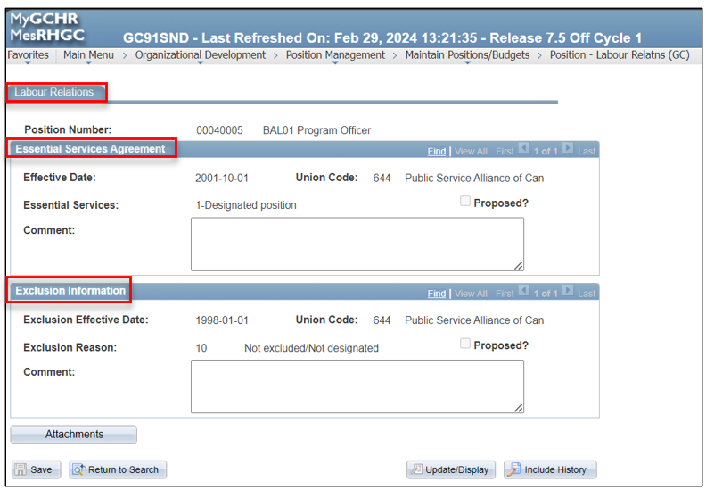

UPK - View Essential and Exclusion Information of a Position

View Position - HR/FIN Delegation (GC)
The Posn – HR/FIN Delegation (GC) page provides managers access to view whether a position reporting to them has HR or financial delegation, along with relevant information, if applicable.
Path in MyGCHR: Main Menu > Organizational Development > Position Management > Maintain Positions/Budgets > Posn - HR/FIN Delegation (GC)
The delegation levels in MyGCHR are based on the organization’s HR Instrument of Delegation and the Financial Matrix Delegation.
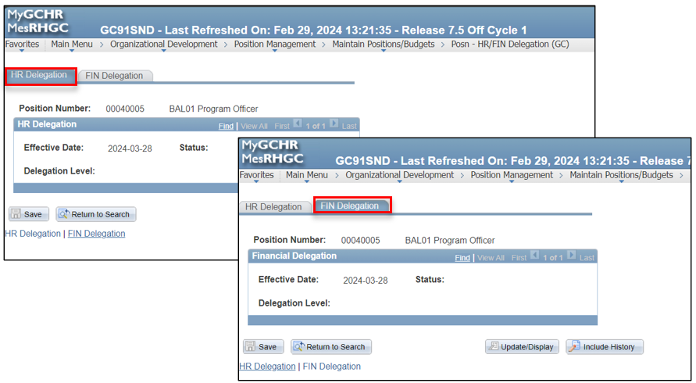

UPK - View the HR and FIN Delegation of a Position

View Position Summary
The Position Summary page provides managers with a convenient overview of all transactions entered in MyGCHR for a specific position that reports to them.
Path in MyGCHR: Main Menu > Organizational Development > Position Management > Review Position/Budget Info > Position Summary
This summary page facilitates efficiency by providing a quick glance at the information, eliminating the need to review each transaction row individually.
You can choose to view the transaction data by category by selecting the appropriate tab: General, Work Location, or Payroll Information.
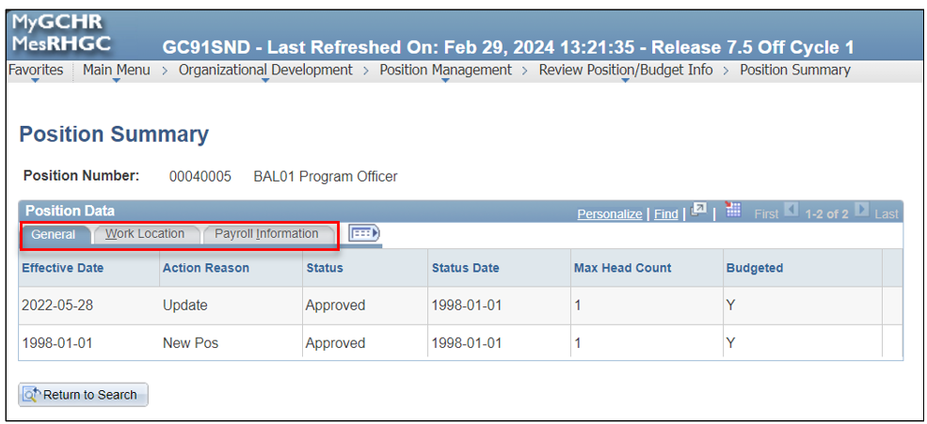
Alternatively, you can choose to view all the data at once by selecting the Show All Columns icon.
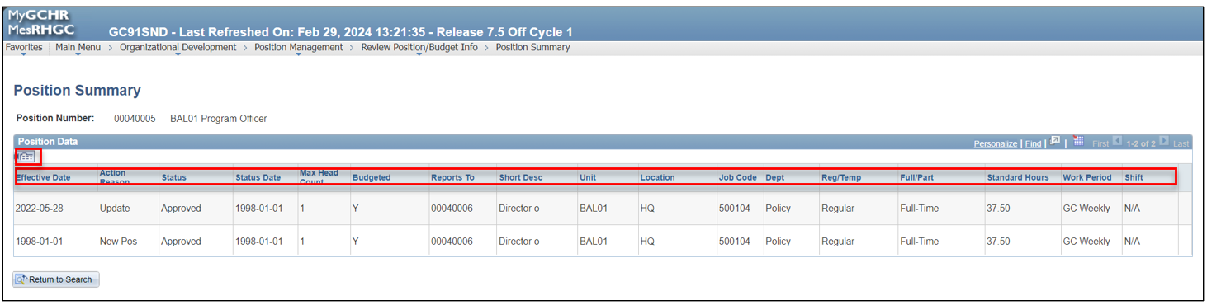

UPK - View Position Summary

Profile Management

View Current Team Profiles
In MyGCHR, employee financial delegation, accommodations, driver's licenses, security clearances, education, qualifications, test results, competencies and telework arrangements are maintained in Person Profiles.
As a manager, you can access and manage profiles of current direct and indirect employees in Current Team Profiles.
Path in MyGCHR: Main Menu > Manager Self-Service > Learning and Development > Current Team Profiles
Note: If you require access to historical profiles of former employees, you can do so through the Team Historical Profiles.
Path in MyGCHR: Main Menu > Manager Self-Service > Learning and Development > Team Historical Profiles
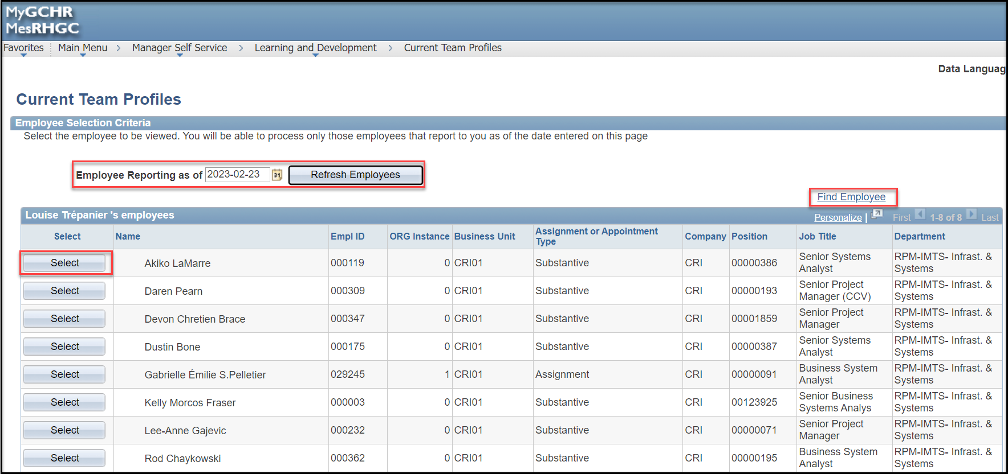

The Employee Reporting as of field defaults to today’s date and the Current Team Profiles page displays your team as of the current date. If needed, you can modify the date to view the list of direct reports as of a specific date.

You can also use the Find Employee link to search for a specific employee.
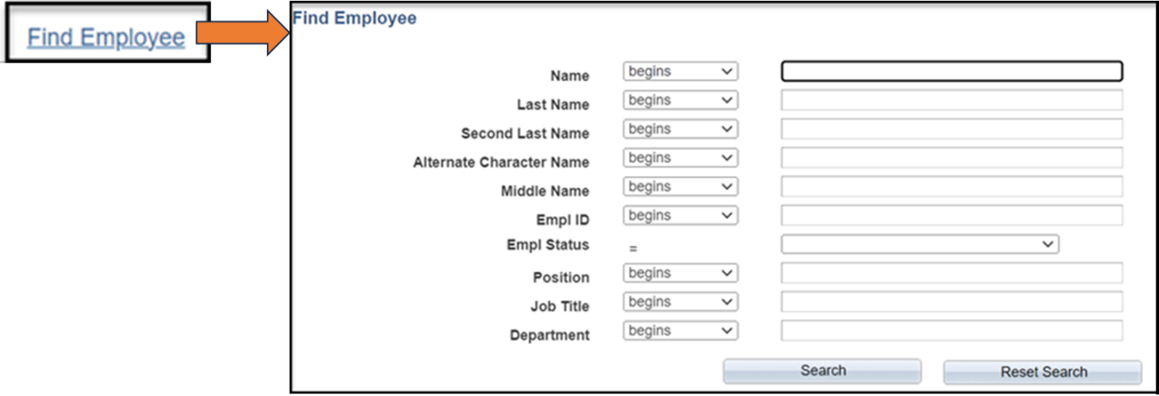

Once you have located the employee whose profile you wish to view on the Current Team Profiles page, simply click the "Select" button next to their name.

On the Select Profile Type page, accept the Profile Type default value of PERSON. Click the Continue button.
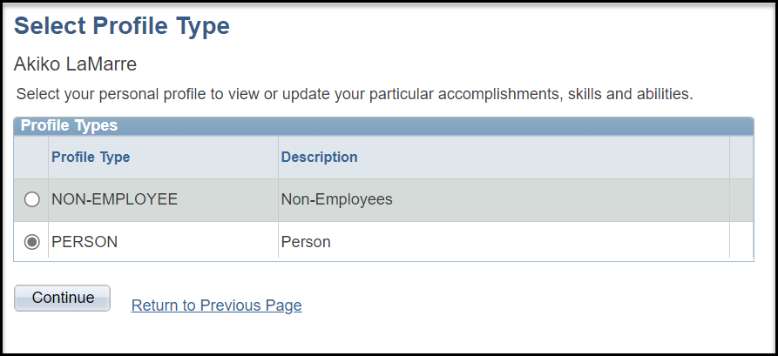

On the Current Person Profile page, you can manage employee accommodations information, approve, or deny competencies, while also reviewing additional profile contents maintained by HR Professionals. This helps maintain up-to-date and complete employee profiles.

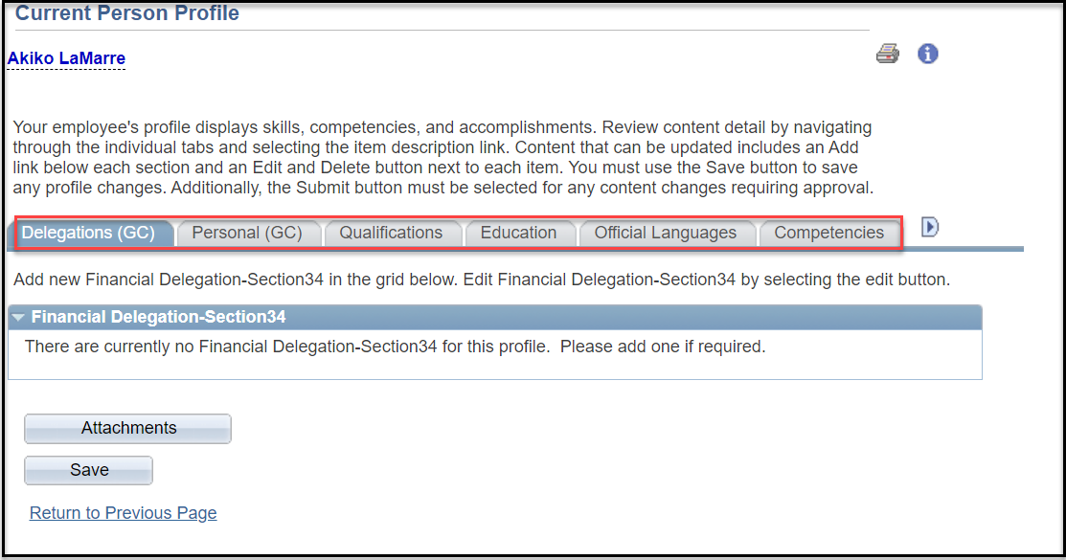

Delegation: Displays the details of the employee’s Financial Delegation-Section 34.
Note: The Financial Delegation - Section 34 link is available only if the employee has completed the required training and has received the authorized financial delegation from finance.

Personal (GC): Contains the following sections:
- Accommodations
- Driver's License Data
- Security Clearance
Note: This tab is not being used by your organization.

Qualifications: Contains the following sections:
- Service Award Dates
- Honors and Awards
- Language Skills
- Licenses & Certifications
- Memberships
- Tests/Examinations
Education: Contains the following sections:
- School Education
- Degrees
- Areas of Study

Official Languages: Displays the SLE Test Results
- SLE Oral Interaction French
- SLE Reading Interaction French
- SLE Writing Interaction French
- SLE Oral Interaction English
- SLE Reading Interaction English
- SLE Writing Interaction English

Competencies: Contains many types of competencies, e.g., Verbal aptitude, technical aptitude etc.

Telework (GC): Contains the following sections:
- Telework Details
- Telework Arrangement
Note: This tab is not being used by your organization.

Conflicts of Interest: not used.

UPK:
- View Current Team Profiles
- Approve or Deny Employee Competency
- View an Employee's Security Clearance, Education and SLE Information

View Employee Personal Information
The View Employee Personal Information page allows managers to access personal information for employees who report to them (directly or indirectly).
Path in MyGCHR: Main Menu > Manager Self-Service > Job and Personal Information > View employee Personal Info
You can view emergency contacts, email addresses (home, business and other), phone numbers (work, work cell, personal, etc.) and birthday. Additionally, this page provides a summary of job information including Employee ID, position information, start date, location, etc.
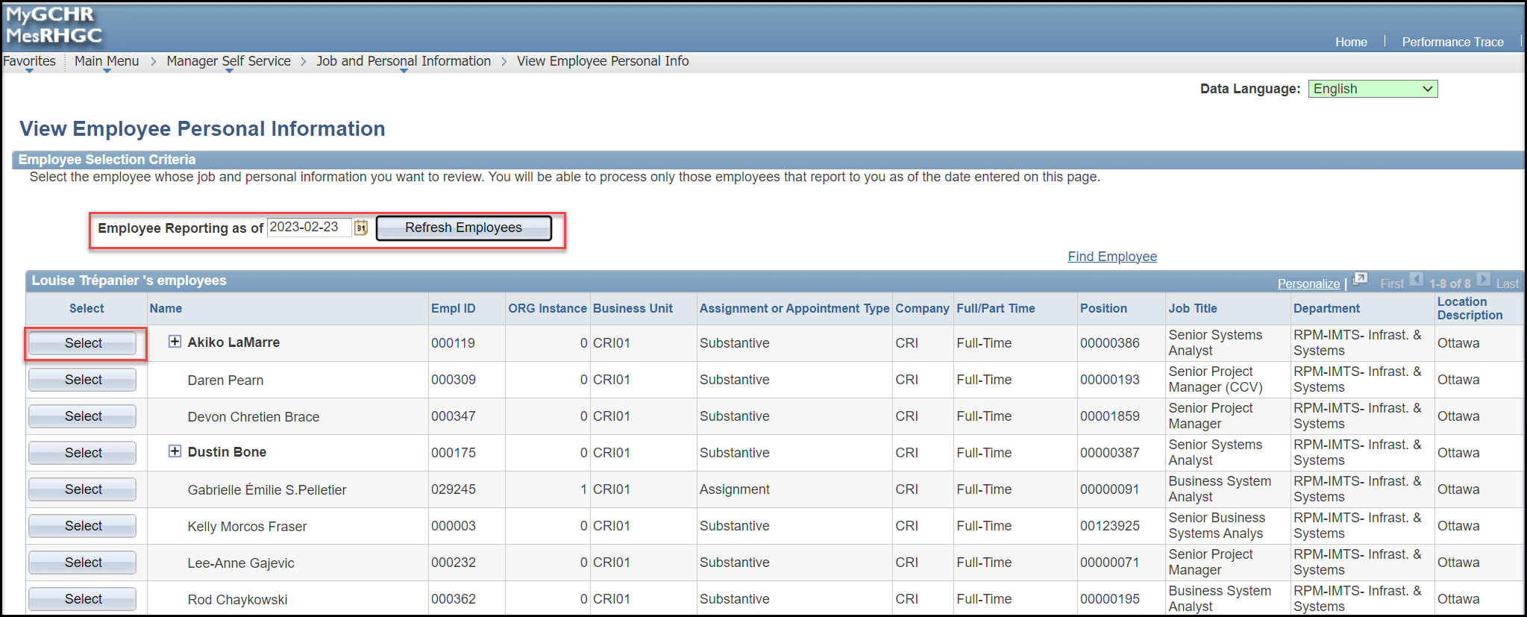

The Employee Reporting as of field defaults to today’s date and the View Employee Personal Information page displays your team as of the current date. If needed, you can modify the date to view the list of direct reports as of a specific date.

You can also use the Find Employee link to search for a specific employee.
Once you have located the employee whose profile you wish to view on the View Employee Personal Information page, simply click the Select button next to their name.

The Employee Information page contains two sections: Personal Information and Additional Information.
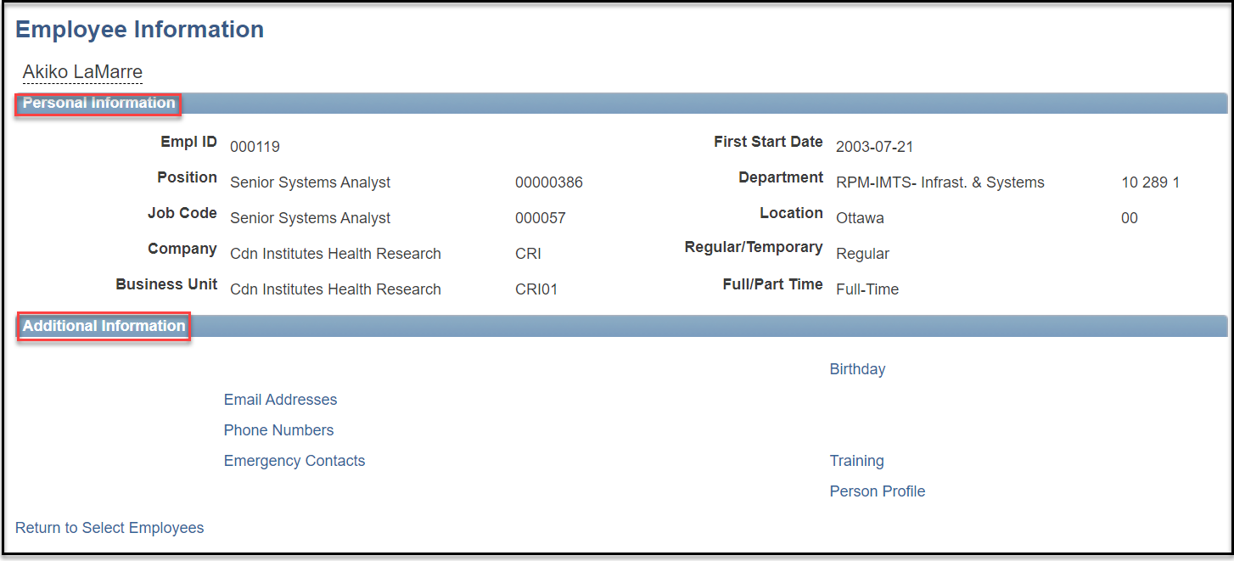

The Personal Information section displays the following information:
- Empl ID: the person's unique identifier in MyGCHR.
- Position: the position title and number (if the person is in a position).
- Job Code: the code used to group jobs into general classifications.
- Company: the government organization that owns the position, e.g., the department or agency.
- Business Unit: the code used to segregate data for your government organization (department or agency) in MyGCHR. This allows your organization to view only data for your organization and provides a way to control access to your data.
- First Start Date: the date on which the employee joined the government organization.
- Department: the organizational unit with which the person or position is associated, e.g., Corporate Services, etc.
- Location: the location where the work is being performed.
- Regular/Temporary: the person’s tenure. Regular if the employee is indeterminate or Temporary if the employee is a term or other tenure.
- Full/Part Time: the person’s full time or part time status.
Note: This information is also available in the Manager Dashboard.

The Additional Information section provides links to the following personal information:
- Email Addresses
- Phone Numbers
- Emergency Contacts
- Birthday
- Training
- Person Profile
Note: If you’ve clicked on any of the links in the Additional Information section, click the Return to Employee Information link at the bottom of the page to return to the Employee Information page.

UPK - View Personal Information for a Direct Report

Manager Self Service - MyGCHR vs. Phoenix
Managers will enter the Self-Service module for each system separately to access a series of Self-Service tools.

Phoenix | MyGCHR
Managers will access the Self-Service through Phoenix to perform the following actions:  Manager Self-Service (MSS):  - Approve Positive Time Reporting (Time Sheets) for payment.  - Approve leave without pay of 5 consecutive days or less.  - Approve and view his or her employee’s Extra Duty Pay for cash payment.  - Access a Worklist, allowing the manager to see what is pending for his or her action. | Managers will access Self-Service through MyGCHR to perform the following actions:  Manager Self-Service (MSS):  - Assign/Manage Work Schedules.  - Create Personal Schedules.  - Approve requests to bank compensatory leave credits.  - Approve leave without pay of 5 consecutive days or less.  - Approve and view his or her employee’s absence events.  - Mandatory cash-out actions.  - Access the Manager Dashboard to see what is pending for his or her action.

New Terminology – MyGCHR Self Service

Absence Entitlements | Equivalent is Leave Entitlements such as vacation leave with  pay.
Absence Event | Equivalent is Leave Transactions.
Absence Take | This field is used to identify the type of absence (i.e., vacation, sick, family, related, etc.) or event (i.e., Adjustment, comp earned, etc.) being entered.
Absence Type | This value defaults based on the absence type value selected on the Absence Event page.
Forecast | After entering absence events, click this button to run the Forecasting process. This process will determine if you are eligible for the absence event being requested.
Take Codes | Equivalent is Leave Codes.

