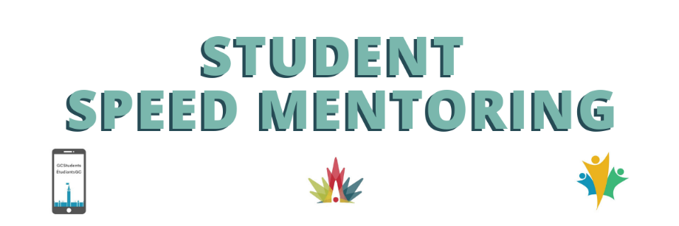
Mentee Instructions for Career Boot Camp Speed Mentoring

How to connect:
- The Zoom link to access the event is provided to you in the calendar invite and/or email confirmation you will have received.
important contacts
Scheduling or general event details: Emily Smith
Technical assistance:
Marc-André LeBlanc
- If you use your work computer, please remember to disconnect from the VPN to avoid overloading the network. Feel free to join from a personal device if preferred as some departments’ access to Zoom or ability to disconnect from the VPN is limited (i.e. IRCC, CBSA and CRA).
- Please join with your personal link, you have been sent this information by zoom directly. If you cannot find your link please reach out to Emily Smith.

Event Layout:
- Once the speed networking starts, you will be prompted to "Join" your assigned breakout room, through a pop-up window.
- Mentees will remain in the same room for the entire event and the Mentors will be moved from room to room during every 15 minute interval.
- You’ll have fifteen minutes to chat with your mentor. You can use the raise hand function and chat throughout the sessions.
- We will broadcast a message when there are 2 minutes left to the round. When the 15 minutes are up the mentor, will be prompted to join another breakout room.
  - If you accidentally leave your breakout room, you will be redirected to the main room where we will have admins standing by who can place you back into your breakout room.

Useful tips to succeed in your sessions:
- Be prepared to provide a bit of information about yourself such as your current role and give some thought to your career goals. Keep this concise and to the point – be mindful of others in your session and the limited amount of time available.
- Lead the discussion by posing questions.
- Feel open to share your experiences and knowledge with everyone while being aware and allowing time for others to share their input as well.
- Try to mute your mic when you are not speaking but always leave your camera on to engage fully in the conversation.
- Remember to dress appropriately and remove anything in your surroundings you don’t wish to be in view of others.
- Ensure you utilize the mute function and consider using headphones to limit background noise from interfering with your conversation. We are all working virtually so no stress if something occurs that is out of your control.

Be prepared to ask questions:
Check out some of our favourite questions and the bios of the mentors who will be present during your session on our wiki page:
2022 Student Speed Mentoring - wiki (gccollab.ca)
https://wiki.gccollab.ca/File:Sample_Questions.docx

