Access and action pending leave requests
(for Chairpersons)

- Log in to MyGCHR (consult the Logging in to MyGCHR for the first time job aid if this is your first time logging in).

- Use the following path: Main Menu > Manager Self Service > Time Management > Approve Time and Exceptions > Absence Requests
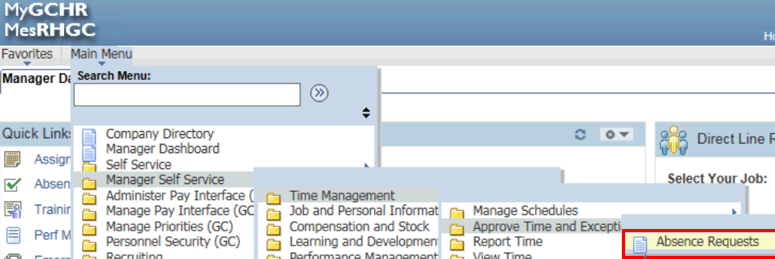

- Click on the member’s name in the Absence Requests table.
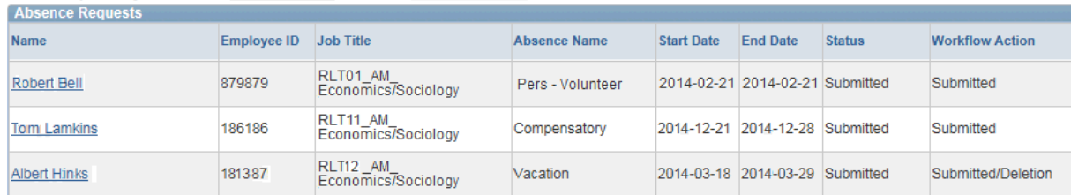

- Click on the Forecast Balance button to determine if your member is eligible to take the leave submitted.

- If eligible, scroll down to the bottom of the page and click on “Forward”.

- Enter your Executive Director’s Supervisor ID (click on the look-up button to find your ED), then click “OK”.

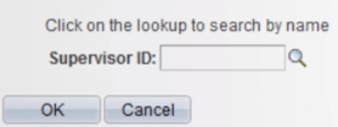

- Click on “Yes”
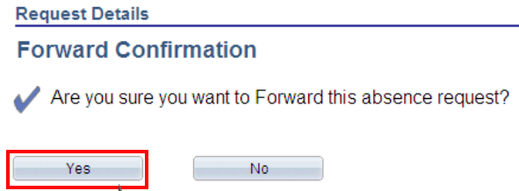

- Click “OK”
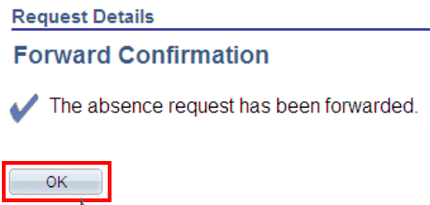

Note: By forwarding the request to your Executive Director, it is understood your wish is for the Executive Director to certify (“Approve”) the leave.

